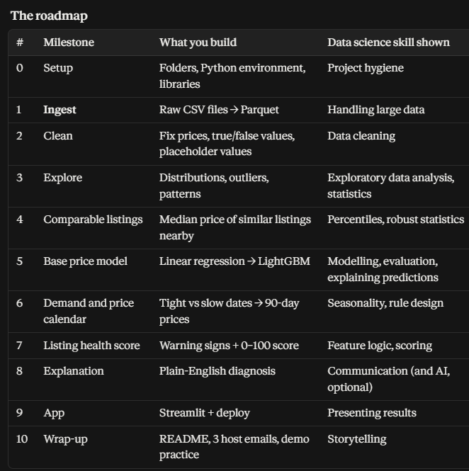
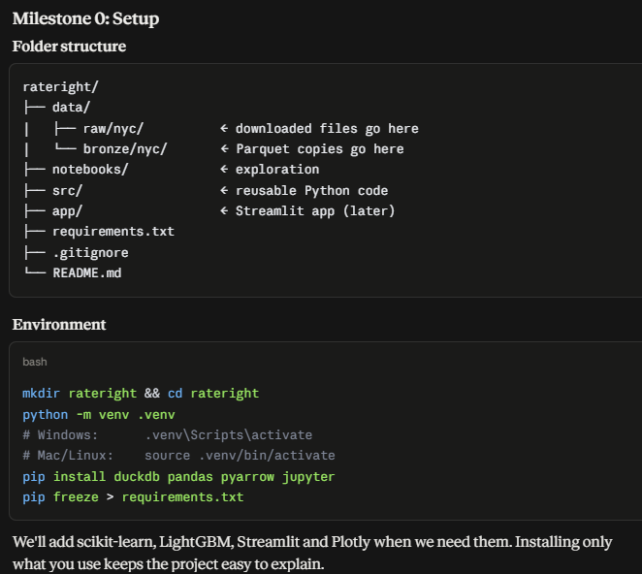

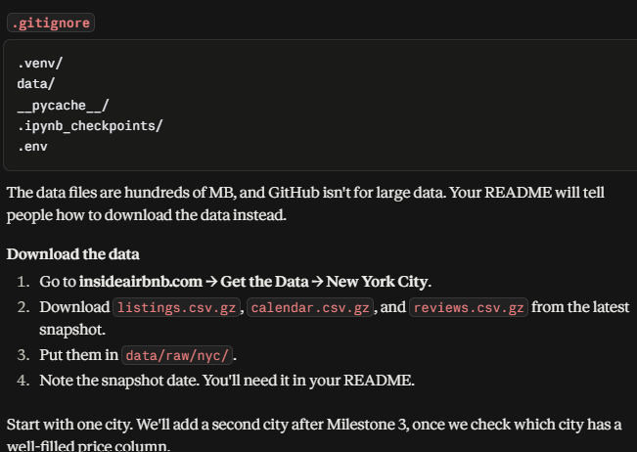
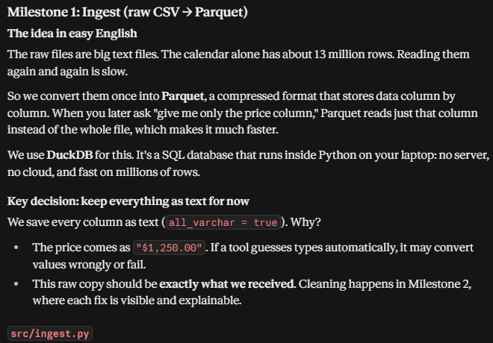
Then code in ingest.py
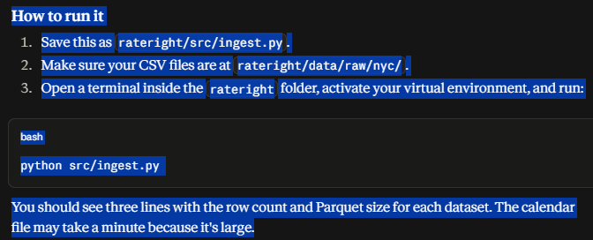
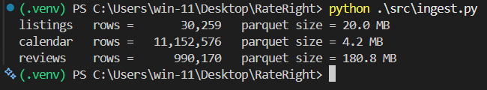
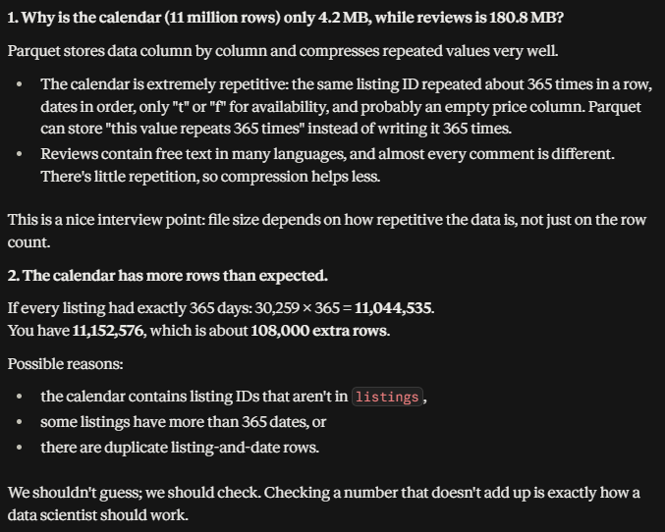
Validation checks
Create notebooks/01_first_look.ipynb and run these cells one by one.
- Write code in it
- Then created data_notes.md (contains everything about till milestone 1)

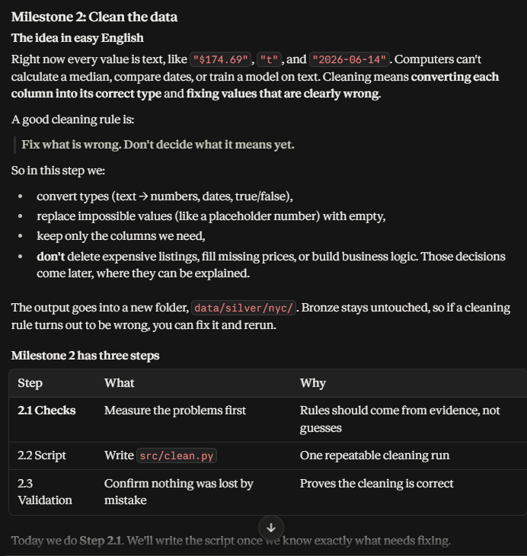
- Write code in 02_cleaning_checks.ipynb
- Write code in src/clean.py
- Write code in 03_silver_validation.ipynb
- Write inside data_notes.md

