**INSTALLATION OF UBUNTU OPERATING SYSTEM**

1. **Download Virtual Box**

Go to the official website <https://www.virtualbox.org/>of Oracle Virtual Box and get the latest stable version.

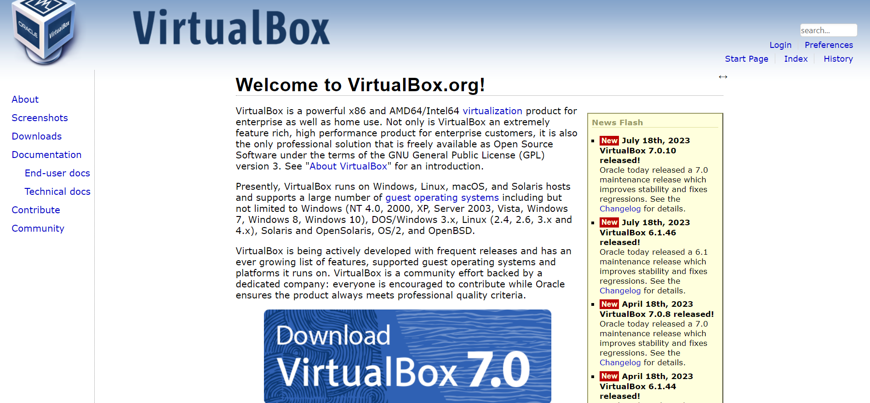

Installing Virtual Box is no rocket science. Just double-click on the downloaded.exe file to run it and follow the instructions on the screen. It is like installing regular software on Windows.

1. **Download Linux ISO**

Next, you need to download the ISO file of the Linux distribution, that is Ubuntu.

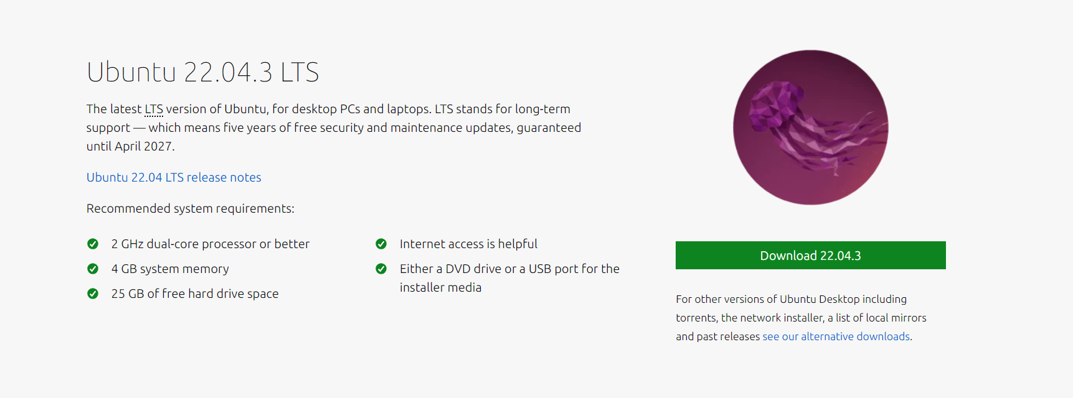

1. **Install Ubuntu using Virtual Box**

Now, you have installed Virtual Box and downloaded the ISO for Linux. You are now all set to install Linux in Virtual Box.

* Start Virtual Box, and click on the New Symbol( it looks like a blue star). Give the virtual OS a relevant name, I’d reckon you give the name of the distro you’re going to install – Ubuntu.

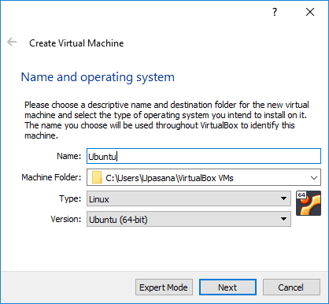

* Allocate RAM to the virtual OS. My system has 8 GB of RAM and I decided to allocate 4 GB of RAM to it. You can use extra RAM if your system has more RAM.

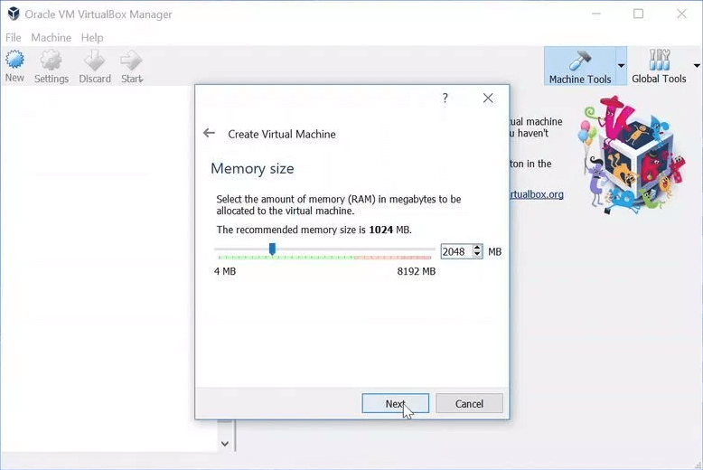

* Create a virtual disk. This works like the hard disk of the virtual Linux system. This is where the virtual system will store its files. Go for the VDI type file, here.

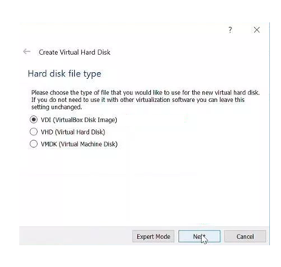

* You can choose either to Dynamically allocate or a Fixed sizeoption for creating the virtual hard disk. The recommended size is 10 GB.

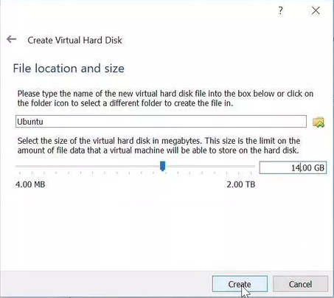

* Once everything is in place, it’s time to boot that ISO and install Ubuntu as a virtual operating system. If Virtual Box doesn’t detect the Linux ISO, browse to its location by clicking the folder icon as shown in the picture.

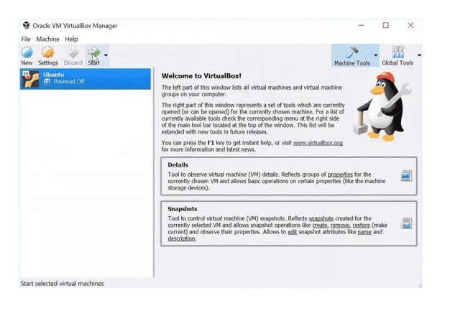

* Soon you’ll find yourself inside Linux. You’ll end up with the option to install it.

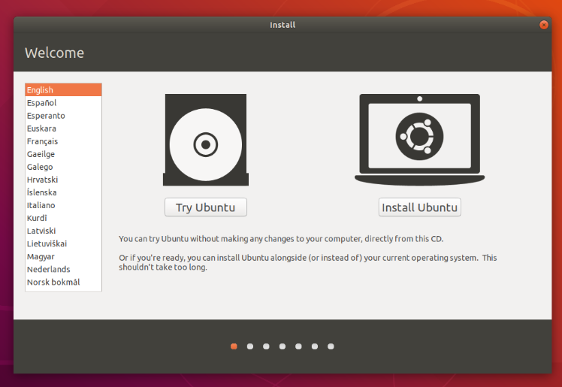

* Now, go ahead and select your preferred option from a barrage of languages enlisted on your left, followed by which, you can choose between either installing Ubuntu directly or trying the desktop first.

Now, you’ll be presented with either a large language pane which you can navigate through using your cursor keys/mouse/touch-pad or a simple installation menu. But this totally depends upon on your computer’s configuration.

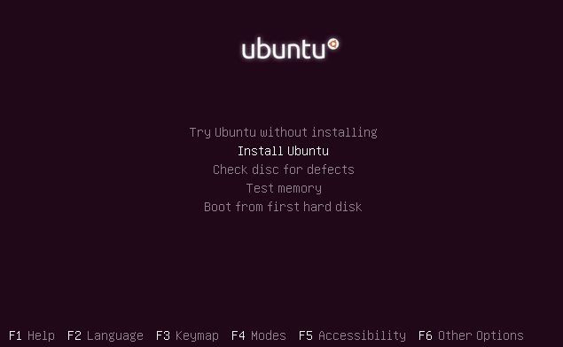

* You’ll probably find an option called ***Install Ubuntu***. Click on that option and press return to launch the desktop installer automatically.
* Alternatively, you could also select the first option, ***Try Ubuntu without installing*** to give Ubuntu a test run.

A few seconds later, after the desktop has loaded, you’ll see a new window. This is the welcome window. At this point, you can select your language from a list on the left and choose between either installing Ubuntu directly or trying the desktop first.

1. **Preparations for Installing Ubuntu**

* Post the language selection, you shall be asked to select your keyboard layout. If the installer doesn’t guess the default layout correctly, you can use the ***Detect Keyboard Layout*** button to run through a brief configuration procedure and then select ***Continue***.
* Next, you shall be asked ***What apps would you like to install to start with?*** Two options will be available to you; ***Normal installation*** and ***Minimal installation*.**
* The first option is the equivalent to the old default bundle of utilities, applications, games and media players. It’s a great launchpad for any Linux installation.
* The second option takes considerably less storage space and allows you to only install what you require.
* Beneath the installation-type question will be two check-boxes; I’d reckon you enable both ***Download*** and ***Install Third-Party Software*.**

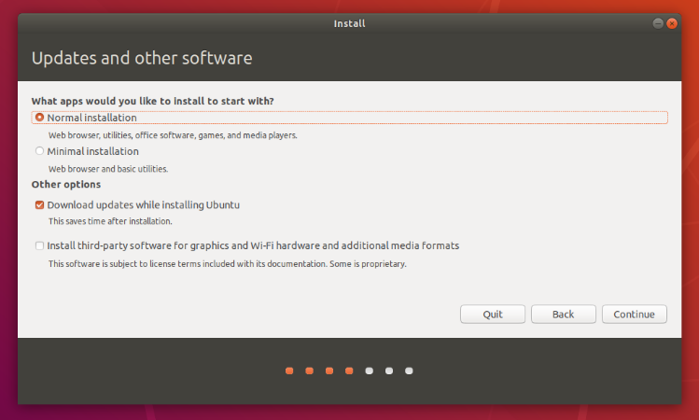

Suppose, you aren’t connected to the internet, you will be asked to select a wireless network, if available. It’s always preferable to stay connected to the internet during the installation so your machine is updated.

1. **Allocate Drive Space**

* There will be a couple of checkboxes to choose from as you can see in the image below. So you can make a choice, if you’d like to install Ubuntu alongside another operating system, delete your existing operating system and replace it with Ubuntu, or Something else**.**

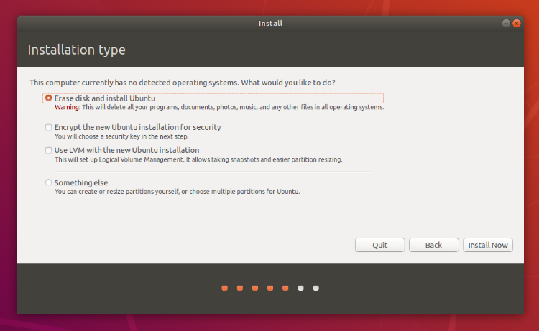

* Click on ***Install Now*.**

1. **Begin Installation**

* A small pane, in the likes of the image given, will appear before you which will have an overview of the storage options you’ve chosen, with the chance to go back if the details are incorrect.
* Click ***Continue*** to fix those changes and start the installation process.

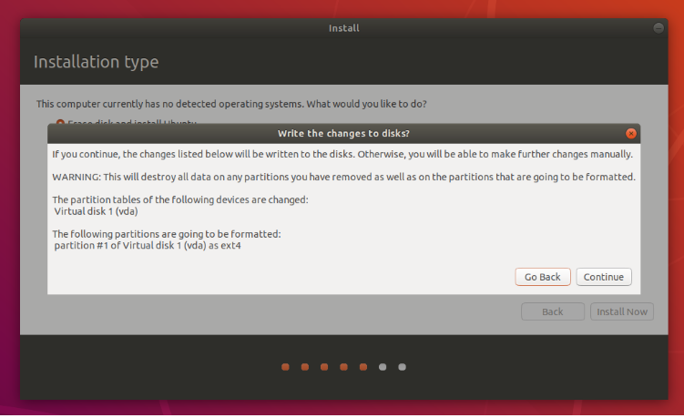

1. **Select Location**

* Your location shall be detected automatically if you’re connected to the internet. Check if your location is accurate. If so, click on ***Forward*** to proceed.

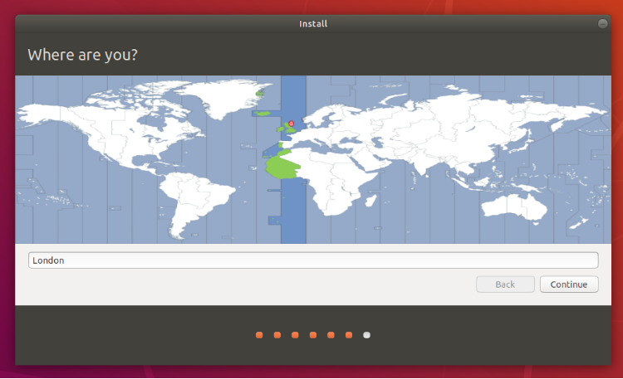

1. **Login**

* The installer shall suggest a computer name, automatically and also the username, once you enter your name. These are pretty simple to change according to your preference. The ***computer name*** is how your computer will appear on the network, while your ***username*** will be your login and account name.
* Next, go ahead set a strong password. It could include uppercase alphabets, lowercase alphabets, numeric and special characters.

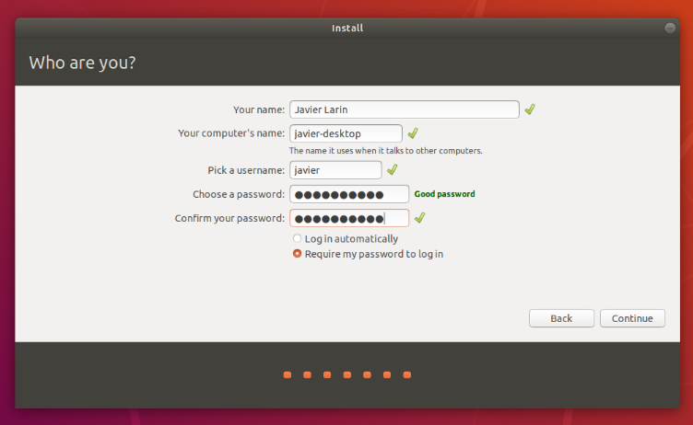

* You could also choose to enable ***automatic login*** and ***home folder encryption***.  This prevents people from accessing your personal files just in case the machine is lost or stolen.

But if you enable home folder encryption and you happen to forget your password, ***you won’t be able to retrieve any personal data*** stored in your home folder, that’s a con. I am not trying to scare you, I promise!

1. **Background Installation**

* The installer begins by telling you a little bit about how awesome is Ubuntu, while it completes in the background. This should only take a few moments.

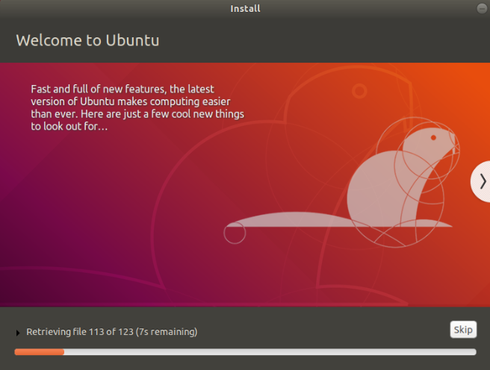

1. **Installation Complete!**

* Now your Distribution has been installed and configured. A small window will appear before you, asking you to ***restart your machine***. Click on ***Restart Now***.

