**LINUX FILE SYSTEM**

A Linux file system is a structured collection of files on a disk drive or a partition. A partition is a segment of memory and contains some specific data. In our machine, there can be various partitions of the memory. Generally, every partition contains a file system.

Linux file system is generally a built-in layer of a [Linux operating system](https://www.javatpoint.com/what-is-linux) used to handle the data management of the storage. It helps to arrange the file on the disk storage. It manages the file name, file size, creation date, and much more information about a file.

The general-purpose computer system needs to store data systematically so that we can easily access the files in less time. It stores the data on hard disks (HDD) or some equivalent storage type. There may be below reasons for maintaining the file system:

* Primarily the computer saves data to the RAM storage; it may lose the data if it gets turned off. However, there is non-volatile RAM (Flash RAM and SSD) that is available to maintain the data after the power interruption.
* Data storage is preferred on hard drives as compared to standard RAM as RAM costs more than disk space. The hard disks costs are dropping gradually comparatively the RAM.

The [Linux](https://www.javatpoint.com/linux-tutorial) file system contains the following sections:

* The root directory (/)
* A specific data storage format (EXT3, EXT4, BTRFS, XFS and so on)
* A partition or logical volume having a particular file system.

**Linux File System Structure**

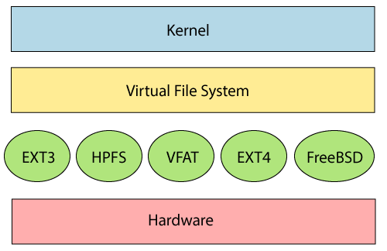

**Directory Structure**

* **/ (root filesystem):** It is the top-level filesystem directory. It must include every file needed to boot the Linux system before another filesystem is mounted. Every other filesystem is mounted on a well-defined and standard mount point because of the root filesystem directories after the system is started.
* **/boot:** It includes the static kernel and bootloader configuration and executable files needed to start a Linux computer.
* **/bin:** This directory includes user executable files.
* **/dev:** It includes the device file for all hardware devices connected to the system. These aren't device drivers; instead, they are files that indicate all devices on the system and provide access to these devices.
* **/etc:** It includes the local system configuration files for the host system.
* **/lib:** It includes shared library files that are needed to start the system.
* **/home:** The home directory storage is available for user files. All users have a subdirectory inside /home.
* **/mnt:** It is a temporary mount point for basic filesystems that can be used at the time when the administrator is working or repairing a filesystem.
* **/media:** A place for mounting external removable media devices like USB thumb drives that might be linked to the host.
* **/opt:** It contains optional files like vendor supplied application programs that must be placed here.
* **/root:** It's the home directory for a root user. Keep in mind that it's not the '/' (root) file system.
* **/tmp:** It is a temporary directory used by the OS and several programs for storing temporary files. Also, users may temporarily store files here. Remember that files may be removed without prior notice at any time in this directory.
* **/sbin:** These are system binary files. They are executables utilized for system administration.
* **/usr:** They are read-only and shareable files, including executable libraries and binaries, man files, and several documentation types.
* **/var:** Here, variable data files are saved. It can contain things such as MySQL, log files, other database files, email inboxes, web server data files, and much more.

**Linux File System Features**

In Linux, the file system creates a tree structure. All the files are arranged as a tree and its branches. The topmost directory called the **root (/) directory**. All other directories in Linux can be accessed from the root directory.

Some key [features of Linux](https://www.javatpoint.com/linux-features) file system are as following:

* **Specifying paths:** Linux does not use the backslash (\) to separate the components; it uses forward slash (/) as an alternative. For example, as in Windows, the data may be stored in C:\ My Documents\ Work, whereas, in Linux, it would be stored in /home/ My Document/ Work.
* **Partition, Directories, and Drives:** Linux does not use drive letters to organize the drive as Windows does. In Linux, we cannot tell whether we are addressing a partition, a network device, or an "ordinary" directory and a Drive.
* **Case Sensitivity:** Linux file system is case sensitive. It distinguishes between lowercase and uppercase file names. Such as, there is a difference between test.txt and Test.txt in Linux. This rule is also applied for directories and Linux commands.
* **File Extensions:** In Linux, a file may have the extension '.txt,' but it is not necessary that a file should have a file extension. While working with Shell, it creates some problems for the beginners to differentiate between files and directories. If we use the graphical file manager, it symbolizes the files and folders.
* **Hidden files:** Linux distinguishes between standard files and hidden files, mostly the configuration files are hidden in Linux OS. Usually, we don't need to access or read the hidden files. The hidden files in Linux are represented by a dot (.) before the file name (e.g., .ignore). To access the files, we need to change the view in the file manager or need to use a specific command in the shell.