**COMMANDS**

1. **Syntax** - echo

**Description** - Echo is a Unix/Linux command tool used for displaying lines of text or string which are passed as arguments on the command line.

**Example** -

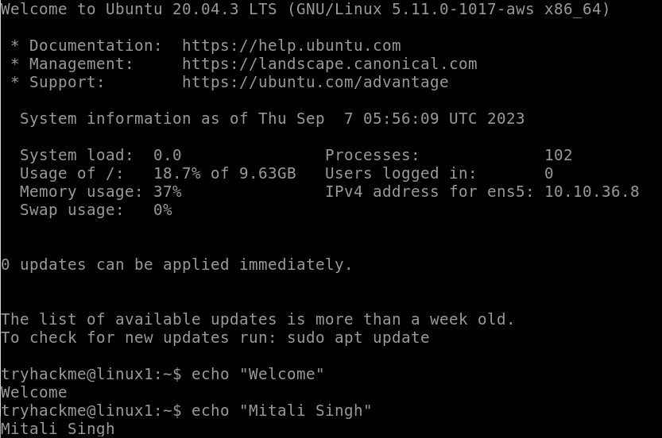

1. **Syntax** - whoami

**Description** - the whoami command displays the username currently logged into the operating system.

**Example -**



1. **Syntax** - ls

**Description** - listing

ls is a Linux shell command that lists directory contents of files and directories.

**Example -**



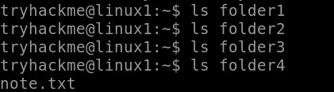

1. **Syntax** - Ls -l

**Description** - Listing files and directories in long list format

It displays the contents of the current directory in a long listing format, one per line.

**Example** -

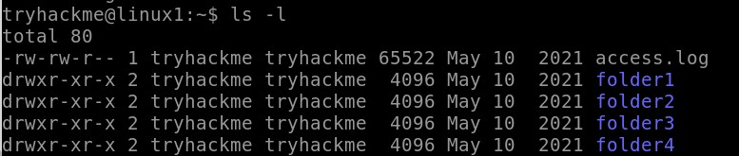

1. **Syntax** - cd

**Description** - change directory

It is used to move efficiently from the current working directory to different directories in our System.

**Example** -



1. **Syntax** - cat

**Description** - concatenate

It reads data from the file and gives its content as output.

**Example** -



1. **Syntax** – Pwd

**Description** –**p**rint **w**orking **d**irectory

It prints the path of the working directory, starting from the root.

**Example -**



1. **Syntax** – mkdir

**Description**- The mkdir command creates directories. This command can create multiple directories at once as well as set the permissions for the directories.

**Example**-

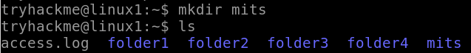

1. **Syntax** – rmdir

**Description**- The rmdir command removes the directory, specified by the Directory parameter, from the system.

**Example**-

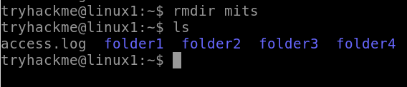

1. **Syntax** – man

**Description** - man command in Linux is used to display the user manual of any command that we can run on the terminal.

**Example**-

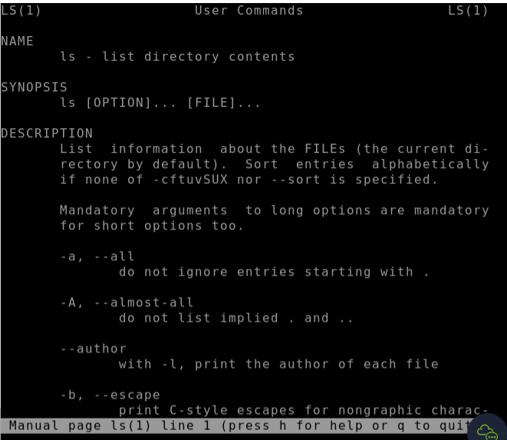

1. **Syntax** – man find

**Description** - The find command helps us to find a particular file within a directory. It is used to find the list of files for the various conditions like permission, user ownership, modification, date/time, size, and more.

**Example**-

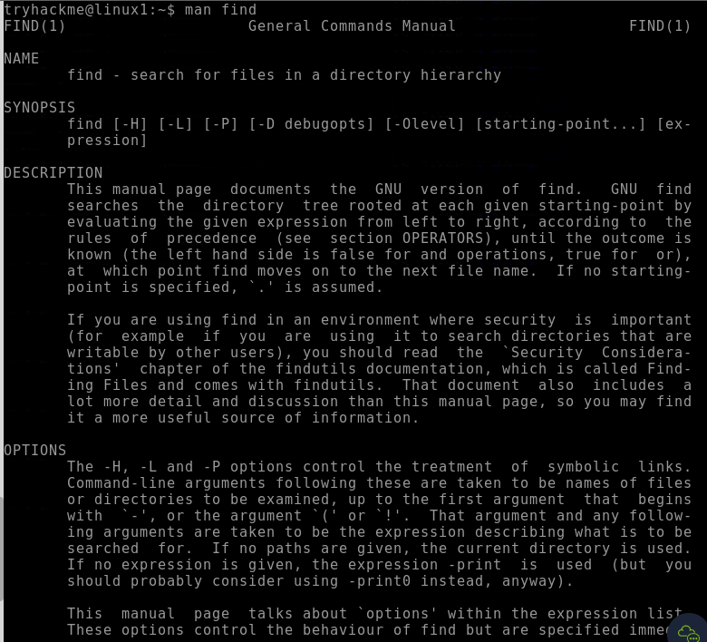

1. **Syntax** – **>**

**Description** - This operator is a redirector - meaning that we can take the output from a command (such as using cat to output a file) and direct it elsewhere.

**Example**-

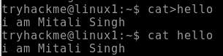

1. **Syntax** – whatis find

**Example**-



1. **Syntax** – Touch

**Description** - The touch command is a standard command used in the UNIX/Linux operating system which is used to create, change and modify the timestamps of a file.

**Example**-



1. **Syntax** – chmod a+x

**Example**-

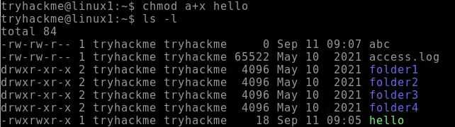

1. **Syntax** – chmod a+w

**Example**-

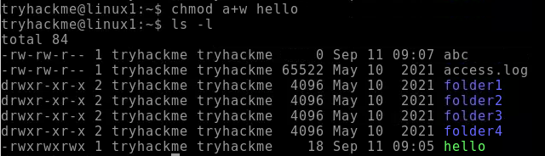

1. **Syntax** – ug+rw

**Example**-

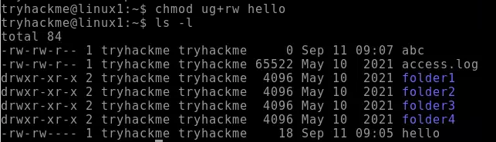

1. **Syntax** – ug-rwx

**Example**-

