BASH SCRIPT/ SHELL SCRIPT

Step 1. Create file **filename.sh**

Step 2. Write content in filename.sh with starting line **#!/bin/bash**

Step 3. Change mode of file to executable ny command **chmod u+x filename.sh**

Step 4. Execute the file by command **./filename.sh**

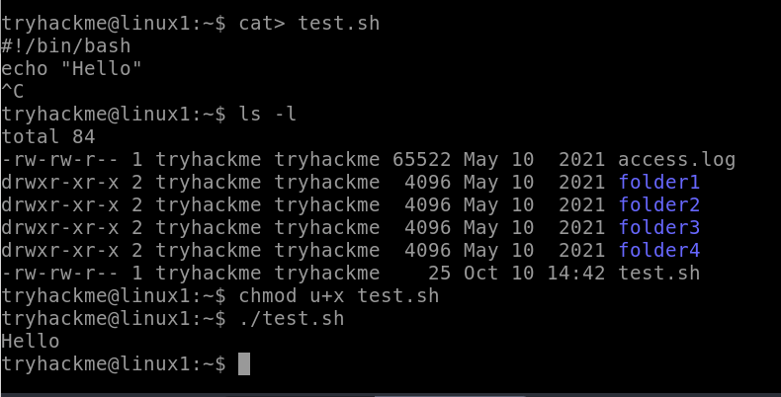

Taking Input from user -

**read input_name**

If we want to execute the use **$input_name**

* Taking string value as input

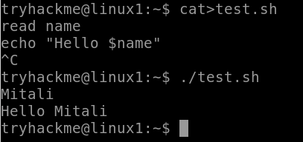

* Taking numeric value as input

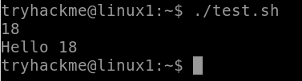

* Add two numeric values

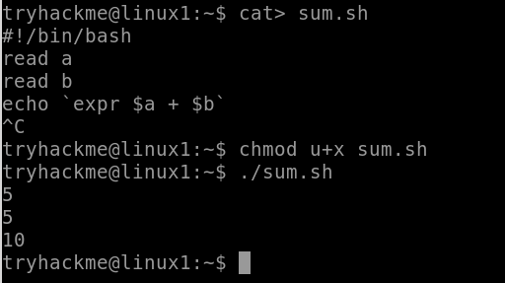

* Arithmetic operation

