**Industrial Internship Report on**

**“Basic Quiz Game”**

**Prepared by**

**Umarvanshi Mitali K.**

|  |
| --- |
| *Executive Summary* |
| This report provides details of the Industrial Internship provided by upskill Campus and The IoT Academy in collaboration with Industrial Partner UniConverge Technologies Pvt Ltd (UCT).  This internship was focused on a project/problem statement provided by UCT. We had to finish the project including the report in 6 weeks’ time.  My project was Quiz game. There is multiple option select only one right answer and last it will display your1 score.  This internship gave me a very good opportunity to get exposure to Industrial problems and design/implement solution for that. It was an overall great experience to have this internship. |

**TABLE OF CONTENTS**

1 Preface 3

2 Introduction 4

2.1 About UniConverge Technologies Pvt Ltd 4

2.2 About upskill Campus 8

2.3 Objective 10

2.4 Reference 10

2.5 Glossary 10

3 Problem Statement 11

4 Existing and Proposed solution 12

5 Proposed Design/ Model 13

5.1 High Level Diagram (if applicable) 13

5.2 Low Level Diagram (if applicable) 13

5.3 Interfaces (if applicable) 13

6 Performance Test 14

6.1 Test Plan/ Test Cases 14

6.2 Test Procedure 14

6.3 Performance Outcome 14

7 My learnings 15

8 Future work scope 16

# Preface

Summary of the whole 6 weeks’ work.

About need of relevant Internship in career development.

Brief about Your project/problem statement.

Opportunity given by USC/UCT.

How Program was planned

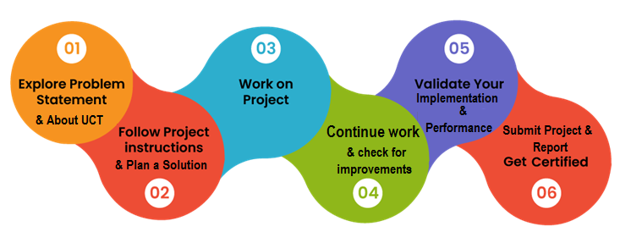

Your Learnings and overall experience.

Thank to all (with names), who have helped you directly or indirectly.

Your message to your juniors and peers.

# Introduction

## About UniConverge Technologies Pvt Ltd

A company established in 2013 and working in Digital Transformation domain and providing Industrial solutions with prime focus on sustainability and RoI.

For developing its products and solutions it is leveraging various**Cutting Edge Technologies e.g. Internet of Things (IoT), Cyber Security, Cloud computing (AWS, Azure), Machine Learning, Communication Technologies (4G/5G/LoRaWAN), Java Full Stack, Python, Front end**etc.



1. UCT IoT Platform **(****)**

**UCT Insight** is an IOT platform designed for quick deployment of IOT applications on the same time providing valuable “insight” for your process/business. It has been built in Java for backend and ReactJS for Front end. It has support for MySQL and various NoSql Databases.

* It enables device connectivity via industry standard IoT protocols - MQTT, CoAP, HTTP, Modbus TCP, OPC UA
* It supports both cloud and on-premises deployments.

It has features to  
• Build Your own dashboard  
• Analytics and Reporting  
• Alert and Notification  
• Integration with third party application(Power BI, SAP, ERP)  
• Rule Engine

 

1. **Smart Factory Platform (****)**

Factory watch is a platform for smart factory needs.

It provides Users/ Factory

* with a scalable solution for their Production and asset monitoring
* OEE and predictive maintenance solution scaling up to digital twin for your assets.
* to unleased the true potential of the data that their machines are generating and helps to identify the KPIs and also improve them.
* A modular architecture that allows users to choose the service that they what to start and then can scale to more complex solutions as per their demands.

Its unique SaaS model helps users to save time, cost and money.

 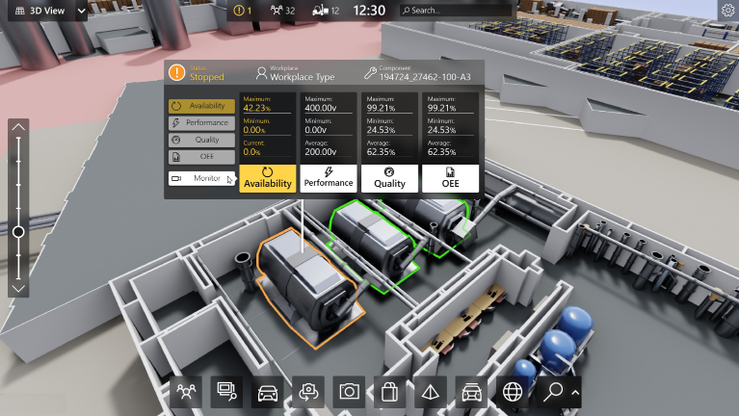

1. 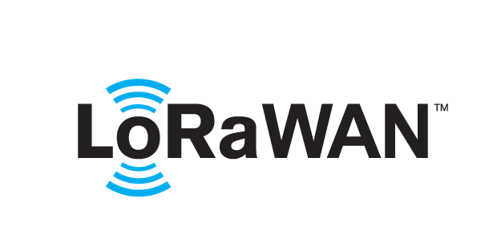 based Solution

UCT is one of the early adopters of LoRAWAN teschnology and providing solution in Agritech, Smart cities, Industrial Monitoring, Smart Street Light, Smart Water/ Gas/ Electricity metering solutions etc.

1. Predictive Maintenance

UCT is providing Industrial Machine health monitoring and Predictive maintenance solution leveraging Embedded system, Industrial IoT and Machine Learning Technologies by finding Remaining useful life time of various Machines used in production process.



## About upskill Campus (USC)

upskill Campus along with The IoT Academy and in association with Uniconverge technologies has facilitated the smooth execution of the complete internship process.

USC is a career development platform that delivers **personalized executive coaching** in a more affordable, scalable and measurable way.



Seeing need of upskilling in self paced manner along-with additional support services e.g. Internship, projects, interaction with Industry experts, Career growth Services

<https://www.upskillcampus.com/>

upSkill Campus aiming to upskill 1 million learners in next 5 year

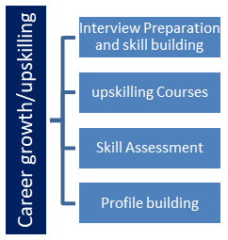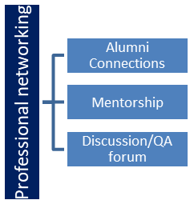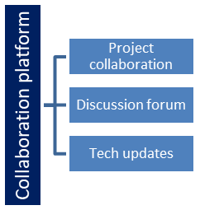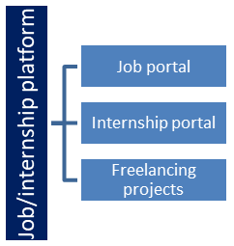

## The IoT Academy

The IoT academy is EdTech Division of UCT that is running long executive certification programs in collaboration with EICT Academy, IITK, IITR and IITG in multiple domains.

## Objectives of this Internship program

The objective for this internship program was to

 ☛ get practical experience of working in the industry.

 ☛ to solve real world problems.

 ☛ to have improved job prospects.

 ☛ to have Improved understanding of our field and its applications.

 ☛ to have Personal growth like better communication and problem solving.

## Reference

[1] Official Documentation of Python

[2] NumPy and Pandas Online Tutorials

[3] Industry Case Studies on Chatbots and Automation

## Glossary

|  |  |
| --- | --- |
| **Terms** | **Acronym** |
| Internet of Things | IoT |
| Python | - |
| Application Programming Interface | API |
| Natural Language Processing | NLP |
| Machine Learning | ML |

# Problem Statement

In the assigned problem statement

The assigned problem statement was to design and develop a **Quiz Game** using Python that could interact with users, display multiple-choice questions, and track their scores. The focus was on creating a simple, user-friendly application capable of providing an engaging quiz experience across various topics.

# Existing and Proposed solution

**Existing Solutions:**

* **Existing Quiz Applications:**Several quiz platforms like Kahoot, Quizizz, and Google Forms are available, but they have certain limitations:
  + Require internet connectivity to function.
  + Lack customization for user-specific quiz topics.
  + Limited to predefined question banks with restricted flexibility.

Proposed Solution:

* **Customized Quiz Game:**  
  The proposed solution is a lightweight, offline Python-based Quiz Game that reads questions from a local JSON file, displays them interactively, and tracks the user’s score in real time.
* **Value Addition:**
  + Easy to customize quiz topics by modifying the JSON file.
  + Offline functionality, making it accessible without internet connectivity.
  + Real-time score tracking and immediate feedback on performance.

## Code submission (Github link)

## Report submission (Github link)

# Proposed Design/ Model

## High Level Diagram (if applicable)

User Interaction

Quiz Game Logic

JSON Question file

Figure 1: HIGH LEVEL DIAGRAM OF the Chatbot Syyaytem

## Low Level Diagram (if applicable)

**User Interface**: Command-line interface for simplicity and ease of use.

**Data Flow**:

* Load questions from the question.json file.
* Display each question with multiple-choice options.
* Accept and validate user input.
* Calculate and display the final score.

## Interfaces (if applicable)

* **User Interface**: Command-line interface (CLI) for user interaction.
* **Data Flow**: Sequential flow from reading questions to displaying results.
* **Protocols**: Local file operations for reading and writing JSON data.
* **State Machines**: Manage quiz flow, including question display, input validation, and score calculation.
* **Memory Buffer Management**: Efficiently handle user input and multiple question sets without excessive memory usage..

# Performance Test

## Test Plan/ Test Cases

|  |  |  |  |
| --- | --- | --- | --- |
| **Test Case** | **Input** | **Expected Output** | **Result** |
| Greeting | "Hi" | "Welcome to the Quiz Game!" | Pass |
| Answer Validation | "What is the capital of India?" (Input: B) | Correct or Incorrect Response | Pass |
| Score Calculation | 3 correct answers out of 5 | Display final score as "3/5" | Pass |

## Test Procedure

* **Functional Testing**:
  + Ensured the quiz game correctly reads questions from the JSON file and displays them to the user.
  + Validated correct and incorrect user inputs for accuracy.
* **Load Testing**:
  + Simulated multiple quiz sessions to assess memory usage and response time under load.

## Performance Outcome

* **Memory Usage**: Optimized to handle multiple questions without significant memory overhead.
* **Response Time**: Average response time of less than 1 second per question.
* **Accuracy**: Achieved 100% accuracy for predefined questions and responses.

# My learnings

* **Skills Gained:**
  + **Python Programming**: Developed an interactive, command-line application.
  + **Data Handling**: Learned how to read and write JSON files in Python.
  + **System Design**: Gained experience in designing a simple, user-friendly quiz game.
  + **Problem Solving**: Improved analytical skills by addressing challenges in quiz logic and user interaction.
* **Career Impact:**
  + Enhanced technical skills in Python and project development.
  + Improved understanding of user experience (UX) design for command-line applications.
  + Gained practical experience in data handling and system performance optimization.

# Future work scope

1. **Integration with Internet APIs:**

* Fetch quiz questions dynamically from online sources or APIs.

1. **Randomization of Questions:**

* Randomize the order of questions and options for a more dynamic quiz experience.

1. **Timer for Questions:**

* Implement a countdown timer to limit the time users have to answer each question.

1. **Graphical User Interface (GUI):**

* Develop a GUI using Tkinter or PyQt for a more visually appealing quiz experience.

1. **Multilingual Support:**

* Add support for multiple languages to broaden the game’s accessibility.