List of Work to Do

ROYAL TECHNOSOSFT

Advance java

Data Structure

Html

MySql

ONLINE COURSE

Inmovidu course on web devlopment

FCC java Script

COMPITITIVE COADING

Eulers

Geeks For Geeks

CodeChef

PROJECT MAKING

HULK FITNESS

E-SHOPING

-----------------------------------------------------------------------------------------------

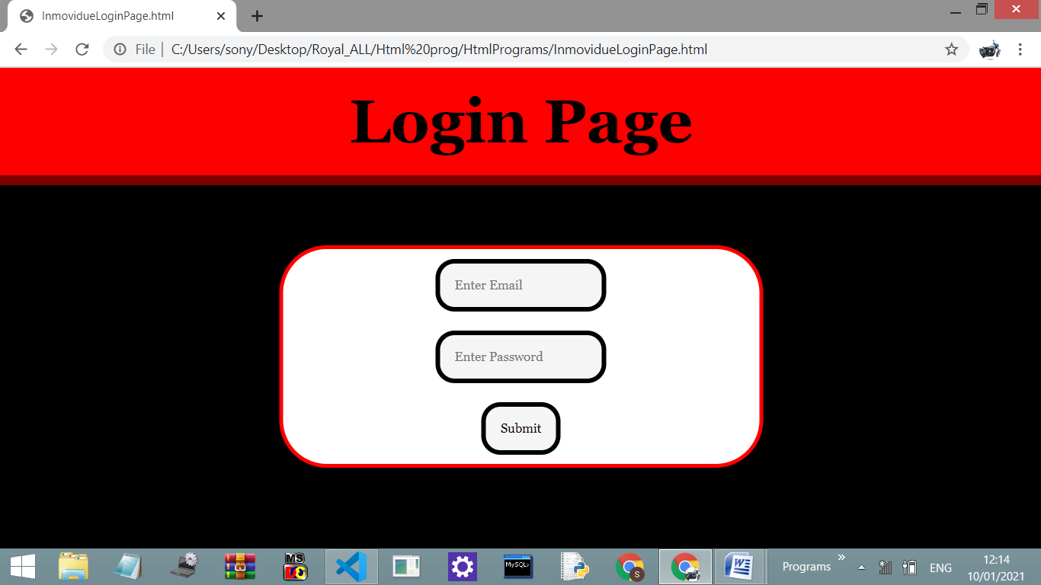

<!DOCTYPE html>

<html>

    <head>

        <style>

            body{

                background-color: black;

            }

            \*{box-sizing: bor1der-box;margin: 0;padding: 0;font-family: Georgia, 'Times New Roman', Times, serif;}

            hr{

                border: 5px solid maroon;

                background-color: maroon;

            }

            header{

                padding: 20px;

                text-align: center;

                font-size: xx-large;

                background-color: red;

            }

            form{

                position: absolute;

                margin-top: 50px;

                top: 50%;

                left: 50%;transform: translate(-50%,-50%);

                width: 500px;

                background-color:white;

                text-align: center;

                border-radius: 50px;

                border: 4px solid red ;

            }

            input{

                background-color: whitesmoke;

                border-radius: 20px;

                border: 5px solid Black;

                padding: 15px;

                margin: 10px;

            }

        </style>

    </head>

    <body>

        <header><h1>Login Page</h1></header><hr>

        <form action="Inmovidu1.html">

        <input type="email" placeholder="Enter Email" name="email" id="email"><br>

        <input type="password" placeholder="Enter Password" name="password" id="password"><br>

        <input type="submit" value="Submit">

    </form>

    </body>

</html>

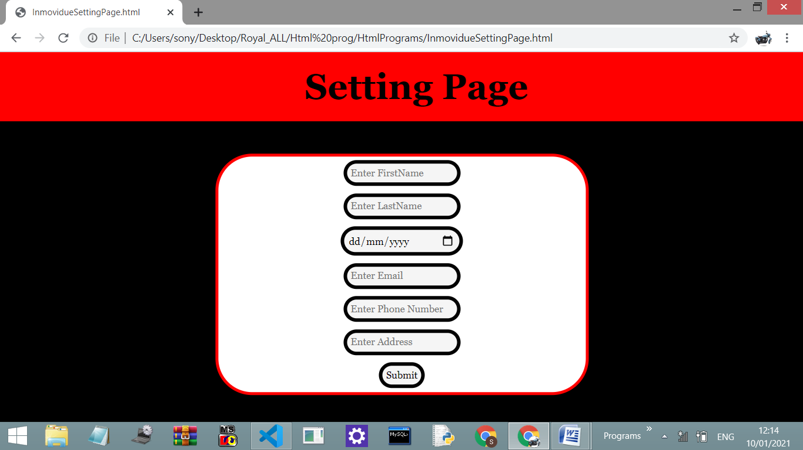

<!DOCTYPE html>

<html>

    <head>

        <style>

            body{

                background-color: black;

            }

            \*{box-sizing: bor1der-box;margin: 0;padding: 0;font-family: Georgia, 'Times New Roman', Times, serif;}

            hr{

                border: 5px solid maroon;

                background-color: maroon;

                }

            header{

                z-index: 3;

                padding: 20px;

                text-align: center;

                font-size: x-large;

                background-color: red;

                position: fixed;

                width: 100%;

            }

            form{

                z-index: 2;

                position: absolute;

                margin-top: 50px;

                top: 50%;

                left: 50%;transform: translate(-50%,-50%);

                width: 500px;

                background-color:white;

                text-align: center;

                border-radius: 50px;

                border: 4px solid red ;

            }

            input{

                background-color: whitesmoke;

                border-radius: 20px;

                border: 5px solid Black;

                padding: 5px;

                margin: 5px;

            }

        </style>

    </head>

    <body>

        <header><h1>Setting Page</h1></header><hr>

        <form action="Inmovidu1.html">

        <input type="text" placeholder="Enter FirstName" name="firstname" id="firstname"><br>

        <input type="text" placeholder="Enter LastName" name="lastname" id="lastname"><br>

        <input type="date" placeholder="Enter DOB" name="dob" id="dob"><br>

        <input type="email" placeholder="Enter Email" name="email" id="email"><br>

        <input type="tel" placeholder="Enter Phone Number" name="phone" id="phone"><br>

        <input type="text" placeholder="Enter Address" name="address" id="address"><br>

        <input type="submit" value="Submit">

    </form>

    </body>

</html>