I intend to create Space Invaders 3D. In this game, the player will take control of the “core cannon”, humanity’s final defense against an onslaught of aliens resembling sea creatures. The player will move the cannon along a flat plane to line up shots against enemies in the sky, while also dodging incoming projectiles. The invaders will fly along predetermined paths, requiring players to aim and time their slow-moving shots. Invaders will also slowly fly down to the surface. If one reaches the ground, the player loses. The player will also need to remove barrier cubes that prevent you from shooting the enemy. The primary difference between this game and the original arcade game is the addition of a third dimension and a first-person point of view. Players must navigate the play space to find enemies before they reach the surface. The enemies will also appear larger as they come closer, giving the player a sense of fear and adrenaline to keep the game exciting. Enemies spawn in waves, and the goal of the game is to kill all the enemies in a wave to reach the next one and survive as long as possible. A number of points are also given upon killing each enemy.

Controls: The player will move using the WASD keys and shoot with the left mouse button.

Enemies:

Octopus (Large Invader): Spawns closest to the player and does not shoot, but may block view of enemies that do.



Crab (Medium Invader): Spawns further away from the player than the Octopus. Occasionally shoots, but not as often as the squid.

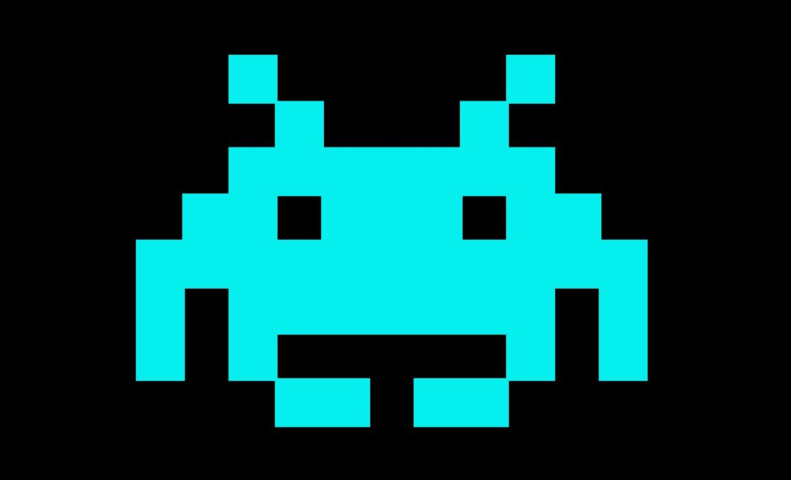

Squid (Small Invader): Spawns furthest from the player. Shoots more often than the crab.



UFO: Rarely spawns, and does not attack or fly closer, but gives a large amount of points.



Barrier: Stops the player from hitting enemies and must be shot and destroyed.

