
School of Engineering and
Information Technology

ICT286 MAJOR ASSIGNMENT ONE
CHECK LIST

Surname (Family Name): Panicciari__________________________

Given Names: Mitchell____________________________________________

Student Number: 32674186__________________________________________________

Tutor’s Name: Mohammad Alhabashneh_______________________________________________

Assignment Due Date: September 2nd_______ Date Submitted: September 2nd_____

Your assignment should meet the following requirements. Please confirm this (by ticking boxes) before submitting your assignment.

- All details above are complete.
- The archive file (either a tar file or a ZIP file) contains the file Assignment1.docx. The documentation was prepared according to Documentation Requirements specified in Major Assignment 1’s question sheet.
- The archive file includes the code for the three questions. The code for each question is stored under a separate directory named q1, q2 or q3 respectively.
- The websites for the three questions are hosted on ceto server and their URLs are given in the relevant documentation in file Assignment1.docx.
- You understand that the archive file should be submitted to ICT286 Unit LMS.
- You have kept a copy of this assignment, including the archive file.

Contents
List of URLS 3
Question 1: A Website About Yourself 4
Description of the question 4
Discussion of my solution 4
Self-diagnosis and evaluation 4
List of URLS 4
List of screenshots 5
Question 2: Display Web Browser Information 6
Description of the question 7
Discussion of my solution 7
Self-diagnosis and evaluation 7
List of URLS 7
List of screenshots 8
Question 3: Enter and Sort Student Names 9
Description of the question 9
Discussion of my solution 9
Self-diagnosis and evaluation 9
List of URLS 9
List of screenshots 10

List of URLS

Index page

http://ceto.murdoch.edu.au/~32674186/assignment1/index.html

Question1

http://ceto.murdoch.edu.au/~32674186/assignment1/q1/home.html
http://ceto.murdoch.edu.au/~32674186/assignment1/q1/photos.html
http://ceto.murdoch.edu.au/~32674186/assignment1/q1/audiovis.html
http://ceto.murdoch.edu.au/~32674186/assignment1/q1/contact.html
http://ceto.murdoch.edu.au/~32674186/assignment1/q1/css/styles.css

Question 2

http://ceto.murdoch.edu.au/~32674186/assignment1/q2/question2

http://ceto.murdoch.edu.au/~32674186/assignment1/q2/css/styles.css

Question 3

http://ceto.murdoch.edu.au/~32674186/assignment1/q3/question3
http://ceto.murdoch.edu.au/~32674186/assignment1/q3/css/styles.css
Question 1: A Website About Yourself

Description of the question
Design and code in HTML5 and CSS a web site that describes yourself. The actual content is up to you but you may include personal details, such as your name and photographs, something about your life, what you are doing, the sports you love, your family, anything you are passionate about. There is no limit on what you can write. If you have any privacy concerns you may replace some real information with fictitious ones (e.g., date of birth, contact details, and names of family members). For the purpose of this question, I am only concerned about the presentation quality, not the accuracy of the information.

Discussion of my solution

For my solution first off I created a wireframe for all of my pages to have the same layout and navigation bar. I created four pages one being the home page, photos page, audip/video page and finally a contact me page. I separated my pages into different divs and used html5 semantics to structure everything. My home page is very simple with just three sections using different css to style them and make them look nice. For my photos page I created a class which allows for the photos to line up nicely and be in separate boxes, I choose a width and height that would complement the pictures nicely and fit the aspect ratio. For my audio and visual page I simply put in two elements one being the audio and one being the video, I put them into containers for it to look nicer and have a nice flow. For the last page which is my contact me page it does not function but I decided to make this in order to show some more of my skills in html and to have something different, it is just some headings with input boxes and a textarea under them accompanied with a submit button.

Self-diagnosis and evaluation
What features have been fully completed, and is working?

I have made a website which describes myself.
All of my pages except one of them validates with xhtml5 the pages which validate are “home, contact, and photos”.
I used many of the html5 semantic elements such as footer, header, section and figure.
My css was done externally.

What features have been completed but not fully working?

My audio visual page does not fully validate with xhtml5, I get an error associated with the controls attribute and could not get it to fully validate but everything else validates properly.

What features have not been fully completed or not attempted?

All features fully completed.

List of URLS

http://ceto.murdoch.edu.au/~32674186/assignment1/q1/home.html
http://ceto.murdoch.edu.au/~32674186/assignment1/q1/photos.html
http://ceto.murdoch.edu.au/~32674186/assignment1/q1/audiovis.html
http://ceto.murdoch.edu.au/~32674186/assignment1/q1/contact.html
http://ceto.murdoch.edu.au/~32674186/assignment1/q1/css/styles.css

List of screenshots
The home page of my website
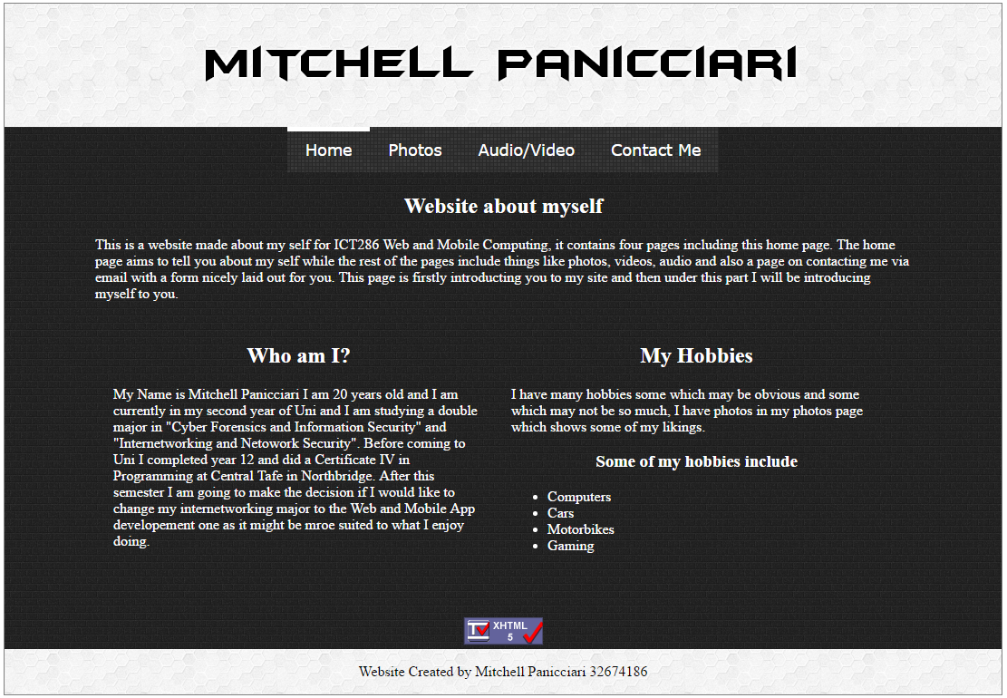

My photos page

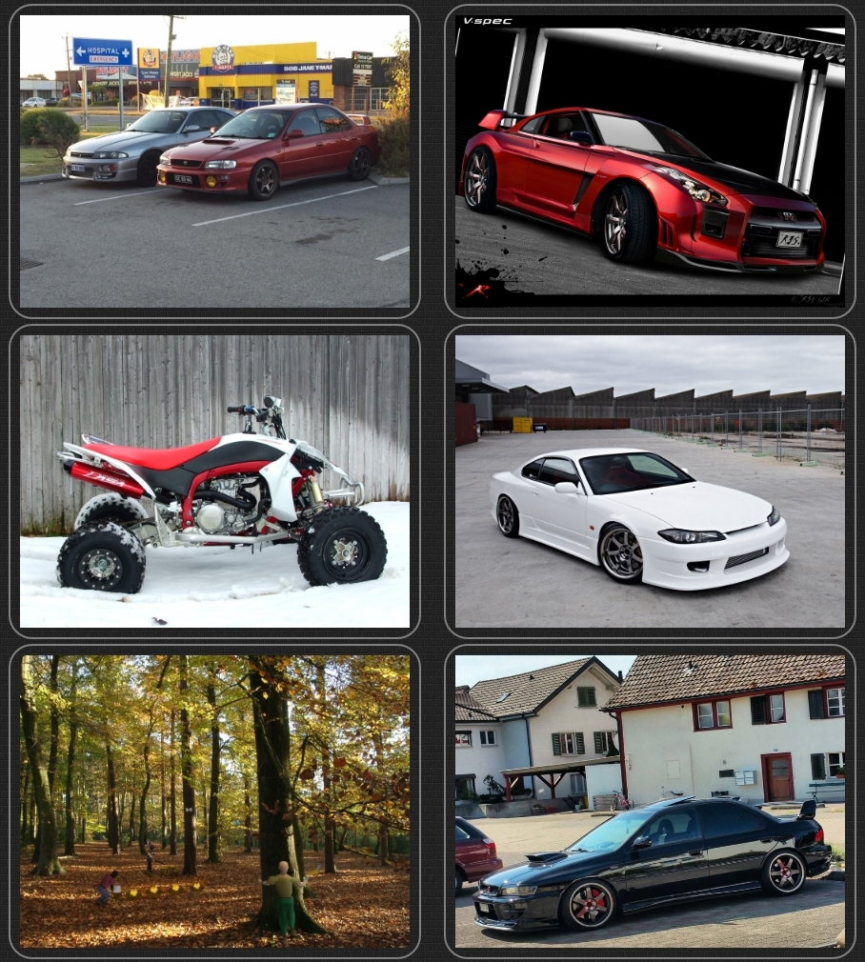

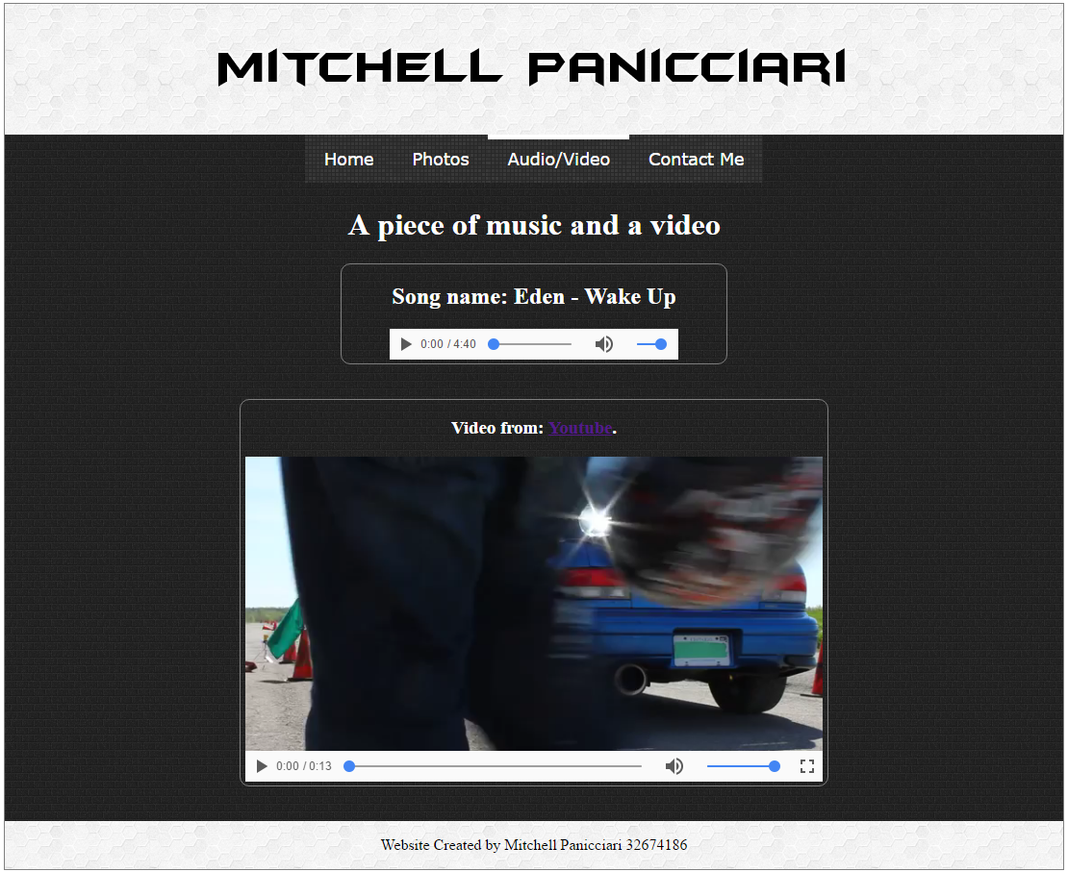
My audio and visual page

My contact me page

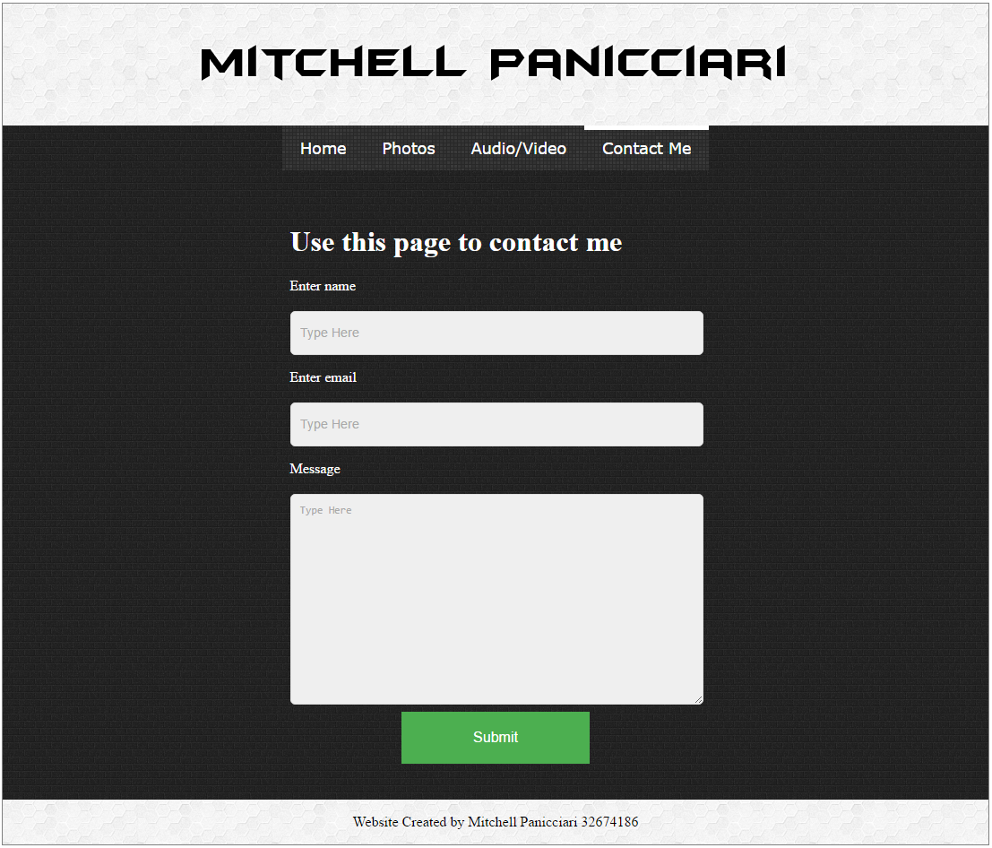

Question 2: Display Web Browser Information

Description of the question
Use JavaScript to display the following information:
- The current date and time in the following format: Day, Date Month Year (Hours:Minutes). Use the following colours for different date and time components: Day in red, Date in green, Month in yellow, Year in blue, Hours and Minutes in brown.
- The name of the web browser used to display the page.
- The number of forms and links in the page (for testing purpose, please include a few forms and hyper-text references in the page).

Discussion of my solution
For the first part of my solution showing the date and time and having it in different colours I chose to use the document.write method and have it update the page using the span tag which allowed for all of the elements to be inline and also have different colours. I used an external stylesheet to achieve the different colours. This part of the solution reached my expectations and does what it is meant to do an improvement would be creating arrays which correspond to the month and day names and have it so the month name and day would display instead of the numbers which would make the date and time easier to read.

The second part of my solution which was checking what browser the client accessed the page on was done through a simple nested if statement. The statement checks the string retrieved from navigator.userAgent and checks if a certain string is contained in it which determines which browser is being used. For example if they user accessed from internet explorer the string would contain MSIE. An improvement that could be made to this site would be adding in extra checks for other browsers and even displaying what version of the browser they are currently using. This aprt of my solution met my expectations I tried I ton multiple browsers and I got the correct output.

For the third part I added in two forms and three links for the JavaScript to be able to count and display. The solution was simple it uses getElementsByTag name method to count all elements with the tag “a” and the tag “form” those values are then displayed. This part of the solution met my expectations I tested it by adding and removing forms and links and the numbers would update through JavaScript.

Self-diagnosis and evaluation
What features have been fully completed, and is working?
The current date and time is displayed in the format: Day, Date Month Year (Hours:Minutes).
Day is displayed in red, date is displayed in green, month is displayed in yellow, year is displayed in blue and hours and minutes are both displayed in brown.
The name of the web browser is displayed.
The count of links and forms on the page are displayed properly.

What features have been completed but not fully working?

All features completed are fully working.

What features have not been fully completed or not attempted?

All features fully completed.

List of URLS
http://ceto.murdoch.edu.au/~32674186/assignment1/q2/question2

http://ceto.murdoch.edu.au/~32674186/assignment1/q2/css/styles.css

List of screenshots

Showing the date and time at 2:04 and at 2:18.
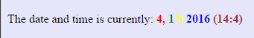

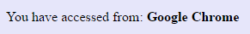
Displaying what browser the page was accessed from using Google Chrome and using Mozilla Firefox.

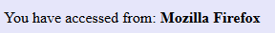

Showing the forms and links on the page and then showing how they are counted and that number being displayed.
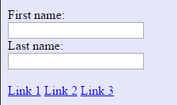

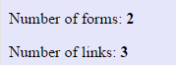

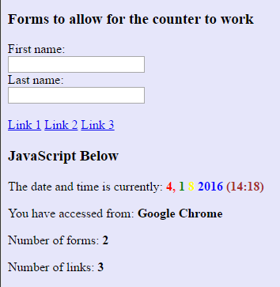
Showing the page in its entirety.

Question 3: Enter and Sort Student Names

Description of the question
Create a form to allow the user to enter student names, one at a time. These names are added to an array and displayed in the page using the textarea form element. Each time a new name is entered, it is added to the array, and then the array is sorted in alphabetical order before the names in the array are displayed in the textarea, one per line.

Discussion of my solution
For my solution I used a function in JavaScript which would do all of the work to print out the array to the textarea element. The function printArray() is called when the user presses the submit button on the form, the function reads what value is inside the form and uses the array push method to add it to the student array. The array is then sorted using the array sort method and is then added to the text area element using the array join method which puts all of the elements into a string and then returns the string, the join method will also take a certain separator for formatting and in this case the newline “\n” separator was used so that each element would be printed on a separate line. The function also has a call to another function which simply resets for form so that it is empty for the next name to be entered.

The result of my solution meets my expectations as it does what it was meant to do and I chose to use this solution because it is what made sense to me the most. Some improvements could be made to my website this would include checking the input to make sure the user is actually inputting names and not just numbers or characters and while not asked for a reset button to clear the array would also be a good improvement.

Self-diagnosis and evaluation
What features have been fully completed, and is working?

My solution has a form which allows for the user to enter student names one at a time.
The names from this form are added to an array and displayed on the page in a textarea element.
Before the array is printed to the textarea all of the elements are sorted in alphabetical order.
All of the elements of the array are printed on a separate line.

What features have been completed but not fully working?

None all features completed are fully working.

What features have not been fully completed or not attempted?

None all features fully completed.

List of URLS

http://ceto.murdoch.edu.au/~32674186/assignment1/q3/question3
http://ceto.murdoch.edu.au/~32674186/assignment1/q3/css/styles.css

List of screenshots

The webpage when it is first loaded p showing the blank textarea and the form to allow for the user to enter in student names.
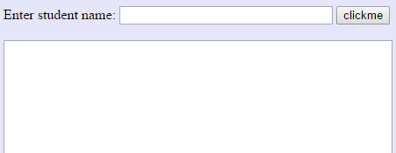

Entering in a student’s name.

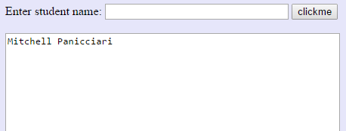
User clicks the button and the students name is added to the array and printed to the textarea.

Entering in a student’s name.

User clicks the button and the students name is added to the array and printed to the textarea and is in alphabetical order.

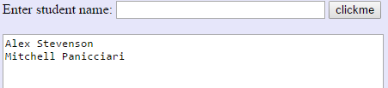

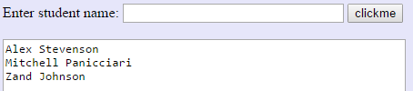
Another name has been added to the array and has been sorted into alphabetical order before being printed to the textarea.

