Github: https://github.com/MitchelWeber/Assignment2_OS
1. Introduction
The purpose of this project is to implement the Banker’s Algorithm, a classic deadlock avoidance strategy used in operating systems. The algorithm checks whether granting resource requests will keep the system in a safe state, meaning no deadlock can occur. This program takes input describing processes, allocated resources, maximum resource requirements, and computes whether the system is currently safe.

2. Program Description
This program reads an input file containing:
- Total number of processes
- Total resource types
- Available resources
- Allocation matrix
- Maximum demand matrix
Using this data, the program:
- Computes the Need matrix
- Applies the Banker’s Algorithm to verify system safety
- Outputs whether the system is in a safe or unsafe state
- If safe, prints the system’s safe execution sequence
This implementation is written in C++ and compiled using:
g++ -std=c++17 banker.cpp -o banker
The program is then executed as:
./banker input.txt

3. Sample Input
5 3
10 5 7
0 1 0
2 0 0
3 0 2
2 1 1
0 0 2
7 5 3
3 2 2
9 0 2
2 2 2
4 3 3

4. Sample Output

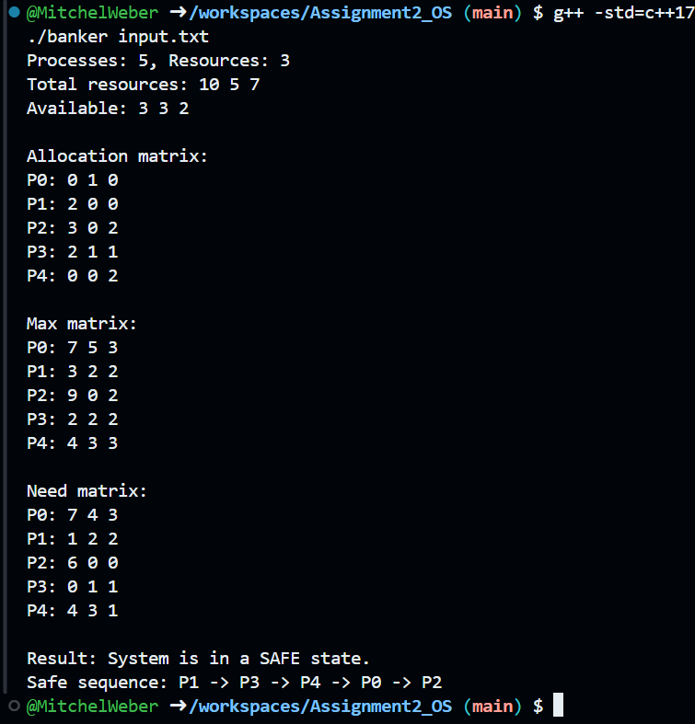

5. How the Program Works
- The program calculates the Need matrix using:
Need[i][j] = Max[i][j] - Allocation[i][j]
- It then checks for a safe sequence by repeatedly selecting a process whose needs can be satisfied with the current available resources.
- If all processes can finish without causing deadlock, the system state is safe.

6. Conclusion
This assignment successfully demonstrates the Banker’s Algorithm and shows how operating systems can evaluate whether granting resource requests is safe. By calculating the need and simulating execution, the program determines whether a safe sequence exists. The example input produced a safe ordering, showing that the system is free from deadlock.

