Database design:

There should be a tab for each major component. The components are: Customer, Inventory, Employees, and Management

**Customer**

* Ability to search for books by title, author, isbn, or genre
* Able to select book and add to “cart”
* Able to purchase the book (this will be a pretend transaction)
  + At checkout, user can enter matching name and membership id for 10% discount
* The order is tracked through the store and then decreases the amount of inventory by the amount purchased

**Inventory**

* Section to add the book to the catalogue
  + Book has following information to add: author, isbn (must be unique), publication date, edition, price, page count, description
* Section search by title, author, or isbn, get confirmation before removing from inventory
  + Give 2 options for selected book:
    - Update book information
    - Remove book from inventory

**Employees**

* See scheduled shifts (handled in the management tab)
* Check in/out of shift, exclusive to current status (on the clock, off the clock)
* Section to give customer membership status (associating the customerID with the membership table)

**Management**

* Before being able to manage elements like the employees employed, need to add store
  + Store has storeID, name, address, phone, email, and opening_hours
* Adding employees to store
  + Employee has employeeID, first_name, last_name, position, hire_date, salary, email, phone
* Ability to edit, remove, or schedule employees at store on a given date and time.
* Add, remove, edit supplier
  + supplierID, name, contact person, phone, email, lead time delays

## ER Diagram

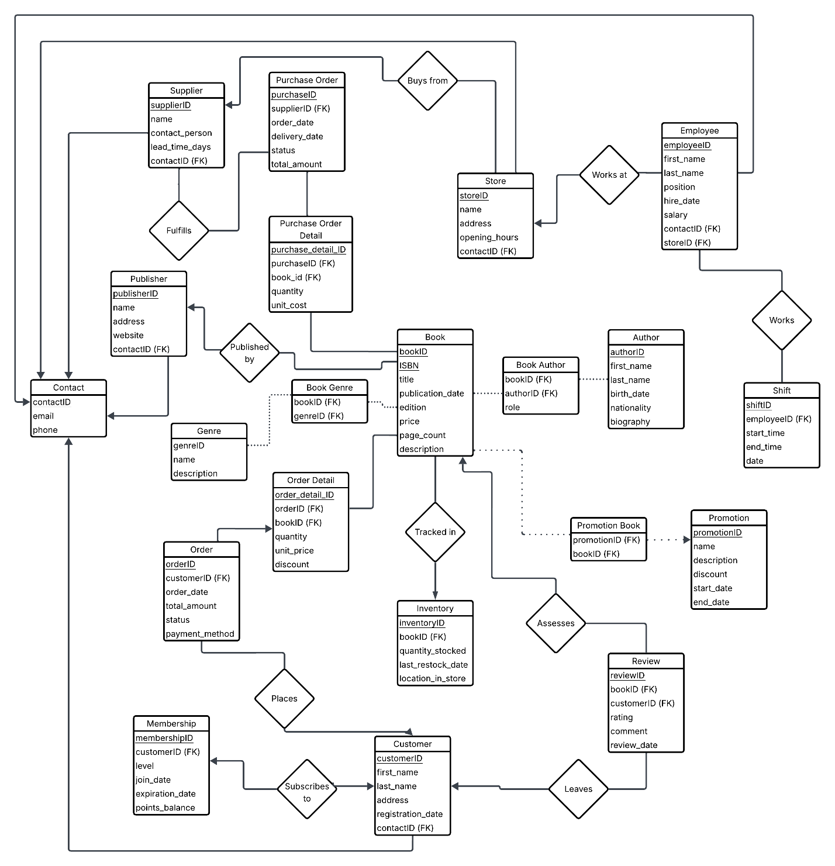

## Relational Schema

----- Core Entities -----

Contact (

contact_id PK,

email,

phone

)

Book (

book_id PK,

ISBN,

title,

publication_date,

edition,

price,

page_count,

description,

publisher_id FK → Publisher

)

Author (

author_id PK,

first_name,

last_name,

birth_date,

nationality,

biography

)

Publisher (

publisher_id PK,

name,

address,

website,

contact_id FK -> Contact

)

Genre (

genre_id PK,

name,

description

)

Customer (

customer_id PK,

first_name,

last_name,

email,

registration_date,

contact_id FK -> Contact

)

----- Inventory & Sales -----

Inventory (

inventory_id PK,

book_id FK → Book,

quantity_in_stock,

last_restock_date,

location_in_store

)

Order (

order_id PK,

customer_id FK → Customer,

order_date,

total_amount,

status,

payment_method

)

Order_Detail (

order_detail_id PK,

order_id FK → Order,

book_id FK → Book,

quantity,

unit_price,

discount

)

----- Store Operations -----

Store (

store_id PK,

name,

address,

opening_hours,

contact_id FK -> Contact

)

Employee (

employee_id PK,

first_name,

last_name,

position,

hire_date,

salary,

store_id FK -> Store

contact_id FK -> Contact

)

Shift (

shift_id PK,

employee_id FK → Employee,

start_time,

end_time,

date

)

Supplier (

supplier_id PK,

name,

contact_person,

lead_time_days,

contact_id FK -> Contact

)

Purchase_Order (

po_id PK,

supplier_id FK → Supplier,

order_date,

expected_delivery_date,

status,

total_amount

)

Purchase_Order_Detail (

po_detail_id PK,

po_id FK → Purchase_Order,

book_id FK → Book,

quantity,

unit_cost

)

----- Additional Features -----

Review (

review_id PK,

book_id FK → Book,

customer_id FK → Customer,

rating,

comment,

review_date

)

Book_Author (

book_id FK → Book,

author_id FK → Author,

role

)

Book_Genre (

book_id FK → Book,

genre_id FK → Genre

)

Promotion (

promotion_id PK,

name,

description,

discount_percentage,

start_date,

end_date

)

Promotion_Book (

promotion_id FK → Promotion,

book_id FK → Book

)

Membership (

membership_id PK,

customer_id FK → Customer,

level,

join_date,

expiration_date,

points_balance

)