Thomas Hannan - Elliott Hannan - Mitchell Lewis Lloyd Parker - Oliver Ingarfield - Eric Shearer
[Email address]
AUSDEV
Assessment 2: Team Project

Introduction to Information Technology
COSC2196

This assessment supports the Graduate Outcomes of Enabling Knowledge, Critical Analysis, Problem Solving, Communication and Team Work.
• CLO 1: describe and apply basic concepts of contemporary technologies
• CLO 2: analyse human and social contexts of technological innovations
• CLO 3: apply the knowledge of various ICT components to create a prototype of a product/service
• CLO 4: identify principles of collaborative work and explain potential conflict resolution techniques
• CLO 5: participate effectively and creatively in a team environment
• CLO 6: prepare a professional and comprehensively written IT report within provided parameters
Table of Contents
Team Members 3
Thomas James Hannan 3
Elliott Ray Hannan 3
Mitchell Lewis 3
Eric Shearer 3
Oliver Ingarfield 4
Lloyd Parker 4
Team Profile – Test Outcomes 5
Tools: 6
Canvas: 6
Outlook: 6
Microsoft Teams - OneNote 6
GitHub 7
Ideal Jobs 8
Common Elements: 8
Differences from positions: 9
Career paths: 10
Industry Data 11
IT Work – Interview an IT professional 16
Luke Wallace 16
IT Technologies 20
Clouds, Services and Servers 20
Autonomous Vehicles 22
Machine Learning 24
Robots 27
Project Idea 29
Windows program and setting profiler 29
Overview 29
Description 29
Tools and Technologies 29
Outcome 29
Reflections 30
Thomas Hannan 30
Elliott Hannan 30
Mitchell Lewis 30
Eric Shearer 30
Oliver Ingarfield 31
Lloyd Parker 31
Reference List: 32

Team Members

Thomas James Hannan
S3957297
S3957297@student.rmit.edu.au
https://dusselll.github.io

Born and raised on the Sunshine Coast in Queensland, a background in sales and marketing and has a hands-on approach to business. Started Real Time Removals in 2013 that specialised in interstate transport out of the NT and Western Australia, it was a successful business model that relocated families’ interstate. An avid gamer that has a basic knowledge and understanding of IT, he will add value to AusDev by understanding the value of an efficient system to a complex business. The capabilities of streamlining process’s and seeing the benefits in real time is something that is beneficial both financially and personally.

Elliott Ray Hannan
s3957296
s3957296@student.rmit.edu.au
https://ice-n9ne.github.io/s3957296-Eportfolio/

Born and raised on the Sunshine Coast Queensland, Elliott is 30 years of age. Elliott has grown up spending most of his time in the outdoors, doing things like surfing, hiking, spearfishing and camping. He spent the last 8 years of his life living in Melbourne working in the hospitality and beer industry, the last two of which he was a beer plumber! Making sure the thirsty people of Melbourne could get a pint full of the good stuff! AusDev is his next project and with a great love of IT he will bring value to the team.

Mitchell Lewis
s3958079
s3958079@student.rmit.edu.au

Mitchell is 30 years old, he is a Australian born in Adelaide. As far as his culture goes, his great grandmother is aboriginal, but other then that he is Australian. Mitchell quite likes learning about the aboriginal culture, especially about "the dreaming". He has a certificate I&II in it from Charles Darwin University. Other that that he was enrolled in a bachelor in IT course online. However the service was so bad that he decided to quit and wait till online learning had improved. Mitchell knows quite a bit of the Japanese language as he has always been fascinated by their culture, this will help AusDev potentially expand internationally. Mitchell enjoy making things. Whether it is with his hands, or digital in a game. He likes to create and solve problems.

Eric Shearer
s3655694
s3655694@student.rmit.edu.au

Born and Raised in the Bega Valley, on the far south coast of NSW. Family background is Brittish on one side, and Australian on the other back to the late 1800s. Limited Knowledge of IT beyond that it is very useful and has a significant impact in today's world. Interests in IT are in its use both personally and professionally, allowing for gaming personally and use professionally to complete tasks, this knowledge will be valuable in helping AusDev grow. Studies are to help me complete a Bachelor of Business, majoring in Financial Planning.

Oliver Ingarfield
s941433
s941433@student.rmit.edu.au
https://github.com/OLRAIN/Stuff/blob/main/Profile/Oliver.html

Born in Darwin, moving to Melbourne, Adelaide and then Canberra. And traveling to a couple of south east Asian countries, Oliver has traveled and seen several different places. At times of rest, Oliver would enjoy both playing games and reading several books. During year 12, Oliver took a IT class where he learnt basic python coding which will be very important in developing key functions within AusDev. This is what started an interest in coding and IT.

Lloyd Parker
s3956398
s3956398@student.rmit.edu.au
https://lparker123.github.io/Assignment1/

Born and raised in Melbourne to British parents, Lloyd’s interest in IT started when he was 10 years old playing and modding games on the family computer, since then has built almost a computer every year. His experience with hardware will be very important in developing AusDev. Lloyds other hobbies include brewing his own beer and going to and playing sports weekly. Lloyd did a year coding back in school and spent 2 years business analytics at Deakin University and has used excel in the last 3 years at his work so has a good knowledge of using excel.

Team Profile – Test Outcomes

AusDev | Myers-Briggs | Learning Styles | Other
Tom | Campaigner | Tactile | Big 5 personalities - Openess
Elliott | Advocate | Pragmatist/Reflector | Leadership style – Postmodern leader
Mitch | Executive
Lloyd | Analyst | Visual | Eysenck Personality – Temperament: Phlegmatic
Eric | Assertive Logistician
Oliver | Logician | Tactile
The test outcomes for each person in the team (all 3 tests), and your understanding of how this information may be helpful to the
group. You should do this as soon as your group is formed. You will have a chance to reflect on how well the group has worked
later.

Tools:

The tools that were used while completing this assignment include Canvas, Outlook, MS teams and Github.

Canvas:

The group was formed initially by Thomas Hannan posting on the discussion board in Canvas:
https://rmit.instructure.com/courses/96673/discussion_topics/1455290
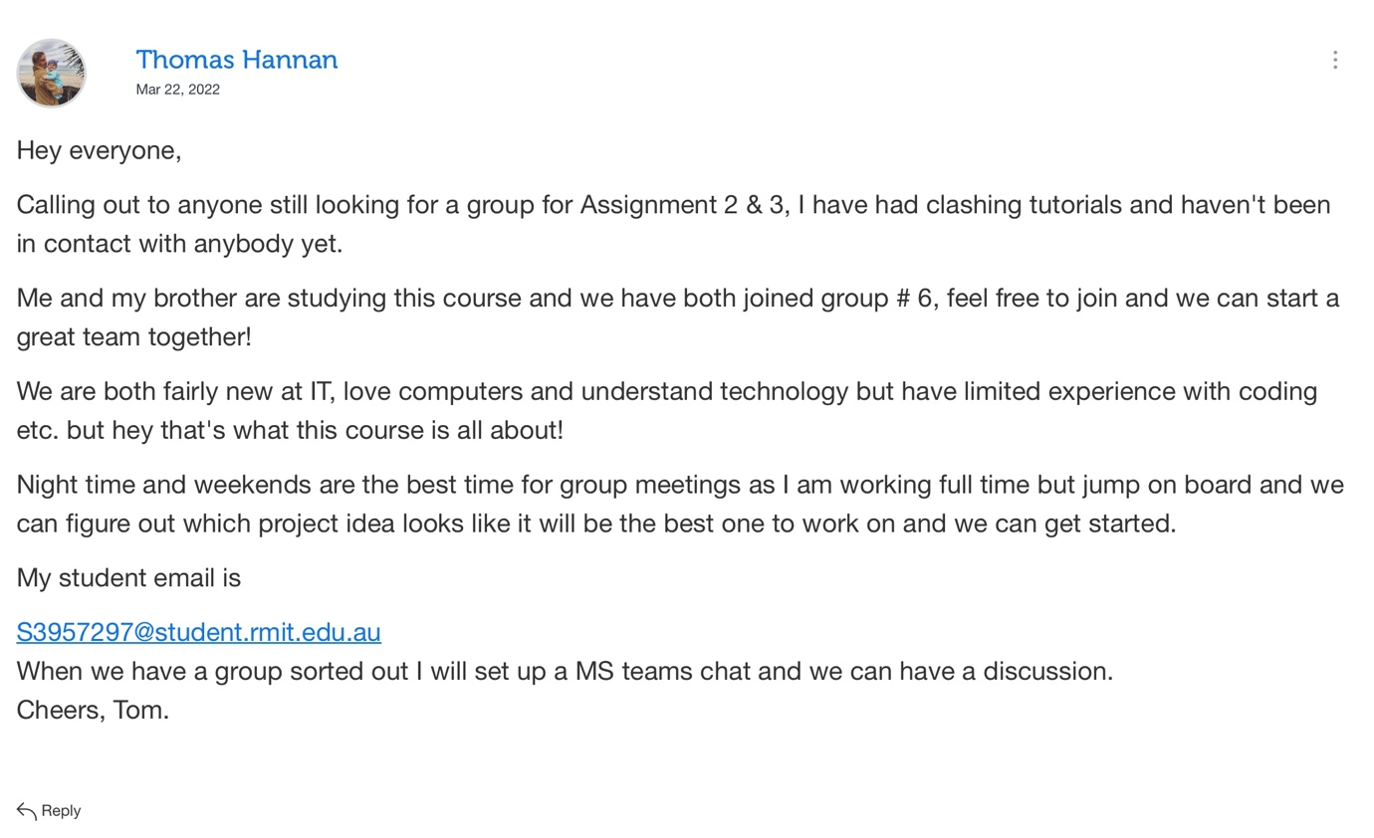

The response from that post formed the team, there was a lot of discussion on other threads of people posting their IT experience and asking to join other groups. AusDev was more about anybody is welcome to join, regardless of their experience.

Outlook:

Toms’ student email was listed on the discussions board on Canvas, everybody that wanted to join made contact through Outlook via their student email where a link to MS teams was sent out to join. Further emails sent via MS teams to the team members student email with notifications of upcoming meetings and other information.

Microsoft Teams - OneNote

This was by far the most useful form of communication and a great tool for organisation. There was meeting agendas created through OneNote that during meetings could be edited and updated in real time. This was a fantastic tool and is very helpful in storing important information to go back to. Through OneNote multiple tabs were created to organise work into sections and to be able to draft and write notes.

2nd Meeting – link to notes from the second meeting organised, which ended up dividing all responsibilities among group members and was used as a place to write and store information related to individual topics within the assignment.

2nd meeting recorded on Microsoft teams:
https://rmiteduau.sharepoint.com/sites/IntroductiontoITAssignments23/Shared%20Documents/General/Recordings/Meeting%20in%20_General_-20220404_193015-Meeting%20Recording.mp4?web=1

GitHub

The link to your group’s website

https://github.com/Mitchell-Lewis/Assignment-2-G6

The audit trail on the Git repository does not fully represent the timeline or effort and communication with the group’s work. MS teams was primarily used as the main tool for communication and organisation and therefore a better reflection.

Ideal Jobs

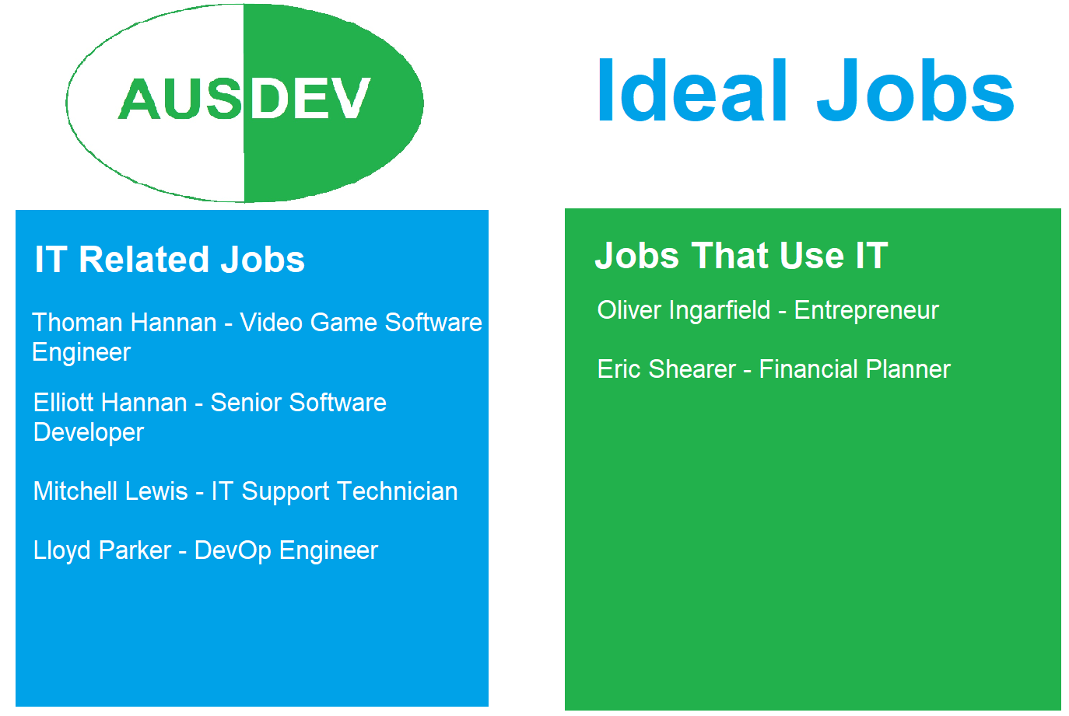

Common Elements:

There are a few common elements with our ideal jobs from the fact we are studying at RMIT to gain the practical skills required such as programming to learning interpersonal skills like teamwork to get our ideal jobs in the future. A lot of the ideal jobs we are looking for are based in the Information Technology industry, so learning and building on the practical skills we need at RMIT is important. Even though the few jobs our group has identified as ideal jobs outside of the IT industry, we still need to focus on learning skills such as team building and using programs while at RMIT.

Another common element is that we have looked at a few quite senior jobs roles such as, a DevOp Engineer who needs to know a lot all aspects of building and maintaining a program, being an Entrepreneur in the IT space which requires a wealth of experience to be able to identify and then be able to implement and create what you require and a Senior Software Developer at Unity which requires years upon years of experience in the engine itself as well an in depth understanding C++ and C# languages.

Differences from positions:

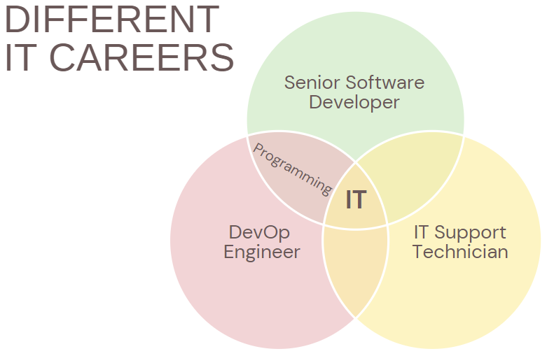

In AusDev despite a lot of our ideal jobs being based in the IT industry many of the positions are wildly varied, such as an IT Support Technician requires a different set of skills to a Senior Software Developer. An IT Support Technician may require more interpersonal skills and understanding as you are dealing with potentially less tech savvy and frustrated end users who are having problems with software or hardware. Whereas a Senior Software Developer isn’t an external facing role which won’t have to deal with customers or people outside of their team in terms of software.

Another difference is that some roles such as a Senior Software Developer and DevOp Engineer would have as part of their roles to understand the code and their respective languages to do their job to make programs, where as an IT Support Technician might have to an understanding about how software works they wouldn’t have to do any particular coding themselves and have other work arounds to get software to work.
We also have a couple ideal jobs that aren’t exclusive to the IT industry such as being an Entrepreneur and Financial Planner, these jobs, while almost always will use IT in their jobs, aren't focused on IT which is a step away from writing code every day as a Senior Software Developer.

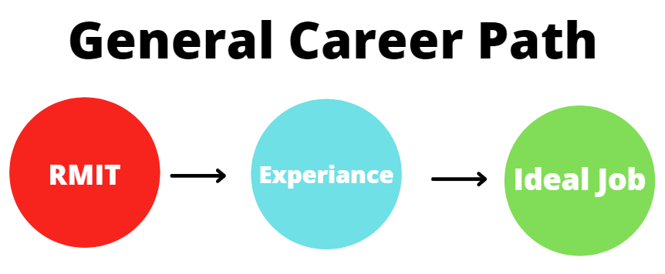
Career paths:
A lot of the ideal jobs are experienced roles so require getting skills then experience to obtain them. All the ideal jobs at AusDev require some level of tertiary education to start with, so completing our respective courses at RMIT is the first starting point for all of us to gain the start of the skills we require. Next point is gaining experience, some of the Ideal Jobs such as being an Entrepreneur doesn’t really require any experience but gaining hands-on experience will be invaluable to see how to run a business and produce a product, and being an IT Support Technician which regularly requires a Diploma or Bachelor of Information Technology so once Mitchell finishes at RMIT he should be able to get this position. As for becoming a Senior Software Developer, a Financial Planner and DevOp Engineer these jobs require a few years of experience after completing tertiary education, these jobs would require getting an entry level job in their respective fields to acquire.

Industry Data

In AusDev we had a variety of ideal jobs from our team members. We’ve decided to group the ideal jobs into exclusively IT related careers and into careers that use IT. We’ve grouped Game Developers, IT Support Technician and DevOp Engineer into IT exclusive career paths and Entrepreneur and Financial Planner in careers that use IT.

Looking at the career skills that are in greatest demand provided by the Burning Glass Technologies, we can see that a lot of the skills that are in demand for BGTOCC Family: Information Technology have a lot of common elements that you’d expect across almost all careers not just IT related careers so would be applicable to our members who haven’t chosen IT related careers.

In the Burning Glass Technologies listings for Top Titles only one of our ideal jobs comes up in their listing jobs which is Senior Software Developer(Engineer) which accounted for 0.3% of listing, however all of the IT Titles add up to 9.6% of the Titles Listed. Other ideal jobs looked at by AusDev weren’t listed on Burning Glass Technologies study such as IT Support Technician and DevOp Engineers for we can assume were not listed often enough to make it onto their list. The fact these jobs didn’t make the Burning Glass Technologies didn’t make the study doesn’t detract Mitchell and Lloyd from pursuing these roles, but it does mean that they understand they are niche roles in the industry as a whole, which means they may have to start in alternate role then move into their more niche chosen roles when they come up in the market.

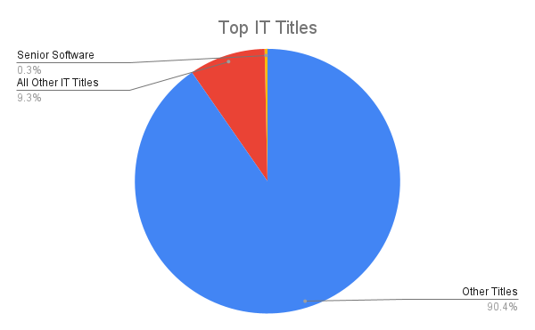

These common skills that would be just as applicable for a Game Developer, an Entrepreneur, an IT Support Technician or a Financial Planner, the skill in most in demand by being required by 36.3% of all posting in the Burning Glass Technologies study is Communication Skills. Good Communication Skills is required in all careers whether that be because you’re working in a team, customer facing or business facing, as long as you’re interacting with anyone being able to effectively communicate ideas and understand other people’s ideas is key to success. We also see that a lot of the other skills can be grouped under Communication Skills which further highlights how important being an effective communicator is. For example, having skills in Writing (12.8%), having Presentation Skills(3%), being Articulate(1.8%) and having good English skills (2.1%) all come under the umbrella of Communication Skills.

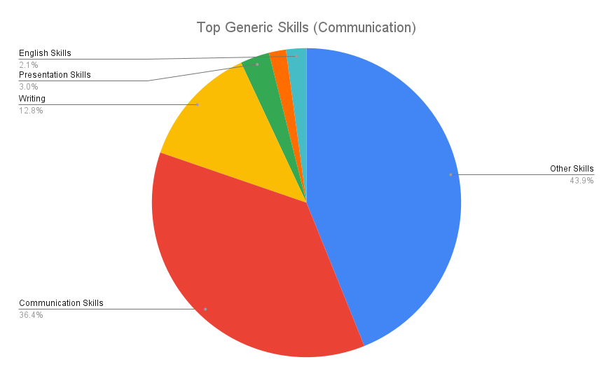

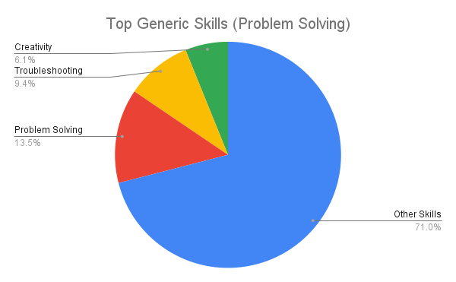
The second highest in demand is Problem Solving which 13.4% of posting required, this is another skill that would be required across all careers whether than be a Financial Planner or DevOp Engineer. In life whether that be professional or otherwise, not everything goes your way and being able to work through any potential issues that come up and deal with the unexpected without having to be babysat is key to all careers. Again, highlighting how important Problem Solving is in careers is that a few of the other required skills can be grouped with it such as, Troubleshooting (9.4%) which by definition means solving problems and Creativity (6.1%) which is used to solve problems in perhaps new and effective ways.
While not all the IT related skills will be applicable to all our team's ideal jobs we believe, there are still skills that are required that would be useful for all our ideal jobs. Skills such as Microsoft Windows which is required by 9.8% of listing, would be useful in using a Microsoft computer in being an Entrepreneur and IT Support Technician as of March 2019 over 800 million devices use Windows 10 alone (https://www.zdnet.com/article/microsoft-says-windows-10-is-now-on-more-than-800-million-devices/). Having a good understanding of Microsoft Windows would also include having good skills in Microsoft Office which another 4.8% of postings wanted.

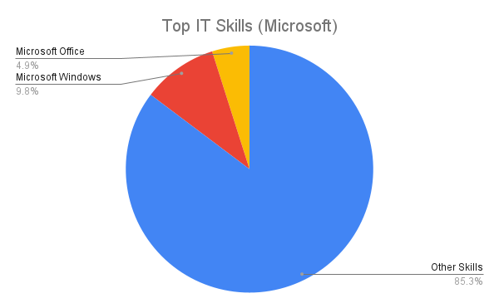

Another skill that is applicable to both IT careers and IT related careers is having good knowledge of Project Management which is required by 8.2% of posting. Every endeavor you get into whether that be as a hobby or professionally can be broken down into being a project. Employers clearly in the IT industry see Project management as an essential skill, when using Project Management skills in a professional environment another skill that is looked for is understanding the Business Process which is required by 3.8% of posting.
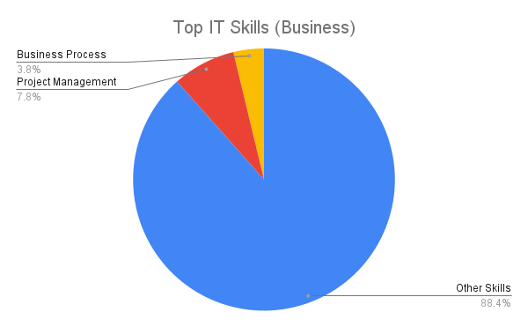

Looking at the more IT related skills that would be applicable to the IT related careers, having and understanding in C# and Git are skills that are required for our ideal jobs related to IT. However these are skills that aren’t highly ranked on the Burning Glass study with C# only required by 6% of posting and Git only needed by 4.5% of postings. These are the only skills that are on the Burning Glass Technologies study that come up in our team’s ideal job postings which we believe shows how specific IT related roles are in the world as some IT careers can focus on one specific coding language which is not used outside of its field.
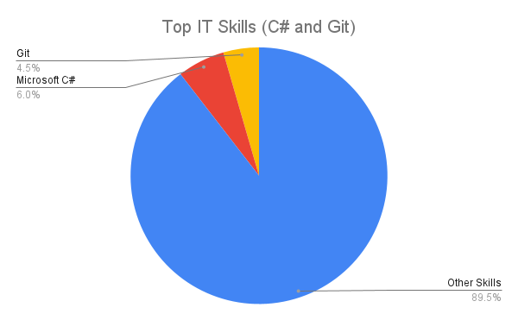
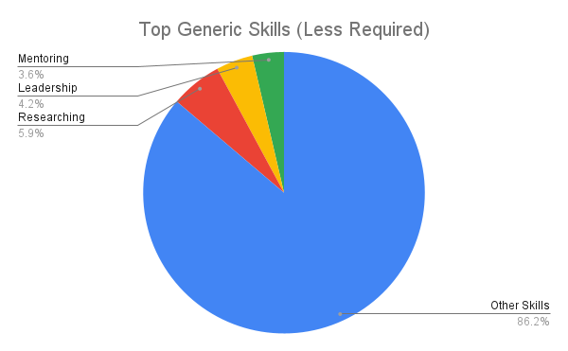
As a team we believe that all the general skills listed on the Burning Glass Technologies study are required on some level or another. However, a few of the skills that may be required less than others could be Researching as if you do come into any troubles you might have to research a solution but our ideal roles you would like to think once we reach them we would have a clear understanding on what we need to do, Researching is in demand on 5.9% the postings. Another less used skill could be Leadership as all our ideal jobs aren’t roles that are in charge of large teams, leadership is required in 4.2% of posting. Continuing with that the groups ideal jobs aren’t being in charge of large groups another less used skill could be Mentoring which is required in 3.7% of postings. This being said, all these less used skills we believe would still be useful to have and understand to be an effective professional.
The most required IT skills that weren’t touched on early when relating to our teams’ ideal jobs are SQL, JavaScript and JAVA which are required by 13%, 10.7% and 10.4% respectively, these are all skills and programming languages that members of AusDev should learn to a comparable level as they are required by more than a third of the IT industries jobs. The combined total of the 3 largest IT skills in demand just barely equal over a third of listings shows how varied the listing and jobs in the IT industry are where if you refer to the Generic Skill list Communication Skills alone accounts for being on more than a third of listings.
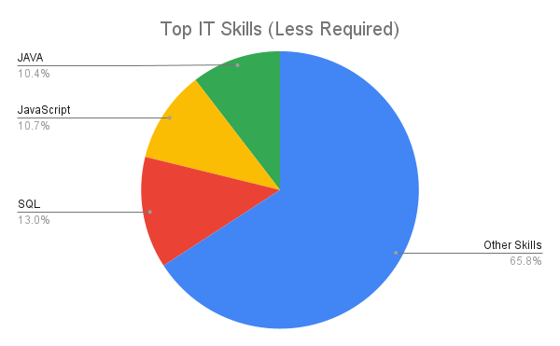
As we can see there are a lot of skills that carry over from the IT related careers to careers that are not exclusively IT related whether that be generic skills or even IT skills. The skills you need in a professional environment carry over to all careers.

IT Work – Interview an IT professional

Luke Wallace

luke.wallace@lendlease.com
Please tell us about your IT work. What exactly do you do?

I work for Lendlease which is a Tier 1 construction company, I am on the design team, and we do all the ITC/Audio visual and networking design for big commercial towers, hospitals, big infrastructure projects, in every industrial sector out there. If it requires fancy technology, I am involved in it. I am in the building team division of Lendlease, we will put in for bids for big major projects like multi plex, then we will put in a gross maximum price offer based on the documentation that the client gives us. There is a lot of reading a lot of determination from understanding what tech aspirations and requirements are needed, some clients know what they want, for example hospitals, digital departments within health industry are quite advanced in requirement sets. We look at requirement sets in alignment with architectural aspirations of the building. Almost every building now has converged networks, we will put a baseline design which we would then tender if they are successful with the bid.

We put in a gross maximum price with the preferred construction company then if they are awarded the contract they will go and develop design briefs further and then they will come up with performance specs which we will write which will then be divided into the various work packages, generally with work packages we will either edit or review other consultancies work, they are the converged network of the base building, sometimes it involves multiple converged networks because for example some hospitals have an engineering converged network, and a clinical network so there are two layers of networks doing two different functions. They are trying to do a fully converged network so eventually converging networks reduces infrastructure footprint required for the buildings which saves money and time for large projects.

So, there is networking in there, some converged networking, Wi-Fi, desktop surveys, audits, estimation of how many access points are required, inbuilding mobile coverage, requires distributed antenna system that allows mobile coverage withing building, interface and integrated service platforms. The term smart building is a broad and loose term, most of the building management systems, are pretty smart, they do a lot, the integrated service platforms will bring in all the other building systems onto one platform, so you have one data aggregated platform that’s taken all the data and stored it for analytics, so the building industry is jumping ahead trying to find value out of all the data from the building from thousands and thousands of data points they produce daily that adds value to the business.

So, would there be an interface that both employees and clients or visitors use that is all recorded on one system?

Integrated service platforms are called a single pane of glass, so basically within the building and facilities management business’s, we will build the building and hand over to operators or facility managers, sometimes give it over to the owner. Big companies that do it, JLL and spotless etc. these integrated service platforms allow them to manage all the technology and access control, security cameras etc, all from one single platform. Then we can say for commercial towers where there is multiple tenants, we can then give them access to the floors they have leased, they can then get aggregated data and understanding of their usage and utilisation. Now we have access to IOT another broad term for an internet connected device, we can put sensors in the building, these advanced workplace sensors are doing light levels, sound levels, so many other metrics involved to collect more data.

Sounds very complicated.

It is quite stupendous how complicated it can be. Imagine a builder, that does bricks and mortar, glass, concrete, wood, carpet, that’s there frame of mind, they know they have to put in a building management system, security, HVAC so they need guys like us, technology consultants to be able to pave the way so that when they are building these buildings, so that the technology actually works, because sometimes the buildings are built and the technology doesn’t work, and they don’t understand why because there has been a gap there, in the design process.

Would you primarily focus on engineering the hardware more so than the software? Or do they both go hand in hand?

Requires a bit of both, they go hand in hand, exactly. So, the software requires the hardware to run, so you have to size it correctly, at least with networking it is pretty much hardware, couple that with network management systems software like solar winds, then you have the standard layer 7 applications stacked to manage the networks, firewalls etc. while doing the performance specifications we are trying to be descriptive, while being high level so you have to have a very high level of understanding of network technologies per sae, even the different level of vendor offerings, every vendor does it slightly different, so when we go to tender and get responses back, we have to analyse the responses and evaluate if their offering is going to be compliant or not and to be able to give a recommendation back to the business to say yes go ahead sign this vendor up or sign this system integrator up, because they will deliver what is to be asked of them.
Please tell us about the industry you work in, Is it competitive? Are there many other business’s doing the same thing at a similar level?

Yes, it is very competitive, the level of technology going into buildings today is above and beyond a general building consultancy, most buildings will have security, so access controls CCTV, also BMS, building management systems, that controls HVAC, hydraulics and then you have lighting etc. so you have technology consultants that are more considered as technical services consultants, which come up with some of the specifications that go out to market, which then the services team analyse and evaluate those responses. What happens in the past, all those services would be provided with their own network, because networks are now being converged due to the value add that you get from that and the flexibility from converging them, not having all these individual networks, one for lighting, one for BMS, one for security. That is sort of where our niche lies because a lot of the consultants these days are technically advanced consultancies, but we specialise in these work packages, and technology stacks that they don’t seem to do that well.

Audio visual is my niche, I have seen it change from standard composite video all the way now to streaming video over the internet and networks. I have seen the full evolution of that technology to today, composite video is a thing of the past, VGA is a thing of the past and now these other technology consultants are started to do their own audio-visual consultancies, and, in the past, you would have an audio-visual consultant and that’s all they would do. Now you have got these building service consultants and they are just coupling these extra value adds into their business models.

Would your company go to an older building that has 10-12 systems running independently and go in and fix it? or contribute new things?

Yes, we do that as well, we term it greenfield and brownfield, example is cairns convention centre, basically they are doing an expansion project on that and also did a refurbishment. That is basically stripping out 20 years of old services and tech and putting in a new network based, audio-visual system, over 6 million worth of AV going into an existing building, you could imagine refurbishment and brownfields are super challenging, rarely do they go right as there are so many moving parts and so many unknowns, you may touch one thing that was meant to be retained and it breaks it, but you can’t fix it because its old so you have to replace it. Some projects you will have a brown and a greenfield so you will be building a new building, but you will need to interface with old buildings, very common with school campuses and universities. They will always have a green and a brown filed that you will have to interface with.
What other kinds of work do you have to do?

A lot of the work I do is sitting on teams meeting, a lot of teams conferences, a lot of workshops, requirement gathering, on a project at the moment that we are heavily engaged in months and months of workshops trying to gather requirements from the business, getting more in depth information on technical and functional requirements, we always do technical and functional requirement registers so then when we are going to market we have got some defined requirements that the tender’s will need to respond to.

Sometimes I will do support, Lendlease is also a business that has technology obviously, and we will sometimes get asked to help out the IT support team and the digital team, I’ve helped them out with video conferencing aspects because that’s my niche, just helping out where you can.
Who are all the different people you interact with in your work? Please tell us about
them. Please tell us about your interactions with other IT professionals.

The It professionals are within our group particularly on the consultancy level, dealing with the IT support team is more rare but in my past roles I was part of the IT support team, In the UK I was working for Barclays, I was part of the infrastructure engineering team, we had a whole little test data centre where we could spin up hardware and software and test it out and evaluate the test, and also get penetration testing, that was almost 100% dealing with IT professionals of different experiences and skill sets. Today mostly I will deal with service managers, design managers, other consultants and then just construction managers.

Are they the people just within Lendlease? Or do you deal with clients or investors?

The way we term client is anyone that employs our services, so Lendlease building is our client, we are also working closely with SA digital health and we are working with Macquarie bank as well, in general discussions, open discussions with them, and other consultancies, WSP is another one we are in close conversations with them about a number of projects. It’s pretty broad what I do.
What aspects of your work do you spend most time on? Is it audio visual stuff? Please tell us about these.

Actually, its project related so it is hard to say, some days or months will be focused on audio and visual because we will have one or two projects that have a serious AV footprint, at the moment I am working more on ISC and ISP so integrated service platforms for a commercial tower in Melbourne. So, it just depends on the project, the other portion of the time will just be helping out the bid team, doing what they call PROA, Projects, Risks, Opportunities and Assumptions, so basically, we will look at the clients’ briefs and then just say this could cost ex amount, that’s not clearly defined, and that type of stuff helps the bid trying the value manage and become more competitive while bidding. We also deal with the developers, and always spending a little bit of time across the board but generally most of the time is project related and specifically around requirements or design and then delivery.
Which aspects of your work do you find most challenging? Is it people or the computers?

Ha-ha, that’s a good question actually, might have to stop recording.

Sometimes just the business can be challenging, the business is a beast, well enterprise business is a beast, they have their own little needs and requirements of you. Sometimes I would like to just get head down thumbs up and just get focused on projects and let the business fly around you. It seems to work for me sometimes, we continuously go through restructuring, which is always a bit concerning, enterprise love restructure things every 6 months in their organisation, that can be challenging.

Do they have KPI’s and targets or do you get a bit of free reign?

That’s an interesting thing, they do say you have to set your goals, it’s not that they are challenging, the problem is that trying to achieve these goals while so busy on projects is the hard bit.
People can be challenging, our team is pretty good, you have got to be friendly, not tough but you have to stand your ground and you have got to be honest, if something doesn’t work or you can see something isn’t going to work you have to speak up, and say I have got a concern here or we need to consider this, etc. etc.

How often would you meet people face to face, fairly regularly or is the majority online?

At the moment, never, ha-ha, this is it, this is meeting in person these days. In the past it was more regular, but obviously being a national company, it is even harder. Travel restrictions have been in place for a few years so haven’t been able to go anywhere. Before that it was quite unique to go on site and meet the project team. Sometimes I will go to the office but that’s only a couple of times a month, but there is value from working from home as well.

Finally, can you share an example of the work you do that best captures the essence of
the IT industry?

I always think the IT industry is a very very very broad industry, so what I do is very specific so that’s a hard question.

I guess it’s just systems integration, that’s like the pinnacle of IT, that’s the whole point of it at the start?

Yeah true, well the IT industry needs a network and IT is all about integrating systems.

IT Technologies

Clouds, Services and Servers

What does it do?

A cloud server is a remote server that allows access to differing services depending on a client’s requirements. All cloud servers provide backups for files, for smaller personal clients, they can securely back up photos and videos for an individual or family. Larger cloud servers allow for business to secure their own professional files. Business' can hire servers for their business which can lower their initial overheads as that they do not require as much expensive hardware to operate, they can purchase smaller think clients instead of a full computer modem for each of their workstations. This also reduces the upgrade costs on their computer hardware when it is due for replacement. Using this, business can outsource some things to the cloud service providers, such as securely backing up their files as one of the services that cloud servers give is to securely backup files. Along with this most cloud services includes 24/7 support for business clients in the case that they have any issues with their server.

Cloud computing has different packages for different needs. For a smaller need, an individual or family can have access to a smaller memory bank to back up personal files, such as Google Photos which allows for an individual or family to be able to securely back up photos and videos to ensure that they are not lost in the case of an accident or disaster. An example of this would be if a child were to drop a phone that had personal photos on it, if the photos are uploaded onto a cloud server, then they can be retrieved and are not lost. For business' there are different packages that are tailored towards different needs. There are general packages for small to medium business that are more affordable and generally suit their needs. There are additional packages for larger business that are more suited to their needs. Many cloud service providers also have packages for IT and web developers that are suited to their requirements. These different packages usually come with the ability to scale their needs, allowing for business growth, or other varying needs depending on other things like seasonal work. These different options allow for the different clients of Cloud services to be able to have their own dedicated server for their business for a stable platform that is maintained by the service provider that gives an ongoing stable platform for their business that can be changed or updated as the business' needs change over time.

One important feature of Cloud storage is that it has multiple redundancy measures in place to ensure the secure upkeep of their servers for their clients even in the case of a hardware failure or disaster. Cloud servers are split across multiple secure locations with backups of the clients’ files being held in secondary locations. There are different levels of security on servers, with various digital securities and firewalls to ensure that people cannot access client data without the proper authority. Within Server locations there are additional securities in place that ensure that people cannot access the physical servers unless they are meant to be there. The servers are kept in state-of-the-art buildings that monitor and maintain the physical servers to ensure that they do not fail due to issues such as overheating. Many servers are held in secure locations that are purpose built to withstand the specific hazards of their locations. Servers in some locations in Australia have seasonal Cyclones and so those servers are built in a manner to secure them against Cyclones. Other sections of Australia are susceptible to bush fires and so the servers in those areas are built with that in mind. If you go overseas, then as there are other hazards and the servers are built with different considerations in mind. Japan for example, Cloud Data Centers are built taking into account that Japan has many volcanos, earthquakes and tsunami's and so the server buildings are required to be built to resist those natural disasters.

What is the likely impact?

The likely impact of Cloud technology in the future is not likely to change significantly to what is currently available. The changes will come from it becoming more and more used with a greater portion of the market using cloud computing and as it becomes more effective and affordable for both personal and business use.

One change following the improvements to cloud computing would be towards additional virtualization of workplace computing to cloud servers. As the effectiveness of cloud computers improves for business' it becomes more reasonable to have their computing done through cloud servers, instead of maintaining their own local servers, especially as the servers are maintained by specialists and usually have 24/7 support in the case of any issues arising. This also helps as it frees up workers to focus on their specialized field instead of being concerned with their local IT systems.

As cloud servers have constant improvement with greater storage capacity and internet speeds this will generate net increases to effectiveness from those servers. This will assist with improvements to software that are used across the cloud. As cloud processing becomes more effective the software that is being used can become more powerful to allow for it to generate superior reports and documents for its users or clients with less effort from its users, allowing for improved services and job turnover while not having to increase workload for workers, improving business and overall performance.

For personal use it will continue to affect how people use their computers, over the last years there has been a decrease in the required hard drive size for personal computers as more people are saving their files in cloud storage, it is mostly people who have not up taken cloud storage who save everything on their local computer or people who run more powerful programs on their computer that require greater hard drive space. One key part of this is gamers, where they currently have games downloaded directly onto their computers, however recent development to cloud computing has started to allow for games to be played through the cloud, eliminating some of this requirement for hard drive space, however there are still issues with this technology that will likely be fixed over time.

How will this affect you?

These changes will continue to affect everyone in various ways. There have been moves away from storing files on personal hard drives, and instead moving files onto cloud servers for security and backup, as hard drives do degrade and fail over time. This creates an additional level of security and peace of mind in case something was to happen to those personal hard drives ensuring that files are safe and secure. This has become even more apparent since the black summer bushfires where many families lost many precious photos and memories. Now all newly taken photos are regularly backed up securely in the cloud.

There are various ongoing changes to how cloud servers affect professional work practices. As available server size and speed increase it will certainly increase computing speed for those professions that use cloud storage, allowing for increased efficiency when generating reports and other documents for work. as servers become more affordable there will likely be a greater move away from smaller businesses having their own local server towards having access to a cloud server instead. Maintaining existing local servers becomes more costly as the hardware ages and becomes outdated. Alon with this it is quite costly to replace or upgrade existing local servers, and as such it should slowly become more effective and more affordable to simply transfer their business away from their local server and onto a cloud server. for the business that do take this up it should make for more streamlined work. While many companies are moving towards up taking cloud servers there will remain many companies that prefer to have their own local server as it remains entirely within their own control, which is an additional consideration that business need to take into account when determining if they want to utilize local of cloud servers.

Autonomous Vehicles

What does it do?

An autonomous vehicle is a vehicle that can navigate and deliver a payload, whether that be people or cargo, without the need for a human to interact with the controls. It can scan and detect its surroundings and react without driver intervention. With a truly autonomous vehicle, a human is not needed to perform any driving function or decision making. the first official autonomous vehicle was developed in 1977 by the Tsukaba mechanical engineering laboratory. Which used an old analogue computer, that used 2 cameras to pick up special lane markings to facilitate autonomous driving. The first autonomous road trip was in 1995 by CMU'S navlab 5, driving across America, from Pittsburgh to San Diego. Driving autonomously for all but 50 of the 2850 miles.

There are multiple levels of automation when it comes to vehicles. These range from level 0 with no automation, to level 5 with full automation, in which even a steering wheel is optional.

- Level 0 means there is no automation or driver assistance. All control of the vehicle is up to the driver.
- Level 1 is driver assistance, where only a single automation system is present, such as cruise control.
- Level 2 is partial automation, where the vehicle has limited control over acceleration and steering. A human driver is still required to monitor the situation and can intervene at any time.
- Level 3 automation is what we have included is some high-end vehicles today, such as a tesla. This is where automation can control the vehicle under the right circumstances, such as on a highway. The vehicle can monitor its surroundings and can avoid obstacles and collisions with other non-automated vehicles and obstructions.
- Level 4 is where the vehicle can run autonomously in most situations, is aware of its surroundings and can react to most situations. However, a human driver is still required to monitor the situation.
- Level 5 is complete automation. This is where the vehicle can run autonomously in all situations. A driver is not required, and a steering when can even be excluded.

These days driverless cars are undergoing rapid change and development. Currently autonomous vehicles use a variety of sensors to detect road markings and objects. Radar is used to detect nearby vehicles and other moving objects. allowing for the vehicle to detect if an object is moving toward or away from it. It is used mainly for collision avoidance and other features such as adaptive cruise control and blind spot detection. Lidar uses a laser to scan its surrounding and create a 3d view of the area around the vehicle. Its high accuracy and small processing requirement made it great for quickly determining immediate surroundings. The vehicle uses multiple cameras to view its surrounding and detect vehicle, people, animals and any obstruction that may enter the roadway. It’s also used for object recognition. such as traffic lights, emergency vehicles, construction hazards etc. GPS is used to give the car its global position and a map of its surroundings to facilitate autonomous driving. Right now, the main technological innovation is image and data processing. The onboard cameras are able to gather most of the data used for driving under normal conditions. However, the main drawback is the amount of raw data that needs to be processed and interpreted by the computer. This is slow and right now it is not ideal for situation that require immediate action. Machine learning and neural network will most likely be the technology that moves this forward and allow reliable cheap autonomous vehicles. The other innovation we will see is seamless communication between vehicles. Having the ability to have a direct data link to all vehicles mean that the vehicle will not have to guess what every other vehicle is doing. Saving valuable processing power.

What is the likely impact?

Autonomous vehicles are likely to be a world changing invention. just like electricity or the internet before it. It is set to be one of the biggest game changers in vehicle history. The ramification will be felt in just about every industry.
Just as the introduction of autopilot in aviation has made air travel the safest way to travel, the impact from global adoption of level 5 autonomous vehicles cannot be understated. To be able to hop into a autonomous vehicle and have the confidence that it will be able to react to any situation and keep you safe in your travels will forever change how we use vehicles. In the private sector, it will make tasks like food delivery or package delivery much more reliable and efficient. Ride sharing services will benefit hugely from the adoption of autonomous vehicles. A customer will be able to open an app and be able to request a ride. Then to be able to step into a autonomous vehicle and be able to be delivered anywhere without having a driver will be monumental to the industry. Speaking of industry. Having automated trucking and freight delivery will facilitate a major boom in the freight industry. However, all this novation and automation comes at a cost. It will put millions of people out of a job and will kill the trucking and taxi industry as we know it. The ramification of this will be immense. With millions of people now looking for jobs, unemployment will skyrocket and there will be a backlash towards autonomous vehicles. Some experts say that this will increase the divide between the rich and the poor. With wealthy people being able to enjoy the luxury of autonomous vehicles, while the poor that have been kick out of their jobs and will most likely not be able to afford the autonomous vehicles that took their jobs in the first place.

How will this affect you?

I think this will affect me in many ways. To be able to jump into a car and get some work or study done would be great, or to catch up on some much-needed sleep. To catch an automated bus to a train station and arrive precisely on time will greatly increase my usage of the public transport system. I have insomnia and do not drive when I have been unable to sleep. With autonomous vehicles I will be able to travel allot more. If we had level 5 autonomous vehicles, I would feel a lot safer knowing that most people will be using autonomous vehicles, and that the likelihood of getting into an accident will be drastic lowered. With increased safety and reduced death toll attributed to motor vehicles, car insurance will become a lot more affordable. Currently if i am waiting on a delivery I am given a time frame of when the parcel will be dropped off at my door. With autonomous vehicles that time frame will be a lot more accurate. And I will be able to work around that time a lot better. I worry about my family driving. My mum drives almost an hour to and from work every day, which worries me as she can come home rather tired. But with level 5 autonomous vehicles I will not have to worry about that anymore. My sister works with race horses and has to both schedule deliveries and get some herself. With autonomous vehicles her workload will be significantly reduced. My grandparents live almost 2 hours away in Snowtown. They come down to Adelaide weekly and I worry about them driving so far in their old age. But with autonomous vehicle they will be able to come down a lot more often. I believe with the adoption of autonomous vehicles will come the rise in online purchases. My cousin works in a car dealership. I think the amount of people that will buy a car from a dealership will decrease, and I think this would make his job a lot more difficult.

Machine Learning

What does it do?

Machine learning is an offshoot of Artificial Intelligence (AI), advanced computer systems are used to analyse massive amounts of data from which the machines begin to find patterns and eventually start to make predictions on the tasks given to them. These data sets can be anything from images, to text, to numerical values, likes, dislikes, essentially anything that programmers and developers can feed into the “minds” of the computers.

Tasks that once took countless manhours to complete are now performed in massive quantities and a fraction of the time. Some basic applications of machine learning include software in autonomous vehicles, advertising/marketing, financial security, biometric recognition, medical diagnostics, classifications, and the list continues to grow every day.

The difference between the way the human mind learns, and the way machines learn is the way we process information. Humans learn from our past experiences, whether positive or negative these seemingly insignificant parts of our life impact on how we proceed in the future. Machines are a bit different, being a creation of man, they only have the data we provide them. The more data we give them, the better the ability for them to solve the problem. Depending on what the problem the machines are to solve, different learning techniques must be implemented. These techniques include Supervised Learning, Unsupervised Learning, Reinforcement Learning and Deep Learning.

Supervised learning

As the name suggests supervised machine learning requires supervision to solve the problem at hand. This is done by supplying the machine data with both labels and features. For example, the machine is fed a picture (the data) of a cat (the label) and features including things like shape, colour, size etc. Eventually, with the use of algorithms, the machine itself will be able to associate certain features and determine whether the data presented is a cat or not.

Unsupervised learning

Unsupervised learning occurs when large sets of unlabelled data are presented to the machines. The data is then analysed, and the computers begin to form some sort of structure to make sense of. Depending on the data set it will look for patterns and similarities and extract useful features from it. This learning technique is used mostly for more complex tasks compared to supervised learning. It is useful for when data needs to be classified first and labelled later. This may be the case in scenarios where the machine is trying to find anomalies in massive data sets.

Reinforcement learning

This learning technique takes more of a biological approach towards machine learning. Through feedback given to the machines they are able to navigate around problems to reach their desired outcomes. These computer systems are given either positive or negative feedback on their decisions, and through trial and error, they can build their own framework to complete the task at hand. The reinforcement technique shares many similarities with the supervised learning model although it does have some limitations. Without reinforcement the machine is limited to what data it is fed and can never achieve higher intelligence than the person programming it. Reinforcement learning allows the machine to go above and beyond the capabilities of the human mind and skillset.

Deep learning

Deep learning is a technique that uses a neural network inspired framework and layering to find patterns through large sets of unstructured data. These machines are designed to emulate the human brain and how it functions, and in doing so, can solve much more complex problems and find patterns other techniques cannot. This technique is helping us discover new technologies in medical diagnosis, automated vehicles, and biometric recognition, to name a few. With such complex algorithms deep learning machines require massive volumes of data compared to other more rudimentary techniques.

As machine learning continues to make unprecedented advancements on the technological front, we, as a human race, are living in a very exciting time in history. On a daily basis we are exposed to the powers of machine learning without even realising it. Everything from targeted marketing to traffic directions, all influence us to some extent. At the same time, we are feeding data back to these machines to enhance the user experience for a later date. The possibilities to significantly change the way humans live are just over the horizon.

What is the likely impact?

Many companies across the globe have been using machine learning for a number of years, they continuously collect and analyse, user data and use it for things like fraud detection, spam email detection and targeted advertisements. So already there are real-world applications that people may or may not be aware of.

As such large portions of life are being spent online, security is becoming a huge concern in the cyber world, and we are actively trying to implement these artificial intelligences to combat the issue. The more data we allow the machines to process the more accurate they can become in pinpointing potential threats to our personal information and finances.

But with the good comes the bad. In the case of the Cambridge Analytica scandal, machine learning was used to process data from millions of American Facebook users and their friends. The data was used to label and classify users into different personality types depending on their likes and usage on the social network. These results were then used to target Facebook users that matched similar profiles. Psychographic advertisement then targeted unsuspecting voters in a bid to influence the 2016 election. Not only does this raise many ethical issues when it comes to machine learning and what happens with our data, but it may have directly affected the lives of not just the American people, but the lives of people across the globe.

Whilst data on what the impacts machine learning specifically, will have on the workforce in years to come are not clear. It is estimated the humans will lose up to 85 million jobs to Artificial Intelligence over the next 5 years. However, the jobs created to maintain and program these systems in the future are estimated to be up to 97million.

How will this affect you?

On a day-to-day basis most people would not realise just how much machine learning affects them. Every time you open Spotify or watch Netflix there are complex algorithms working tirelessly to enhance user experience. Some may see this as an invasion of privacy or a misuse of personal data but ultimately each one of us are getting that tailored experience. The same may not be able to be said for the actual content, but the intentions are there.

Love it or loathe it, your data is being collected and processed every time you turn on one of your devices. The data being collected is now big business and with the aid of machine learning it is being used to directly influence you spending habits, your political ideology and maybe things we are not yet aware of.

With medical application of machine learning, this technology is now beginning to transcend the digital realm, to directly impacting our health and well-being. Advancements in early cancer detection, prediction and treatment of illness, and even administration, are already impacting the lives of people worldwide.

Another exciting advancement is self-driving vehicles are slowly becoming a reality, and without machine learning, the capabilities of these vehicle would not be possible. The more self-driving cars on the road, the safer the roads are said to become. This will directly reduce the number of casualties on our roads and make our lives just that little bit safer.

As students of Information Technologies, machine learning will only open-up more doors of opportunity. We are at the precipice in advancements of technology and machine learning is at the forefront. Its web is far reaching and is able to be implemented into seemingly endless facets of our lives. The more digging we do, the more AI and machine learning surprises us, and we think to ourselves “What’s next?”

Robots

What does it do?

Robots help aid humanity in various ways. From simple things around the house, to aiding in major productions at factories. They help with minor but important areas of farm work to assist in areas of medicine and healthcare. Around the house, we can see robots in the toys that kids play with and with small vacuum robots. Within farming, robots have been developed to detect when a fruit is ripe and harvest them. Robots are also capable of detecting the location of weeds and removing them. And if you want to look closer to something more familiar, then look towards the robotic tractors that can be hooked up to the same machinery as a regular tractor. Robots also help in the production of products as they have become a major part in factories. Robots are often used in the production line to help with mass produced products as machines do not get bored much like a human would. They can be used to do a task that is simple and repetitive, but requires being done many times over and over again. In cases where a human touch is needed, robots can aid the human in the workload to make it easier for them. Though the production of food and physical goods is not the only way that they help in the improvement of human lives. Robots can also be used in the medical industry. An exoskeleton can be used to help someone who has lost the ability to control their body as much as they would normally. The development of prosthetics has allowed some people to regain a limb, some being controllable with the mind. We also see robots being aids in surgery. We also see robots deployed into areas that are normally too dangerous for humans to enter. A good example of this would be the robots often used in space and sent to planets to help further aid in research. Another example would be the robots used for military purposes. When used by the military, it can be used to scout potentially dangerous areas to assess for enemies or other dangers. It can also be used to scout areas in disaster response to help save time with sending humans on the ground. In the future we will likely see further improvements in the areas above. Another would be robots in factories would be able to produce parts for their own bodies. Then with other robots, both detect where robots are damaged and repair the broken parts, in theory, allowing them to run autonomously without human intervention. What has allowed the advancement of robotics to make this possible would be the further development in artificial intelligence which gives the robots their “minds” to move on their own. Another advancement that has aided in the development in robotics is the advancement in autonomous vehicles as some robots use a similar technology as the autonomous vehicles. The development of robotics has allowed for several advantages for humanity. With the further increase in population, the need for more products, both food and non-food has been met with the increase in productivity. Though a disadvantage of this is the loss of human jobs, forcing people if they want to keep a job, to change to a new profession. Another limitation is that at the current moment, robots can only do what they have been programmed to do. This does mean more complex jobs require humans. Through the advancement of machine learning and greater artificial intelligence.

What is the likely impact?

With the use of robots increasing in our daily life, the amount of products available to the increasing population can be met. Because robots can do one or a few tasks forever given they do not break down or run out of material to work with, this has allowed for greater efficiency. Robots are being used in areas and tasks that would have been mainly taken by humans, Because of this, there is the worry of human jobs being taken over by these robots. Though this does not mean that the amount of jobs for humans has been reduced, it just means a change to where humans are required. Robots are not at the point that they can work by themselves, human supervision is needed to check and to detect if there is a fault in production. Also because robots will eventually need repair, the increase in maintenance jobs has increased along with jobs to create new and improved robots. Also there are still jobs that require a human touch and some people prefer products that are handmade even if they cost more. Another change in workplaces is that medical facilities will have an increase in preference in hiring doctors and nurses that would be more familiar with the medical robotics if the facility used them. It would also see an increase in people capable of being skilled in the operation and repair the robots made for medical purposes. There would also be an increase in people working in areas other than production as their jobs would have been taken away by the robots and they do not have the necessary skills or experience to shift jobs in the same field.

How will this affect you?

With the further improvement of robotics in the medical industry, the overall health of the human population should improve. With the improvement of robotics in surgery, the likelihood of complications should decrease. With the improvement of robotics in prosthetics, it will allow for humans who have lost limbs to walk again or hold objects with their mechanical hands. With robots being used in farming, it can help improve the overall production of foods without the need to hire as many people as producing the same amount without the usage of robots would. Improvements with robots in production will likely improve what products are available to people while also decreasing the price of the products. For people that are still in school, robots taking over jobs will not affect them in a major way as they would be able to work with the improvement in robotics. As for the people who work in production, they could lose their jobs as the higher ups decide to replace the humans with robots and they do not have any other skills that the company would want to keep. So overall, the younger generation will likely to improve with the introduction of robotics as their jobs will likely complement it. As for the parents of those younger generations, it depends on what jobs they have and their education. For people with a specialised education it is not likely to affect their work security in any major way. For the population as a whole, the improvement of life will likely improve for most members of society that the robots will reach. As for the people in urban areas, robots and the improvement will likely have little effect.

Project Idea

Windows program and setting profiler

Overview

Description

Tools and Technologies

Outcome

Reflections

Thomas Hannan

I have really enjoyed this process, we kind of rushed at the start in making a group, anyone was welcome and everybody kind of just joined, everyone has put in a lot of effort, attending the meetings and made contributions to the assignment equally. I have never worked on something with somebody remotely before and I was surprised at how smooth the process was and how much effort everyone was putting in.
We have worked effectively as a team and I am proud of the work that’s produced, the only thing that could have made it better is if we were a bit more organised earlier in the process. In saying that the difference would have very small, it didn’t affect us to much just something to improve on next time.
What surprised me was the level of work produced by the other team members, and the understanding they have of IT. I felt like I knew the least in our team about the IT industry and how some things work, but through communicating with the team regularly and getting things explained it really help me develop my knowledge and skill set.
I learnt that in a group not to be shy or uncomfortable on webcam, I am new to talking to strangers on webcam, but we are all here to do the same thing and we were all in the same position, which I think helped a lot. Everyone in our team was friendly to each other, it is important to be able to communicate, work through problems and be respectful.
Personally, I am very new to GitHub, I am still learning but do not understand a lot of its tools and potential uses, it is something I need to work on into the future. I have used Microsoft Teams as my main point of contact to share information/documents, easily discuss issues through chat and OneNote. The ability to schedule meetings that can be recorded and shared later is amazing at keeping track of work and having a timeline.

Elliott Hannan

Considering this subject is our first on our journey to complete our degrees it was the general consensus that we have done quite well. Trying to get everyone together early was a little bit of a struggle, bearing in mind our first few meetings had been super late notice. Once we got some momentum with what each of us were to achieve, we coasted through to submission.

The allocated work was balanced quite well, and no one seemed to be under immense pressure. We were all willing to pick up extra work when needed. Regular check-ups where each of us provided an update on what we had done, where we were on our drafts and any general enquiries helped us finish in a timely manner.

An area that could be improved on in the future is having a bit more interaction with how we could improve on ideas we already had the foundation for. Unfortunately, we are doing 100% online interactions/meetings, so it is hard to bounce ideas from one another without being face to face. With more meetings lined up for the future we are going to be able to mitigate this issue.

Mitchell Lewis

Eric Shearer

I believe that most of what we did as a group went well. We split up the work between us well and each took on a portion of the workload. We had meetings twice a week that kept us up to date with what one another were doing and helped us to make sure that we were all completing our tasks in a timely manner and make sure we didn’t fall behind and made it to our deadlines.
One problem that had occurred was that we had trouble organizing our early meetings and that they were made with very short notice. That being said, after we all got together and were having meetings together, we started to be on the same page and were all organized and working together. Surprisingly there were no issues within the group itself, everyone all pitched in and did their part, counter to what has occurred in group assignments I have been involved in previously that always had one person who was riding on the rest of the group's coattails.
This assignment has shown me that if you can get a group of people working together towards a common goal that you can accomplish tasks that are far too vast to complete alone. I do not believe that this will be accurately reflected in our GitHub logs, however the various notes that we worked through in MS teams have a better log of what we accomplished together with notes and updates made next to one another's work.

Oliver Ingarfield

Lloyd Parker

Reference List:

Robots – Oliver Ingarfield

Anon, (n.d.). 8 Examples of Robotics in Everyday Life – StudiousGuy. [online] Available at: https://studiousguy.com/robotics-examples/.
BBC Science Focus Magazine. (n.d.). Robots: What you need to know about the past, present and future of robotics. [online] Available at: https://www.sciencefocus.com/future-technology/robots/.
Cordray, R. (2014). What Jobs Will Robots Take From Humans in The Future? [online] WIRED. Available at: https://www.wired.com/insights/2014/07/jobs-will-robots-take-humans-future/.
FutureLearn (2021). The future of robotics: How will robots change the world? [online] FutureLearn. Available at: https://www.futurelearn.com/info/blog/general/introduction-robotics-future-robots.
Ohio University. (2018). 5 Industries Utilizing Robotics | Ohio University. [online] Available at: https://onlinemasters.ohio.edu/blog/5-industries-utilizing-robotics/.
Pocket-lint (2019). Pocket-lint. [online] Pocket-lint. Available at: https://www.pocket-lint.com/gadgets/news/134820-real-life-robots-that-will-make-you-think-the-future-is-now.
Sciencing. (2010). What Robots Are Used Today? [online] Available at: https://sciencing.com/what-robots-are-used-today-12745877.html.
Software, S. (2021). 12 jobs that AI will replace in future. [online] Resources Library. Available at: https://www.saviom.com/blog/12-jobs-that-robots-ai-will-replace-in-the-future-and-12-that-wont/.
VentureX - Future Tech (2021). The Future of Farming Robots - 13 High Tech Examples (Compilation). YouTube. Available at: https://www.youtube.com/watch?v=uD4mJCgsmdM.

Machine Learning – Elliott Hannan

Heath, N 2018, What is machine learning? Everything you need to know, ZDNet, ZDNet.

What is Machine Learning? n.d., www.ibm.com.

Simonite, T 2019, How Do Machines Learn?, Wired, WIRED.

Ray, S 2018, Essentials of Machine Learning Algorithms (with Python and R Codes), Analytics Vidhya.

IBM 2020, What is Supervised Learning?, www.ibm.com.

Clouds, Services and Servers – Eric Shearer

GeForce Now, accessed 10 April 2022 <https://cloud.gg/>

Cloud servers Australia, accessed 9 April 2022, <https://www.cloudserversaustralia.com.au/>

Data Center Map, Australia Data Centers, accessed 9 April 2022, <https://www.datacentermap.com/australia/>

Data Canter Map, Japan Data Centers, accessed 9 April2022, <https://www.datacentermap.com/japan/>

Data Flair, Future of Cloud Computing – 7 Trends & Prediction about Cloud, accessed 10 April 2022, <https://data-flair.training/blogs/future-of-cloud-computing/>

Google Photos, accessed 9 April 2022 <https://www.google.com/photos/about/>

