Pipeline

1. Weekly Database Update

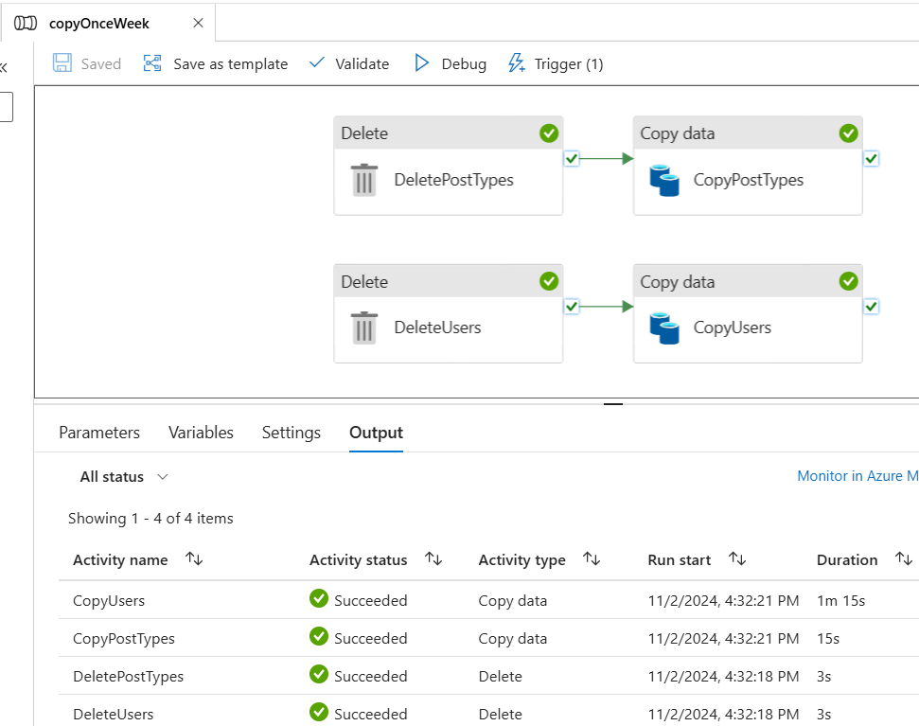

1. Daily Sentiment Machine Learning predictive Check

1. Linked Services

