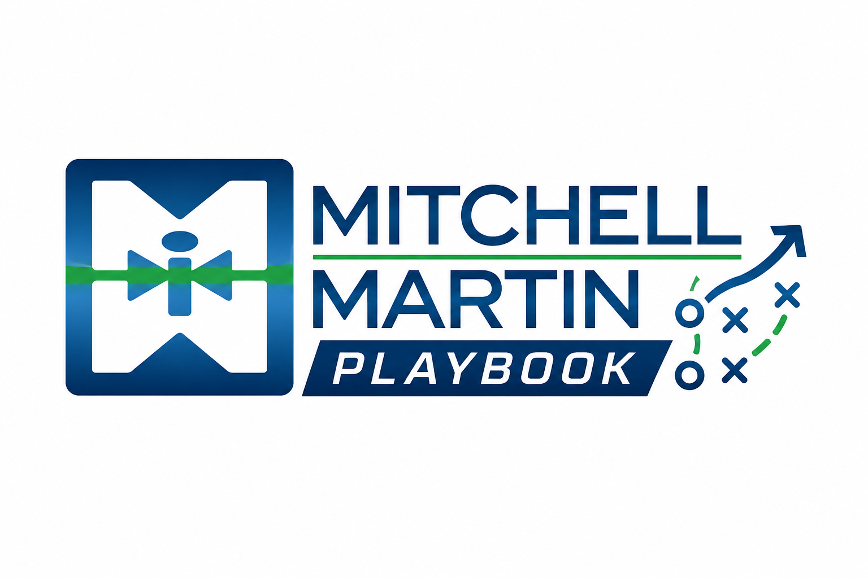
Job Ranking Parameters
Reference guide for classifying open roles — Platinum through 4 Rated
 | Platinum | 1 Rated | 2 Rated | 3 Rated | 4 Rated
Bonus criteria required | 3 of 6 | 2 of 6 | 2 of 8 | 1 of 7 | Auto-assigned offshore/automation
Must Haves
Hiring manager contact | ✓ Intake call  No other vendors  Recruiter/RM included | ✓ Ongoing communication | ✓ Manager direct job | ✓ HR direct contact | —
Bill rate / salary range | ✓ Confirmed | ✓ Confirmed | ✓ Confirmed | ✓ Target market rate | ✓ Provided
Acceptable bill rate (market rate) | ✓ | ✓ | ✓ | — | —
Clear job spec / notes | ✓  Resumes direct to HM  CC/BCC recruiter | ✓  Resumes direct to HM  cc/bcc recruiter | ✓ | ✓ | ✓
Vendor / intake call | — | — | — | ✓ | —
Bonus Criteria (hit required number above)
Weekly resume review / cadence | ✓ | ✓ | ✓ | ✓ | —
New client | ✓ | ✓ New client or new HM at existing | ✓ | ✓ | —
Ropes sold | ✓ | ✓ | ✓ | ✓ | —
Interview times / manager calendar | ✓ | ✓ | ✓ | ✓ | —
Exclusivity | ✓ | ✓ | ✓ | ✓ | —
New job (recently opened) | ✓ | ✓ Within 5 business days | ✓ Recently opened | ✓ Recently opened | —
Job around MSP | ✓ | — | — | — | —
Resumes sent to hiring manager | — | — | ✓ | — | —
Proof of HM contact (not TA/HR) | — | — | ✓ | ✓ | —
Delivery Commitment
Target | 2 Grade A MMI Candidates within:  • 48 hours for contract roles  • 72 hours for Ropes Tested candidates  • 5 days for full-time roles | 2 Grade A MMI Candidates within:  • 48 hours for contract roles  • 72 hours for Ropes Tested candidates  • 5 days for full-time roles | Candidates within:  • 48 hours for contract roles  • 72 hours for Ropes Tested candidates  • 5 days for full-time roles | Candidates within:  • 48 hours for contract roles  • 5 days for perm roles | Candidates within:  • 48 hours for contract roles
If target not met | RM sets up LI or JobDiva shared search to review activity and progress together.  Daily check-ins continue until qualified candidates are submitted. | RM sets up LI or JobDiva shared search to review activity and progress together.  Daily check-ins continue until qualified candidates are submitted. | RM sets up LI or JobDiva shared search to review activity and progress together.  Daily check-ins continue until qualified candidates are submitted. | RM sets up LI or JobDiva shared search to review activity and progress together.  Daily check-ins continue until qualified candidates are submitted.

