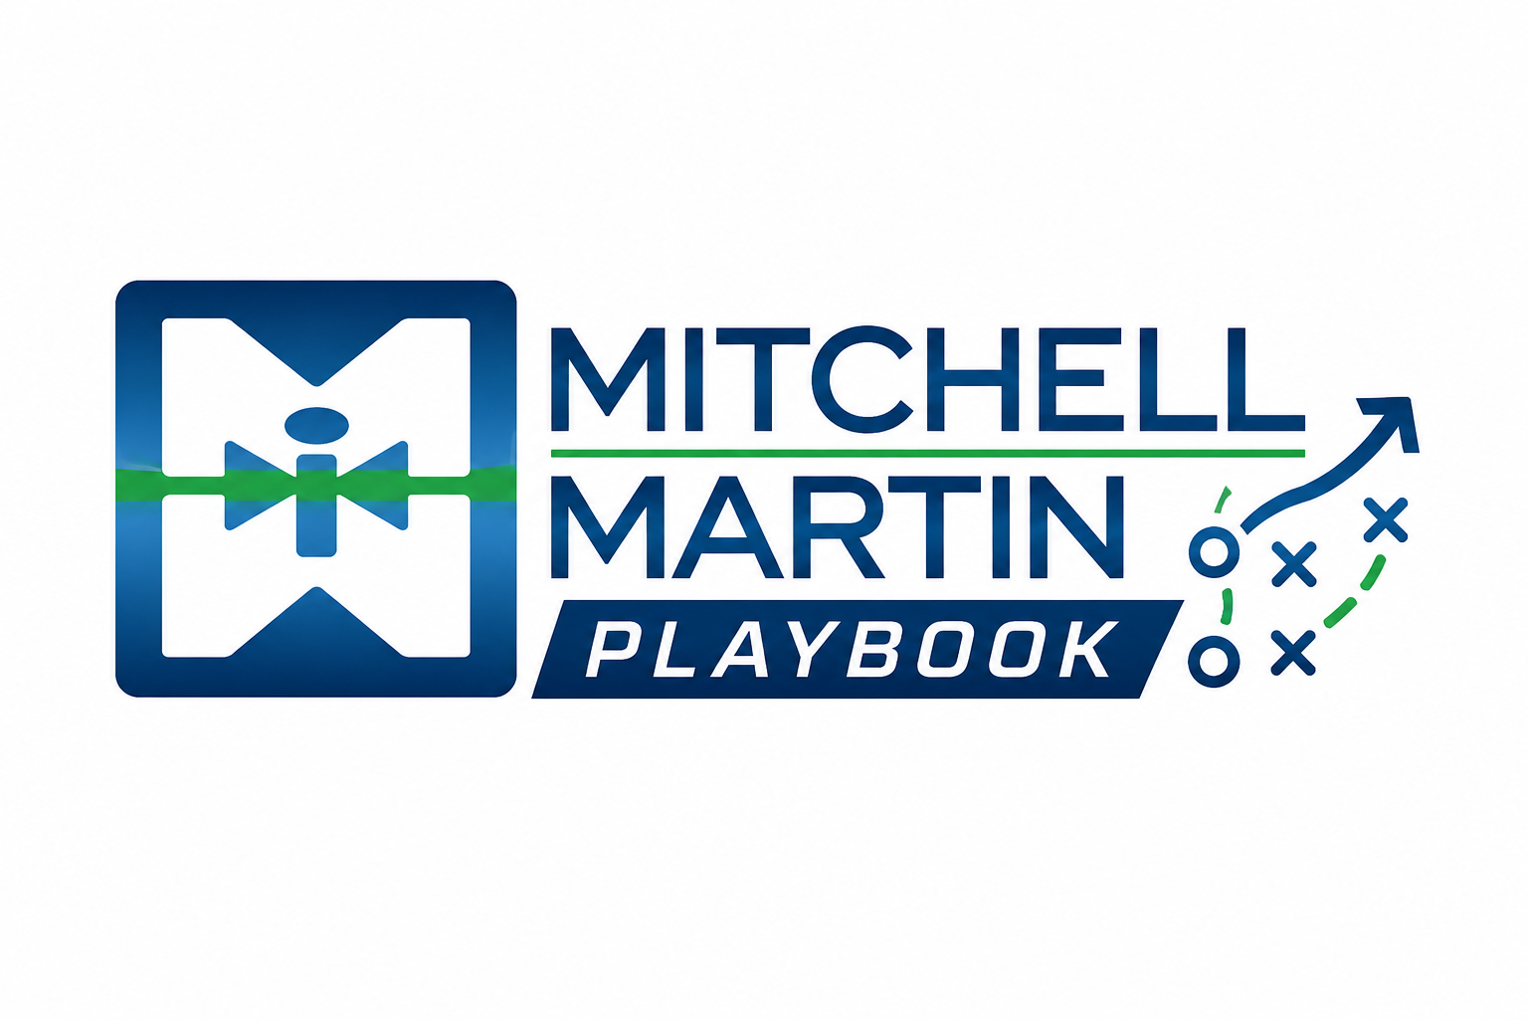
MMI Buyer Strategy Questions
Discovery prompts for buyer strategy and account mapping.

Core questions
- What business outcome is at risk if this role stays open?
- Who owns the decision, budget, process, and final yes?
- Where has the current hiring motion broken down?
- What would make a staffing partner strategically useful instead of transactional?

Enterprise vs. mid-market
Enterprise accounts are structured, layered, and volume-oriented. Mid-market accounts are relationship-led, flexible, and education-heavy. A balanced book gives the business repeatability, agility, margin opportunity, and more ways to win.

DMU/I buyer map
- Decision Maker: final authority; lead with outcomes and economics.
- User: interacts most with the firm and candidates; satisfaction drives future business.
- Influencer: shapes the decision; address risks proactively to avoid delays.

