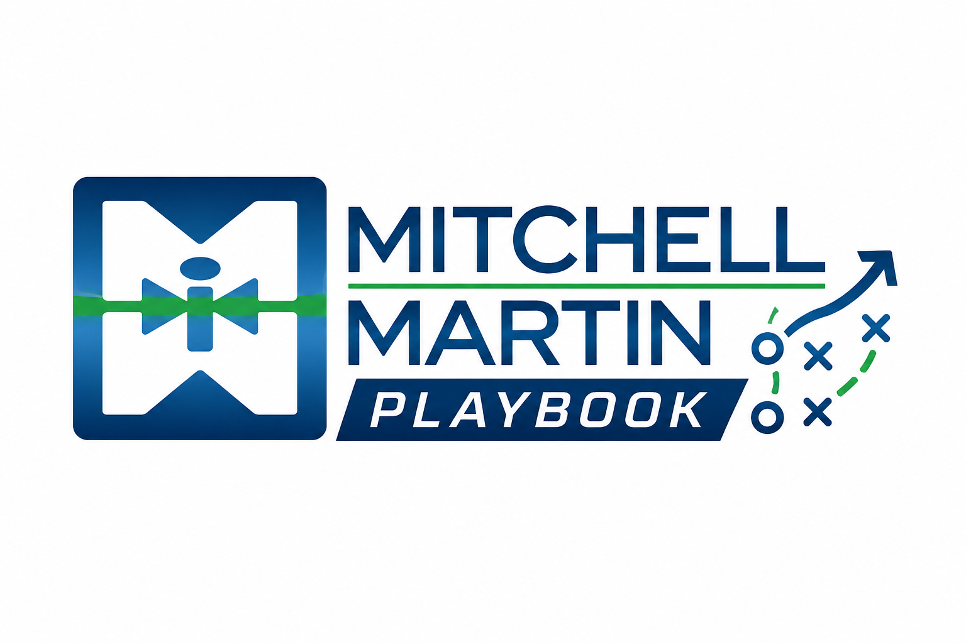
CORP Discovery Question Bank
A takeaway guide for business development calls, intro meetings, and relationship-building conversations.
C  Contact  Understand the person, role, influence, and communication style. | O  Organization  Map the business, structure, priorities, and pressure points. | R  Recruitment  Diagnose hiring process, challenges, decision path, and vendor usage. | P  Projects  Find upcoming work, skills needed, timing, and where staffing can help.
How to use this: Do not ask every question. Pick two or three from each area, listen carefully, then go deeper where the buyer gives you a signal.

C - Contact
Learn who the person is, what they own, how they are measured, and how much influence they have over staffing decisions.
Question area | Questions to ask
Role and responsibility | - Can you walk me through your role and what you are responsible for day to day?  - Which teams or functions do you support most closely?  - What decisions usually come to you versus your manager or leadership team?  - Where do hiring, delivery, or workforce issues show up in your role?  - What does a successful quarter look like for you personally?
Influence and decision path | - When a staffing need comes up, where do you usually get involved?  - Who else weighs in before a staffing partner is approved or used?  - Are you usually the person identifying the need, approving the need, or managing the work?  - Who would feel the pain first if this role or project stayed uncovered?  - What would make you comfortable introducing a partner to the right person internally?
Communication style | - What is the best way to follow up with you when something is relevant?  - Do you prefer quick calls, short emails, or scheduled touchpoints?  - What information is useful to you, and what feels like noise?  - How much detail do you like before deciding whether a conversation is worth your time?  - What would make a staffing conversation feel valuable instead of transactional?
Relationship building | - How long have you been with the organization?  - What has changed most since you joined?  - What are you focused on improving this year?  - What types of partners have been helpful to you in the past?  - What should someone understand about your team before trying to help?
Listen for | - Role authority, personal priorities, stakeholder names, preferred communication style.  - Signals that they can introduce you, influence decisions, or identify pain early.  - Language they use to describe success, pressure, risk, or frustration.

O - Organization
Map how the company operates, where pressure is building, and which departments are likely to need staffing support.
Question area | Questions to ask
Business and structure | - How is the organization structured across teams, locations, or business units?  - Which groups are growing, changing, or under the most pressure right now?  - Are decisions mostly centralized, or do departments manage hiring independently?  - How does your team interact with HR, procurement, finance, or talent acquisition?  - Where does outside staffing fit into the broader workforce strategy?
Priorities and pressure | - What are the biggest business priorities for the next six to twelve months?  - What initiatives are most important to leadership right now?  - Where is the organization feeling capacity strain?  - Are there timelines, launches, audits, go-lives, or deadlines driving urgency?  - What happens operationally if roles stay open too long?
Change signals | - Have there been recent leadership changes, reorganizations, acquisitions, or expansions?  - Are any departments adding headcount or changing how work gets delivered?  - Are you seeing more contract, contract-to-hire, or direct-hire needs lately?  - Are budget cycles affecting hiring timing?  - What has changed about hiring compared with last year?
Vendor environment | - How does the organization currently work with staffing vendors?  - Is there an MSP, VMS, preferred supplier list, or MSA process?  - What does a partner need to do to earn trust here?  - Where have vendors helped, and where have they fallen short?  - Are there compliance, pricing, or process requirements we should understand early?
Listen for | - Growth areas, business pressure, procurement process, account complexity, timing signals.  - Departments that may have repeat demand or overlooked whitespace.  - Barriers such as MSP/VMS rules, vendor limits, compliance, rate pressure, or budget timing.

R - Recruitment
Diagnose the hiring motion: what they need, why it is hard, who is involved, and where the current process breaks down.
Question area | Questions to ask
Current hiring landscape | - What does your current hiring landscape look like?  - Which roles have been hardest to fill recently?  - Where are you seeing the biggest skill gaps?  - Are openings mostly growth-related, replacement, project-based, or backfill?  - What roles are most important to fill quickly?
Process and decision path | - What does the hiring process look like from opening a role to making an offer?  - Who owns requirements, interview feedback, approvals, and final decision?  - How many interview steps are typical?  - Where does the process usually slow down?  - How quickly can the team move when the right candidate is identified?
Quality and fit | - What separates a strong candidate from an average one for your team?  - What skills are non-negotiable versus nice to have?  - What soft skills or work style traits matter most?  - What causes candidates to fail in the interview process?  - What does someone need to understand about the environment to succeed after day one?
Market and delivery friction | - Are you seeing enough qualified candidates from current channels?  - Are compensation, location, remote policy, or speed affecting candidate interest?  - How often do candidates drop out or accept competing offers?  - What feedback do candidates give about the opportunity?  - Where could a staffing partner make the biggest difference?
Partner expectations | - What does a good staffing partner do differently for your team?  - What information do you need upfront to trust a submission?  - How do you prefer to receive candidate updates?  - What would make you want to use a partner again?  - If we found the right profile, what would the next step be?
Listen for | - Hard-to-fill roles, real urgency, decision makers, process gaps, candidate fit criteria.  - Pain around speed, quality, submittal relevance, compensation, interview discipline, or competing offers.  - Clear next step: intro meeting, job order, stakeholder introduction, or follow-up with market data.

P - Projects
Find upcoming work that creates staffing demand, then connect talent strategy to timing, skills, and business impact.
Question area | Questions to ask
Upcoming initiatives | - What projects or initiatives are coming up that may require additional talent?  - Are there implementations, upgrades, migrations, audits, launches, or transformations planned?  - Which projects are highest priority for leadership?  - What work is currently at risk because of capacity or skill gaps?  - Where do you expect workload to increase over the next quarter?
Skills and team needs | - What skills will be required to deliver the project successfully?  - Are those skills already on the team, or will you need outside support?  - Do you need individual contributors, team leads, project managers, or niche specialists?  - What experience would make someone productive quickly?  - Are certifications, domain experience, systems knowledge, or compliance requirements important?
Timing and urgency | - What is the target start date or deadline?  - What milestones could be affected if the right people are not in place?  - When would you need to see candidates to stay on track?  - How long can the team operate without this support?  - What would trigger a decision to bring in contract help?
Budget and approval | - Is budget already allocated, or would approval be needed?  - Who approves outside project support?  - Is the work better suited for contract, contract-to-hire, direct hire, or a project team?  - Are there rate, tenure, location, or compliance constraints?  - What information would help leadership approve support faster?
Expansion opportunity | - If we helped on this project, where else could similar support be useful?  - Are other teams facing the same skill or capacity challenge?  - Who else is responsible for related initiatives?  - Would it be useful to compare the market for these skills before the project ramps up?  - What would a successful partnership look like by the end of the project?
Listen for | - Project timing, business consequence, skills needed, budget state, approval path.  - Signals for contract demand, specialist needs, team augmentation, or repeat project work.  - Opportunities to introduce market intelligence, talent availability, or a scoped follow-up meeting.

Quick call flow
Open  State who you are, why you are calling, and ask permission for one question. | Diagnose  Use CORP to understand person, company, hiring motion, and project pressure. | Connect  Tie MMI value to the specific pain or opportunity they shared. | Advance  Secure a next step with owner, date, purpose, and useful follow-up.

Notes from the conversation
Contact
Organization
Recruitment
Projects
Pain / trigger
Next step

