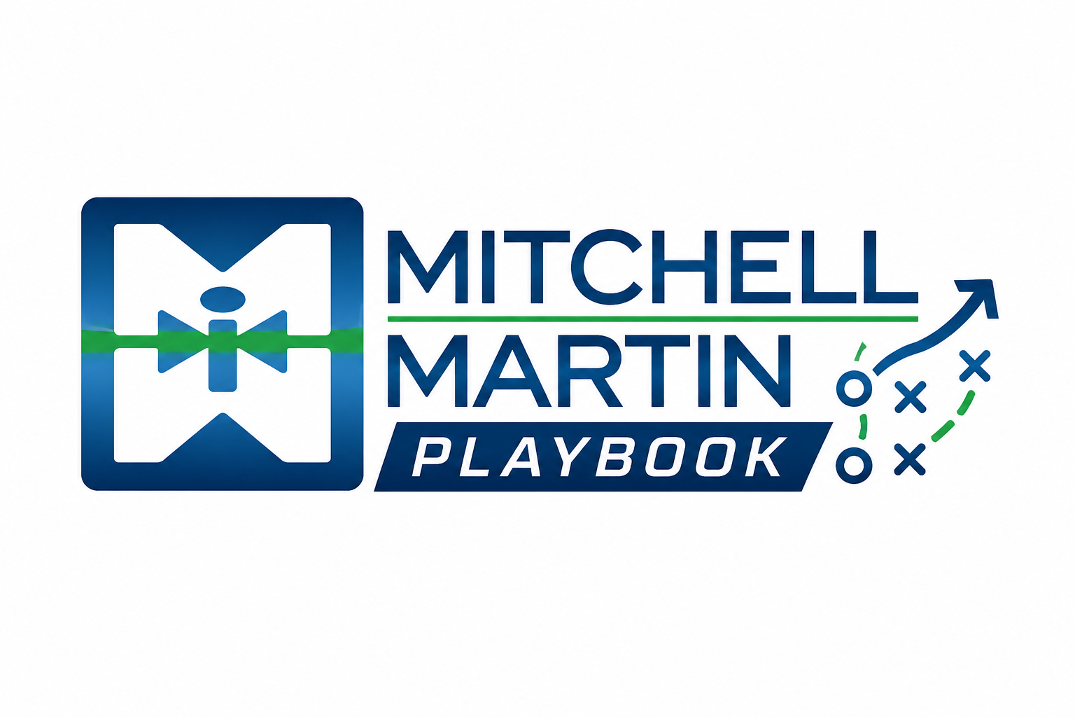
MMI Closeout Checklist
Interview debrief, onboarding, and assignment record steps.

Interview debrief
- What did the client like?
- What concerns remain?
- Who else is involved in the decision?
- What is the next step and date?
- What can delivery adjust before the next submittal?

Before onboarding
- Confirm the JobDiva job title mirrors the consultant contract.
- Confirm location is the correct work location.
- Confirm the contact is the correct manager.
- Confirm remote, onsite, or hybrid status is accurate.
- Recruiting confirms/corrects candidate information before onboarding starts.

Assignment record flow
- Sales completes the bill side after receiving the JobDiva start-record notification.
- Recruiting completes the pay side after receiving notice that the bill side is complete.
- Direct placements go to the Invoice Placement tab.
- Send new deals to itonboarding@itmmi.com or hconboarding@hcmmi.com.
- If CDM is involved, send to CDM first.

3rd parties and ICs
- For a 3rd party, first add the company in JobDiva and classify it as a 3rd Party.
- On the pay side for a 3rd party, classify employment category as subcontract, add corp name, and enter the TaxID.
- For an independent contractor, classify employment category as independent contractor, add the IC's name under corp, and enter the TaxID.

After start
Send assignment record changes, extensions, and rate changes to support@itmmi.com. For untraditional deals, reach out to Jordan before guessing the workflow.

