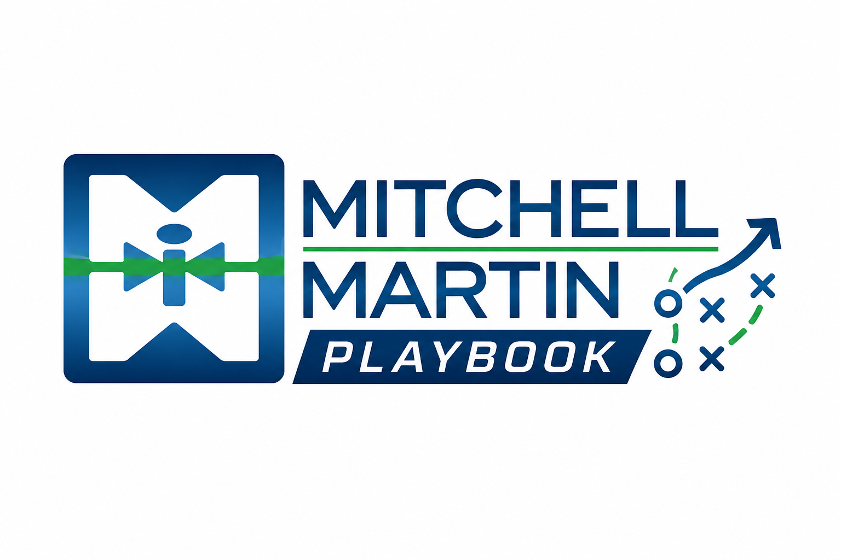
MMI First Deal Checklist
Assignment Record and Invoice Placement first-deal path.

First deal steps
- Confirm deal type: contract, contract-to-perm, direct placement, subcontract, or independent contractor.
- For contract starts, confirm the JobDiva job record, candidate details, start date, work location, manager, remote status, and assignment record details.
- Sales completes the bill side when the start record notification arrives; recruiting completes the pay side after bill-side completion.
- For permanent placements, use Invoice Placement instructions with salary, fee, start date, client approval, and invoice details.
- Route onboarding cleanly and send later assignment record changes, extensions, or rate changes to support@itmmi.com.

