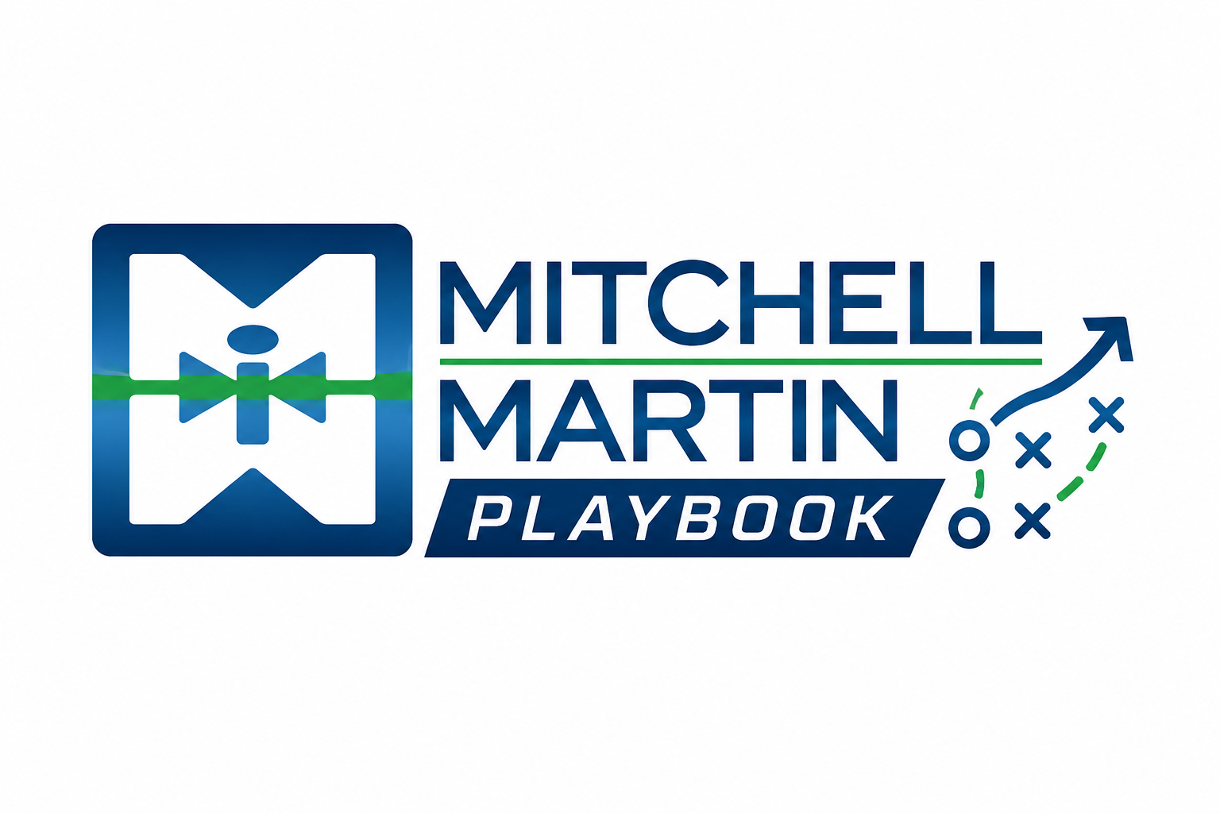
MMI Foundation Notes
Company story, positioning, values, and talk tracks.

Core story
Mitchell Martin is a people-first, employee-owned staffing and talent solutions company founded in 1984. The sales story should connect relationships, specialized recruiting expertise, market context, and smart technology.

Positioning
We help organizations build capable teams by combining human insight, long-term candidate relationships, disciplined delivery, and technology-supported staffing workflows.

Proof points
- Founded by Eugene Holtzman in 1984
- Employee-owned company
- Teams across the United States, India, and the Philippines
- Specialized support across IT, healthcare, healthcare IT, and professional services

Shared values
- People first, always
- Act like an owner
- Stay hungry, stay human
- Move with purpose
- Stronger together
Talk track
Mitchell Martin helps organizations build capable teams by combining specialized recruiting expertise, long-term candidate relationships, market context, and technology-supported delivery. We look beyond keyword matching to qualify for the role, environment, manager expectations, schedule, compliance needs, and what will make the person successful after day one.

