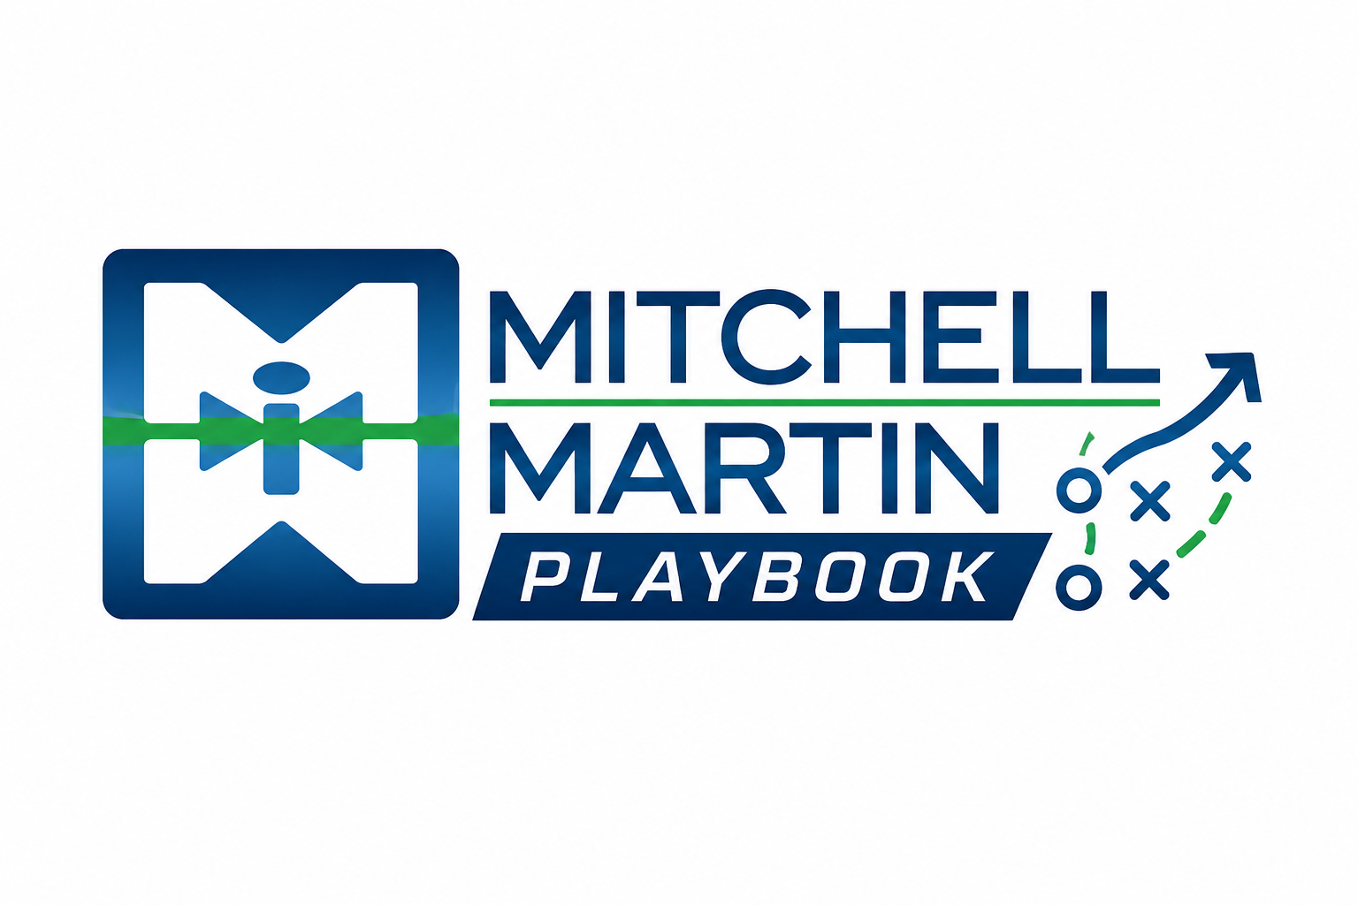
MMI Market Intel Call Prep
Use data to sharpen staffing conversations.

Bring evidence
Bring hiring trends, compensation benchmarks, skill availability, time-to-fill, and interview-to-offer data into the sales conversation.

Frame the pressure
Frame the market around the buyer's pressure: speed, quality, cost, risk, or continuity.

