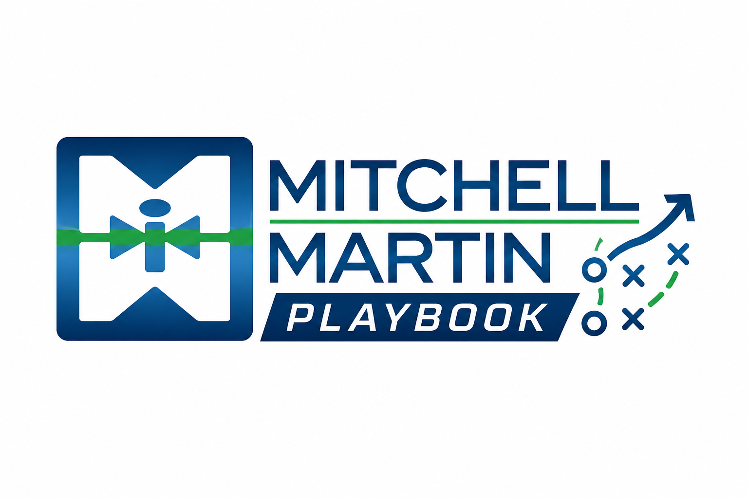
MMI Meeting Checklist
Preparation, conversation, and follow-up checklist.

Before
Research buyer, business pressure, market signals, likely roles, and proof points.

During
Diagnose pain, urgency, process, decision path, and success criteria.

After
Recap, assign next steps, align delivery, and document the opportunity.

Cold call / voicemail structure
- Who you are.
- Where you are calling from.
- What you specialize in.
- The reason you are calling.
- Open question.

Qualified job order intake
- Why is the position open, and how is the work currently being done?
- Confirm remote, hybrid, onsite, immigration, work hours, shift, start date, duration, project description, and job duties.
- Capture skills, years of experience, education, certifications, environment, soft skills, culture, and top three requirements.
- Confirm bill rate, salary if C2H or full-time, follow-up day/time, exclusivity ask, interview time blocks, and interview process.
- Route contract roles to jobqueue.contract@itmmi.com and full-time roles to jobqueue.perm@itmmi.com.

