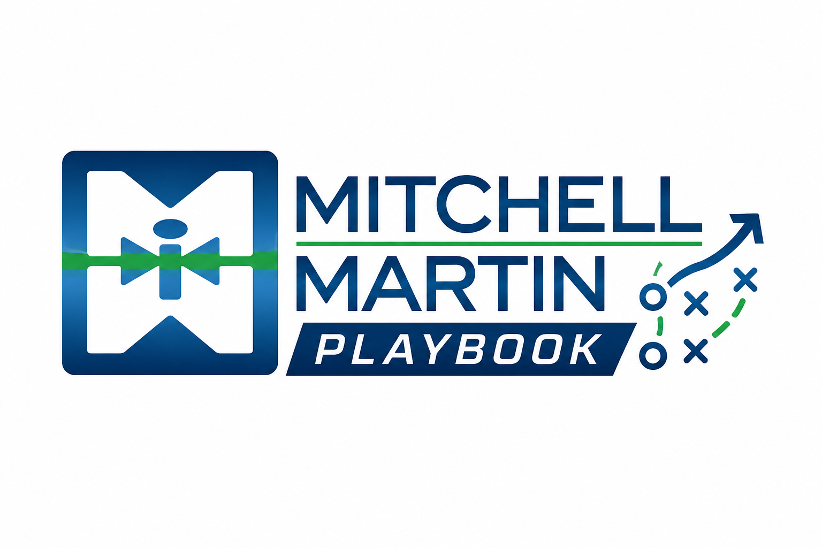
MMI Networking Referral Prompts
Warm-path questions for networking and referrals.

Referral prompts
- Who in your network is hiring, expanding, transforming, or frustrated with hiring velocity?
- Who recently changed roles and may be rebuilding a team?
- Which candidate, consultant, or client relationship can create a warm path?

