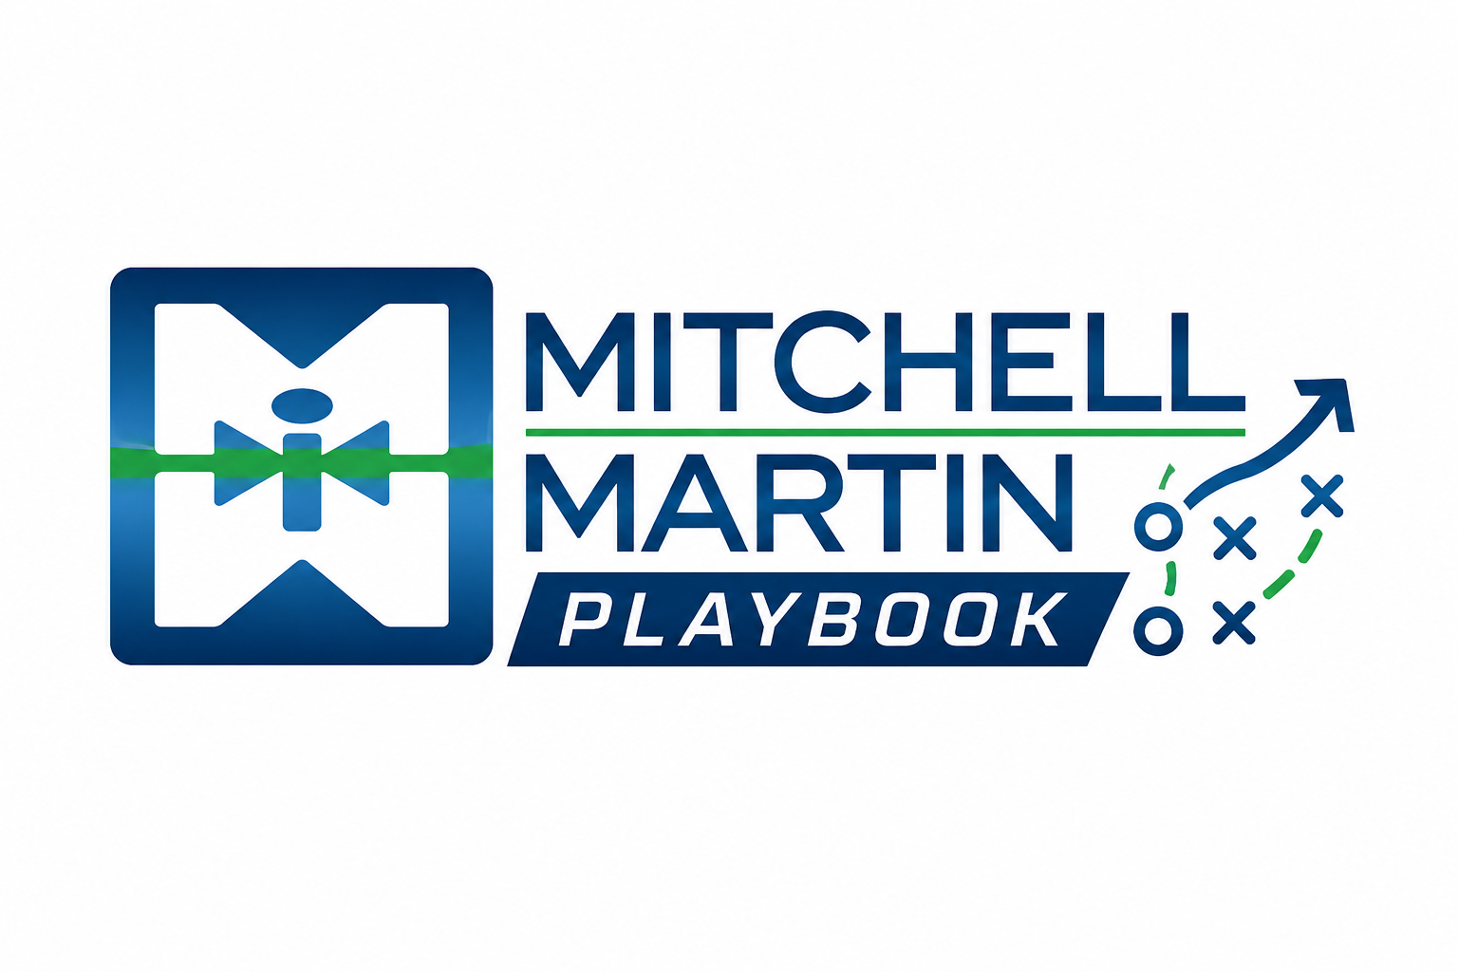
MMI Objection Handling Guide
Ask, acknowledge, reframe, and advance common buyer pushback.

Resolution model
- Ask: Clarify what is really behind the objection before responding.
- Acknowledge: Show you heard the concern without sounding defensive.
- Reframe: Connect MMI to a gap, niche, benchmark, speed issue, or risk the buyer already has.
- Advance: Earn the next step: a name, a meeting, a role, a follow-up date, or a test search.

Common objections
- Approved vendor / vendor list: Ask how vendors get added and whether niche partners are used for hard-to-fill roles.
- MSP / VMS program: Respect the program, then learn the tool, program owner, review cycle, and delivery gaps.
- HR owns all hiring: Work with HR and confirm the manager's role in defining must-haves.
- Fees, rates, or price is too high: Shift from price to vacancy cost, market reality, speed, and quality.
- Happy with current vendors: Look for gaps around niche roles, time-to-fill, quality, or urgency.
- Too busy / send me information: Ask what information would be useful and set a follow-up.
- No needs / budget not approved: Learn planning cycles, upcoming initiatives, likely skill needs, and reconnect timing.

