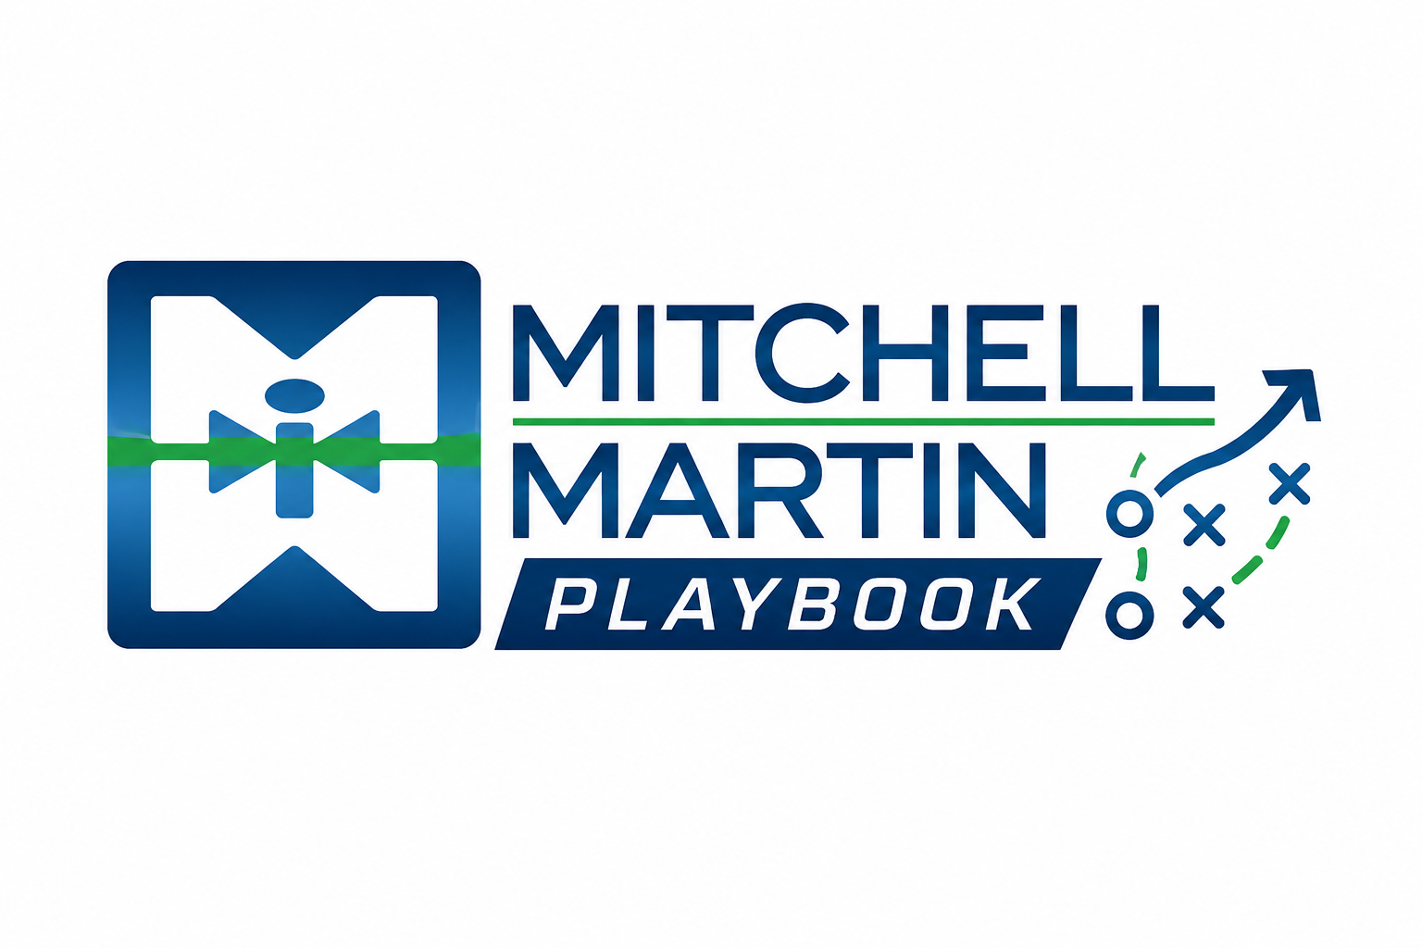
MMI Pitch Talk Tracks
Concise talk tracks for risk, speed, and cost conversations.

Risk
We reduce uncertainty by validating talent before it reaches your team, then using AI-supported insight to keep hiring and execution decisions sharper.

Speed
The value is not just more resumes. It is proven, ready-to-perform talent delivered quickly enough to protect project timelines and operating plans.

Cost
We help leaders move work into the right operating model without trading away quality, compliance, or manager confidence.

