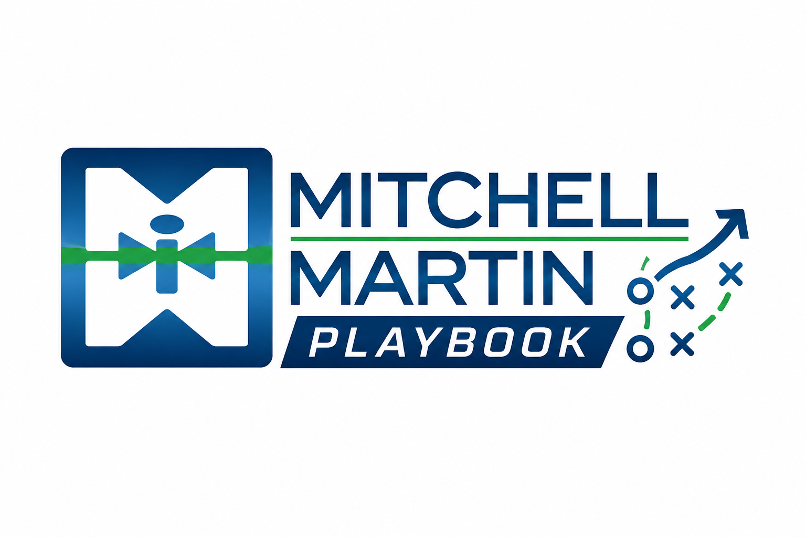
MMI Proof of Partnerships
Proof points for strategic partnership conversations.

Strategic partner, not transactional staffing provider
In partnership with a major investment bank, MMI helped validate and de-risk a long-term staffing strategy under intense regulatory pressure and cost constraints.

Results
- 50%+ interview progression rate vs. 10% internal success rate
- 105 total placements
- 80 converted to full-time employees
- Resume delivery in under one week

