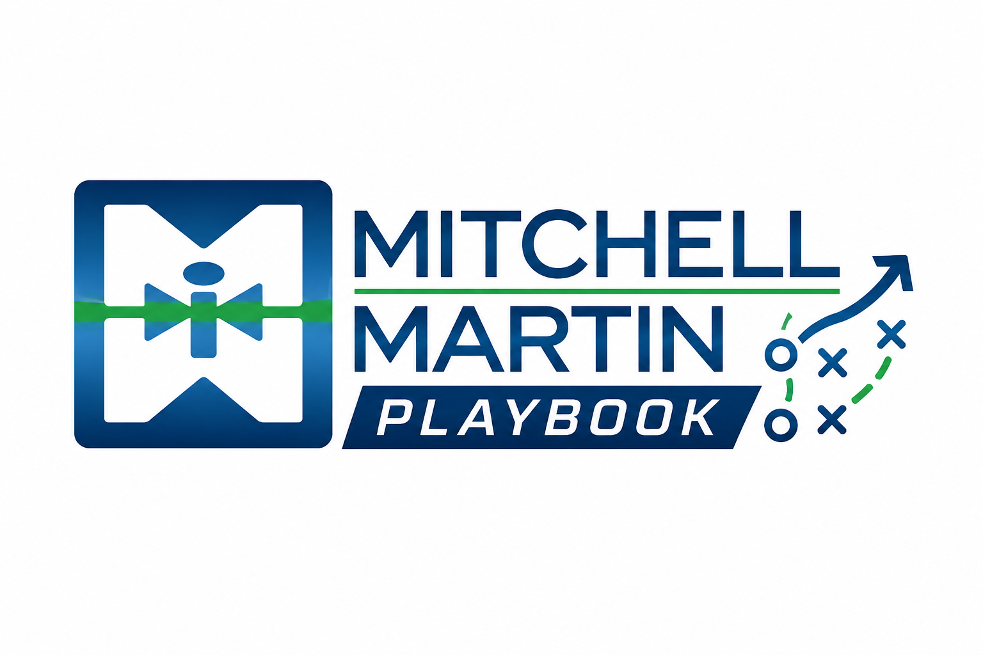
MMI Prospecting Prompts
Signals and weekly motion prompts for pipeline creation.

Signals to check
- Referrals
- Candidates
- Consultants
- Current clients
- New executives
- News
- Job boards
- MSA accounts

Weekly motion
Combine warm network moves, market triggers, data-backed campaigns, and disciplined call blocks.

