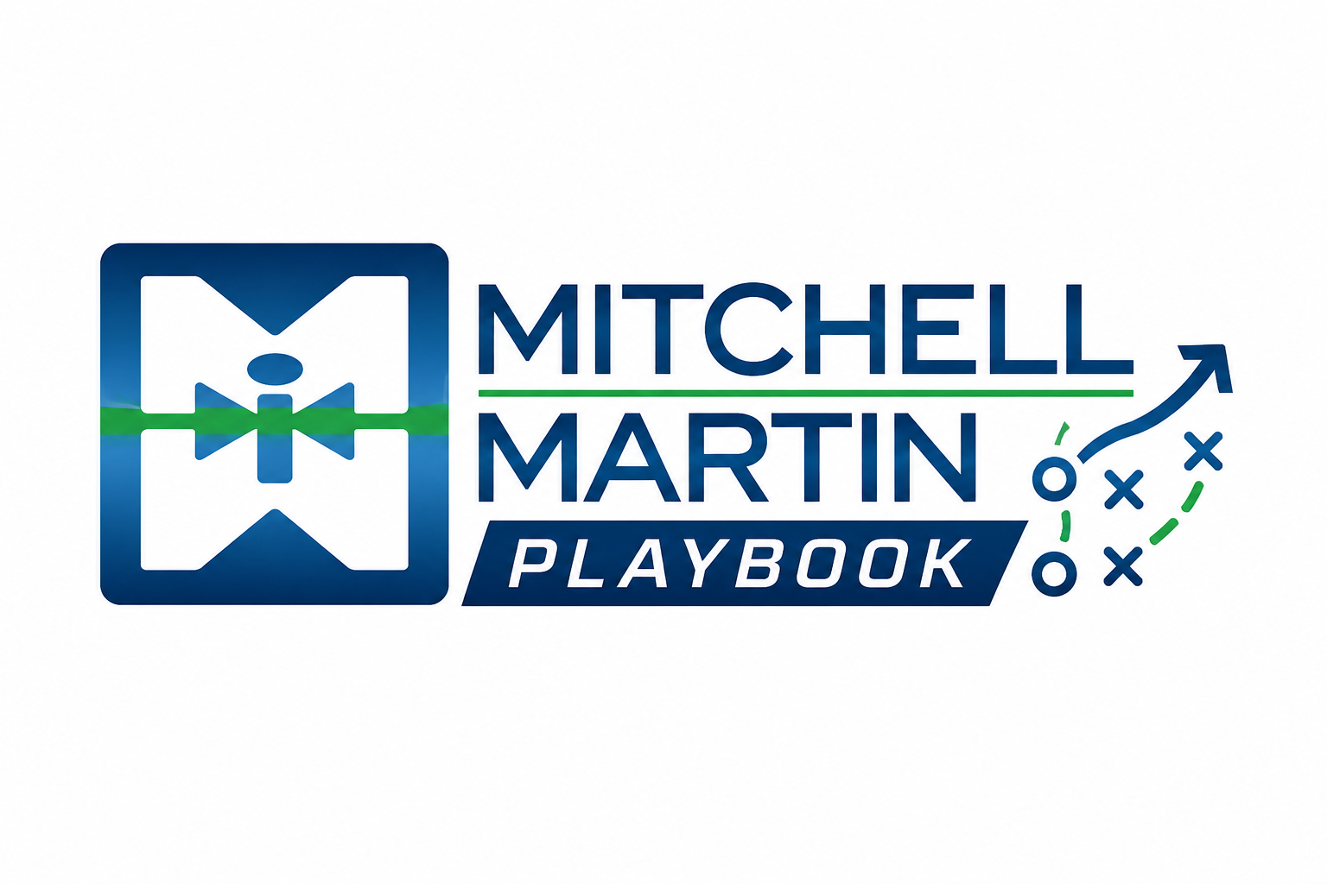
Submittal Template
Hi (Account Executive),
Attached is the resume of (Candidate Name) for the (Role) at (Company). His/her qualifications include:

- Excellent experience as a (Job Title) for (Industry or Style of Company) Ex- major Fortune 500 companies
- Extensive experience (Actionable Responsibility for MUST have)
- Strong experience and knowledge with (Must for the Job)
- Extensive experience ((Actionable Responsibility for MUST have)
- Strong experience ((Actionable Responsibility for MUST have)
- Extensive experience (Actionable Responsibility for MUST have)
- IF CERTIFICATIONS LIST or education desired- EX- AWS Certified Solutions Architect and Docker Certified
- Excellent communication skills and available to interview immediately

NOTES:
- Visa Status:
- Location (open to Remote or open to hybrid, onsite?):
- Desired Base:
- Desired Hourly Pay Rate:
- Reason Leaving:
- Reason for Gaps:
- *If any short-term stints* Reason for Short-Term stints(Specify on each- the why)
- Interview Availability:
- Interview Activity:
- When Candidate Can Start: (Ex- 2 weeks notice)
- LinkedIn Profile ( Include URL from LinkedIn)

(Include this if Grade A Candidate)
Grade A Candidate Checklist:

MUST HAVES:

•Formatted resume that fits the job
•Tailored SOP Pitch to the role
•Salary or rate within range of bill or salary

Include all that apply- (minimum 3 needed):
•SOP Verified References collected
Include actual references Here
•Former MMI Consultant or perm placement
•Met with or video interview
•Ropes tested with good – great score

