Project Management

**Tasks – Story Points Actual Hours**

Learn more CSS, PHP, SQL and html – 8 ✓ 10

Create/design webpage(s) – 2 ✓ 5

Learn how to use a database – 5 ✓ 5

Implement username/password login – 5 ✓ 3

Implement user comment box – 2 ✓ 1

~~Add spam filter – 2~~

~~Add password salting - 4~~

Learn how to save information for running totals of polls - 3 ✓ 2

Learn how to properly store poll information – 2 ✓ 2

Update UI - 3 ✓ 5

Implement votes table for vote verification - 3 ✓ 2

Organization

Coding:

JJ – 30%

Mitch – 40%

Trevor – 30%

Documentation:

JJ – 20%

Mitch – 50%

Trevor – 30%

Testing:

JJ – 50%

Mitch – 30%

Trevor – 20%

Testing

The purpose of this application is to provide testing of database checking, insertion, and retrieval for C346 website project.   
  
Functionalities to be tested include:  
- Creating user accounts  
- Creating new polls  
- Voting  
- Poll retrieval  
  
  
--------------------------------------------------Testing Account Creation---------------------------------------------------  
Creating 10 new user accounts with the password "password"...  
  
New account created successfully.   
username = user0, password = password, email = ""   
  
New account created successfully.   
username = user1, password = password, email = ""   
  
New account created successfully.   
username = user2, password = password, email = ""   
  
New account created successfully.   
username = user3, password = password, email = ""   
  
New account created successfully.   
username = user4, password = password, email = ""   
  
New account created successfully.   
username = user5, password = password, email = ""   
  
New account created successfully.   
username = user6, password = password, email = ""   
  
New account created successfully.   
username = user7, password = password, email = ""   
  
New account created successfully.   
username = user8, password = password, email = ""   
  
New account created successfully.   
username = user9, password = password, email = ""   
  
  
  
Creating 3 new user accounts with existing usernames...   
  
Error: Username user0 already taken.   
Error: Username user1 already taken.   
Error: Username user2 already taken.   
----------------------------------------------------------------------------------------------------------------------------------  
  
--------------------------------------------------Testing Poll Creation------------------------------------------------------  
Note: Tests that text fields are completed.  
  
With all fields completed:   
New poll created successfully.  
Title = title, author = author, Option 1 = option 1, Option 2 = option 2  
  
With Title absent:  
Error: Missing required field(s).  
  
With Option 1 absent:  
Error: Missing required field(s).  
  
With Option 2 absent:  
Error: Missing required field(s).  
  
With Author absent:  
Error: Missing required field(s).  
----------------------------------------------------------------------------------------------------------------------------------  
  
--------------------------------------------------Testing Voting--------------------------------------------------------------  
User votes on option 1 of a poll...  
Voted successfully  
  
User votes on option 2 of the same poll...  
User already voted  
  
New user votes on option 1 of a poll...  
Voted successfully  
  
Previous user votes on option 2 of the same poll...  
User already voted  
----------------------------------------------------------------------------------------------------------------------------------  
  
--------------------------------------------------Testing Poll retrieval from database-------------------------------------  
Traversing "users" table in database and pulling data to display username and id...  
  
username = user0 id = 57  
username = user1 id = 58  
username = user2 id = 59  
username = user3 id = 60  
username = user4 id = 61  
username = user5 id = 62  
username = user6 id = 63  
username = user7 id = 64  
username = user8 id = 65  
username = user9 id = 66  
  
Table "users" currently holds 10 users.  
----------------------------------------------------------------------------------------------------------------------------------

Manual Testing

(create_account.php) – Testing for functionality of submitting new username and password to database

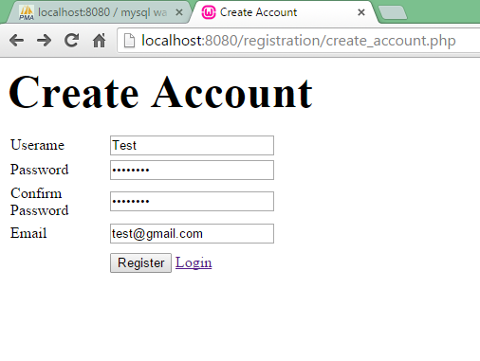

(MySQL server after submitting)

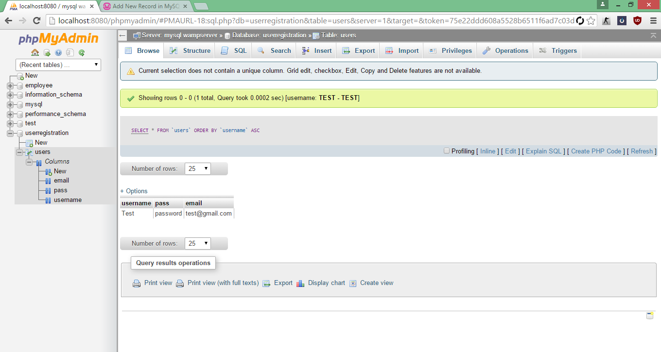

(create_account.php) – Testing for new account using already taken username

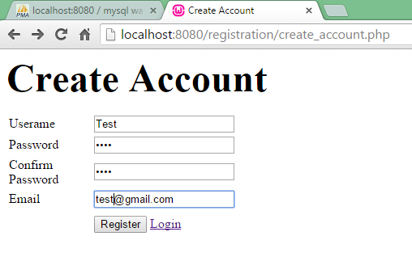

After submission:

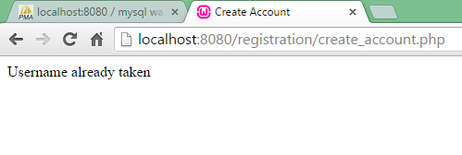

(create_account.php) – Testing for non-matching passwords

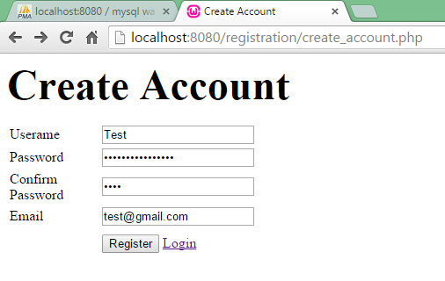

After submission:

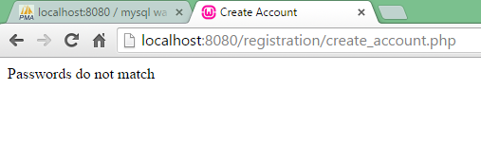

We will add tests in PHP code for legitimate email format and that the email has not already been registered.

(index.php) – login page

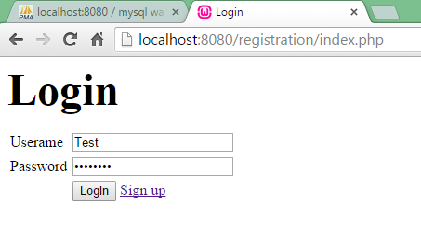

After submission (correct username and password):

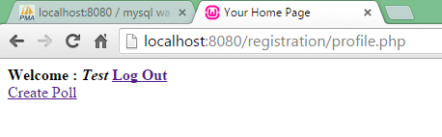

A proper login redirects to the user’s profile where they can logout or create a poll.

(index.php) – Testing improper login (incorrect username):

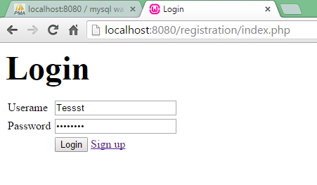

After submission:

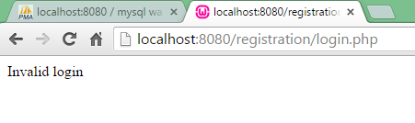

(index.php) – Testing improper login (incorrect password):

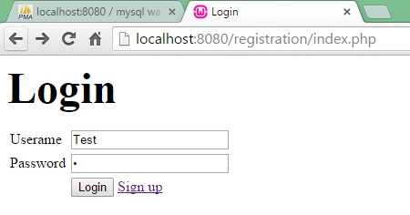

After submission:

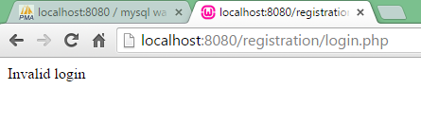

(profile.php) – Testing logout



After logout, user is redirected to the login page:

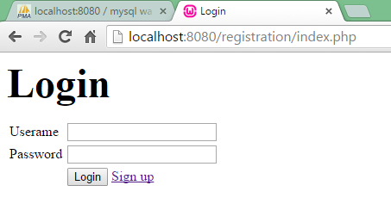

(create_poll.php and other pages that require a user to be logged in) – Testing the functionality of PHP sessions to redirect users away from content that requires a user to be logged in. Here, I manually type the url for create_poll.php. After trying to access it, without being logged in, I am redirected to the login page.

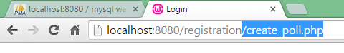

After submission:

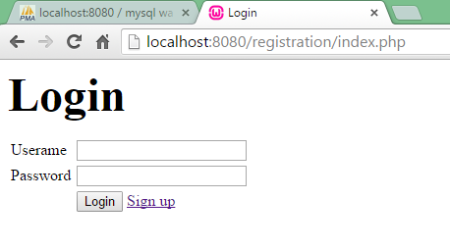

(create_poll.php) – Testing the functionality of creating a poll

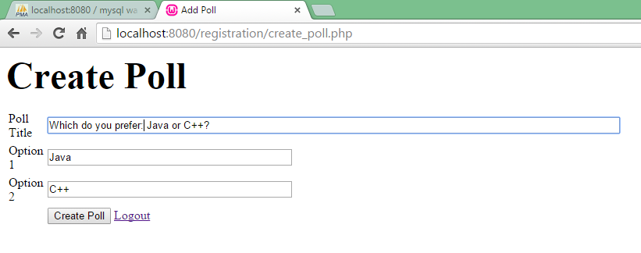

Webpage after submission:

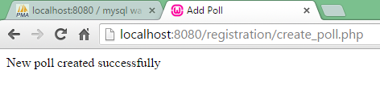

MySQL database after submission:

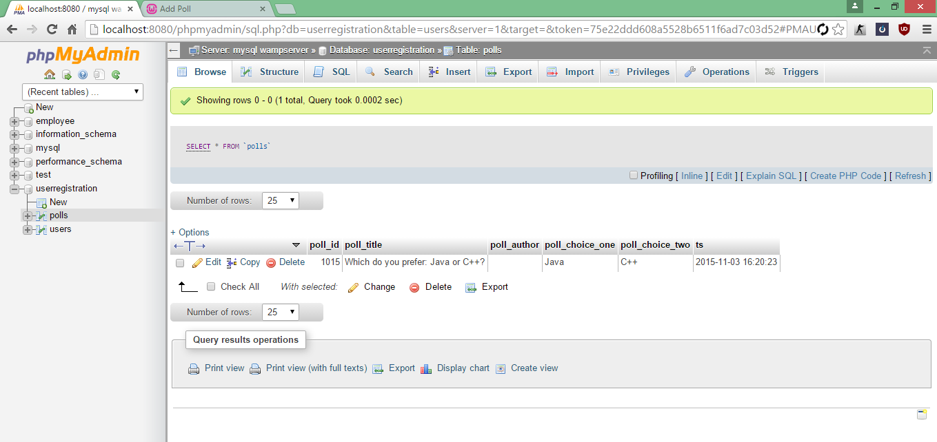

We will change the various plain echo statements that say “New poll created successfully” to instead redirect the user to another page.