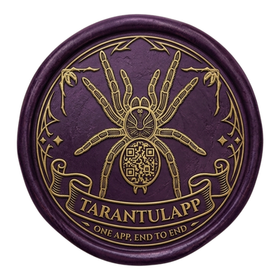

TarantulApp — specimen QR codes
Codes link to each specimen’s public card. In Word: File → Print.
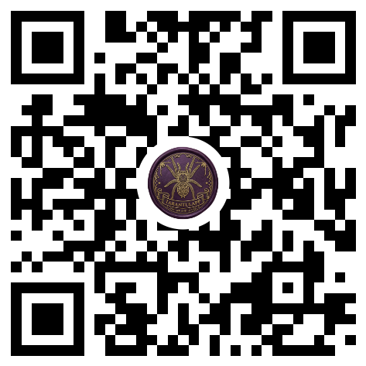  Prueba baboon  Pterinochilus murinus  ID: a814a03c | 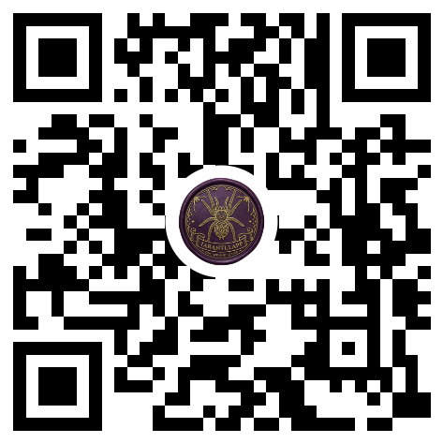  Prueba Goliath  Theraphosa blondi  ID: 596eb310
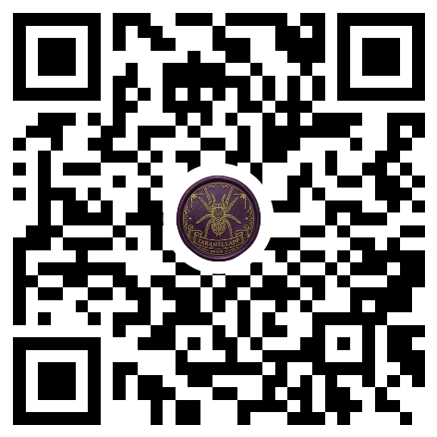  Prueba fossorial  Cyriopagopus lividus  ID: 53a2f6d3 | 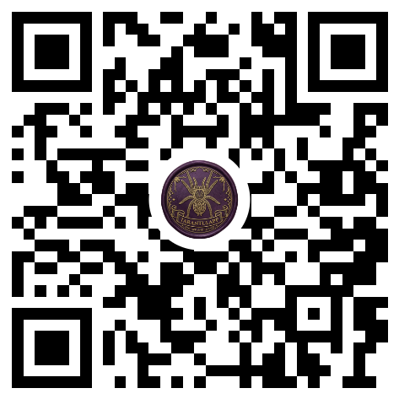  Arborea  Caribena versicolor  ID: d657670c
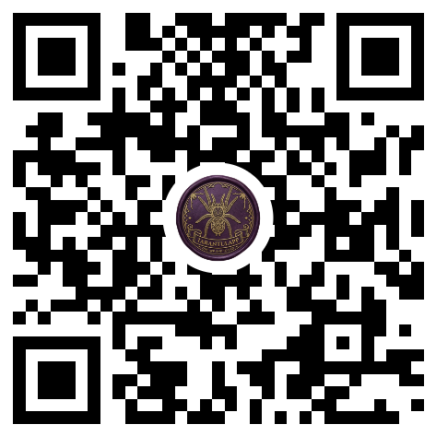  Nuevo  Chromatopelma cyaneopubescens  ID: 6b2ef62a | 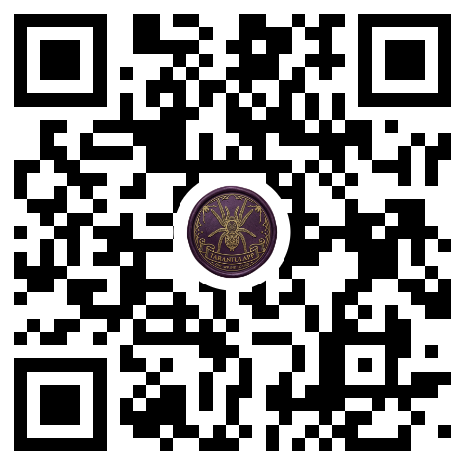  Emilia  Brachypelma emilia  ID: 7d157568
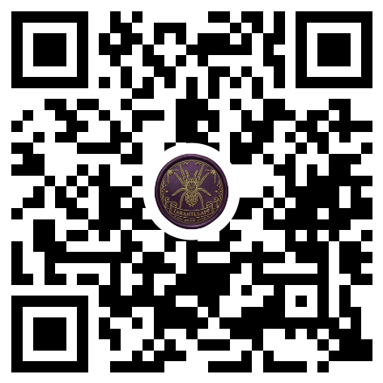  Lamoose  Tliltocatl albopilosus  ID: 5af60478 | 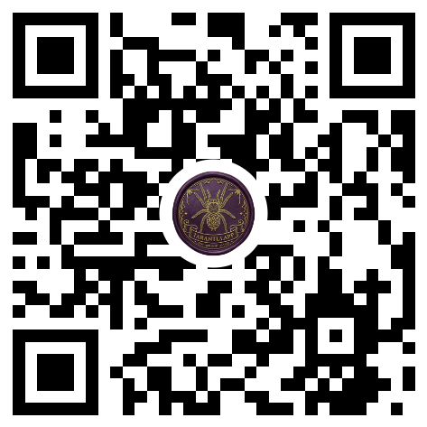  Alf  Tliltocatl albopilosus  ID: 655be795
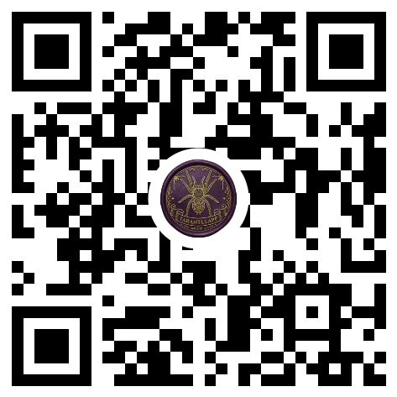  Honami  Brachypelma hamorii  ID: 051d3876 | 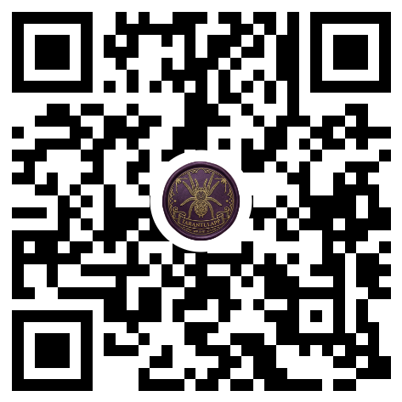  Marti  Acanthoscurria geniculata  ID: 4b13a523
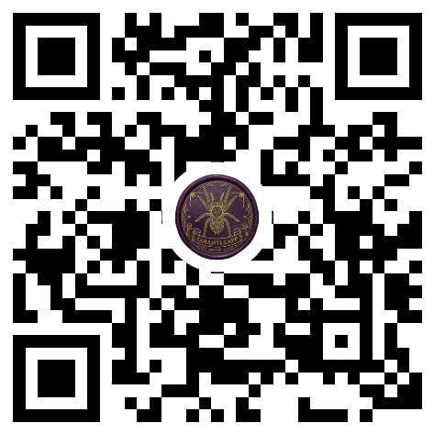  Beetlejuice  Acanthoscurria geniculata  ID: 36b53ae8 | 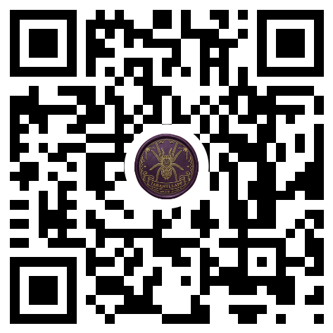  Morgan  Tliltocatl kahlenbergi  ID: 969cdde5
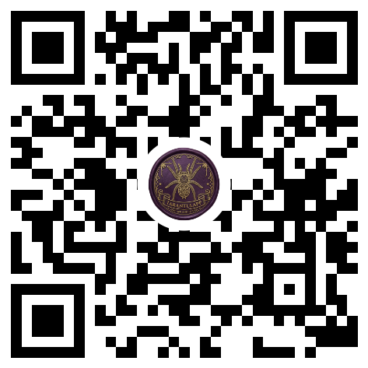  Ferdinand  Grammostola pulchripes  ID: 3db499f6 | 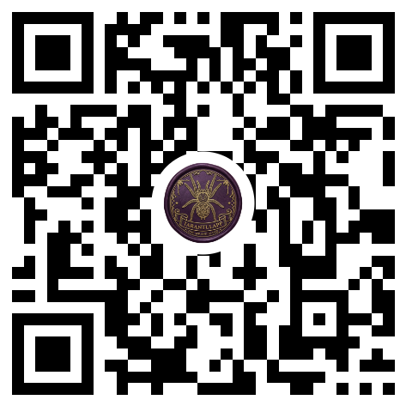  Hulk  Tliltocatl verdezi  ID: 3a508941
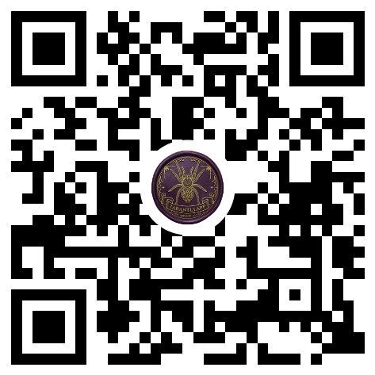  Spider-Man  Tliltocatl albopilosus  ID: caa92629 | 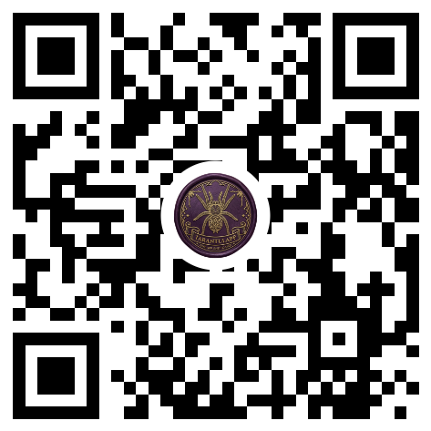  Chiquilín  Tliltocatl albopilosus  ID: 9417ee35
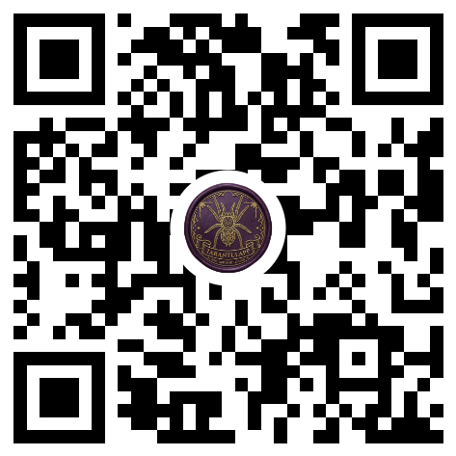  Maximus  Tliltocatl vagans  ID: 1518003a | 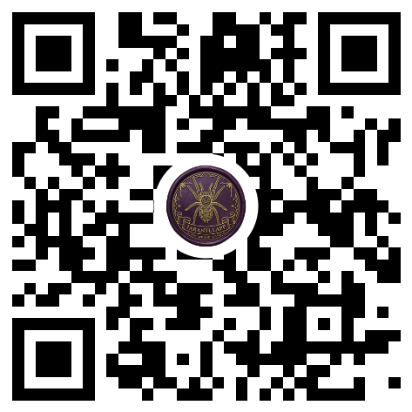  Aragog  Brachypelma auratum  ID: 0f662962
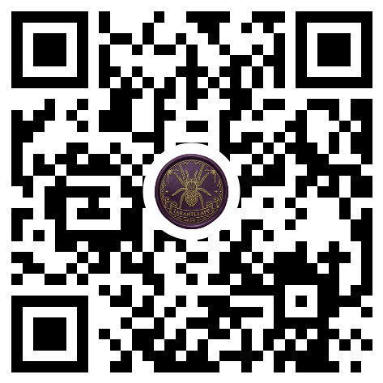
Sully
Lasiodora parahybana
ID: 44a1639e

