Chapter 10

Internet Protocols Part II and MPLS

Outline

- Domain Name System (DNS)
- Dynamic Host Configuration Protocol (DHCP)
- HTTP (Hypertext Transfer Protocol)
- Internet Control Message Protocol (ICMP)
- Routing
- Network Diagnostic Commands
- Multi-protocol Label Switching (MPLS)
- IP Multicast
- Internet Group Management Protocol—IGMP
- Socket Programming

Objectives

After completing this chapter, you should be able to:

- Explain the application of DNS.
- List DNS operations.
- List top level DNS domains.
- Define the components of DHCP.
- Explain the operation of DHCP.
- Explain the operation of HTTP.
- Define the types of HTTP packets.
- Explain Internet Control Message Protocol (ICMP).
- List several routing protocols.
- Explain link characteristics.
- List network diagnostic commands.
- Explain the operation of MPLS.
- List the applications of IP Multicasting.
- Able to write simple socket program.

10.1 Domain Name System (DNS)

Introduction
Memorizing a word is much easier than memorizing a long number, such as seen when trying to remember the word “Yahoo” vs. the number “67.195.160.76”. Therefore, computer hostnames are frequently represented by a word rather than an IP address. In order for a client computer to access a web site, send an E-mail, or connect to another computer through the Internet, the client computer must have the IP address of the destination, but this may not be known to the user. To accomplish this, the client computer uses DNS to obtain resolve a known hostname to the IP address of the host. The RFC 881, 882, and 883, which have been published by IETF, explain DNS operation.

DNS is a distributed database containing information about domain names and their corresponding IP addresses. DNS uses a tree hierarchy which consists of a root and TLDs (Top Level Domains). The TLD defines the type of organization, such as “edu”, which represents an educational organization. Top Level Domain names can be categorized as shown in Figure 10.1.

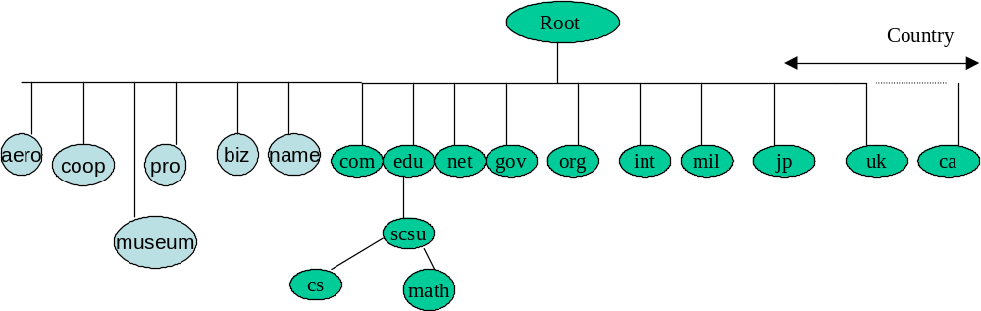
TLD

Figure 10.1: DNS Top Level Domain Names

aero Air transport industry museum for museums
edu Educational sites mil Military
gov Government sites org Organization (non-profit organization)
com Commercial sites int International Organization
net Major Network Providers biz for businesses
coop cooperatives name use for individual

A two-letter abbreviation is used for a particular country such as “uk” for United Kingdom and “fr” for France.

An organization must register its sub-domain name with the Internet Assigned Number Authority (IANA). For instance, southernct.edu is registered by IANA and must be a unique name in its domain. Southern must also specify two DNS servers: primary and secondary, which hold the hosts’ names and corresponding IP addresses.

DNS Root Servers

There are 13 root DNS servers, and they support both IPv4 and IPv6; the website https://www.iana.org/domains/root/servers shows information about DNS root servers.

DNS Names
DNS names use a fully qualified domain name (FQDN). A FQDN is a DNS domain name made of its location on the TLD separated by “.”, such as cs.southernct.edu.
DNS Operation

The function of DNS is to convert the host name to the IP address much like a phone directory converts a name to a phone number. In order for a client computer to access the yahoo.com web site, the client must have the IP address of the Yahoo server. The client must send a query to the DNS server and request the IP address of Yahoo. There are two methods that can be used by a client to request an IP address. These methods are DNS recursive queries and DNS iterative queries. By default, DNS uses iterative queries.

A. DNS Iterative Query

The client computer at southern requests connection to yahoo.com. The client computer requires the IP address of yahoo.com’s server. The following steps describe the iterative query that allows the client to obtain the IP address of yahoo as shown in Figure 10.2

- The client sends a query to the southernct.edu DNS server (ns1.southernct.edu) to resolve the name to an IP address. If Southern’s DNS server resolves the client request, then it will send the IP address of yahoo’s server to the client. If Southern’s sever does not have IP address for yahoo, the process goes to step 2.

- Southern’s DNS server sends a request to the Root DNS server, requesting the IP address of yahoo.

- The Root server sees that the requested information (FDQN) name has a TLD with .com. It sends the IP address of one of the .com servers that has the IP address of Yahoo’s DNS server to Southern’s DNS.

- Southern’s server sends the request to the .com TLD server to resolve the name to an IP address.

- The .com TLD server responds with the IP address of yahoo’s DNS server.

- Southern’s DNS server sends a request to the DNS server of yahoo (authoritative) for the IP address.

- The Yahoo DNS server resolves the request and transmits the IP address to Southern’s Server.

- Southern’s server transmits the IP address to the client.

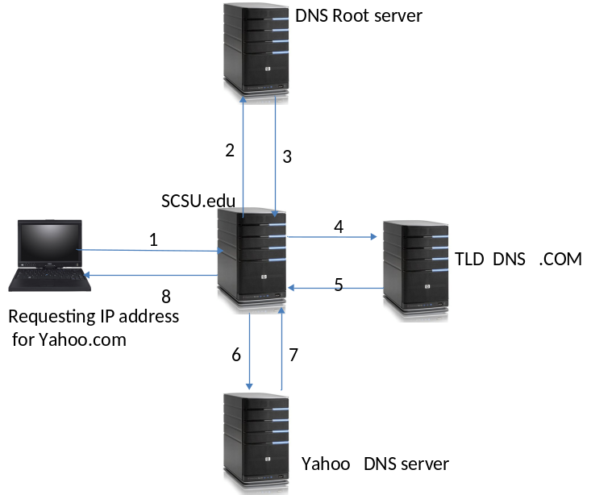

Figure 10.2: Iterative DNS Query

B. Recursive Query Operation

In a recursive query, the root DNS obtains the IP address requested by the client and sends it to the client as shown in Figure 10.3.
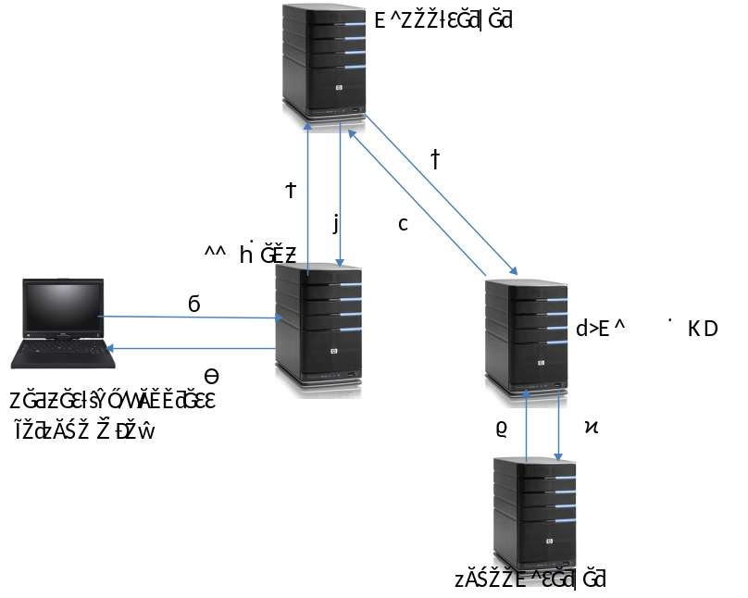

Figure 10.3: Recursive Query Operation

Primary and Secondary Domain Name Servers

The function of secondary DNS server is to provide back up for primary DNS server. If the primary server goes down, then clients of an organization cannot resolve the host name to the IP address without having a backup server. A primary domain name server holds the Zone files (Resource Records) used for resolving host names to IP addresses.

Zones and Zone Files
Zones

A zone is a part of domain name system that contains Resource Records and is managed by an administrator. Figure 10.4 shows one of Southern’s DNS zones. The southernct.edu can have one zone which include all sub-domains, or split each sub-domain into separate zones or across DNS servers.
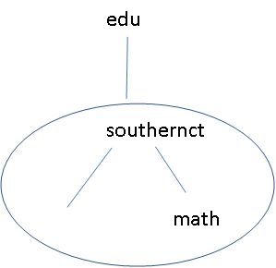

CS

Figure 10.4: SouthernCT DNS Zone
Zone file
The Zone file holds Resource Records (information about domain names and their corresponding IP addresses). This file is transferred to the secondary server using TCP connection.
Resolver
A resolver is a program that runs on a client for generating query messages from the server, and the same program runs on a DNS server for responding to DNS queries.

C. DNS Packet Format

DNS uses the UDP protocol for transmitting query packets and receiving query responses. Figure 10.5 shows the DNS packet format.
Identification
Flags
Number of Questions
Number of answer RRs
Number of Authority
Number of additional RRs
Questions (Name, Type)
Answers (Resource Record)
Authority
Additional Information
0
31

Figure 10.5: DNS packet format

Identification (16 bits): The identification field is used to identify the packet, and it is generated by the device transmitting the query packet. The response packet uses the same identification number as the query packet.

Flags: The flag field is 16 bits, and contains the following flags:
QR
Operation Code
AA
TC
RD
RA
Reserved
Response code
1 4 1 1 1 1 3 4

QR (Query/Response): QR =0 means that a packet is query packet, and QR=1 indicates the packet is a response to a query.

Operation Code: The operation code defines the type of query message, and can be the following:

Operation Code Description

0 Standard query

1 Reverse query

2 Request server status

3 Reserved

4 Primary server informing the secondary server that data for a zone has changed

AA (Authoritative Answer Flag): This bit is set to 1 in a response to indicate that the server that created the response is authoritative for the zone. If it is 0, that means that the response is from a non-authoritative source.

TC (truncated): This flag set to 1 means that the message was truncated, while 0 indicates otherwise.

RD: RD=1 means that the client has requested a recursion method.

RA: This flag is used as response to RD, and when set to 1 means that the response uses recursion.

Response Code: Some of the response codes are:

Code Value Description

0 No error

1 Format error

2 Server was unable to respond

3 Name in the query does not exist in the RRs

Questions: Defines the number of questions in the query message.

Answers: Defines the number of answers in the query response.
Authority: Specifies the number of resource records in the Authority section of the message
Number of additional RRs: Defines the number of RRs in the additional section

D. DNS Resource Record
The Resource Records contains the following information:
Name Class Type Value TTL
yahoo.com IN A 209.191.122.70 3600s (1h)
- Name: The domain name that the resource record belongs to (the domain name may have more than one resource record).
- Time to Live: This is a 32-bit integer. The TTL is measured in seconds. The value zero indicates the data should not be cached.
- Class: This field usually contains the value ‘IN’, and it represents if this record is to be used by the internet.
- Type: The type field defines the type of resource record, which can be:

Type Description

A The address in the record is IPV4
AAAA The address in the record is IPv6
MX The record is a mail exchange
NS The record is a name server
PTR This is a pointer that points to another file to resolve name server and IP
CNAME This is canonical name type of record
SOA This is the start of authority type of record

- Value: This field can be a number, ASCII strings or any domain. The semantics of Name and Value depends on the type field.

DNS Root Servers
DNS root servers are the network of 100 servers that are located in different countries and managed by 12 organizations. For locations of the root servers, visit https://root-servers.org/.

10.2 Dynamic Host Configuration Protocol (DHCP)
Introduction
Manually assigning IP addresses to host computers in a large network is very time consuming. To overcome this problem, TCP/IP offers Dynamic Host Configuration Protocol (DHCP), which is an extension of the boot protocol. DHCP uses the UDP protocol to communicate with a DHCP server. The client broadcasts a packet with the IP address 255.255.255.255 (broadcast address). The broadcasted packet contains the hardware address of the client. The DHCP sever responds to this request.

DHCP Components
To have a DHCP service on a network, it requires three types of software: a DHCP Client, DHCP Server, and DHCP Relay Agent.

DHCP Client: Most Network Operating Systems (NOS) offer DHCP software for clients such as Windows 10. The DHCP client software enables the client workstation to obtain its IP address from the DHCP server automatically. Clients broadcast a packet to the network that has the DHCP server in its broadcast domain (i.e. the same segment).

DHCP Server: The DHCP Server holds a range of IP addresses and responds to any request made by a DHCP client. Note that the DHCP Server and the client host must be in the same broadcast domain; otherwise the DHCP Relay Agent software is required.

DHCP Relay Agent: When the DHCP server is not located in a broadcast domain of the client station, the router that the client station is connected to requires the DHCP Relay Agent software as shown in Figure 10.6.
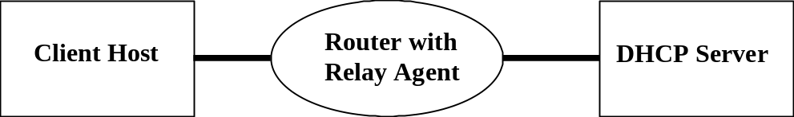

Figure 10.6: A Router with a relay agent in a client host/DHCP server connection.

The function of the DHCP relay agent is to accept the broadcast packet from the DHCP client and send the packet to the DHCP server. The relay agent changes the broadcast packet to a unicast address by using its own IP address, then sends it to the DHCP server. The DHCP server responds to the DHCP Relay Agent. The DHCP relay agent then forwards this response to the DHCP client.

The DHCP server supports different methods to allocate IP addresses to a client host:

- Automatic allocation: DHCP assigns a permanent IP address to the host.
- Dynamic Allocation: DHCP assigns an IP address to a host for a limited period of time (this time is called Lease Time). If the client does not need the IP address, the DHCP server can reuse this IP address and assign it to another host. This method is used by Internet Service Providers to assign IP addresses to their clients in order to be connected to the Internet temporarily.
- Manual Allocation: The network administrator assigns an IP address to the host and the DHCP server transfers that IP address to the client.

DHCP Operation
The following steps describe the operation of DHCP as shown in Figure 10.7:
- The DHCP client does not have an IP address, and so it broadcasts a packet on the network requesting an IP address from the DHCP server. This packet is called a DHCP Discovery packet.
- The DHCP server responds to the DHCP Discovery packet by sending a DHCP Offer packet to the client. The DHCP Offer packet includes the client IP address, the address mask and the lease time (the amount of the time that the client can hold this address). In the middle of the lease time the client host sends a renewal packet to the DHCP server to find out if it can keep the same IP address for the next lease time.
- When the client host has received a DHCP Offer packet from the DHCP server, it can accept the address offered or reject it. Therefore, the client sends a packet to the DHCP server to inform either the acceptance or rejection of the IP address. This packet is called the DHCP Request packet.
- The DHCP server sends a DHCP ACK to the client in response to the client’s DHCP Request and informs the client of the completion of the DHCP process.
- The client receives the DHCP ACK packet with configuration from the DHCP server. Now the client is configured. If a client receives a DHCP NACK (negative acknowledgment from the DHCP server), then the client host cannot use this IP address.
- If the client host does not need an IP address, it will send a DHCP Release packet to the DHCP server to release the IP address.
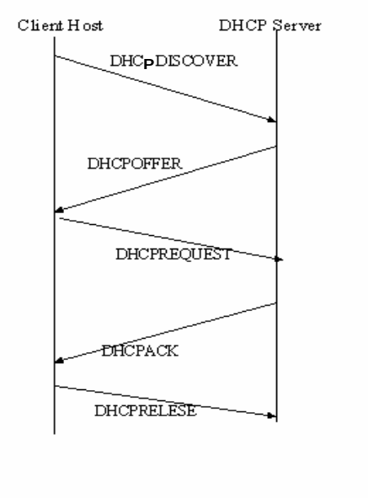

Figure 10.7: DHCP Operation

DHCP Packet Format
DHCP is an application protocol for UDP. Figure 10.8 shows the payload of an IP packet with DHCP. Figure 10.9 shows the DHCP packet format.

IP Header | UDP header | DHCP Packet

Figure 10.8: IP packet with DHCP.
1 32
Op Code 8 bits | Hardware Type 8 bits | Hardware Length 8 bits |  | Hop Count 8 bits
Transaction ID 32 bits
Number of Seconds 16 bits |  |  | Unused 16 bits

Client IP Address 4 bytes

Machine IP Address 4 bytes

Server IP Address 4 bytes

Gateway IP Address 4 bytes

Client MAC Address 6 bytes

Server Host Name up to 64 bytes

Boot file name up to 1284 bytes

Vendor-Specification Information up to 64 bytes

Figure 10.9: DHCP packet format
The following describes the function of each field in the DHCP packet format:

OP Code: The Op code indicates a request from a client or a reply to a request (1 for request, 2 for reply).

Hardware Type: The hardware type indicates the type of network card being used (such as IEEE 802.3 or Token Ring).

Hardware Length: The hardware length indicates the size of the hardware address or MAC address (6 bytes).

Hops: The hops field indicates the number of hops a packet can make on route to the destination. The maximum number of hops is 3.

Transaction ID: A random number set by the client. It is used by the client and the server to coordinate messages and responses.

Number of Seconds: The number of seconds is set by the client. The secondary server does not respond until this time has expired.

Client IP Address: If the client does not have an IP address, this field will be set to 0.0.0.0.

Server IP Address: The server IP address is set by the server.

Router IP: The router IP is set by the forwarding router.

Client Hardware: The client address is set by the client and is used by the server to identify which client the request came from.

Server Host Name: optional

Boot File Name: The client can leave this field null or indicate the type of the boot file.

Vendor Specification: This field is used for various extensions of the bootstrap.
UDP Header: The UDP header contains source and destination port numbers. The BOOTP uses two reserved port numbers. Port number 68 is used for the client and port number 67 is used for the server.

10.3 HTTP (Hypertext Transfer Protocol)
The IETF published HTTP documents RFC 1945 and RFC 2616. HTTP is an application protocol for TCP which uses port 80 for communications between clients and servers. Hypertext Transfer Protocol is used for the transferring of Hypertext Markup Language (HTML) documents. HTML is a tag and hypertext documents have links to other documents such as images and videos.
The address of a web page is defined by a URL (Uniform Resource Locator) such as http://www.southernct.edu/csdept/picture.gif

Where http is the protocol, southern is the host name, “.edu” is the TLD, and csdept/picture.gif
is the path name.

In HTTP, the client requests a web page and the server responds by sending the web page to the client as shown in Figure 10.10.

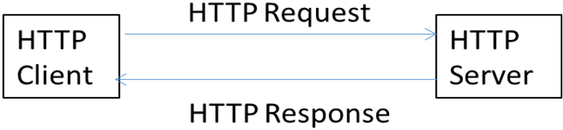
Figure 10.10: HTTP operation
HTTP is implemented by both client and server software. It performs the following tasks for transferring a web page from a server to a requesting client.
1. The browser makes a connection to the server over TCP port 80.
2. The browser sends a request to the server.
3. The server sends a response to the browser.

HTTP Characteristics

- HTTP is a stateless protocol, meaning that an http server does not keep any information about the clients that requested web page.
- HTTP Connections: HTTP offers two type of connections called non-persistent and persistent connections.
A. Non-Persistent Connection: Each request and response are sent over a separate connection and the connection is closed after a single request/response pair. HTTP/0.9 and HTTP 1.0 use non-persistent connection.
B. Persistent connection: All requests and responses are sent over the same connection. HTTP version 1.1 uses persistent connection.

HTTP Packet Format
HTTP defines two types of packets: client packets and server packets.

- HTTP Client Packet Format: Figure 10.11 shows an HTTP packet format which consists of a Request line, Header lines, a Blank line, and a Message Body.

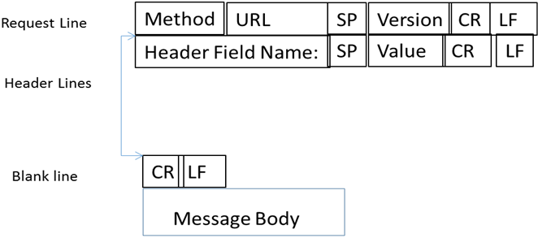
Figure 10.11: HTTP Request Packet Format
SP: Space
CR: Carriage Return
LF: Line Feed
CR = %0d = \r
LF = %0a = \n
% means hex

Method: Defines the type of request sent by the client to the server such as:

GET: Used by the client to request a document from the server and is identified by the URL.

HEAD: The HEAD method is similar to GET except that the server does not return a message-body in the response.

POST: Used by a client to submit information to the server.

PUT: Used for updating information on the server.

Example of a Client request:
Request line GET /csdept/picture.gif HTTP/1.1
Header line HOST: www.southernct.edu
Header line Connection: close ; uses non-persistent connection
Header Line User-Agent: Internet Explorer
Header Line Accepted-Language: English
HTTP Response Packet Format
An HTTP server responds to a client request with an HTTP response packet. Figure 10.12 shows HTTP packet format.

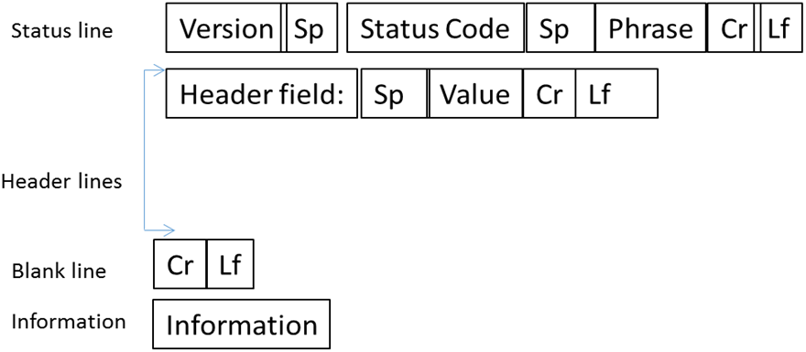
Figure 10.12: HTTP Response packet format
The following describes the function of each filed in Figure 10.12.
Status line HTTP 1.1 200 ok
Header Line Connection: close
Header Line Server: csdept
Header Line Last-Modified: Mon, 6,2010 09:21GMT
Header Line Content-Length: 500
Header Line Content-Type: Text/HTML
Blank line
Message Body

Status Code Definitions

Success (2XX): This class of codes indicates that request was successful, which includes:
200 OK
201 Created
202 Accepted
203 Non-Authoritative Information
204 No Content -205 Reset Content
206 Partial Content

Redirection (3xx): This class of codes indicates that an action is required to be taken by the client in order to complete the request.

301 Moved Permanently
302 Moved Temporarily

Client Error (4xx): This class of codes indicates client errors such as:

400 Bad Request
401 Unauthorized
402 Payment Required
403 Forbidden
404 Not Found

10.4 Internet Control Message Protocol

Internet Control Message Protocol (ICMP) is used to report error messages during packet delivery by an Internet Protocol such as protocol unreachable, network unreachable, network congestion, packet is too large, and announcing timeouts (TTL field drops to zero). Also, ICMP is used by the network administration for diagnostics purposes such as the Ping and Tracert commands. ICMP is an Internet Layer Protocol and ICMP packets are transported by IP to the destination. ICMP messages can be divided into two groups: error messages and information messages. Figure 10.10 shows the ICMP packet format.
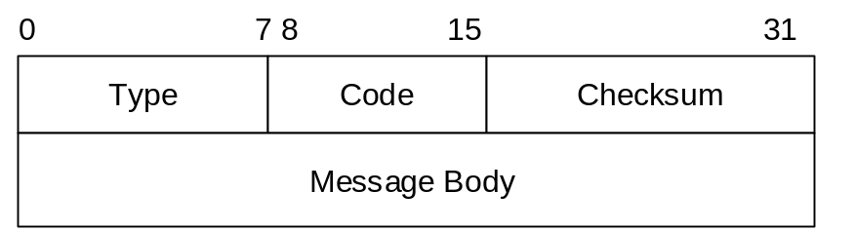

Figure 1: ICMP packet format.
Figure 10.13: ICMP packet format
Type (8 bits): Indicates the type of message. Numbers 0 through 127 indicate error messages, and numbers larger than 127 represent information messages. Table 10.1 shows type values and their meanings.
Table 10.1 Type Values and Meaning
Type Value | Meaning
1 | Destination unreachable
2 | Packet is too large
3 | Time exceeded
4 | Parameter problem
128 | Echo Request
129 | Echo Response
Code (8 bits): Provides additional information about the message type. For example, for a type value of 1 (destination unreachable), the code number specifies more detail information as shown in Table 10.2.
Table 10.2 Error Messages and Associated Code Values.
Code | Definition
0 | No route to destination
1 | Communication with destination prohibited
2 | No route to destination
3 | Not Assigned
4 | Address unreachable
129 | Port unreachable

Checksum: This field is used for error detection of ICMP headers and messages.
Packet too Large: Consider Figure 10.14 in which two networks are connected by a router. Network A is a token ring with MTU of 18000 bytes and Network B is an Ethernet with MTU of 1500 bytes. If station A sends an IP packet to station B, station A sends the packet to the router and the router examines the DF bit (do not fragment) in the IP header. If this bit is set, indicating that the packet is not to be fragmented, then the router is not able to send the packet to station B and the router discards the packet. The router then sends an error message to station A indicating that the packet is too large and the MTU for the packet should be 1500 bytes. Station A sends a new packet with the MTU of 1500 bytes to the router. This is called Path MTU discovery. Figure 10.15 shows the ICMP packet format for Path MTU discovery.

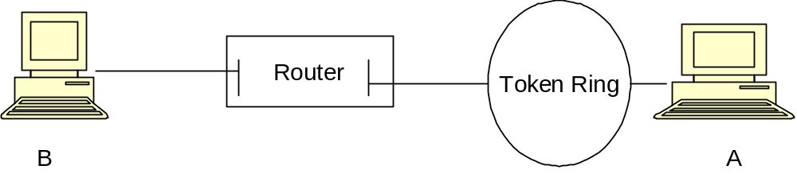

Figure 10.14: Two networks with different MTUs are connected via a router.

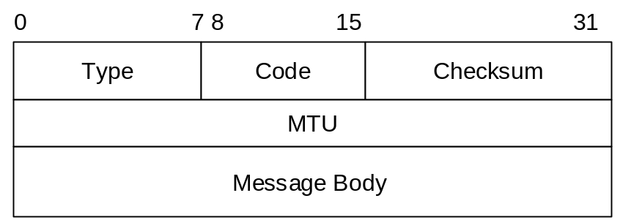

Figure 10.15: ICMP packet format for MTU discovery.
In Figure 10.15, the type field is equal to 2, code field is zero, and MTU field is maximum transmission unit of the next-hop link.
Time Exceeded: When an IP packet travels through the Internet, the TTL field decrements by one each time the packet passes through a gateway. When the TTL value becomes zero, the gateway sends the ICMP message of Time Exceeded.
Parameter Problem: When a router discovers an error in an IP packet, the router discards the packet and sends a Parameter Problem to the source.
Echo Request and Response: An ICMP echo-request message, which is generated by the ping command, is sent by any host to test node reachability across an Internetwork. The ICMP echo-reply message indicates that the node can be successfully reached.

10.5 Routing

The function of a router is to determine the path for transporting information (packets) through the Internet. Furthermore, routing is the method of moving packets from one network to another network. Figure 10.16 shows four networks connected through the routers R1, R2, R3 and R4. Consider the following questions when host A wants to send a packet to host B:

- How does host A knows that host B is connected to router R3?
- What is the best route for sending information from host A to host B? Host A can send packets to host B by using three different paths. Host A can send packets to host B using the path R1-R2-R3 or R1-R4-R3 or R1-R2- R4-R3. The router determines the best route for sending information by using a routing algorithm to build a routing table.
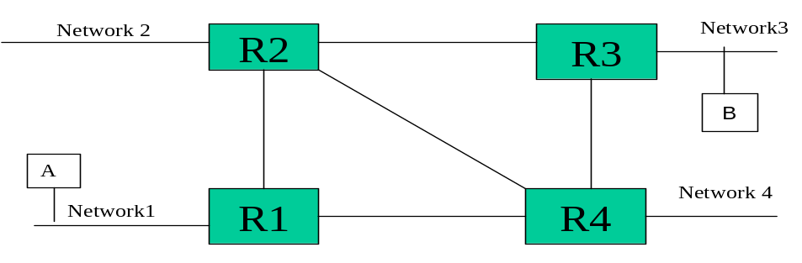

Figure 10.16: Networks connected by four routers

Link Characteristics

Routers use different metrics (Link Characteristics) to find the best route for sending a packet to the destination. The metrics are:

Hop count: The hop count measures the number of hops that a packet must go through in order to get to the destination.

Throughput: The data rate of the link.

Communication Cost: The cost of transmitting information from source to destination.

Delay: Measures the amount of time it takes a packet to travel from source to destination.

Configuring the Routing Table

There are two ways to configure the routing table: Dynamic Routing and Static Routing.

Dynamic Routing: In dynamic routing, the routers use a routing protocol to build their routing tables. If there is a change in the network configuration, a dynamic routing protocol broadcasts the changes to all the routers in the network in order to update all routing tables. Some the most popular dynamic routing protocols are:

- Routing Information Protocol (RIP)
- Open Short Path First Protocol (OSPF)
- Interior Gateway Routing Protocol (IGRP)

Static Routing: Static routing tables are configured manually by the network administrator. Static routing is often used for small networks. The problem with this type of routing is that if there is a change in network topology or a network link failure, all the routing tables need to be manually updated.

Figure 10.17 shows a network with three routers: A, B, and C. Router A has an Ethernet link E0 and one serial link S0. Router B has two serial links S0 and S1 and one Ethernet link E0. Router C has one serial link S0 and one Ethernet link E0. Class B IP addresses (180.160.0.0) are used to assign an IP address to each host.

As a network administrator, one would need to assign an IP address to each network and to each host.

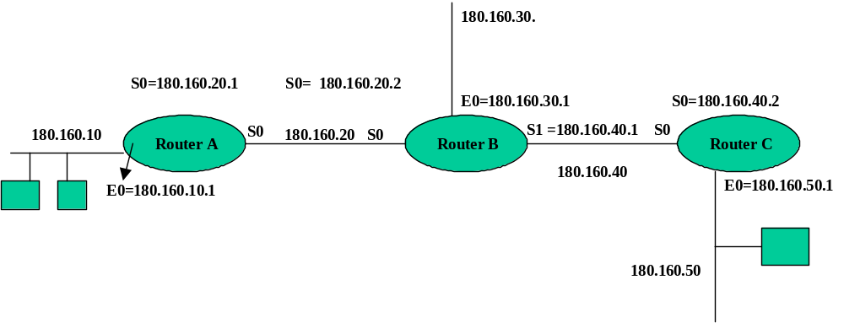
Figure 10.17: Networks connected by three Routers.

The following IP addresses are assigned to the following networks:

180.160.10. the network connected to the Ethernet port of Router A
180.160.20. the serial link between router A and Router B
180.160.30. the Ethernet network connected to router B
180.160.40. the serial link between routers B and C
180.160.50. the Ethernet network connected to Router C

In static routing, the routing table is built and updated manually. The IP routing table has the following fields:

A. IP address of remote network
B. Sub-net mask
C. IP address of default gateway

Tables 10.3, 10.4, and 10.5 show the Routing table for routers A, B, and C.

Table 10.3 Routing Table for Router A

Remote Network Subnet Mask Default Gateway

180.160.50. 255.255.255 180.160.20.2
180.160.40. 255.255.255 180.160.20.2
180.160.30. 255.255.255 180.160.20.2

Router A can access the other networks through the S0 link of Router B. Therefore, S0 is the default gateway for Router A.

Table 10.4 Routing Table for Router B

Remote Network Subnet Mask Default Gateway
180.160.50. 255.255.255. 180.160.40.2 (S0 of router C)
180.160.10 255.255.255. 180.160.20.1 (S0 of router A)

Table 10.5 Routing Table for Router C

Remote Network Subnet Mask Default Gateway
180.160.10 255.255.255. 180.160.40.1 (S1 of router B)
180.160.120 255.255.255. 180.160.40.1 (S1 of router B)
180.160.30. 255.255.255. 180.160.40.1 (S1 of router B)

10.6 Networking Diagnostic Commands

TCP/IP developed networking commands for network diagnostics such as ping, arp, IPconfig, tracert, netstat, and nslookup. The following commands are based on the Microsoft Windows OS:

PING Command

The PING (Packet Internet Groper) command is one of the most useful tools for debugging networks. It is an ICMP echo process used for checking whether a destination host is reachable. PING transmits a 32-byte ICMP echo request to the destination and expects to receive a 32-byte ICMP echo packet from the destination. It also displays the time it took to transmit 32 bytes and receive 32 bytes of data.

B. Address Resolution Protocol
If a router receives a packet for which it does not have the hardware address of the packet in its arp cache table, the router sends a broadcast packet to the hosts on the network and requests the hardware address of the host. All the hosts in the network accept the packet and compare the IP address of the packet with its own IP address. If both IP addresses are the same, the host will respond to the router with a RARP which contains the hardware address of the host.

ARP tables contain both the IP address and the MAC address of a computer. The following is a list of ARP commands.

arp -a Display the contents of the ARP table
arp -d Delete an entry with an IP address
arp -s Add an entry with a MAC address

C. ipconfig /all
IPconfig displays the network settings, physical address, IP address, and sub-net mask of the host, as well as the IP address of the default gateway.

D. Tracert command
Tracert shows the path of a packet from source to destination and the number of gateways the packet travels through.

E. Netstat Command
The netstat command displays information about your network configuration. It comes with following options:

netstat –n displays information on the NIC of your computer
netstat –r displays the IP routing table
netstat -a displays information on TCP and UDP ports
netstat –s displays operational statistics of network protocols

10.7 Multi-protocol Label Switching (MPLS)
MPLS was developed to overcome the deficiency of IP packet delivery over private and public networks. An IP network is connectionless and when an IP packet is received in a router, the router uses its routing table and the IP address of the packet to find the next hop. The IP address does not use a fixed size such as class A, B, C, or D therefore; it takes time to find the next hop. MPLS defines a method for fast packet forwarding over an IP network. It is an independent protocol and it works with multiple protocols such as IP, ATM, and Frame Relay. MPLS adds a label or tag to an IP packet and it uses this label to find the path or next hop. Because the length of the label is fixed, it becomes faster to look up in a table than IP routing. Routers on an IP network use this label to find the next hop. The operation of MPLS is similar to Cell Switching in ATM networks and Frame Relay. MPLS performs the same function as a router but with higher performance. MPLS can be used for VPN, transport layer (layer 2), and connection-oriented service.

MPLS Components and Operation: Figure 10.15 shows an MPLS network that consist of the following components:

- Label Edge Router (LER): A LER is located between the MPLS network and the user networks as shown in Figure 10.18. An LER performs the following functions:

  - When an LER receives an IP packet from a user network, it adds its label to the IP packet and uses its routing table to forward the IP packet based on the label value to the next label switch router.
  - When an LER wants to transmit a packet to the user network, it removes the label field from the IP address and transmits the IP packet to the user network.

- Label Switch Router (LSR): The function of an LSR is to examine the IP packet based on its label and replace the label with a new label. The new label identifies the next hop to which the packet is forwarded.

In Figure 10.15, network A transmits two IP packets to LER1. LER1 uses its routing table to add labels to each packet and forward them to LSR2. LSR2 examines each packet’s label and strips the packet of its label, then inserts a new label, and forwards the packet to the appropriate port of the next hop. IP packet with label 40 is transmitted to LER 4 and IP packet with label 60 is transmitted to LSR3. LER4 examines the label of the IP packet and finds that the packet must be transmitted to user network B. LER4 removes the label from the IP packet and forwards the packet to user network B.

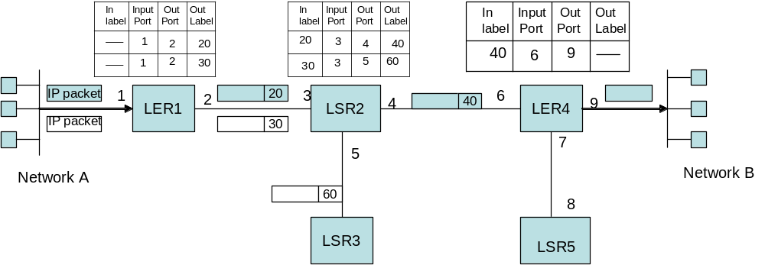

Figure 10.18: MPLS Network

Forward Equivalence Class (FEC): This is a group of IP packets that are forwarded in the same manner over the same path. Therefore, a group of packets with same FEC can be assigned the same labels through the path. Consider that multiple IP packets with the same forwarding characteristics are transmitted by network A to network B. LER1 assigns these IP packets the same labels throughout the path. These packets with same FEC will use the same path. This method reduces the size of the routing table.

MPLS defines only the forwarding methods so other protocols are needed to perform routing and signaling. The routing protocol distributes the networking topology and configures the routing table by using an IP routing protocol such as OSPF, BGP, or RIP. Signaling protocols are used to inform the routers which label, and link, are to be used by the switch for each Label Switching path. MPL advantages are:

- The path from source to destination can be identified in advance.
- It can select network paths in order to have a balanced load in the network
- MPLS can provide a specific path for data.
- MPLS offers quality of Service (QoS) by choosing a specific path in order to provide bandwidth to the application, less delay, and less packet loss.

MPLS label: The MPLS label is inserted in the frame but the location of the label depends on the layer 2 technology. In ATM the label is VPI/VCI and in Frame Relay it is DLCI filed. In an IP packet the label inserted between layer 2 and layer 3 is shown in Figure 10.19. The MPLS label field is 32 bits and the following list describes the function of each field.

Label: This is 20 bits.
CoS (Class of Service): This field is 3 bits and is used for queuing and discarding packets traveling through the network.

S (Stack): This field is one bit and it is used for multiple MPLS Labels.

TTL (time –to-Live): This field is 8 bits and works similar to TTL field in IPv4.

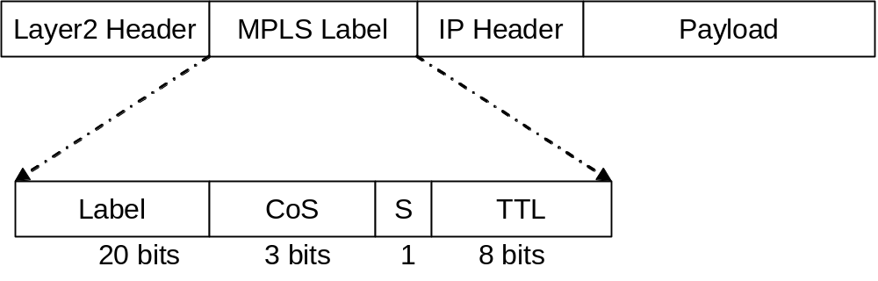

Figure 10.19: MPLS Label Format
10.8 IP Multicast

IP multicast is used for sending an IP packet to a group of receivers in a single transmission. The applications of IP multicast are:

A. Video/audio conferencing
B. Service advertisement
C. Stock distribution
D. IPTV
E. Transferring a bulk of data to multiple receivers
F. File distribution of operating system images in a university

Figure 10.20 shows Unicast and Multicast. In Unicast, the source must send three packets while in IP multicast the source sends only one packet.

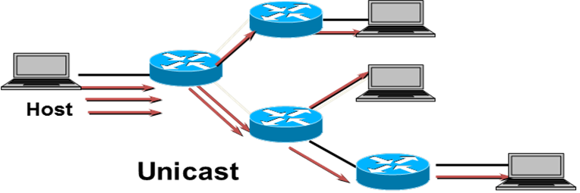

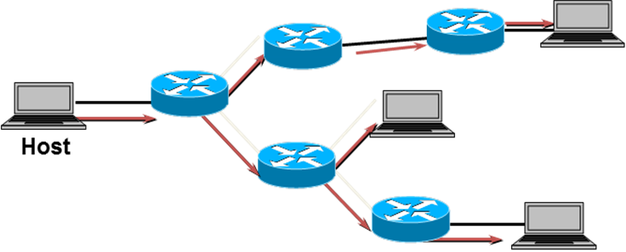

Figure 10.20: Unicast and Multicast diagrams

Characteristics of Multicast Network

- A multicast group is a set of hosts that all have the same IP multicast address.
- The transmitter of a multicast packet transmits the packet to a Multicast Router and the router transmits the packet to all hosts in the multicast group.
- A Multicast Router requires running Multicast Routing Protocol and Internet Group Message Protocol (IGMP).
- Each multicast group is identified by a single Class D IP multicast address.
- Members of a multicast group can be any place in a network.
- Each host in the network can join a multicast group.
- A multicast member (host) can leave the group by informing its multicast router.
- A receiver of a Multicast packet must be a member of group.
- Any host on the network can transmit a multicast packet.
- Each multicast router manages the hosts connected directly to its port using Internet Group Managed Protocol (IGMP).

10.8.1 Internet Group Management Protocol—IGMP

The IETF published IGMP in RFC 1112. IGMP is a management protocol for IP multicast and is used for managing host group membership. It is located in the IP layer of the TCP/IP model as shown in Figure 10.21. IGMP has three versions: IGMP v1, IGMPv2, and IGMPv3.

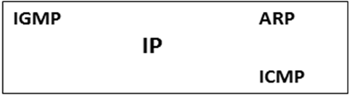

Figure 10.21: IGMP

IGMP Messages

In general, IGMP has two types of messages:

A. Membership query message
B. Membership report message

A membership query message is transmitted by the router periodically to active, directly connected, hosts. This type of message is used for requesting information about host membership. Each active host member responds to the query with a membership report message. A Host sends an IGMP report to a router for joining a group. When a host wants to send a multicast packet to a group, it places its data in a UDP packet with a multicast IP address as the destination address. Figure 10.22 shows the IP multicast network.

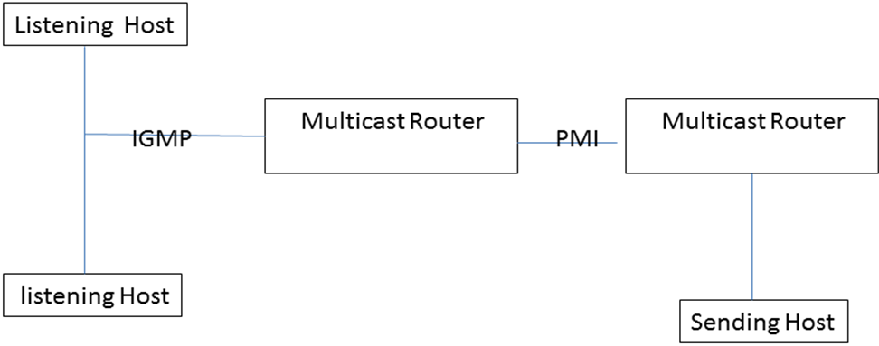

Figure 10.22: IP multicast network

A multicast router uses IGMP to learn which groups have members on each of their attached physical networks. It also keeps a list of multicast group memberships for each attached network.

IGMP packet format
Figure 10.23 shows the IGMP packet location in an IP packet and Figure 10.24 shows the IGMP packet format.
Figure 10.23: IGMP packet
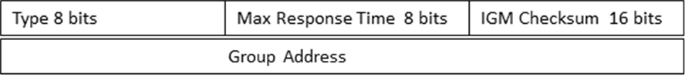
Figure 10.24: IGMP Packet Format
Type (8 bits): This field defines the type of packet as shown in the following table.
Type value in Hex | Description
0x11 | Group membership Query
0X12 | IGMPv1 Membership Report
0x15 | Cisco Trace Messages
0x16 | IGMPv1 Membership Report
0x17 | IGMPv2 Leave Group.
Max Response Time: This field is 8 bits and is used for membership. It defines the maximum allowed time before sending a responding report.
IGMP Checksum: This field is 16 bits and is used for error detection.
Group Address: This field is 32 bits. For a general query, this field set to zero such as in a membership query, and for a specific group, it is set to the group address.
10.9 Socket Programming
Socket programing is used for communications between a client and server through a network. A socket is a binding of an IP address and port number used for communications. The two processes communicate by sending their data into a socket, and then processing that data. Figure 10.25 shows the communications between a client and server using sockets.

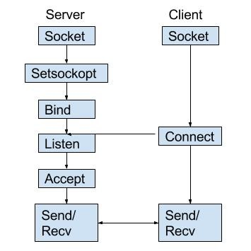
Figure 10.25: Socket programming between a client and server

The following steps show an implementation of socket programming for client and server using Python.

- Import socket module
- Create a socket
- Binding the socket to an address and port
- Connecting to a socket
- Listening and accepting connections
- Transferring and receiving data.

Socket Methods: The following are lists of methods used for socket programming:
s.recv() used to receive data from a socket over TCP
s.send() used to send data to a socket over TCP
s.recvfrom() used to receive data from a socket over UDP
s.sendto() ` used to send data to a socket over UDP
s.close() closes a socket
s.gethostname() gets the hostname of the machine that the program is currently running on

- Import the socket module
import socket

- Creating a socket
A socket can be created by making call to the socket.socket() method.

s = socket.socket(socket.family, socket.type)
family: AF_UNIX is used for Unix, and AF_INET use for Internet.
type: SOCK_STREAM is used for TCP protocol while SOCK_DGRAM is used for UDP protocol.

A. On the server side – create a TCP socket for listening
s = socket.socket(socket.AF_INET, socket.SOCK_STREAM)

B. On the client side – create a socket to connect to

s = socket.socket()

3. Binding the socket to an address and port
On the server side, the socket must be bound to the host’s IP address and port number by using bind(). If the server’s IP address is 192.168.1.2 and the desired listening port is 8000, then the binding will be:
s.bind((“192.168.1.2”, 8000)
In this model, the client does not require binding.
4. Connecting to the Socket
Clients make a connection to the server by using connect() method.
s.connect(address)
where the address field is the IP address or hostname and port number of the host to connect to.
s.connect((“192.168.1.2”, 8000))
5. Listening and accepting connections
The server must listen to its port for incoming connections by using the listen() method:
s.listen(5)
where the argument represents the number of connections, and therefore must be at least 1.
Once listening, the following function is used for accepting a connection on that socket:
clientsocket, address = socket.accept()
- Transferring and receiving data
Data is sent and received by either the server and client using the send() or recv() methods:
s.send('Message12345'.encode())
data = s.recv(1024).decode()

Data must be encoded before being sent, and decoded at its destination as needed. The recv() method allows a buffer to be set, in this case receiving in chunks of 1024 bytes. With this process, the following outlines the creation of two python programs to be used to demonstrate socket programming, a client and a server capable of communicating across different computers on a local area network.

Computer 1:

- Open command prompt.
- Type “ipconfig”.
- Find your IPv4 address. Either write this down or keep the command prompt open.
- We will now write code for the server using python. Start by opening notepad and typing the following code (everything after # is a comment and does not need to be typed):

import socket # imports the socket module

serversocket = socket.socket(socket.AF_INET, socket.SOCK_STREAM)

host = "192.168.1.6" # set this to the IPv4 address of Computer 1

port = 8000 # you can use any port as long as another service is not using it

serversocket.bind((host, port)) # binds the address and port to the socket

serversocket.listen(5) # has the socket start listening for incoming connections

while 1:

(clientsocket, address) = serversocket.accept() # accept incoming connection

data = clientsocket.recv(1024).decode()

print (data)

# send a message back to the client
clientsocket.send("You have successfully connected".encode())

Now, save this file on Computer 1 as server.py and run it using Python. Keep this running, as the next step involves connecting to this server.

Computer 2:

Now we will create the client, open a new notepad and type the following code:

import socket # imports socket module

s = socket.socket() # creates a new socket

host = "192.168.1.6" # set the host to the IPv4 address of Computer 1

port = 8000 # use the same port that was used on the server

s.connect((host,port)) # connects to the server

s.send('Message12345'.encode()) # sends a message to the server

data = ‘’ # creates a variable to hold the incoming message

data = s.recv(1024).decode() # accepts and stores the incoming message in data

print (data) # prints the message

s.close # closes the connection

Save this file on Computer 2 as client.py. Now, run the client using Python. You should receive the message “You have Successfully connected”.

Summary

- DNS uses a tree hierarchy which consists of a root and TLDs.
- There are 13 DNS root servers.
- DNS clients use Iterative Queries or Recursive Queries to resolve a URL to an IP address
- Each organization is required to have a Primary DNS and Secondary DNS server.
- DNS Resource Records contain a Name, Class, Type and Value.
- Dynamic Host Configuration Protocol (DHCP) is used to assign IP addresses to a host dynamically.
- The components of DHCP are: DHCP Client, DHCP server, and DHCP Relay Agent.
- A DHCP server supports Automatic Allocation, Dynamic Allocation, and Manual Allocation for assigning IP addresses to clients.
- The application of DNS is to convert the URL or hostname of a server to an IP address.
- The function of a router is to determine the path for transmitted packets through the Internet.
- In a router, the path of information is determined by the Routing Table.
- The routing table can be configured in two ways: Static Routing or Dynamic Routing.
- A Static Routing Table is configured manually, and a Dynamic Routing table is configured automatically.
- MPLS uses label switching to route the information.
- A socket is a combination of IP address and port number.
- In socket programing, the client requests a connection.
- In socket programming, the server listens on its port for client requests.

Key Terms
Binding | Network control protocol
DHCP Relay Agent | Routing
DNS Root servers | Routing Information Protocol
DNS Root Servers | Socket
Dynamic Host Configuration (DHCP) | Static routing
Dynamic Routing | Top Level Domain
Multi-protocol Label Switching (MPLS) | Top Level Domain

Review Questions

Multiple Choice Questions

- An organization requires:
- One DNS server
- Two DNS Servers
- Tree DNS servers
- More than three DNS servers

- How many root DNS servers exist?
- 1
- 10
- 12
- 13

- Which of the following methods is used for resolving an IP address with a DNS server?
  - Iterative query
  - Recursive query
  - ARP
- a & b

- Which of the following protocol is used for DNS?
  - UDP
  - TCP
  - ARP
  - a & b

- DHCP is used to assign __________ to a client.
- IP addresses automatically
- MAC addresses automatically.
- IP addresses manually
- MAC addresses manually

- A ___________ holds a range of IP addresses.
- Client server
- DHCP server
- Router
- Relay agent

- The function of a relay agent is to__________.
- pass the broadcast message
- block the broadcast message
- change the broadcast message to unicast
- change the unicast message to multicast

- DHCP Discovery packets are transmitted as_______ packets
- Broadcast
- Unicast
- Multicast
- a & b

- DHCP offer packets are transmitted as_______ packets
- Broadcast
- Unicast
- Multicast
- a&b

- The function of a router is to___________.
- Find the destination IP address.
- Find the destination MAC address.
- Find the path to a destination for transporting packets.
- None of the above

- Static routing tables are updated by_________.
- a server
- the network administrator
- automatic method
- none of the above

- Dynamic routing tables are updated by_________.
  - a server
  - the network administrator
  - automatic methods
  - none of the above

- MPLS uses ______ for routing of packets.
- Label
- IP address
- a&b
- MAC address

- A socket is a combination of a port number and
- IP address
- Hostname
- Default gateway
- a&b

- In a socket programming model, which device is listening to its port for incoming connections?
- Server
- Client
- All station on network
- Only server
Short Answer Questions

- What is the function of a DNS server?
- List the types of DNS queries.
- Show the DNS resource record format.
- What is the transport layer protocol used for DNS?
- What commands are used to clear the DNS cache table?
- What commands are used to display the DNS cache table?
- List three diagnostic tools you can use for DNS troubleshooting.
- List at least 5 TLDs.
- What is the minimum number of DNS servers an organization must have?
- Does an organization have separate DNS servers for IPv4 and IPv6?
- What is the application of DHCP?
- List the components of DHCP.
- Explain DHCP dynamic IP allocation.
- List DHCP packets and explain the function of each.
- What is the function of a relay agent?
- List the link characteristics.
- Explain static routing and dynamic routing.
- What is the function of Internet Control Message Protocol (ICMP)
- List three applications IP Multicast
- What is the application of a socket?
- Which device requests connection to a socket?
- Socket is combination of IP address and_____

