Final Project : Game Programming

Mitchell Douma

Steve Hendricks

December 13, 2018

This game has an open world where the player can walk around. They can find different types of items with different uses. Be careful, there are enemies afoot. Including a ferocious dragon!

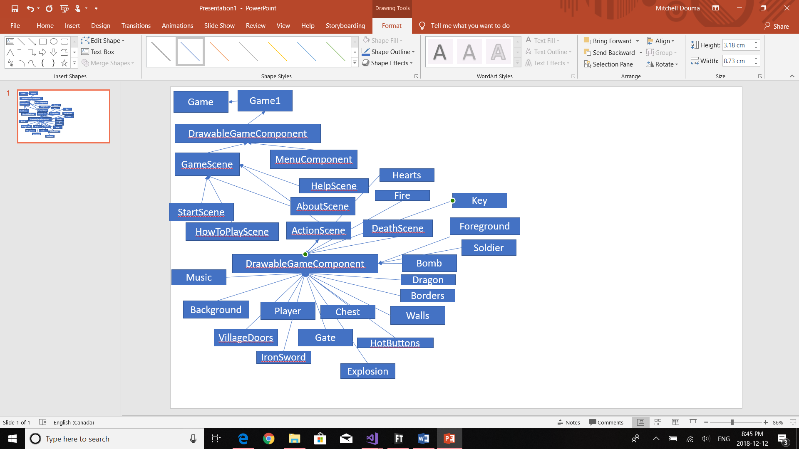

Resources:

Collisions Library: <https://github.com/ProfessorSteveH/prog2370-collisions>

2D XNA Primitives Library: <https://bitbucket.org/C3/2d-xna-primitives/wiki/Home>