1. Gouraud shading approximates the surface’s normal by averaging the normals of all neighboring polygons to come up with a normal for that surface, for which the lighting equation uses. Gouraud shading computes the normal for each vertex and finds the color at the vertex level. It then interpolates for pixels between vertices. Phong shading is used for a greater sense of realism. Phong shading approximates the normal at each and every pixel to find which color it needs to be. Gouraud shading can have the same level of realism as Phong shading if every pixel is a vertex.

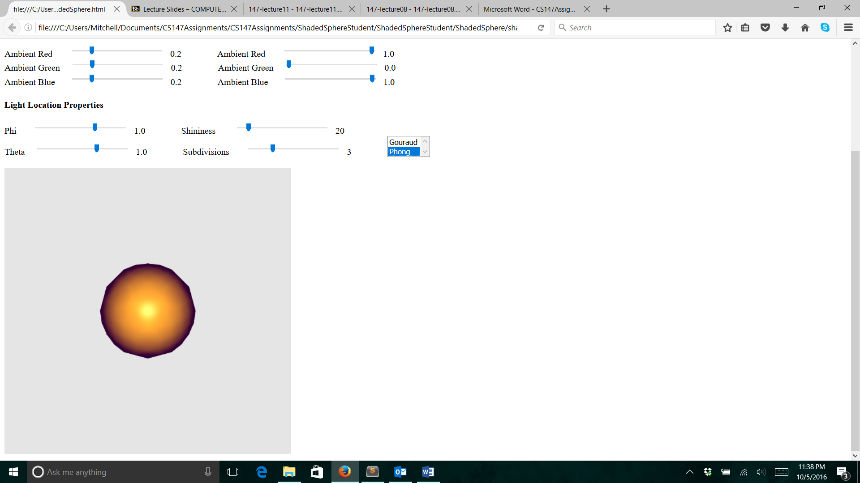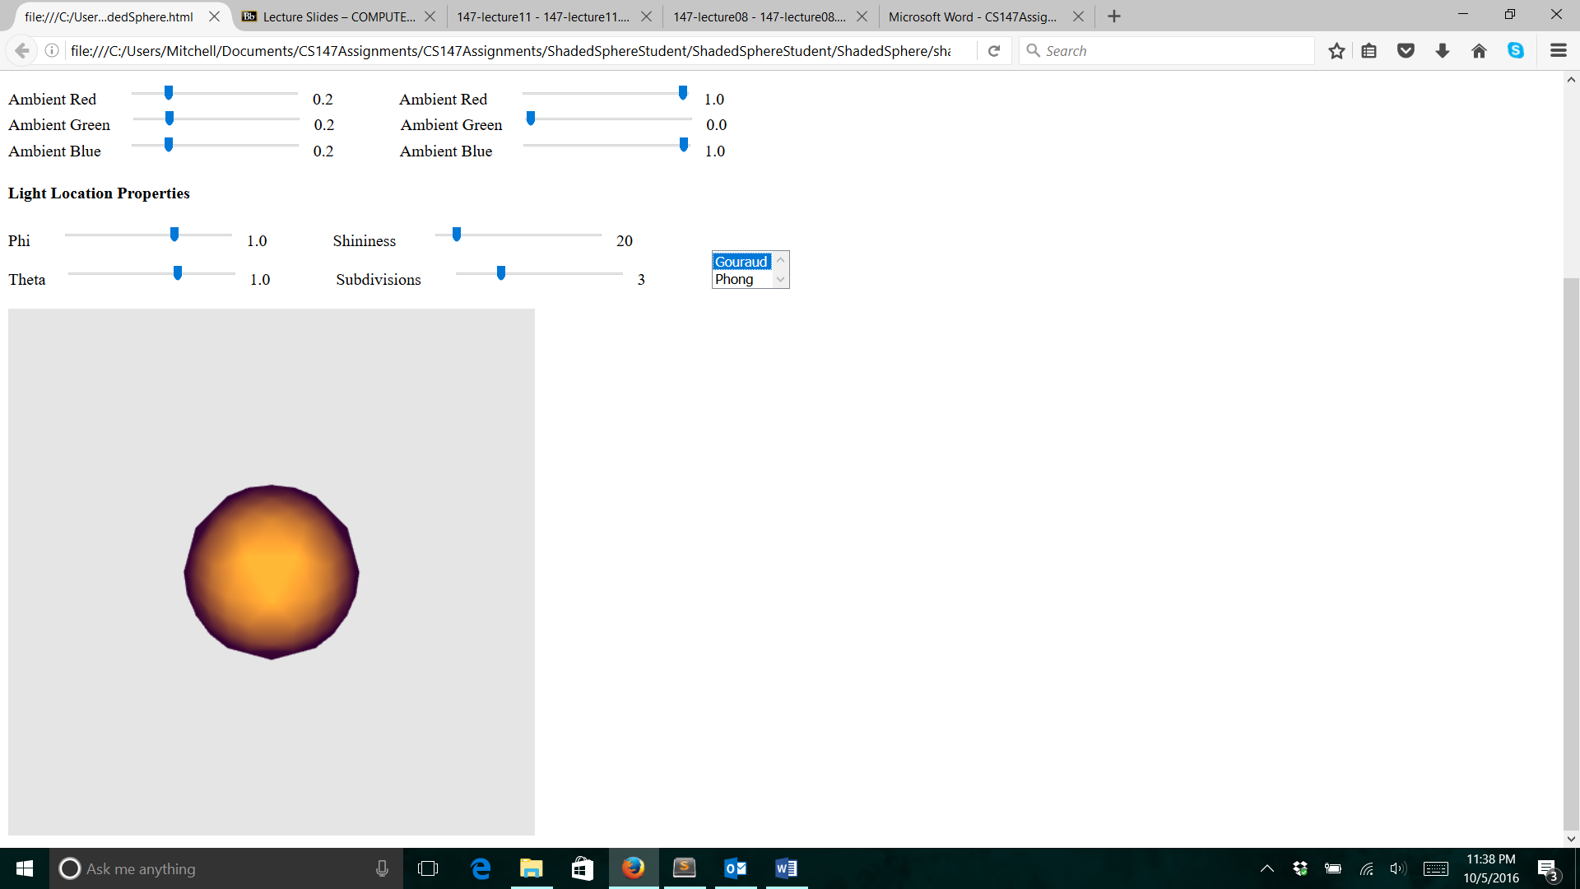

These images are Gouraud on the left and Phong on the right. The Phong shading produces a much more realistic reflection of the light source by having many different rings of color, due to shading at the pixel level. The Gouraud shading produces less difference in color, as it is interpolated between vertices.

1. One major difference between reality and the Phong shading model is that the Phong model assumes only one point of light as the light source. In reality, even ignoring possible other sources, a single source of light has an area to it, not just a singular point-source. This area would cause for a larger variation in lighting. This is ignored, as it would be computationally exhausting. The formula would have to be done for each pixel of the light source as a point light source and then there would have to be another equation to relate all of the different normals that you would get from that. Essentially, accounting for the entire light source’s area would take too much time and wouldn’t add enough realism to justify it. Another major difference is that in the real world, light bounces and radiates from surfaces, but in the model, we assume only one reflection. To compute the bouncing of the light, we would need heavy physics computations that even then are still estimates of reality with assumptions. The amount of computation involved in calculating the bouncing of light would not be worth the added realness.