1. ./cli rm -f test.txt, pwd, ls

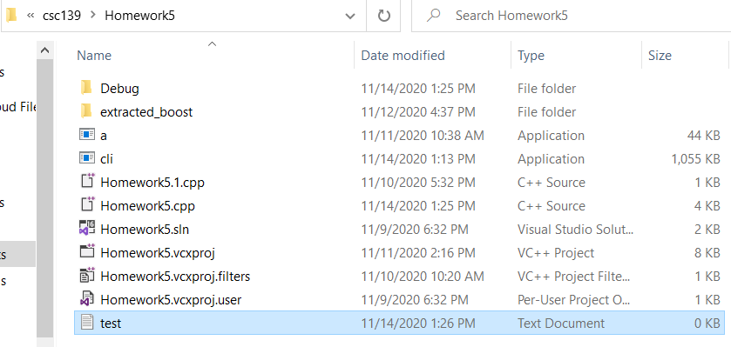

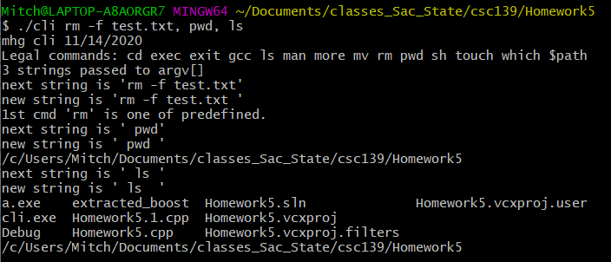

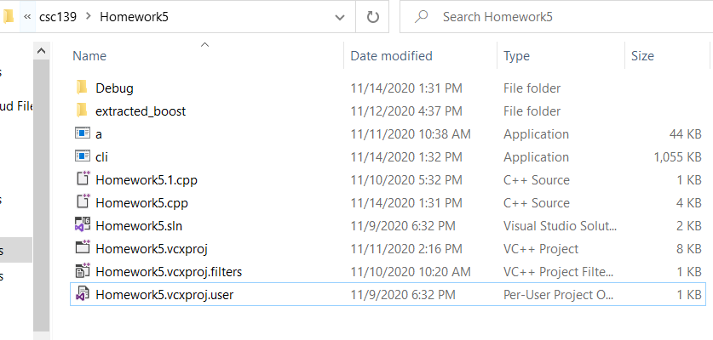

1. ./cli touch touched_file.txt , which aclocal

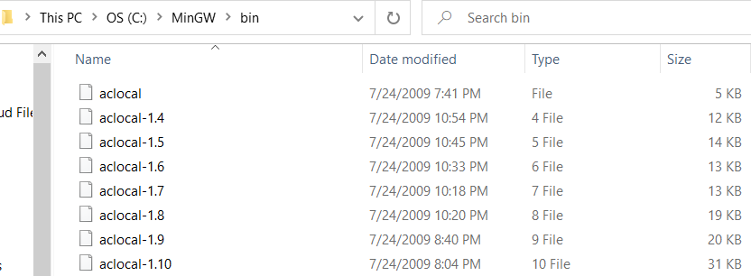

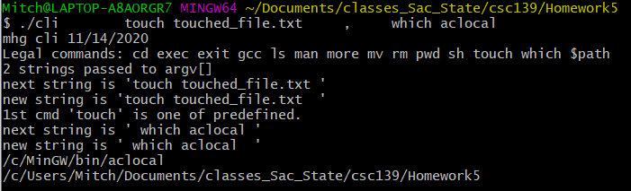

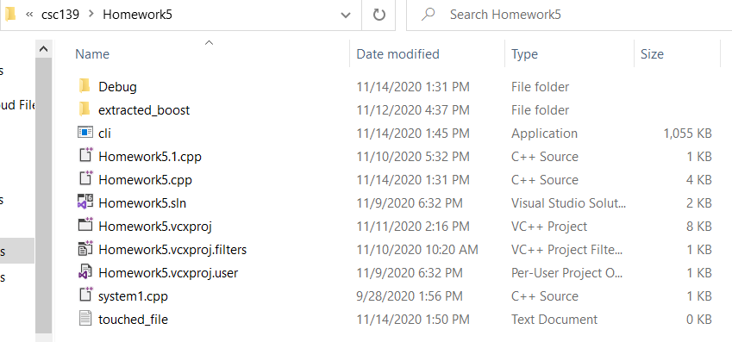

1. ./cli mv touched_file.txt ../temp1 ,exit

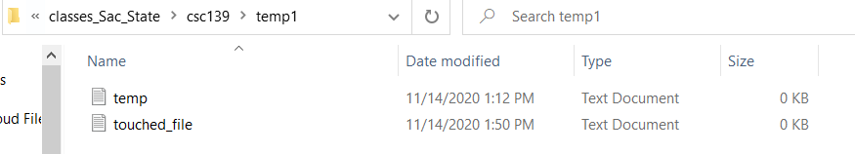

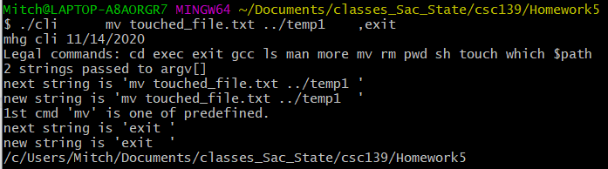

1. ./cli whoami , cd,ls,pwd, mkdir HomeworkTest

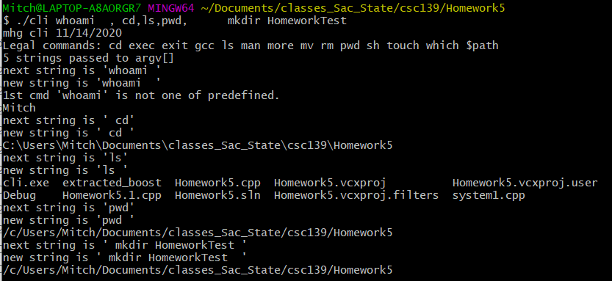

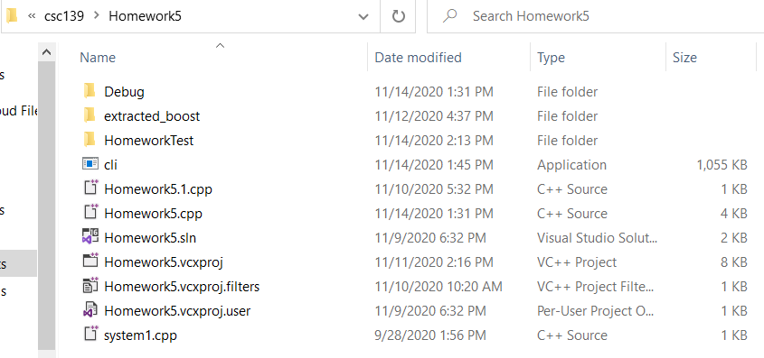

ILLEGAL PARAMETERS

