BENJAMIN SHEPHERD BMus (Hons), PGDip
PIANO TEACHER

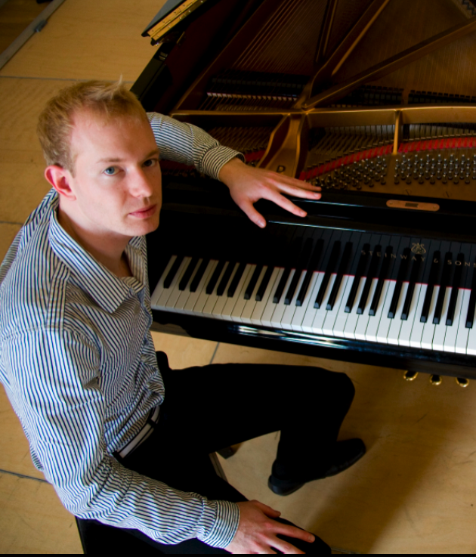

154-A MILL LANE, WEST HAMPSTEAD, LONDON NW6 1TF
E: bshepherd2@tcm.ac.uk
T: 07840 451 802

P E R S O N A L D E T A I L S

Date of Birth: May 21, 1984
Nationality: British
Full, clean UK driving licence
Enhanced CRB check

P E R S O N A L P R O F I L E

An enthusiastic, understanding, communicative and artistic individual who works consistently. An experienced teacher and performer, able to motivate and inspire musicians.

P R O F E S S O R S

- Philip Fowke (Senior Fellow, Trinity College of Music, London)
- Marián Lapšanský (Academy of Music and Dramatic Arts, Bratislava, Slovak Republic)
- Alexander Ardakov (Trinity College of Music, London)
- Penelope Davies (Royal Welsh College of Music and Drama, Cardiff)

T E A C H I N G E X P E R I E N C E & E M P L O Y M E N T

- Piano Teacher, Eltham Green School, London (Presently)
- Piano Professor, The Arts Academy, Chiswick, London (2008 – Present)
- Piano Teacher, The Music House For Children, London (2007 – Present)
- Faculty Support Officer, Trinity College of Music, London (2007 – Present)
- Student Services Mentor & Accompanist, Trinity College of Music, London (2007 – Present)
- Private Piano Teacher, Bratislava (2005 – 2006)
E D U C A T I O N & Q U A L I F I C A T I O N S

- Master of Music Degree - Trinity College of Music, London (2007 – Present)
- Bachelor of Music (Honors) Degree - Trinity College of Music, London (2003 – 2007)
- Foundation Course Certificate - Trinity College of Music, London (2002 – 2003)
- Junior study at the Royal Welsh College of Music and Drama, Cardiff (1998 – 2002)

S P O K E N L A N G U A G E S

- English – First Language
- Slovak - Fluent
- Portuguese - Conversational

M E M B E R S H I P O F S O C I E T I E S / G R O U P S

The London Chopin Society, Prince’s Gate, London
The Franz Liszt Society, London
RWCMD Alumni

A W A R D S & P R I Z E S

- Gordon Foundation Award, 2008 - 2009
- The Alfred Kitchin Scholarship, 2008 - 2009 (Trinity College of Music, London)
- The ‘Beattie’ Prize, 2002 (Royal Welsh College of Music and Drama, Cardiff)

Q U O T E S

‘He plays with assurance, passion and considerable musicality’
Philip Fowke, 11 February 2009

‘Intelligent playing with an appreciation of the elegance and tonal palette of the style’
Stephen Savage, 25 January 2009

‘Benjamin has a natural and sensitive musicality and an intrinsic ease at the piano…he has very special gifts which could make him an outstanding teacher’
Philip Fowke, 06 June 2008

‘He is a serious musician, totally open and committed to whatever he does’
Paul Chapman, 29 November 2007

“Expressive and beautifully phrased…Bravo”
Deniz Arman Gelenbe, 15 April 2005

“The Slavický Burlecsa was played with real bravura and panache”
Douglas Finch, 14 February 2005

“He has very fine hands…physically, he is very strong and supple. He is a very talented musician with a big potential”
Alexander Ardakov, 24 November 2004

“The performance was lyrical, dramatic and well constructed”
Deniz Arman Gelenbe, 5 March 2004

A D D I T I O N A L I N F O R M A T I O N
& P E R S O N A L I N T E R E S T S

Trustee (The Metropolitan Sinfonia)
Student Keyboard Representative, Trinity College of Music, London (2002 – Present)
British Gymnastics Champion, 2008 & 2009 (Tumbling)
Qualified Gymnastics Coach
English Language Teacher, Bratislava (2005 – 2006)

Alexander Technique
Psychology
Pedagogy
Traveling
Linguistics
Reading

R E F E R E N C E S

Philip Fowke, Concert Pianist and Piano Professor (Senior Fellow) Trinity College of Music, London

Sofia Wilde – Music Director, The Music House For Children, Uxbridge Road, London

