**Name:** abc

**Aadhar no**:1234 5678 1234

**DOB**:12/12/85

**Age**: 30

**Gender:** Male

**History:**

* Family has history of Diabetes and BP
* Have had Dengue at the age of 8
* Have had jaundice at the age 20
* Right hand facture in 2009

Allergy

* Allergy of Ofloxacin

**X-rays:**

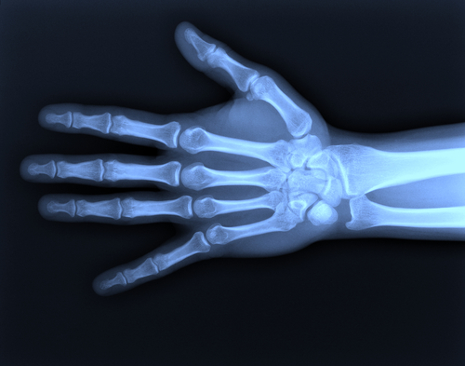

Reports:

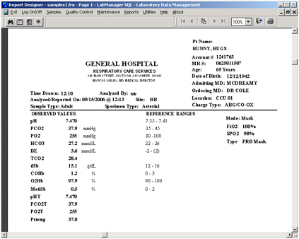

Referred By:

DR. wer

Dr.qwerty