ELECTRIC MOBILITY · KENYA
KOFA KORE2 BATTERY
STATE OF HEALTH (SOH) ANALYSIS
Project Documentation & Technical Report
CRISP-DM Framework · Data Science · Battery Diagnostics

Project information | Details
Project | Kore2 Motorcycle Battery Performance Analysis
Business case | Detect abnormal battery behaviour and identify batteries requiring intervention
Fleet sample | 12 Kore2 batteries
Telemetry | 8,640 readings; 720 readings per battery; 30-second interval
Observation window | 22 October 2025, approximately 08:00–14:00
Primary analytical method | K-Means unsupervised clustering (k=2)
Validation | Mann-Whitney U tests + operational/visual evidence
Application | Streamlit Fleet Health Dashboard
Methodology | CRISP-DM
Team | Team TITANS

Document purpose: This report consolidates the supplied CRISP-DM business documentation, technical notebook, and deployed dashboard screenshots into one project-ready document. It is written for both technical reviewers and non-technical stakeholders.

Table of Contents
- 1. Executive Summary
- 2. Project Background and Business Problem
- 3. Business Objectives and Success Criteria
- 4. Project Scope and Stakeholders
- 5. Data Understanding
- 6. Data Preparation and Feature Engineering
- 7. Exploratory Data Analysis
- 8. Modeling Approach
- 9. Model Evaluation and Validation
- 10. Key Results and Findings
- 11. Dashboard and Deployment
- 12. Recommendations
- 13. Limitations and Risks
- 14. Future Improvements
- 15. Technical User Guide
- 16. Conclusion
- Appendix A. Battery-Level Results

1. Executive Summary
This project investigates a recurring operational problem in an electric motorcycle battery fleet: unusually rapid battery drain and unexpected shutdowns while riders are still operating the motorcycle. The analysis focuses on a 12-battery Kore2 telemetry sample and follows the CRISP-DM methodology from business understanding through deployment.
The supplied notebook contains 8,640 telemetry records, with 720 observations for each battery at 30-second intervals across an approximately six-hour window. The telemetry includes operating state, speed, voltage, current, state of charge (SOC), self-reported state of health (SOH), and ambient temperature. The project converts these raw readings into battery-level behavioural features and uses unsupervised K-Means clustering to discover whether the fleet naturally separates into distinct groups.
A transparent fleet-wide threshold approach was tested first, but it flagged no batteries. The notebook identifies this as an outlier-masking problem: because four of the twelve batteries are severely abnormal, their values distort the fleet mean, standard deviation, and IQR boundaries. K-Means was therefore used as the alternative approach.
The final K-Means model with k=2 identifies four batteries as anomalous: KF-B101, KF-I108, KF-J109, and KF-L111. Compared with the eight normal batteries, the flagged group has approximately 5.7 times the drain rate, a much shorter ride duration, substantially lower reported SOH, and approximately five times greater voltage variability. Mann-Whitney U tests show statistically significant separation on all four core metrics (p≈0.003–0.004). Ambient temperature does not significantly differ between groups (p=0.2828), weakening the hypothesis that heat exposure explains the pattern.
The operational conclusion is that the observed pattern is consistent with a specific group of problematic batteries rather than evidence of a fleet-wide Kore2 design issue. However, the analysis is not a physical root-cause investigation; Engineering teardown and cell-level diagnostics are required to confirm whether the underlying cause is cell imbalance, BMS failure, manufacturing variation, or another hardware issue.
Important interpretation: The dataset is small and represents one telemetry window. The results are strong for this pilot sample but should be treated as an evidence-based diagnostic finding that must be revalidated as more batteries and longer histories become available.

2. Project Background and Business Problem

2.1 Industry Context
Kenya's electric motorcycle market is expanding rapidly, increasing the operational importance of battery reliability. The supplied industry brief describes a sector moving from predominantly petrol motorcycles toward electric two-wheelers, with batteries becoming a critical component for range, uptime, rider income, safety, and customer trust.
For an e-boda operator, battery State of Health (SOH) is different from State of Charge (SOC). SOC indicates how much charge is available at a given moment, while SOH represents the battery's remaining usable capacity and performance relative to its condition when new. A degraded battery can drain faster, experience greater voltage instability under load, and shut down unexpectedly.

2.2 Business Problem
Customer Service reports described rapid battery drain and unprompted shutdowns. The central business question was whether these complaints represented a small subset of defective batteries, a wider Kore2 design or manufacturing problem, or inaccurate/inconsistent reporting. The distinction matters because each outcome leads to a different operational response.

2.3 Why the Problem Matters
- Unexpected shutdowns can interrupt rider trips, reduce income, and create safety exposure.
- Repeated battery complaints can damage rider trust and increase customer churn.
- Without statistical screening, an operator can overreact with an unnecessary fleet-wide intervention or underreact to a genuine defect.
- Degraded batteries can increase swap frequency and place additional pressure on battery-swap operations.
- Granular telemetry provides evidence for engineering investigations, warranty discussions, and supplier-batch tracing.

3. Business Objectives and Success Criteria
ID | Business objective
B1 | Determine whether rapid-drain/shutdown complaints are associated with a specific subset of defective batteries, a fleet-wide issue, or unreliable reporting.
B2 | Protect and rebuild rider trust through evidence-based diagnosis and targeted intervention.
B3 | Avoid both unnecessary blanket action and failure to address genuine defects.
B4 | Create a reusable diagnostic capability that can be applied to future telemetry.

3.1 Data Science Objectives
- Identify abnormal batteries using drain rate, ride duration, voltage stability, and SOH.
- Produce a battery-level flagged/normal output that can be acted upon by Engineering and Customer Service.
- Use more than one line of evidence to validate the separation.
- Test ambient temperature as a plausible confounding factor.
- Design the analytical output so that future telemetry can be scored using the fitted model.

3.2 Success Criteria
- Clear separation between normal and flagged groups.
- Validation through an unsupervised grouping method and independent statistical testing.
- Flagged batteries should show abnormalities across multiple independent metrics.
- Results should be understandable to non-technical stakeholders.
- Outputs should support operational reuse rather than a one-off investigation.

4. Project Scope and Stakeholders

4.1 Scope
In scope: telemetry validation, exploratory analysis, battery-level feature engineering, anomaly detection, statistical validation, confound checking, and translation of findings into dashboard/deployment actions.
Out of scope: physical battery teardown, laboratory capacity testing, confirmed cell-level root-cause identification, and population-level claims about the entire Kenyan electric motorcycle market.

4.2 Stakeholders
Stakeholder | Primary need | Use of results
Engineering | Identify physical units requiring investigation | Teardown, cell diagnostics, batch/root-cause analysis
Customer Service | Resolve rider complaints using evidence | Prioritise replacement and complaint triage
Product / Operations | Understand fleet-wide operational risk | Embed screening into telemetry operations
Management / Investors | Right-sized business response | Approve intervention and manage risk
Riders | Reliable batteries and clear answers | Receive replacement or confirmation based on evidence
Financing / Insurance partners | Evidence of controlled battery risk | Support risk and insurance decisions

5. Data Understanding

5.1 Dataset Overview
Attribute | Value
Number of batteries | 12
Rows | 8,640
Rows per battery | 720
Sampling interval | 30 seconds
Approximate window | 6 hours
Primary operating states | in_use, charging, not_in_use
Core telemetry | speed, voltage, current, SOC, SOH, ambient temperature
Analysis focus | in_use/riding behaviour

5.2 Data Quality
The notebook reports that every battery has the expected 720 rows. Missing sensor values are present within otherwise complete records, rather than entire battery sessions being absent.
Sensor | Missing readings
speed_kph | 4.98%
voltage_V | 4.86%
current_A | 5.35%
soc_percent | 5.06%
state_of_health | 4.80%
ambient_temp_C | 4.88%

Data-quality implication: Approximately 5% missingness exists in individual numeric columns. The feature-engineering code computes metrics from available readings rather than converting missing observations to zero. The notebook also identifies missingness analysis itself as a limitation for future work.

5.3 Initial Signal Relationships
The notebook's in-use correlation analysis reports several useful relationships: speed and current are positively associated (0.78), voltage and SOC are positively associated (0.70), and SOH is negatively associated with current draw (-0.44). These relationships provide useful telemetry sanity checks and support further investigation of battery behaviour.

6. Data Preparation and Feature Engineering
The raw telemetry is converted into one analytical record per battery. This makes batteries comparable and provides the feature matrix required by the anomaly-detection model.

6.1 Engineered Features
Feature | Definition | Interpretation
drain_rate_pct_per_hr | Slope of SOC against elapsed riding time, converted to % SOC lost per hour | Higher values indicate faster depletion
ride_duration_min | Elapsed time between first and last in-use readings | Short duration can indicate early shutdown
soc_at_shutdown | SOC at the last in-use reading | Low value suggests normal depletion; higher residual SOC at stopping can indicate planned stop
soh_pct | Mean battery-reported SOH | Lower values indicate poorer reported health
voltage_std_inuse | Standard deviation of voltage during riding | Higher values indicate greater voltage instability

6.2 Drain-Rate Calculation
Instead of calculating drain from only the first and last SOC observations, the notebook fits a straight line to all available in-use SOC readings for each battery. The slope is interpreted as SOC change per minute, converted to percentage points per hour, and sign-reversed so larger values consistently mean worse drain performance.

6.3 Resulting Battery-Level Dataset
The resulting summary exposes a striking difference between four batteries and the remaining eight. The four highest drain-rate batteries also have shorter ride durations, lower SOH, and higher voltage variability.

7. Exploratory Data Analysis

7.1 Raw Distributions
The notebook examines voltage, SOC, SOH, and ambient temperature distributions. SOH appears in distinct battery-specific spikes rather than a smooth continuous distribution because each battery reports essentially one SOH value during the observation window.

7.2 SOC Trajectories
The unlabelled SOC trajectories provide an early visual signal: four lines decline sharply and terminate much earlier than the other eight, which continue through the longer riding period. This visual pattern motivated formal feature engineering and modelling rather than being treated as proof on its own.

7.3 Operational Interpretation
The key EDA insight is that abnormal behaviour is multi-dimensional. The batteries that drain rapidly are not merely high-drain batteries; they also show early stopping, lower reported SOH, and substantially more variable voltage under load.

8. Modeling Approach

8.1 Attempt 1 — Fleet-Wide Statistical Threshold
The first approach used mean ± 2 standard deviations and a 1.5×IQR rule. Both methods flagged zero batteries across all tested metrics. The notebook explains this as outlier masking: four abnormal batteries make up one-third of the fleet, so the abnormal observations inflate the reference distribution.
Key modeling lesson: A simple threshold can be transparent but unsafe when the proportion of abnormal units is unknown. If the reference population is contaminated by many faulty units, the threshold can move far enough to hide the very failures it is intended to detect.

8.2 Attempt 2 — K-Means Clustering
K-Means was selected because it does not require pre-labelled healthy/faulty examples. The model groups batteries according to the geometry of their four core behavioural features.

8.3 Preprocessing for K-Means
StandardScaler is applied before clustering because the four features have different numeric scales. Without scaling, variables such as ride duration could dominate Euclidean distance simply because their numerical range is larger.

8.4 Selecting k
k | Inertia | Silhouette | Davies-Bouldin | Calinski-Harabasz
2 | 2.832 | 0.862 | 0.230 | 159.504
3 | 1.135 | 0.766 | 0.474 | 185.760
4 | 0.440 | 0.734 | 0.148 | 288.432
5 | 0.130 | 0.644 | 0.187 | 642.203

The notebook selects k=2. Silhouette strongly favours k=2. Other metrics do not unanimously agree, so cluster composition is also inspected. At k=3 and k=4, the same eight normal batteries remain intact while the four abnormal batteries are merely subdivided. This supports the interpretation that the meaningful structure is two broad populations rather than several distinct fault populations.

8.5 Final Model
The final K-Means model uses k=2, n_init=10, and random_state=42. Cluster labels are arbitrary, so the cluster with the higher mean drain rate is designated as the flagged group.

9. Model Evaluation and Validation

9.1 Statistical Significance
Because the sample contains only 12 batteries, the notebook uses the Mann-Whitney U test rather than assuming approximate normality for a two-sample t-test.
Metric | U statistic | p-value | Interpretation
Drain rate | 32.0 | 0.0040 | Significant separation
Ride duration | 0.0 | 0.0033 | Significant separation
SOH | 0.0 | 0.0040 | Significant separation
Voltage variability | 32.0 | 0.0040 | Significant separation

All four metrics show statistically significant separation at approximately p=0.003–0.004. The notebook notes that with 4 versus 8 observations, the p-value is constrained by the small sample size; a larger dataset is needed for more precise evidence.

9.2 Ambient Temperature Confound Check
Group | Mean ambient temperature | SD | Mann-Whitney p
Flagged | 26.12 °C | 0.55 | 0.2828
Normal | 27.17 °C | 1.35 | 0.2828

The difference is not statistically significant. If anything, the flagged batteries were slightly cooler on average. This weakens the explanation that heat exposure alone produced the observed rapid drain and voltage instability.

9.3 Shutdown Evidence
The shutdown-event analysis shows the four flagged batteries stopped riding between approximately 61 and 70 minutes, with roughly 7–22% SOC remaining. The eight normal batteries stopped together at approximately 10:30, around 2.5 hours into the session, with approximately 62–67% SOC remaining. The different patterns support the distinction between abnormal cut-outs and planned stops.

10. Key Results and Findings
Signal | Normal group (8) | Flagged group (4) | Business meaning
Drain rate | 13.93 %/hr | 79.78 %/hr | Flagged batteries drain ~5.7× faster
Ride duration | 149.38 min | 65.00 min | Flagged batteries ride ~2.3× shorter
SOH | 96.55% | 73.06% | Flagged group is substantially lower
Voltage std. dev. | 0.71 V | 3.52 V | Flagged group is ~5× more variable
SOC at shutdown | 64.84% | 13.30% | Flagged units stop much earlier

10.1 Flagged Batteries
- KF-B101
- KF-I108
- KF-J109
- KF-L111

10.2 Overall Interpretation
The four flagged batteries form a coherent behavioural group across independent metrics. The evidence is therefore much stronger than a single abnormal sensor reading. The supplied notebook interprets the pattern as consistent with a specific defective batch rather than a fleet-wide Kore2 design issue. It also explicitly states that physical teardown is still required before claiming a confirmed component-level root cause.

11. Dashboard and Deployment
The deployed Streamlit application turns the analysis into a practical monitoring tool. A user can start with the overall fleet picture, drill down to one battery, review its behaviour, check previous scans, and decide which units need engineering attention.

11.1 Dashboard Capabilities

11.2 Key Analytical Visualizations
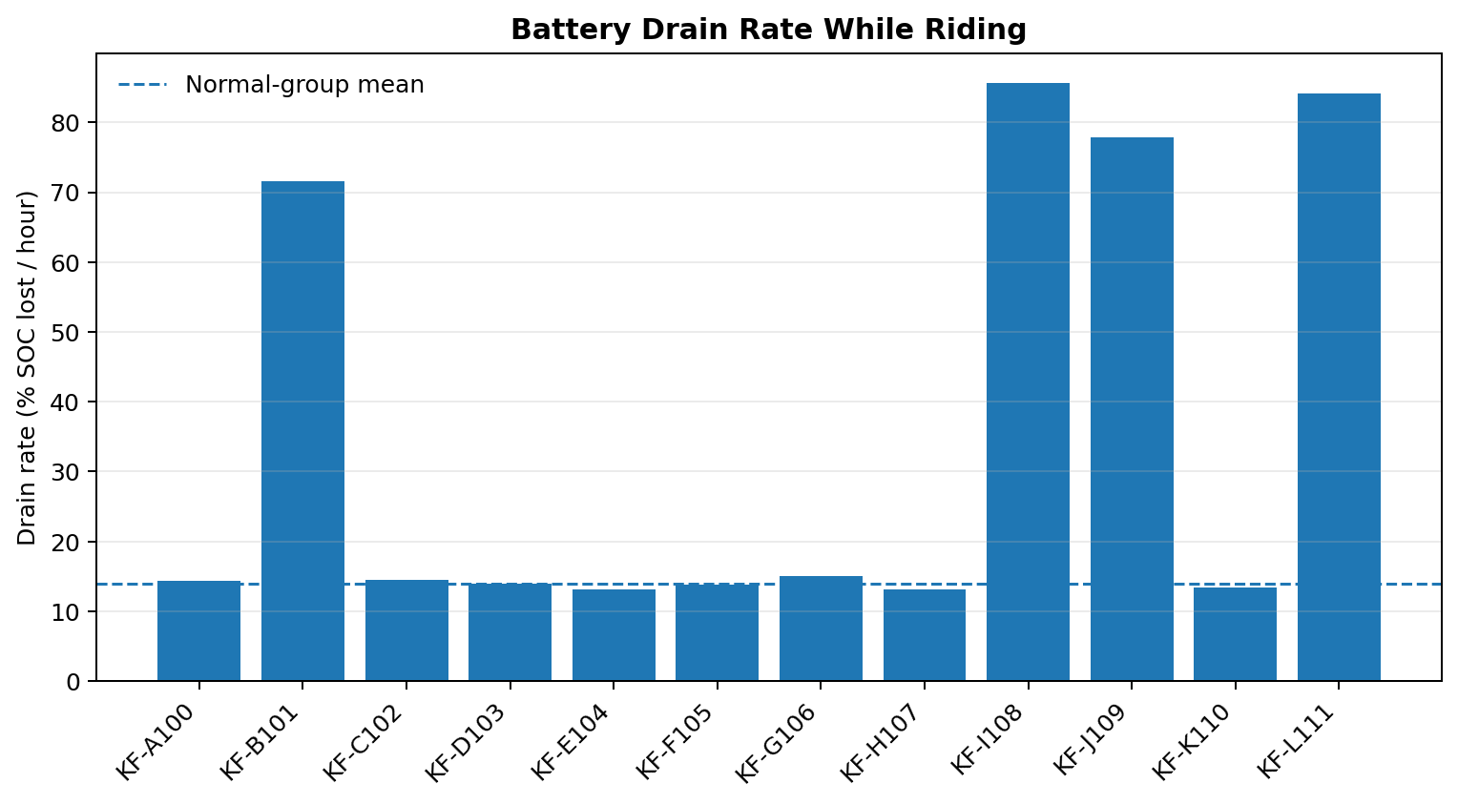
Figure 1. Drain rate by battery. Four batteries sit far above the normal cluster, showing the central operational problem.
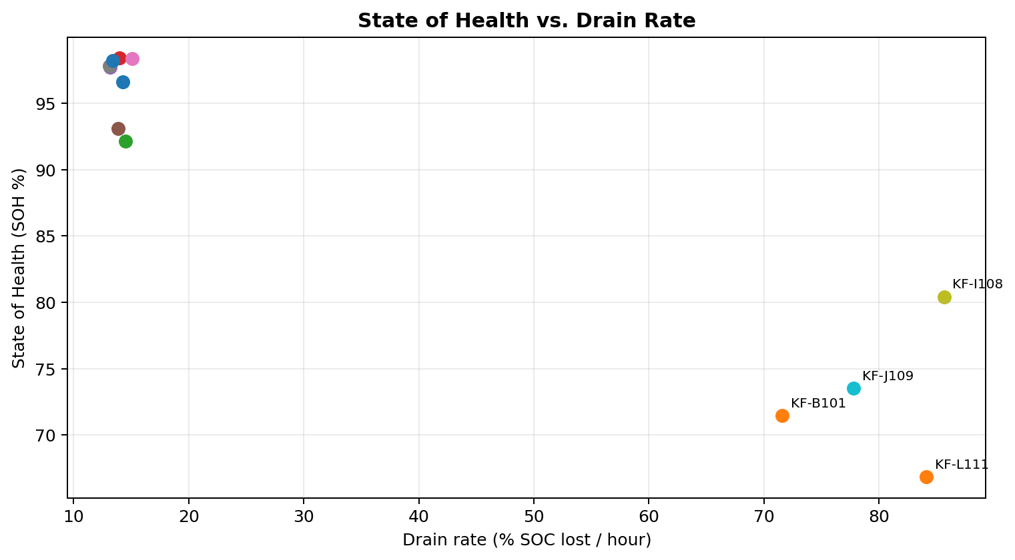
Figure 2. SOH versus drain rate. The batteries with the most severe drain also have lower reported SOH.
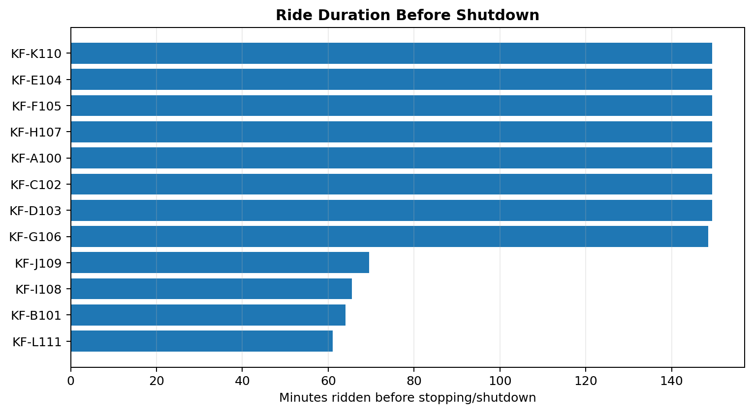
Figure 3. Ride duration before shutdown. The four flagged batteries stop far earlier than the normal group.
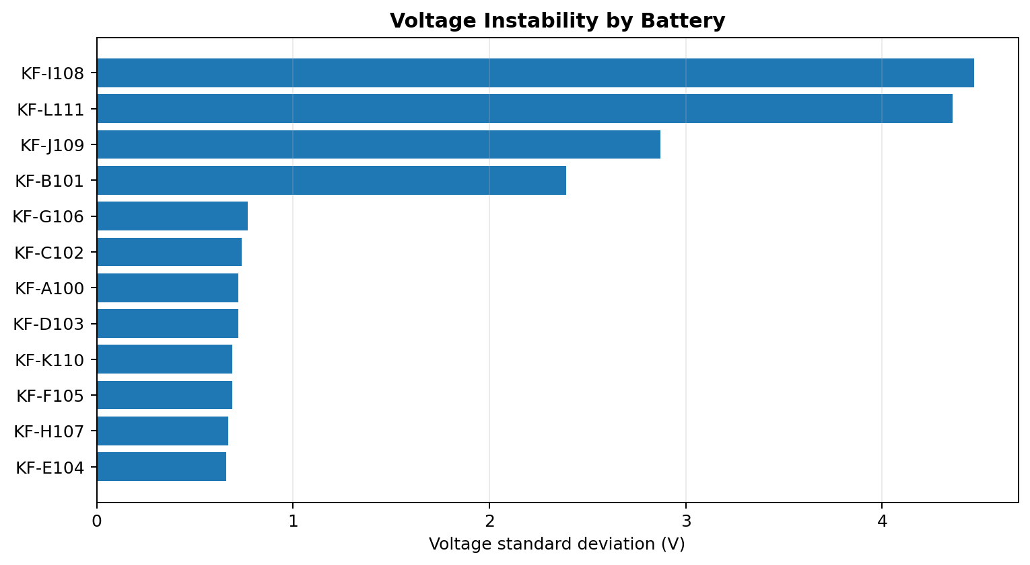
Figure 4. Voltage instability. Higher standard deviation indicates a less stable voltage signal while riding.
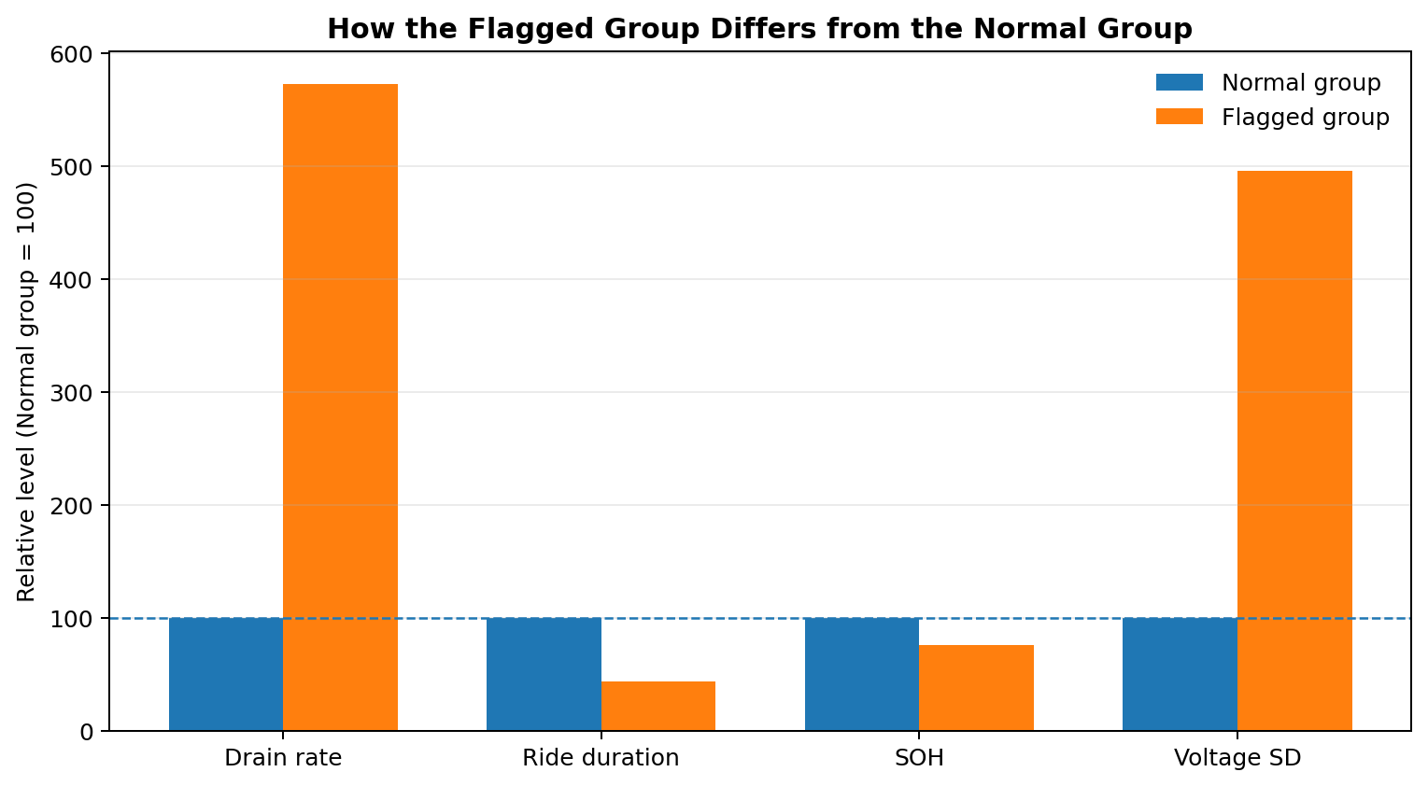
Figure 5. Relative group comparison. The flagged group drains faster, rides for less time, has lower SOH, and shows much greater voltage variability.
The dashboard is supported by the analytical visuals generated in the notebook. These figures are used in the documentation because they explain the battery behaviour directly: which batteries drain fastest, how the two groups separate, how long batteries remain in use, and how voltage behaves near shutdown.
Taken together, these visuals tell the story more clearly than interface images alone. The problem is not simply that four batteries have slightly lower health. They behave differently: they lose charge much faster, remain in service for a shorter period, and exhibit more unstable voltage. That combination is what makes the flagged group operationally important.
- Fleet Overview with total battery count, flagged count, average drain, and average healthy SOH.
- Battery Drain Rate Comparison with a visible safety/control threshold.
- SOH versus Drain Rate visualisation.
- SOC discharge trajectories across the fleet.
- Immediate-action cards for batteries marked for service withdrawal.
- Individual Battery Analysis with battery selection and detailed telemetry plots.
- Voltage-under-load and speed/current monitoring.
- Fleet Data Table with filtering by status and battery ID.
- Scan History for historical records, predictions, and confidence values.

11.3 Deployment Interpretation
The dashboard turns the analytical result into an operational workflow: identify the fleet status, drill into a specific battery, inspect telemetry behaviour, review historical scans, and prioritise batteries requiring action.
Metric consistency note: The dashboard screenshots display a fleet accuracy value of 99.6% and a header referencing K-Means + Random Forest. The supplied analytical notebook, however, documents K-Means clustering and statistical validation and does not contain a Random Forest training/evaluation section or an accuracy calculation. Therefore, this report does not present 99.6% as a validated notebook model metric. If the deployed app contains a separate Random Forest component, its code and evaluation should be added to the project repository/documentation.

Dataset consistency note: The screenshots show live/scan-history dates and dashboard values that differ from the notebook's 22 October 2025 analytical window. The dashboard should therefore be described as the deployed operational layer, while the notebook's 12-battery results are the basis for the documented CRISP-DM analytical findings.

12. Recommendations

12.1 Immediate Actions
- Pull KF-B101, KF-I108, KF-J109, and KF-L111 from service for engineering inspection.
- Perform cell-level and BMS diagnostics on the four flagged units.
- Cross-reference manufacturing dates, supplier batches, component lots, and maintenance history.
- Prioritise replacement or controlled quarantine for affected units rather than issuing a blanket fleet-wide response based on this sample alone.
- Screen additional batteries that exhibit the same rider-reported symptoms.

12.2 Operational Actions
- Integrate the battery-level screening logic into the live telemetry pipeline.
- Maintain a serial-number-level flagged list for Customer Service.
- Recalculate monitoring baselines as new batteries enter the fleet and older batteries age.
- Track ambient temperature and charging conditions alongside battery telemetry to separate battery faults from environmental/charging effects.
- Create an engineering queue linking flagged batteries to supplier and manufacturing metadata.

12.3 Governance and Communication
- Communicate battery decisions using measurable evidence rather than generic reassurance.
- Keep diagnostic findings internal until Engineering confirms the physical fault mechanism.
- Document every replacement, teardown result, and subsequent model decision so future supervised learning can use confirmed labels.

13. Limitations and Risks
Limitation / risk | Implication
Small sample | Only 12 batteries are analysed. The split is strong in this sample but cannot automatically be generalised to the entire fleet.
Single time window | The telemetry represents one approximately six-hour session rather than a longitudinal battery lifecycle.
Sensor dropout | Around 5% of values are missing in each numeric column; the randomness of missingness was not tested.
Self-reported SOH | SOH comes from the battery's own BMS rather than independent laboratory capacity testing.
No physical root cause | Telemetry identifies abnormal behaviour but cannot confirm a cell-level defect without engineering inspection.
k=2 assumption | Clustering-quality metrics do not all agree; the decision is supported by silhouette, cluster composition, domain framing, and the clear four-versus-eight structure.
Potential deployment drift | As the fleet grows, the distribution of normal and abnormal batteries may change, requiring periodic revalidation.

14. Future Improvements
- Collect multi-week or multi-month telemetry to study battery ageing and failure progression.
- Expand the sample from 12 batteries to hundreds or thousands of battery sessions.
- Investigate whether missingness itself is associated with battery faults.
- Add charging-cycle count, battery age, mileage, swap count, charging temperature, and maintenance history.
- Validate the flagged group with physical teardown results.
- Once confirmed fault labels exist, train a supervised classifier using real ground-truth labels rather than K-Means-generated labels.
- Compare K-Means with robust anomaly-detection methods such as Isolation Forest or other density/outlier approaches when the fleet grows.
- Create automated alerting when a battery crosses an operational threshold or is repeatedly assigned to the flagged cluster.
- Track model drift and recalibrate thresholds by geography, battery chemistry, season, and riding pattern.
- Add model explainability at battery level so users can see which signals contributed most to a flag.

15. Technical User Guide

15.1 Analytical Workflow
Stage | Action
1. Ingest | Load telemetry and parse timestamps.
2. Validate | Check row counts, battery IDs, missing values, and sensor ranges.
3. Prepare | Filter in-use records and compute battery-level behavioural features.
4. Explore | Review distributions, correlations, and SOC trajectories.
5. Model | Scale four core features and fit K-Means.
6. Validate | Use clustering-quality metrics, cluster composition, Mann-Whitney tests, and confound checks.
7. Interpret | Translate flagged serial numbers into engineering/customer-service actions.
8. Deploy | Score incoming battery summaries using the fitted scaler/model and expose results in the dashboard.
9. Monitor | Revalidate assumptions and model performance as the fleet changes.

15.2 Dashboard User Workflow
- Open Fleet Overview to assess the current fleet-level condition.
- Use Battery Drill-Down to select an individual battery.
- Review drain rate, ride duration, shutdown SOC, voltage variability, and SOH.
- Inspect SOC, voltage, speed, and current plots for behavioural evidence.
- Use the Fleet Data Table to filter batteries by status or ID.
- Use Scan History to review historical predictions and identify recurring faults.
- Escalate batteries marked for immediate action to Engineering according to operational policy.

15.3 Technical Stack
Component | Role
Python | Core analysis language
pandas | Data loading, cleaning, grouping, feature engineering
NumPy | Numerical calculations and regression-based slope estimation
Matplotlib | Exploratory and analytical visualisations
scikit-learn | StandardScaler, K-Means, clustering-quality metrics
SciPy | Mann-Whitney U significance testing
Jupyter Notebook | Reproducible analytical workflow
Streamlit | Interactive operational dashboard

16. Conclusion
The Kore2 battery project demonstrates how CRISP-DM can turn an operational complaint into a structured, evidence-based data science workflow. The analysis begins with a practical question—why are some batteries draining rapidly and shutting down unexpectedly—and progresses through data validation, feature engineering, anomaly detection, statistical evaluation, and deployment.
The strongest finding in the supplied notebook is the clean separation of four batteries from eight normal batteries. KF-B101, KF-I108, KF-J109, and KF-L111 show dramatically faster drain, shorter ride duration, lower SOH, and much greater voltage instability. Independent Mann-Whitney tests support the separation, while the ambient-temperature check does not support heat as the main explanation.
The appropriate operational response is targeted intervention and engineering confirmation, not an automatic fleet-wide recall. At the same time, the project should not be treated as finished: the sample is small, the observation period is short, and physical root-cause confirmation is still required. The greatest long-term value is the repeatable monitoring capability represented by the deployed dashboard and the fitted analytical workflow.
Final project message: Identify abnormal batteries early, validate the evidence from multiple signals, confirm the physical cause, and integrate the screening process into daily fleet operations.

Appendix A. Battery-Level Results
Battery ID | Group | Drain %/hr | Ride min | SOC shutdown | SOH % | Voltage SD
KF-I108 | Flagged | 85.65 | 65.5 | 6.83 | 80.42 | 4.47
KF-L111 | Flagged | 84.1 | 61.0 | 12.9 | 66.85 | 4.36
KF-J109 | Flagged | 77.8 | 69.5 | 11.89 | 73.52 | 2.87
KF-B101 | Flagged | 71.57 | 64.0 | 21.59 | 71.45 | 2.39
KF-G106 | Normal | 15.07 | 148.5 | 61.89 | 98.36 | 0.77
KF-C102 | Normal | 14.5 | 149.5 | 63.06 | 92.13 | 0.74
KF-A100 | Normal | 14.31 | 149.5 | 63.55 | 96.63 | 0.72
KF-D103 | Normal | 14.0 | 149.5 | 64.67 | 98.41 | 0.72
KF-E104 | Normal | 13.87 | 149.5 | 65.13 | 93.07 | 0.69
KF-K110 | Normal | 13.42 | 149.5 | 66.23 | 98.23 | 0.69
KF-F105 | Normal | 13.16 | 149.5 | 66.87 | 97.73 | 0.66
KF-H107 | Normal | 13.12 | 149.5 | 67.36 | 97.81 | 0.67

Source: supplied CRISP-DM notebook battery-level summary. Values are rounded from the notebook outputs.

Appendix B. How to Read the Key Visualizations
The figures in Section 11 are intended to answer five simple questions. Are some batteries draining much faster? Do those same batteries have lower SOH? Do they stop riding sooner? Is their voltage less stable? And, when the groups are viewed together, is the difference large enough to matter operationally? In this sample, the answer to all five questions is yes.
- Figure 1 focuses on the most immediate operational symptom: rapid loss of charge.
- Figure 2 links battery health to observed behaviour, rather than treating SOH as an isolated percentage.
- Figure 3 shows the practical consequence for rider uptime: the flagged batteries do not sustain the normal riding period.
- Figure 4 provides supporting evidence from voltage behaviour under load.
- Figure 5 puts the four signals on a common scale so the overall difference between the two groups is easy to explain.

