MITCHELLE MUMBUA NGUTA
KIT/GS/046/24
Browser Environment version
index.html
<!DOCTYPE html>
<head>
<title>STUDENT GRADE CALCULATOR</title>
</head>
<body>
<h1> STUDENT GRADE CALCULATOR</h1>
<form id = "gradeForm">
<label for = "studentname">Student Name: </label>
<input type = "text" id="studentname" required><br><br>

<label for ="programming">PROGRAMMING: </label>
<input type ="number" id = "programming" min = "0" max="100" required><br><br>

<label for = "mathematics">MATHEMATICS: </label>
<input type=" number" id ="mathematics" min ="0" max="100" required><br><br>

<label for = "networking">NETWORKING: </label>
<input type = "number" id="networking" min ="0"max="100" required><br><br>

<label for = "database">DATABASE: </label>
<input type = "number" id ="database" min="0" max="100" required><br><br>

<button type = "submit">CALCULATE GRADE</button>
</form>
<div id="result"></div>
<script src="script.js"></script>

</body>
</html>

script.js
const gradeForm = document.getElementById("gradeForm");
const result = document.getElementById("result");

const getGrade = (average) =>{
if (average >= 70) {
return "A";
}
else if (average >= 60){
return "B";
}
else if (average >= 50){
return "C";
}
else if (average >= 40){
return "D";
}else {
return "F";
}
};

const calculateTotal = (marks) => {
let total =0;
for (const mark of marks) {
total += mark;
}
return total;
};

gradeForm.addEventListener("submit",(event)=>{
event.preventDefault();
try{
const studentName = document.getElementById("studentname").value;
const programming = Number(document.getElementById("programming").value);
const mathematics = Number(document.getElementById("mathematics").value);
const networking = Number(document.getElementById("networking").value);
const database = Number(document.getElementById("database").value);

const marks = [programming, mathematics, networking, database];
for(const mark of marks) {
if(mark<0 || mark >100 || isNaN(mark)){
throw new Error("Marks must be between 0 and 100");
}
}

const total = calculateTotal(marks);
const average = total / marks.length;
const grade = getGrade(average)

result.innerHTML = `
<h2>Student Results</h2>
<p><strong>Name: <strong> ${studentName}</p>
<p><strong>Programming: <strong> ${programming}</p>
<p><strong>Mathematics: <strong> ${mathematics}</p>
<p><strong>Networking: <strong> ${networking}</p>
<p><strong>Database: <strong> ${database}</p>
<p><strong>Total Marks: <strong> ${total}</p>
<p><strong>Average Marks: <strong> ${average}</p>
<p><strong>Grade: <strong> ${grade}</p>
`;
console.log(`Results for ${studentName}`);
console.log( `Total: ${total}, Average: ${average}, Grade: ${grade}`);
}
catch(error){
result.innerHTML=`<p style="color:red;">Error: ${error.message}</p>`;
console.error(error);
}

});

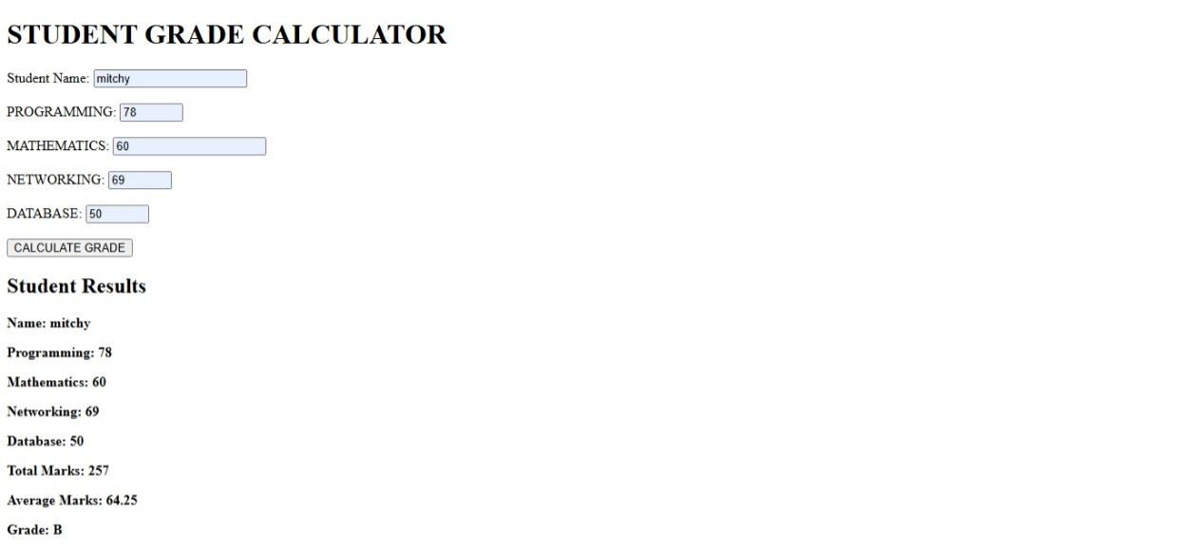

Node.js Environment version
gradeCalculator.js
//Import the readline module to read input from the console
const readline = require("readline");
//Create an interface for terminal input and output
const r1 = readline.createInterface({
input: process.stdin,
output: process.stdout,
});
//Function to calculate the grade based on average marks
const getGrade = (average)=>{
if(average >= 70){
return "A";
}
else if (average >= 60){
return "B";
}
else if (average >= 50){
return "C";
}
else if (average >= 40){
return "D";
}
else {
return "F";
}
};
//Function to calculate the total marks from an array of marks
const calculateTotal = (marks) => {
let total = 0;
for (const mark of marks) {
total += mark;
}
return total;
};
//Ask for the student's name and marks for each subject, then calculate and display the results
r1.question("Enter student name: ",(studentName)=>{
try{
r1.question("Enter Proramming mark: ",(programmingInput)=> {
r1.question("Enter Mathematics mark: ",(mathematicsInput)=>{
r1.question("Enter Networking mark: ",(networkingInput)=>{
r1.question("Enter Database mark: ",(databaseInput)=>{

const programming = Number(programmingInput);
const mathematics = Number(mathematicsInput);
const networking = Number(networkingInput);
const database = Number(databaseInput);

const marks=[programming,mathematics,networking,database];

for(const mark of marks){
if(isNaN(mark) || mark < 0 || mark > 100 ){
throw new Error("Marks must be numbers between 0 and 100.");
}
}
const total = calculateTotal(marks);
const average = total / marks.length;
const grade = getGrade(average);

console.log(`Results for ${studentName}`);
console.log('\n****************************************\n');
console.log(`Name: ${studentName}`);
console.log(`Programming: ${programming}`);
console.log(`Mathematics: ${mathematics}`);
console.log(`Networking: ${networking}`);
console.log(`Database: ${database}`);
console.log(`Total Marks: ${total}`);
console.log(`Average Marks: ${average}`);
console.log(`Grade: ${grade}`);
console.log('\n****************************************\n');
r1.close();
});
});
});
});
}
catch(error){
console.error("Error:", error.message);
r1.close();
}
});

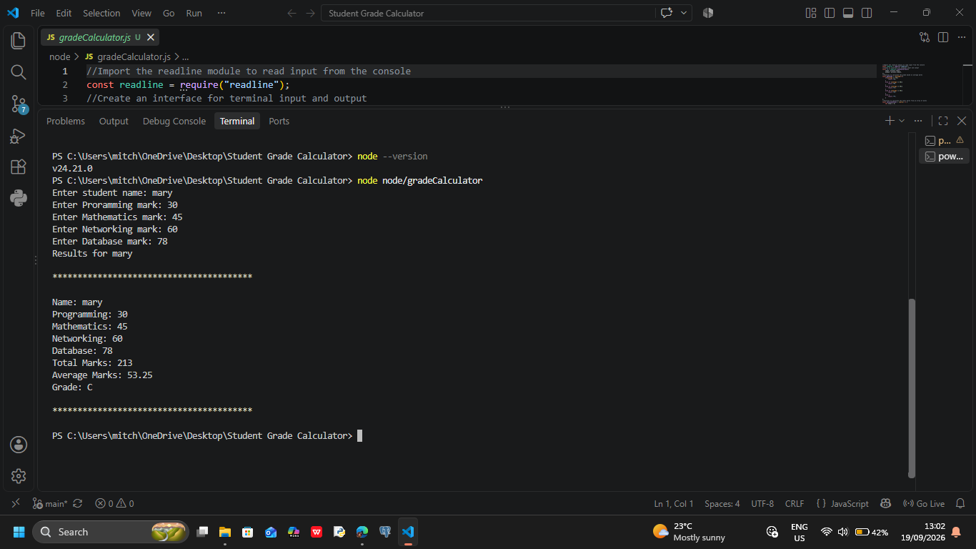
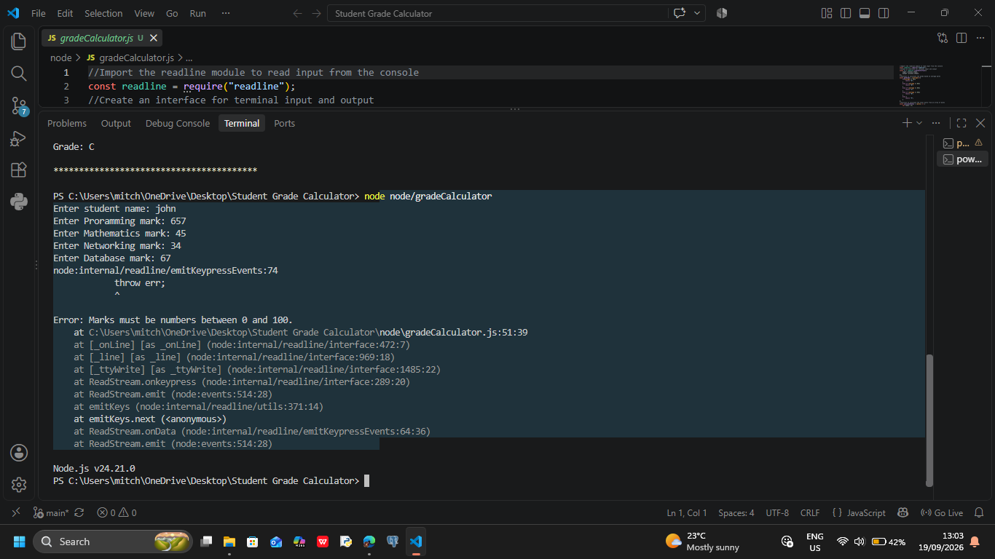

COMPARISON OF BROWSER ENVIRONMENT VERSION AND Node.js ENVIRONMENT
The Student Grade Calculator was developed using JavaScript and tested in both a web browser and Node.js environment.The main calculation logic was kept similar in both versions,while the methods used to obtain input and display output were changed according to the environment.
FEATURE | BROWSER ENVIRONMENT | Node.js ENVIRONMENT
Execution | The JavaScript code is executed by the browser when the HTML page is opened. | The JavaScript file is executed using the Node.js runtime from the terminal.
User input | Input is obtained from HTML form fields using the DOM and document.getElementById() | Input is obtained from the terminal using Node.js readline module.
Output | Results are displayed on the web page using the DOM and innerHTML | Results are displayed directly in the terminal using console.log()
Debugging | Browser Developer Tools and the console can be used to inspect erroes and output | Terminal output and console.log(),console.error() can be used to test and debug the program
DOM access | The browser provides access to the DOM,allowing JavaScript to interact with elements. | Node.js does not provide the browser DOM because it is not running inside a web page.
window object | Browser JavaScript prrovides browser-specific objects such as window | Node.js does not provide the browser window object by default
Environment-specific | Provide access to browser features such as the DOM,forms,buttons and browser Developer Tools | Provides access to servver-side and system-level capabilities such as filr system,terminal input/output and Node.js modules
Input/output modifications | The browser version uses HTML elements and DOM methods for interaction | The Node.js version uses readline and the terminal instead of HTML and the DOM

SIMILARITIES
Both versions use the same basic programming concepts and calculation logic.They use variables declared with let and const,functions,arrow functions,arrays,conditional statements,loops,template literals and error handling.
For example:Both versions store the subject marks in an array,calculate the total,calculate the average and determine the student’s grade.

DIFFERENCES OBSERVED
The main difference was how the program interacts with the user.The browser version requires an HTML page and uses the DOM to obtain input and display results.The Node.js versions does not require HTML and instead obtains input directly from the terminal.
The browser environment also provides browser-specific features such as the DOM and window object.Node.js provides its own runtime features and modules,such as the readline module used in this project for terminal input.

