# **I. Introduction**

## **1. Product Background**

In the current economic situation, we can see more and more young people have to leave home to live in the city. And one of their accommodation options is apartments, and one of the most popular types of apartments is Vinhomes. According to our survey, there are not many platforms that provide apartment cleaning services today and most of them also lack some functions of an ecommerce service platform such as saving order information, according to worker monitoring or service evaluation, which must be contacted via a hotline in order to book a service.

## **2. Business Opportunity**

Therefore, our team developed this app to provide a service booking platform for a cleaning company targeting Vinhomes residents that can be used to conveniently manage orders, workers and customers.

Customers can first create an account and choose a service that suits them, then choose a payment method and time frame for cleaning.

On the workers side, after signing a labor contract with the enterprise, they will be provided with an account from which they will be able to see their work schedule depending on the order, the worker after completing the work. then they will be able to confirm the order, in case the customer cannot be contacted, they can also ask the admin to cancel the order. In addition, they can also apply for leave on our app.

Company employees, can view and accept or reject leave applications or order cancellation requests. View monthly reports and manage customers, workers, add or remove services

# **II. Overall Description**

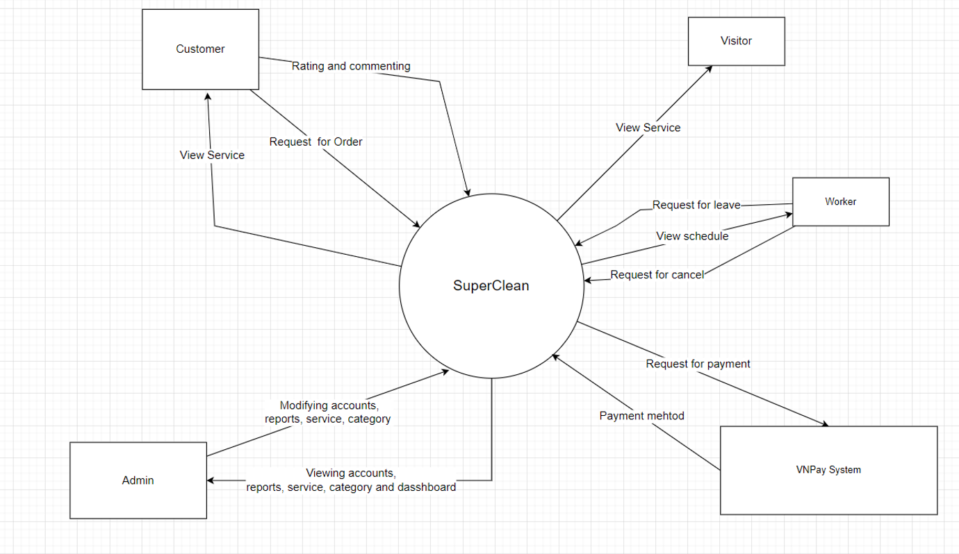

# **III. User Requirements**

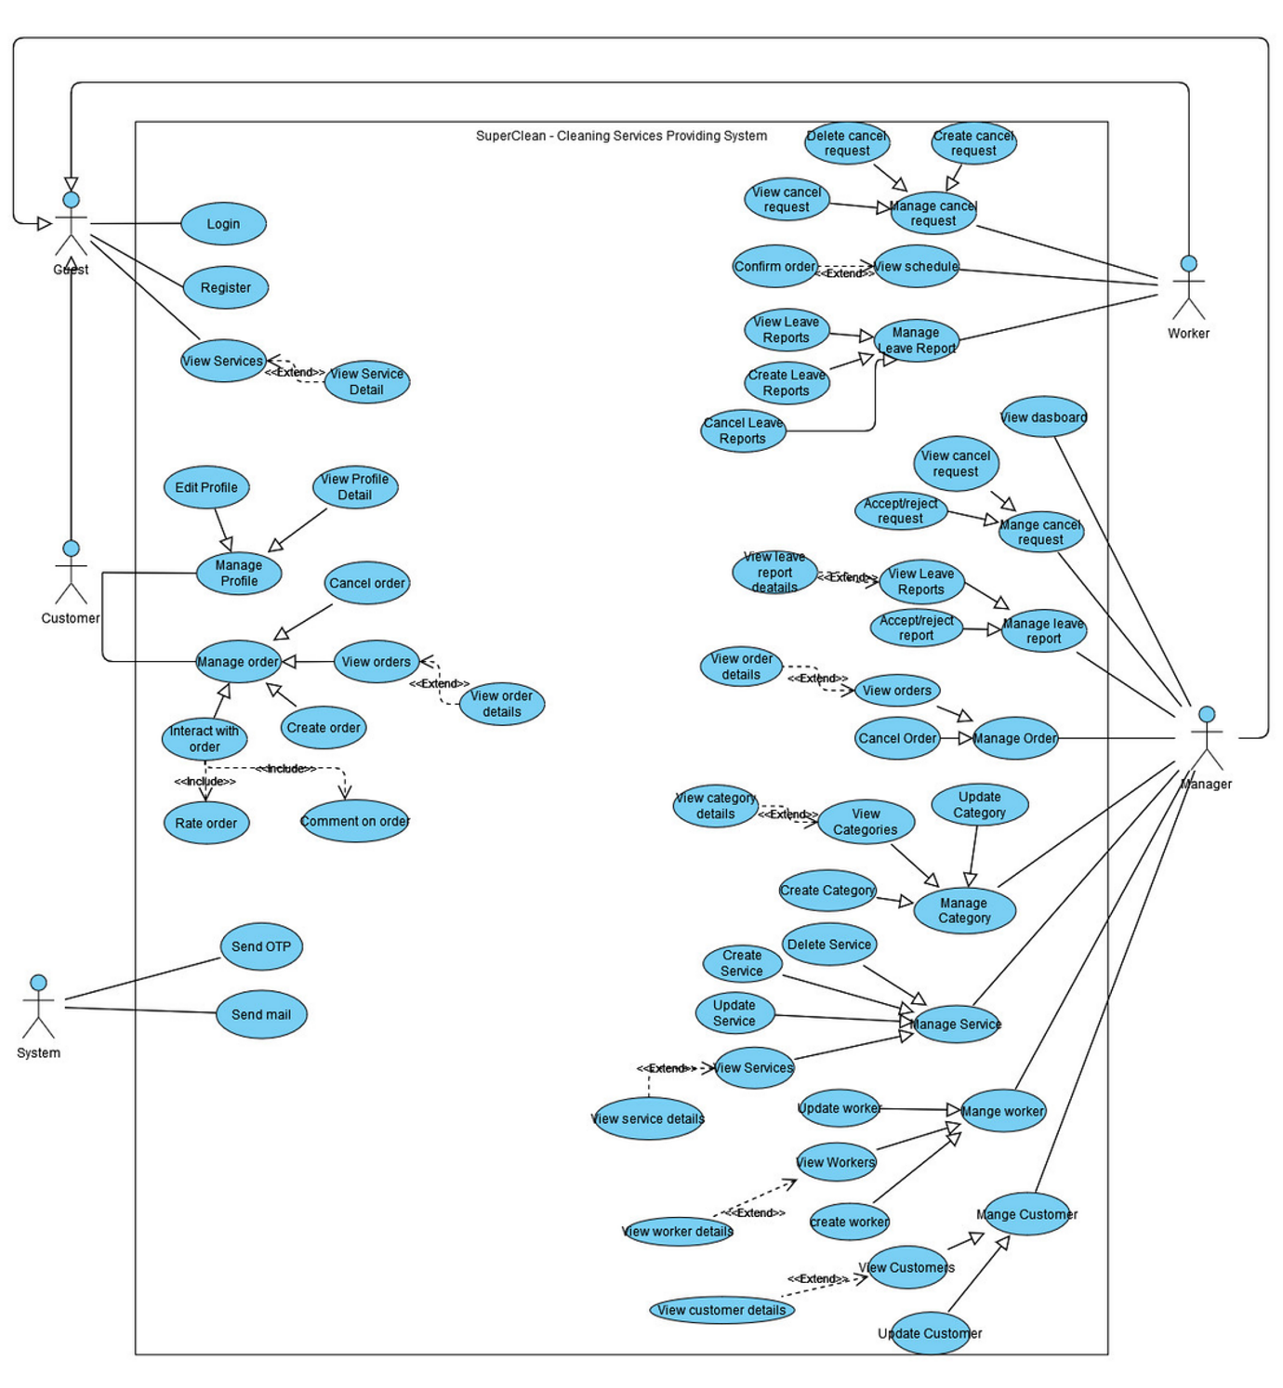

# **IV. Functional Requirements**

I.Screen Flows

1.Customer

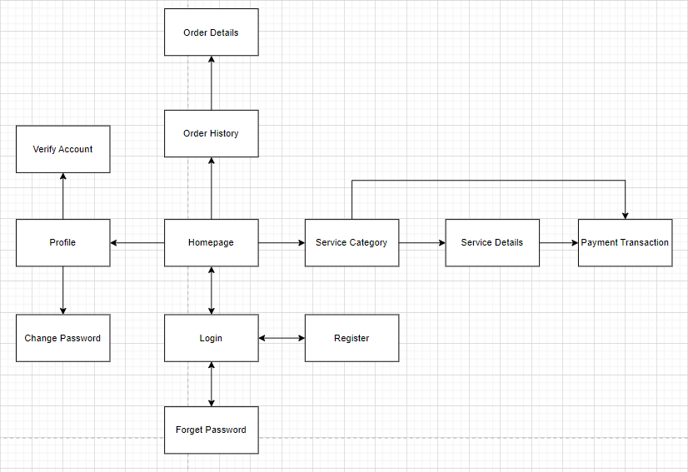

2.Worker

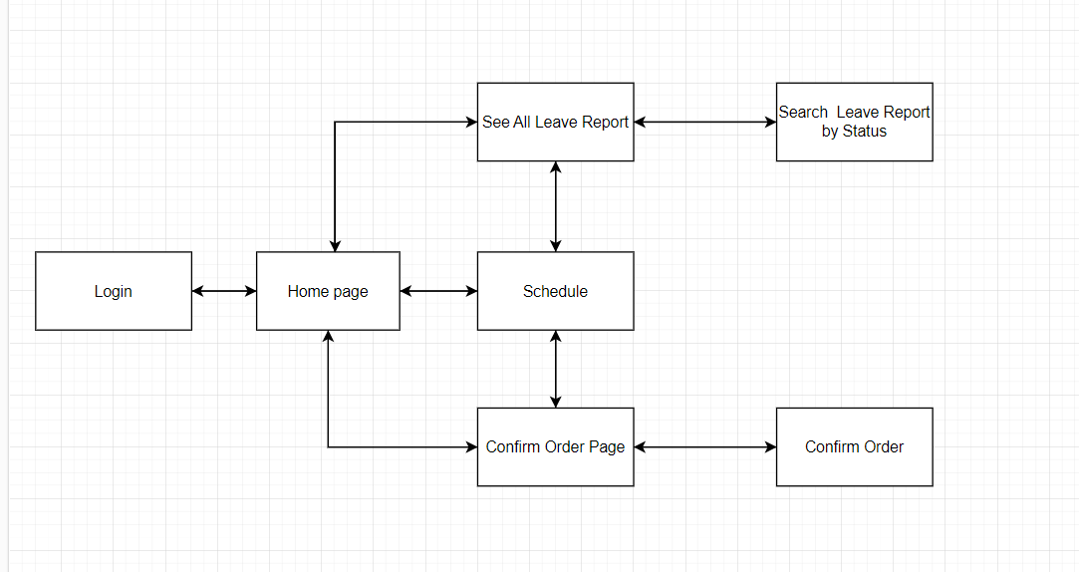

3.Manager

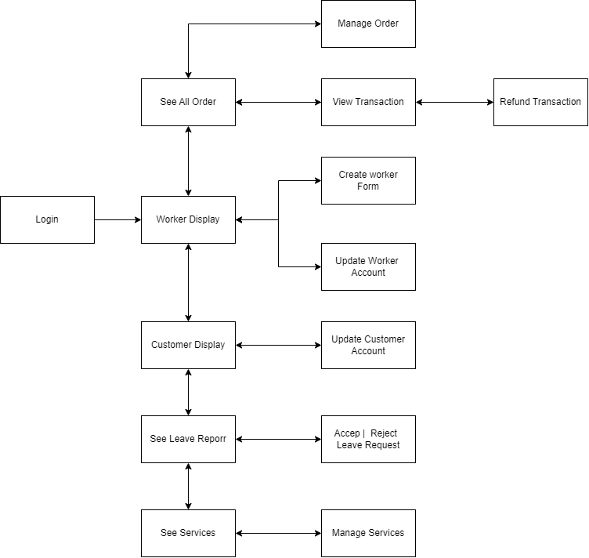

1. Functionals Requirement list

|  |  |  |  |
| --- | --- | --- | --- |
| **#** | **Screen** | **Feature** | **Description** |
| FR-01 | Login | Login | Allow customer to login with their username and password |
| FR-02 | Register | Register | Allow customer to register new account with email, phone numbers and some necessary information |
| FR-03 | Forget Password | Reset Password | Allow customer to reset their password in case they forget |
| FR-04 | Homepage | Logout | Logout of the web app |
| FR-05 | Homepage | Manage service category | View all services that provided by the company |
| FR-06 | Profile manager | Manage profile | Edit profile information and avatar |
| FR-07 | Change Password | Manage profile | Allow customer to change password |
| FR-08 | Verify Account | Manage profile | Verify the account to use the system |
| FR-09 | Order History | Manage Order | View all customer’s order |
| FR-10 | Order Details | Manage Order | View details of specific order chosen by customer |
| FR-11 | Order Details | Rate and Comment on Order | Rate and Review order after completion |
| FR-12 | Service Category | Manage Service Category | View list of services based on category |
| FR-13 | Service Details | Manage Service | View the details of a serviceservice |
| FR-14 | Payment Transaction | Payment | Online banking options |
| FR-15 | See all order | Manage Order | View all order |
| FR-16 | See all order | Manage Order | Cancel Order |
| FR-17 | View Transaction | Manage Transaction | Perform transaction |
| FR-18 | Worker Display | Manage Worker | View all Worker |
| FR-19 | Worker Display | Sort table | Sort Workers by category |
| FR-20 | Worker Display | Manage worker’s information | Update worker’s working status |
| FR-21 | Worker Display | Manage worker’s information | In-active worker’s account |
| FR-22 | Create Worker Form | Manage worker’s information | Create New worker |
| FR-23 | Customer Display | Manage Customer information | View all current Customer Account |
| FR-24 | Customer Display | Manage Customer information | In-active customer account |
| FR-25 | Customer Display | Sort Table | Sort customer by category |
| FR-26 | Update Customer | Manage Customer information | Update customer information |
| FR-27 | Update Customer | Manage Customer Information | Block Customer Account |
| FR-28 | Update Customer | Manage Customer information | Manual Set enable Customer Account |
| FR-29 | Services | Manage Service | View All Current Service |
| FR-30 | Services | Manage Service | Add Service available |
| FR-31 | Services | Manage Service | Disabled-service |
| FR-32 | Services | Manage Service | Update service information |
| FR-33 | Schedule | View Schedule | View schedule of the week |
| FR-34 | Leave Report | Manage Report | Create a report for days-off |
| FR-35 | Leave Report | Manage Report | View all leave report |
| FR-36 | Leave Report | Manage Report | Reject or accept leave report |
| FR-37 | Confirm Order Page | Manage Order | Confirm order after finishing work |
| FR-38 | Send email | On refund | Send email when admin refund or cancel order |
| FR-39 | Send email | On finish order | Send email to customer when worker confirm finish order |
| FR-40 | Send email | On enable account | Send email to customer to enable account |
| FR-41 | Send email | On Enable account | Send sms OTP to Enable account |
| FR-42 | Send sms | On finish order | Send sms when worker confirm finish order |
| FR-43 | Auto cancel order | On predefined timeout | Automatically cancel order when customer dont paid their order in-time |

**1. Login (screenshot)**

1.1 Login

* Function trigger: Clicks on “Login” to login the web app
* Function description: Actors will be redirected to the page based on the predefined role in the database

**2. Register (screenshot)**

2.1 Register

* Function trigger: Clicks on “Register” on the Login page, type in all the necessary information and clicks “Register” on the Register page.
* Function description: Actor will get message “Your account has been registered” and wait for admin to verify the account before using.

**3. Forget password**

3.1 Forget password

* Function trigger: Clicks on “Forget password” on the Login page
* Function description: Actors will be redirected to Forget Password page where they will provided email to get reset password code.

**4. Logout**

4.1 Logout

* Function trigger: Clicks on “Logout” on the homepage
* Function description: Actors will be redirected to the Login page and need to login to go to homepage again.

**5. Manage Service Category**

5.1 View Service Category

* Function trigger: Service category will automatically show right after customer redirect to homepage
* Function description: Actor will have the ability to view all service categories and brief descriptions of each category.

**6. Manage Profile**

6.1 Profile manager

* Function trigger: Clicks on “Profile” to go to profile page
* Function description: Actor will redirect to profile page where they can edit all personal information.

6.2 Change password

* Function trigger: Clicks on “Edit” in profile page to change password.
* Function description: Actor will be able to change password and use it for next login

**8. Verify account**

8.1 Verify account

* Function trigger: Clicks on “Edit” on Account table in admin dashboard
* Function description: Admin will have ability to verify all accounts for customers, managers and workers

**9. Manage Order**

9.1 Order History

* Function trigger: Clicks on “Orders” on the homepage
* Function description: Actor will be redirect to order page that shows all orders that are pending, completed or cancelled. Actor can also view each status and re-order, and finish payment if necessary.
* Screen layout: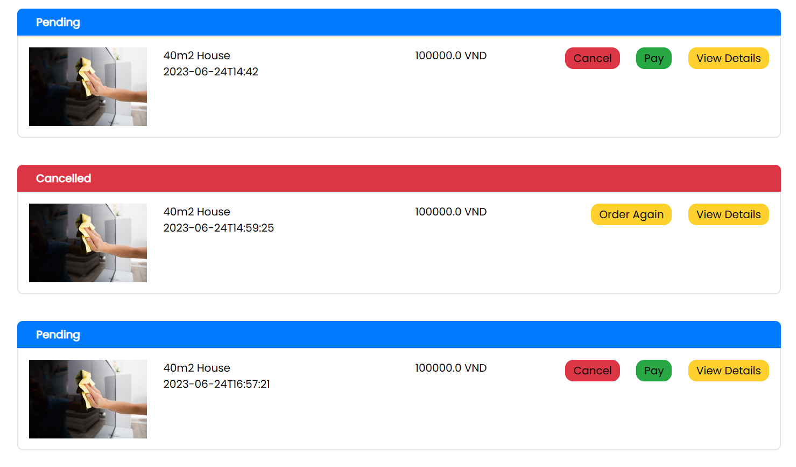

9.2 Order Detail

* Function trigger: Clicks on “View Detail” on specific order
* Function description: Actor will be redirected to the order detail page where all information related to that order (name, date, workers, payments,...) are shown. Actor also can re-order in this page
* Screen layout:

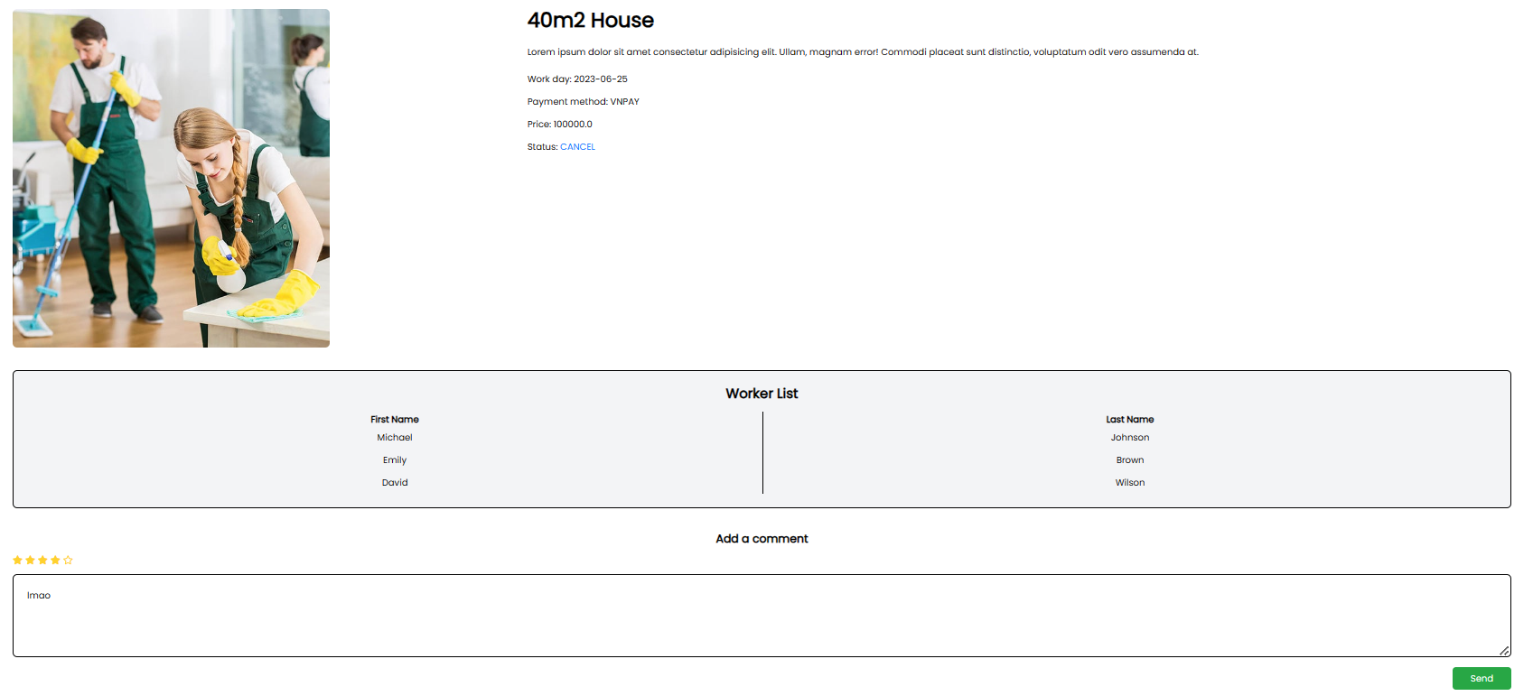

9.3 Confirm Order

* Function trigger: Clicks on “Confirm Order” on specific order
* Function description: Actor will select a picture to prove that the work successfully and confirm the order.

**11. Rate and Comment on Order**

### 11.1 Rate and Comment on Order

* Function trigger: Clicks on “Order History” choose a order, and select number of stars for that order, write a comment for that order and click “send”
* Function description: Actor want to leave a rating and comment on a order, when the service team have finished their work.
* Screen layout: 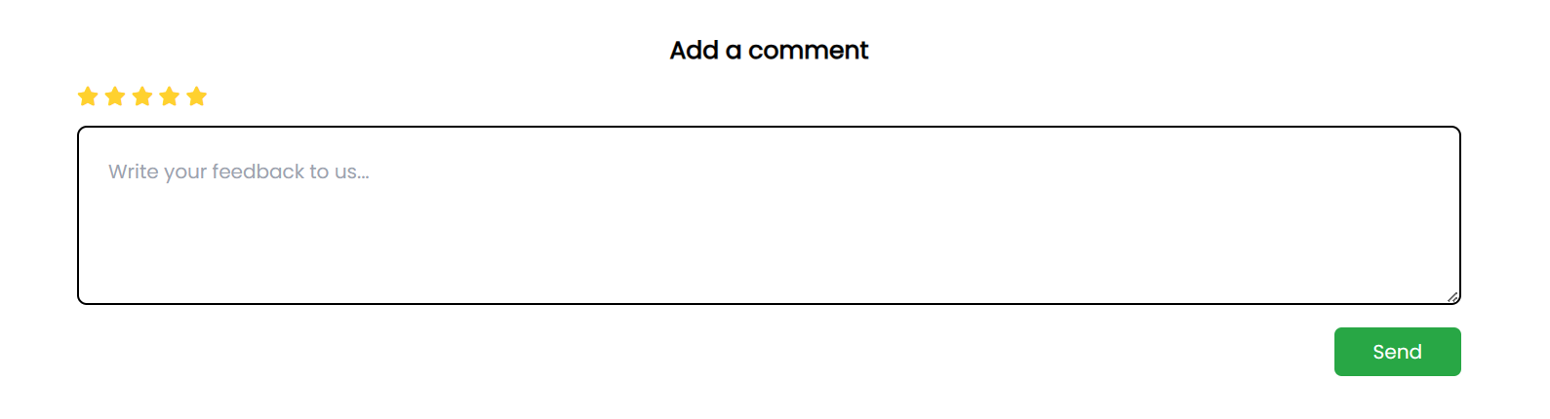
* Function Detail:

11.2 Update Rate and Comment on Order

**12. Manage Service Category**

12.1 Create Category

* Function trigger: Click on “Manage Category” in the navbar.
* Function description: Actor want to add new category, update information for a category, or delete a category
* Screen layout:.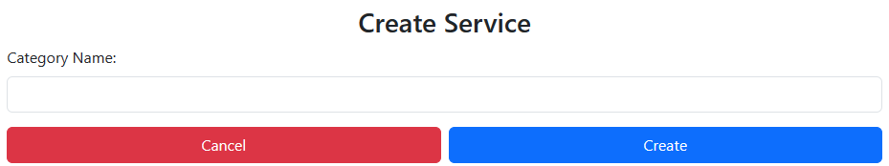

12.2 View All Category

* Function trigger: In Manage category page
* Function description: Actor wants to view all category
* Screen layout: 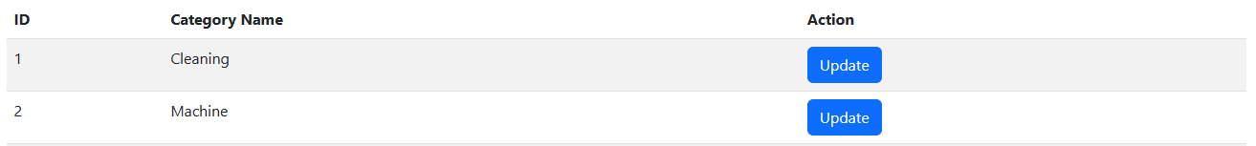

12.3 Update Category

* Function trigger: In Manage category page, click on the update button of the category wanting to update
* Function description: Actor wants to view all category
* Screen layout: 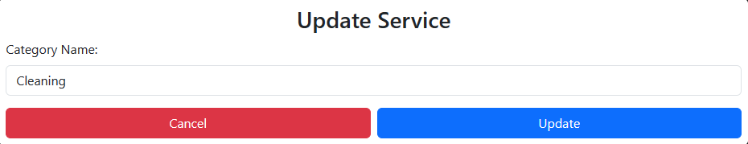

**13. Manage Service**

13.1 Service Details

* Function trigger: In the “Manage Category” click on “Manage Service” that belong that category, click a service and the detail about that service will be displayed.
* Function description: Actor want to see full detail about a service of a category..
* Screen layout:

### 

### 13.2 View all current service

* Function trigger: Click on the “view service” on navbar of admin page.
* Function description: Allow the admin to see all current services of the system
* Screen layout:

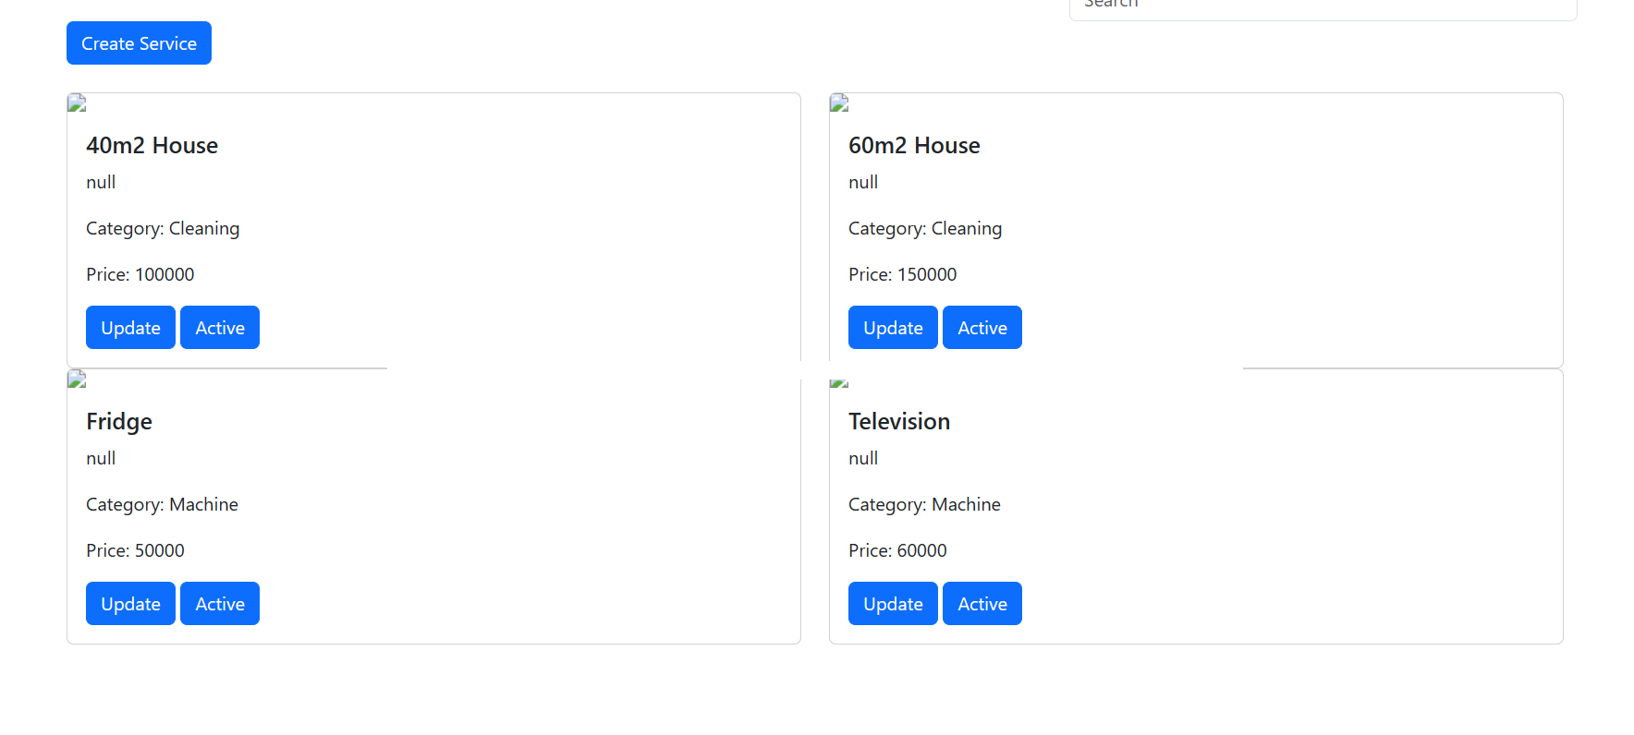

* Function details:

13.3 Add new service

* Function trigger:In Manage Service screen of admin, click on “Create Service” and a form appears for filling information.
* Function description: Admin wants to create a new service for the system
* Screen layout:

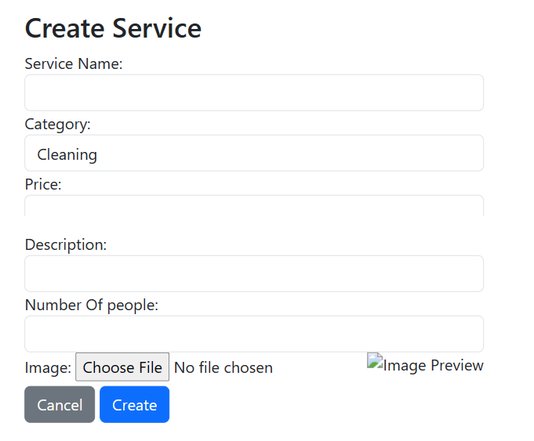

* Function details:

13.4 Disable service

* Function trigger: In Manage Service screen of admin, click on button “Active” or “Inactive”
* Function description: Make a specific service still in work or not in the system.
* Screen layout: 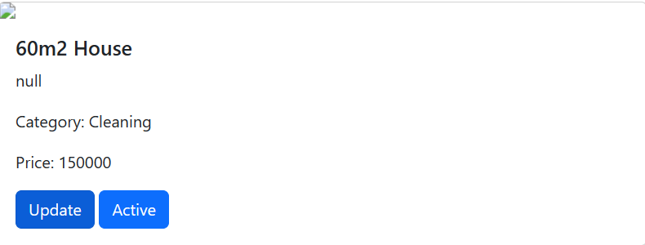
* Function details:

13.5 Update service’s information

* Function trigger: In Manage Service screen of admin, click on the update button of any service to open a form for filling order’s information
* Function description:

Screen layout: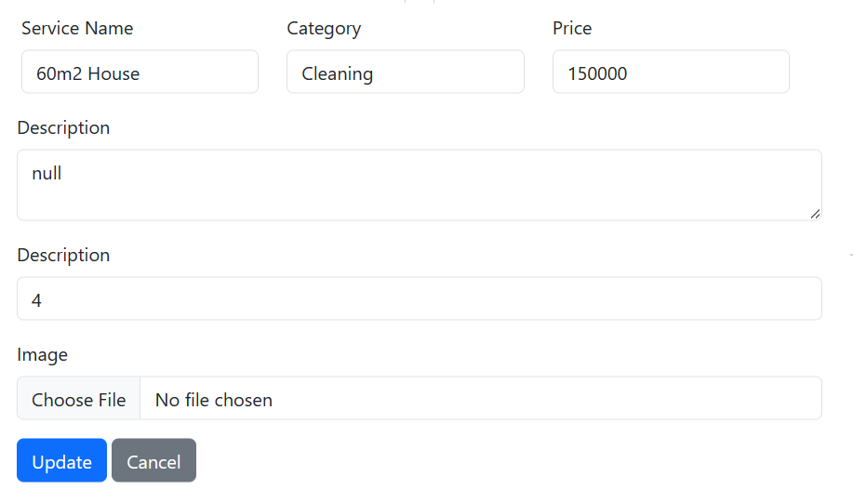

* Function details:

**14. Payment**

14.1 Payment Transaction

* Function trigger: Click “Order” on a service, there will be some payment option for actor to select.
* Function description: Actor want choose a type of payment for an order he/she about to order.
* Screen layout:

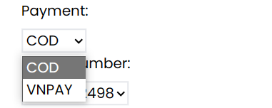

**16. Manage Transaction**

16.1 View Transaction

* Function trigger: Click “Manage Transaction” all the transaction that have been made will be displayed.
* Function description: Actor want to see all the transactions that have been made.
* Screen layout: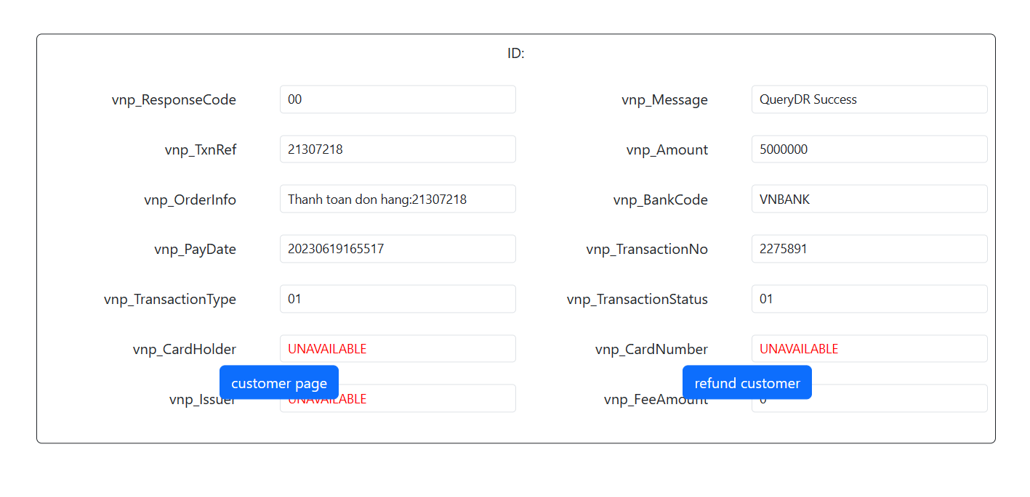

**18. Sort table**

18.1: Sort Customer By Column

* Function trigger: Press category beside search bar
* Function Description: Open a new page include customer personal information and verification
* Screen layout: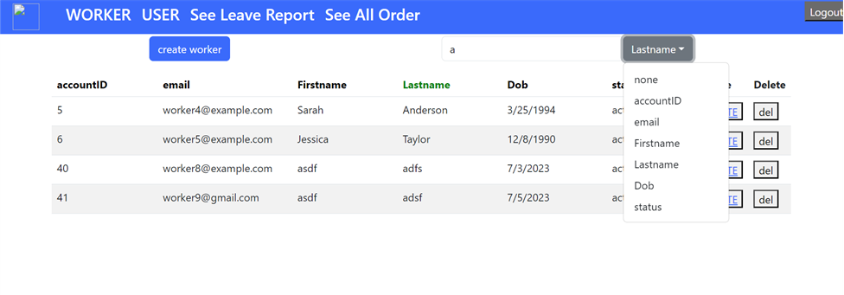

* Function Details:

Data: Information to sort, column choose to sort of none

Functionality: find text inside a row that matches the input, if a category is selected, then it only matches text that belongs to that particular columns, then hide all rows irrelevant, only display matches rows

**19. Manage worker’s information**

19.1:Update worker information

* Function trigger: Manager press button update at the end of rows
* Function Description: This opens a new page showing details of workers.
* Screen layout:

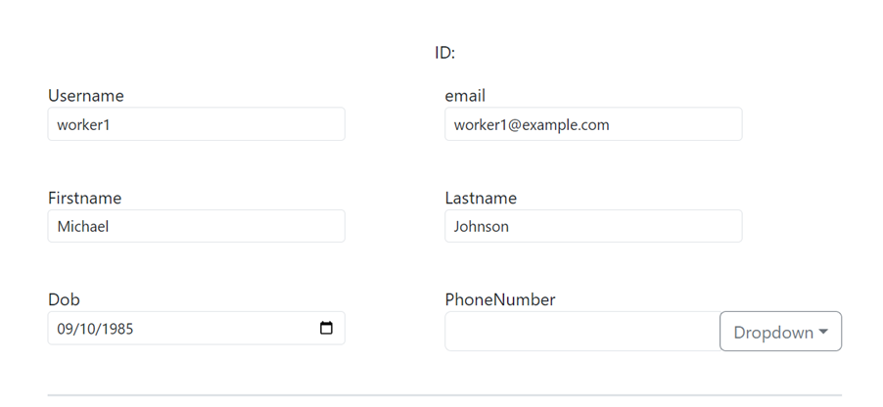

* Function Details:

Data: Account information

Validation: validate input if is correct to the predefined rules on server

Functionality: send a block of Json information back to the server to extract, validate, if successful, then redirect back to the worker display page.

19.2: Update worker status

* Function trigger: Press update button at the end of rows
* Function Description: Open news page, beside workers information, also include with his/her working status, then admin can update, change off days, change working point
* Screen layout:

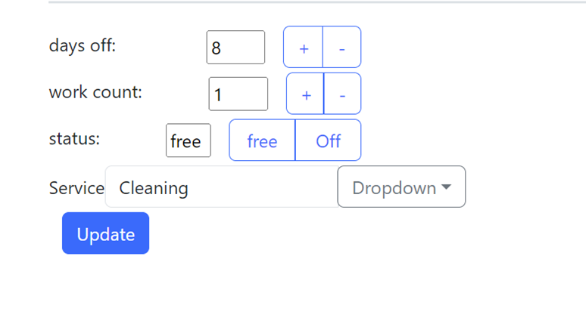

* Function Details:

Data: days off, work-count, status, service

Functionality: send this information back to server, then save to database, if success, redirect back to worker-display page.

19.3: Create New Worker

* Function trigger: Press create button under nav-bar
* Function Description: open a create form for worker, allow admin to
* Screen layout:

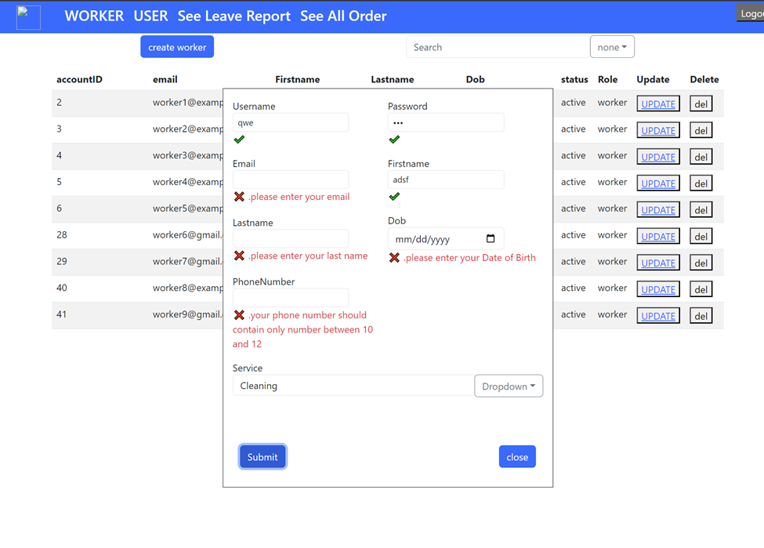

* Function Details:

Data: username, password, email, first name, last name, dob, phone number, service type

Validation: validate input if it is correct to the predefined rules on server, if correct format, then show a tick, if not display error in red font

Functionality: when open create form, manager fills in form then send back to server to validate, if success then it shall display alert to tell manager about it, then reload worker display page, else show error if any exception happens

**26. Manage customer**

### 26.1 Update customer’s information

Function trigger:

Function description:

Screen layout:

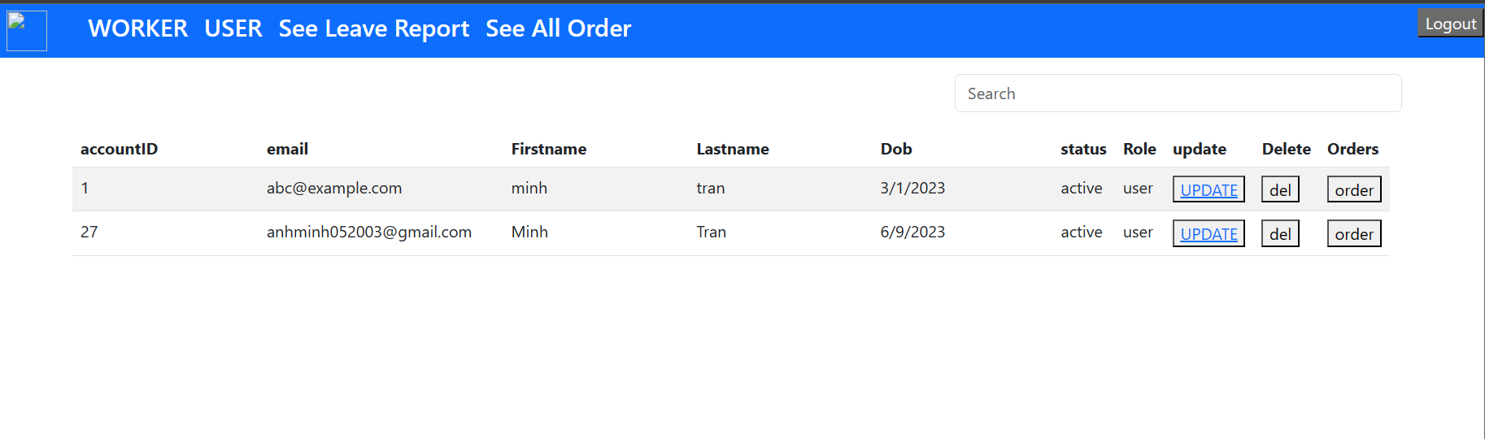

Function details:

26.2 Block/Unblock customer’s account

Function trigger:

Function description:

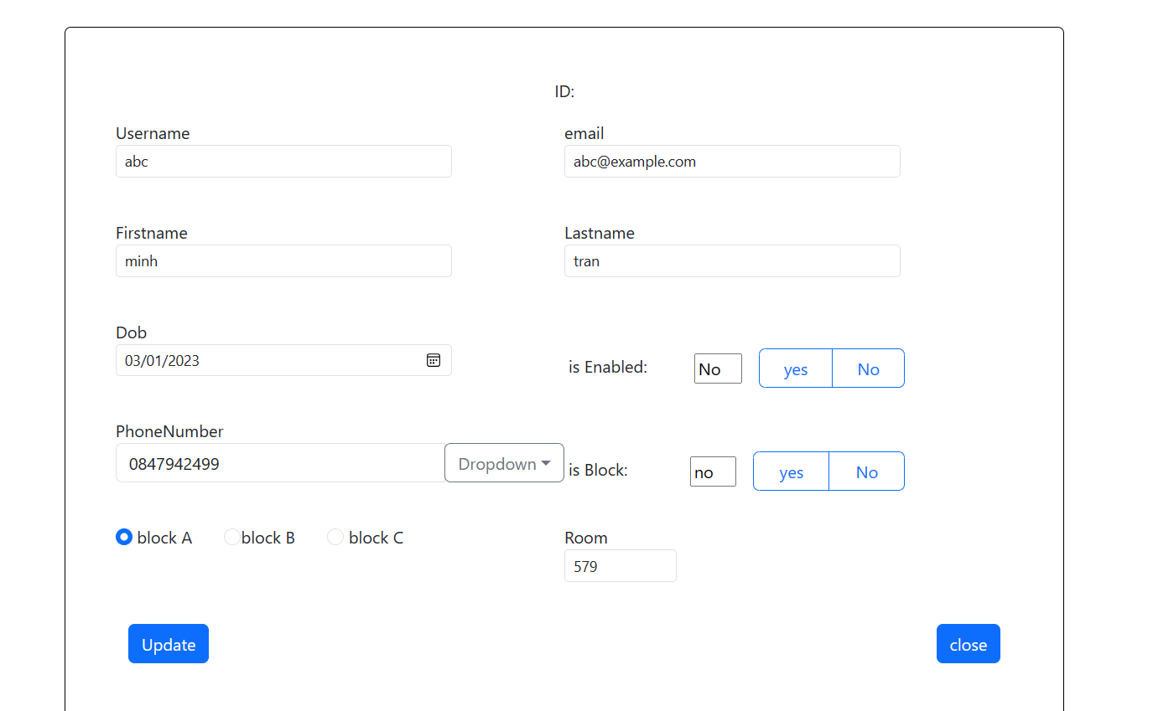

Screen layout:

Function details:

26.3 Manually set customer’s verification

Function trigger:

Function description:



Screen layout:

Function details:

26.4: Display All Customer Account

* Function trigger: Press Customer button on nav-bar
* Function Description: Display all current account of customer to admin
* Screen layout: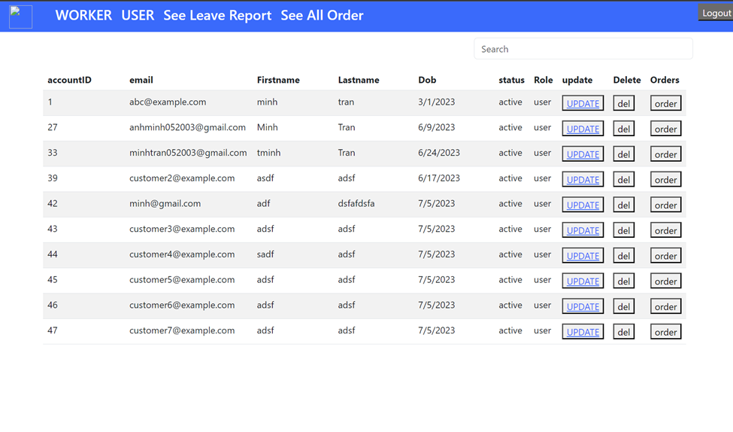
* Function Details:

Functionality: fetch request to server then receive json file, format information and apply it onto table then display to manager

26.5: Set Account Enable

* Function trigger: Press update at the end of rows account customer
* Function Description: Open a new page include customer personal information and verification
* Screen layout: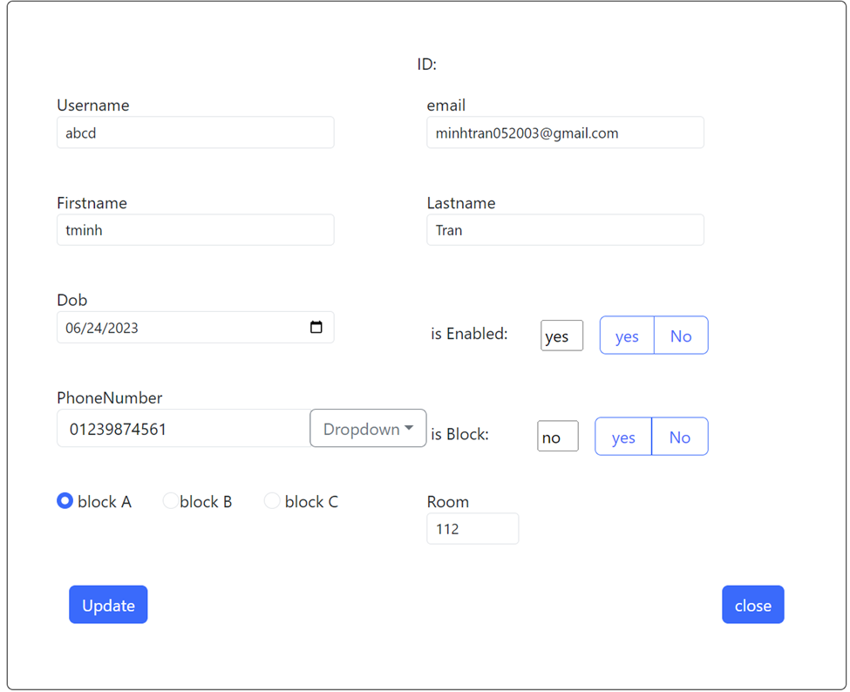
* Function Details:

Data: username, email, firstname, lastname dob, phone number, Boolean is enabled or is block

Validation: validate if input data is in correct format or if they

Functionality: send updated information back to server, then validate the input, if correct, then server update account, then redirect manager back to Display Customer page.

**33. View Schedule**

33.1 View Schedule for work

* Function trigger: After login as role worker
* Function description: Actor wants to see the schedule of the week or any week in a year.
* Screen layout:
* 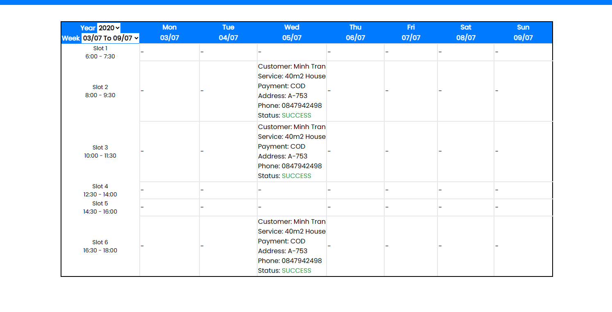

**34. Leave Report**

34.1 Create a leave report

* Function trigger: After login as role worker and in Leave report page click on “Create Leave report”
* Function description: Actor wants to see the schedule of the week or any week in a year.
* Screen layout:

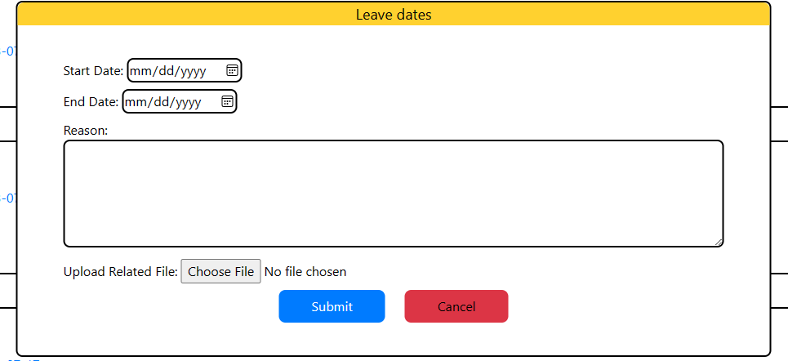

34.2 View leave reports

* Function trigger: After login as role worker and in Leave report page
* Function description: The actor see all the leave report and search by any status
* Screen layout:

