**Practical No.04**

**Q.A]Write a MongoDB query to create Replica of existing database.**

**1] Commands to start mongod at different ports:**

C:\>start mongod --storageEngine mmapv1 --replSet srm --dbpath \data\rs1 --logpath \data\rs1\1.log --port 37017 --smallfiles --oplogSize 64

C:\>start mongod --storageEngine mmapv1 --replSet srm --dbpath \data\rs2 --logpath \data\rs2\2.log --port 37018 --smallfiles --oplogSize 64

C:\>start mongod --storageEngine mmapv1 --replSet srm --dbpath \data\rs3 --logpath \data\rs3\3.log --port 37019 --smallfiles --oplogSize 64

**Output:**



**2] mongo instance at port 37017:**

C:\Windows\system32>mongo --port 37017

**Output:**

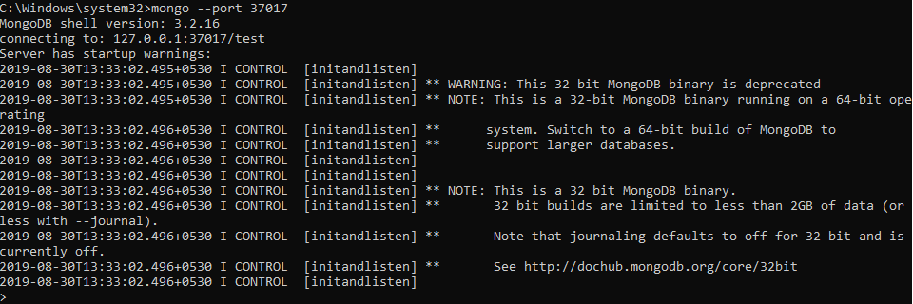

**3] Config:**

config={"_id":'srm',members:[{"_id":0,"host":"localhost:37017"},{"_id":1,"host":"localhost:37018"},{"_id":2,"host":"localhost:37019"}]}

**Output:**

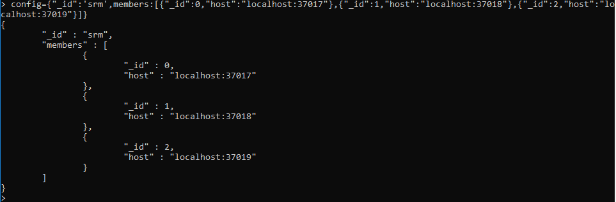

rs.initiate(config)

**Output:**



rs.status()

**Output:**

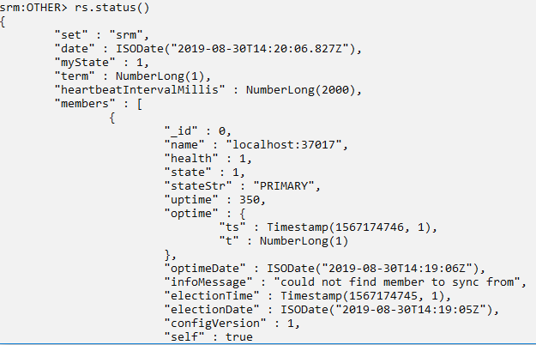

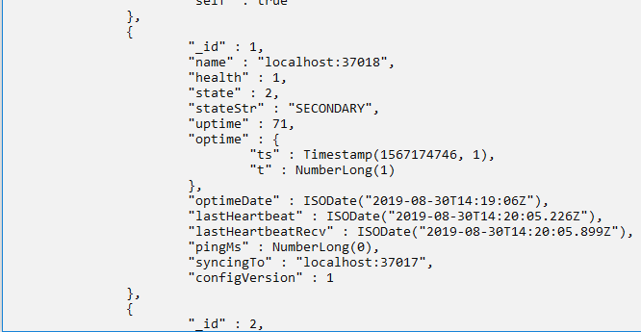

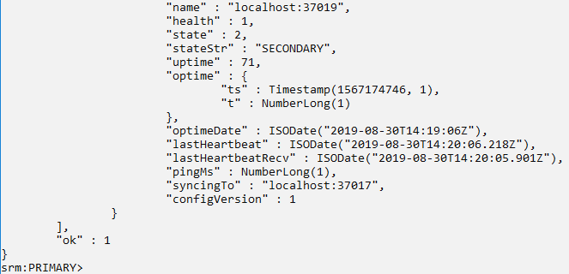

**4] Perform Write and read Operation on Primary node 37017**

use sk

db.stud.insert({"RollNo":101,"Name":"ABC"})

db.stud.find()

**Output:**

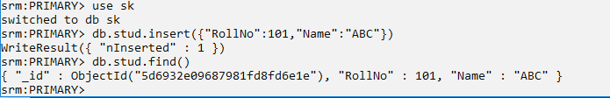

**5] mongo use port 37018:**

C:\Windows\system32>mongo --port 37018

**Output:**

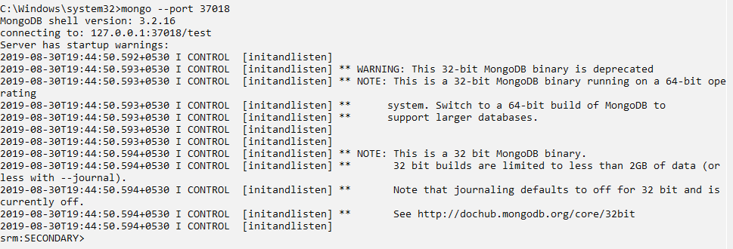

**6] Secondary node can perform only read:**

rs.slaveOk()

use sk

db.stud.find()

**Output:**

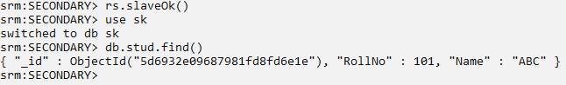

**The data is inserted only primary node not in secondary node**



**7] Shift to primary node(37017) and shutdown server:**

use admin

db.shutdownServer()

**Output:**

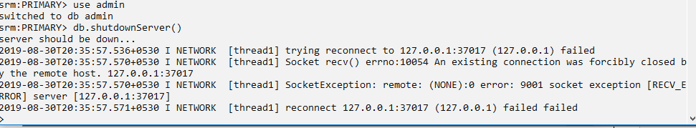

**8] Shift to port 37018 and check status:**

rs.status()

**Output:**

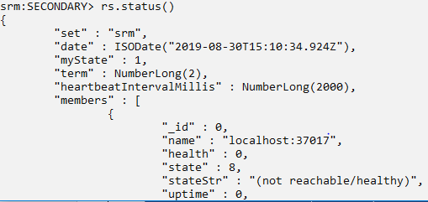

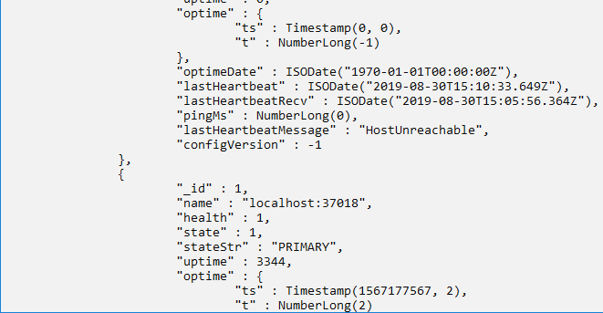

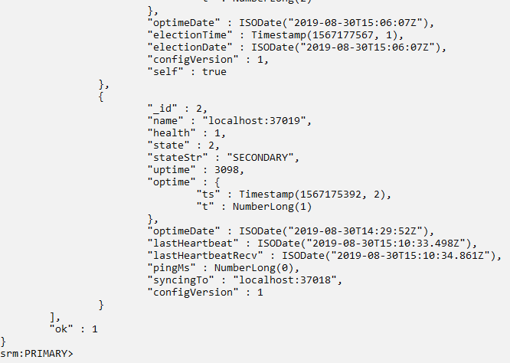

**Q.B] Write a MongoDB query to create a backup of existing database.**

D:\mongo>mongodump

**Output:**

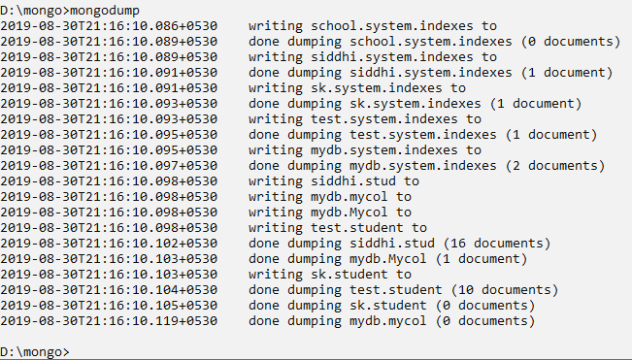

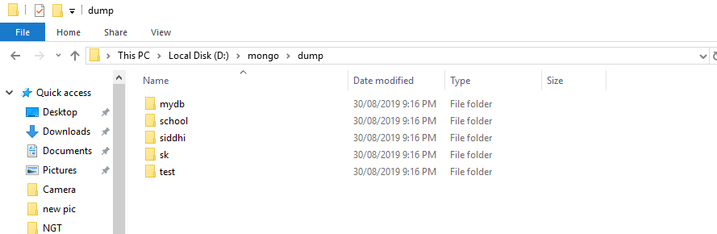

**Q.C] Write a MongoDB query to restore database from the backup.**

D:\mongo>mongorestore --db sk dump/sk

**Output:**

