**Practical No.08**

**A] jQuery Basic, jQuery Events**

**1] Mouse Event:**

**Code:**

<!DOCTYPE html>

<html>

<head>

<script src="jquery.js">

</script>

</head>

<body>

<script>

//click

$(document).ready(function(){

$("#c1").click(function(){

$(this).hide();

});

});

//double-click

$(document).ready(function(){

$("#d1").dblclick(function(){

$(this).hide();

});

});

//Entered mouse

$(document).ready(function(){

$("#m1").mouseenter(function(){

alert("You entered!");

});

});

//Leave mouse

$(document).ready(function(){

$("#m2").mouseleave(function(){

alert("Bye! You now leave!");

});

});

</script>

<p id=c1>click here to hide.</p>

<p id=d1>double click to hide</p>

<p id=m1>enter mouse</p>

<p id="m2">leave mouse</p>

</body>

</html>

**Output:**

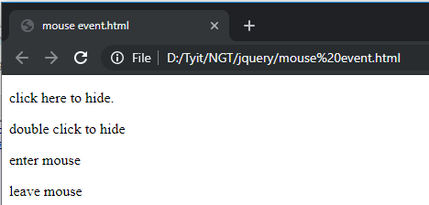

**Click: Double Click:**

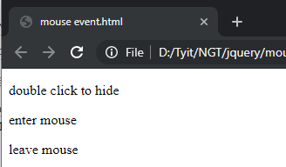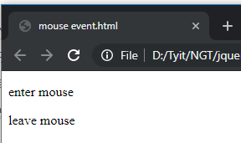

**Mouse enter:**

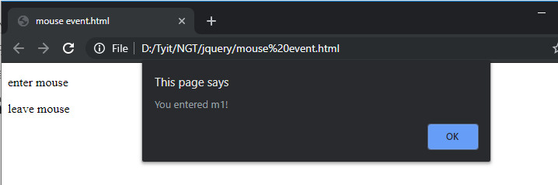

**Mouse leave:**

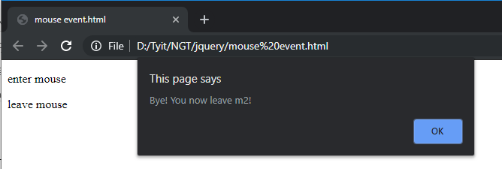

**2] Form Event:**

**Code:**

<!DOCTYPE html>

<html>

<head>

<script src="jquery.js">

</script>

<script>

$(document).ready(function(){

$("input").focus(function(){

$(this).css("background-color", "pink");

});

$("input").blur(function(){

$(this).css("background-color", "blue");

});

});

</script>

</head>

<body>

Email:<input type="text" name="Email"><br><br>

Password:<input type="text" name="Password">

</body>

</html>

**Output:**

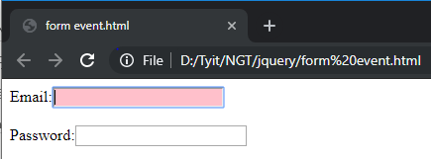

**B] jQuery Selectors, jQuery Hide and Show effects**

**Code:**

<!DOCTYPE html>

<html>

<body>

<script src="jquery.js">

</script>

<script>

$(document).ready(function()

{

$("#bt1").click(function()

{

$("h1").hide();

});

$("#bt2").click(function()

{

$("h1").show();

$("h1").css("background-color","pink");

});

})

</script>

<h1>JAI PUBG</h1>

<button id="bt1">Hide me</button>

<button id="bt2">Show me</button>

</body>

</html>

**Output:**

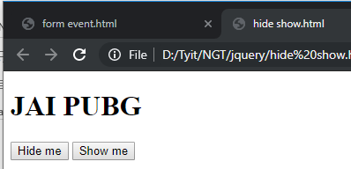

**1] Click on Hide me button: 2] Click on Shoe me button:**

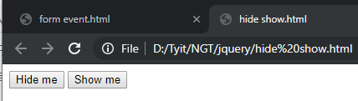 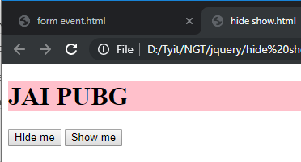

**C] jQuery fading effects, jQuery Sliding effects.**

**Code:**

<!DOCTYPE html>

<html>

<head>

<title>Example of jQuery Fade-In and Fade-Out Effects</title>

<script src="jquery.js"></script>

<style type="text/css">

h1{

padding: 15px;

background: #b5c3c5;

}

h2{

padding: 15px;

background: #b5c3c5;

}

</style>

<script type="text/javascript">

$(document).ready(function(){

// Fadeing out displayed paragraphs

$(".out-btn").click(function(){

$("h1").fadeOut();

});

// Fading in hidden paragraphs

$(".in-btn").click(function(){

$("h1").fadeIn();

});

// Slide up displayed paragraphs

$(".up-btn").click(function(){

$("h2").slideUp();

});

// Slide down hidden paragraphs

$(".down-btn").click(function(){

$("h2").slideDown();

});

});

</script>

</head>

<body>

<button type="button" class="out-btn">Fade Out</button>

<button type="button" class="in-btn">Fade In</button>

<button type="button" class="up-btn">Slide Up</button>

<button type="button" class="down-btn">Slide Down</button>

<h1>Information Technology</h1>

<h2>Next Generation Technology.</h2>

</body>

</html>

**Output:**

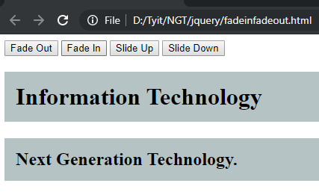

**1] Fade Out:**

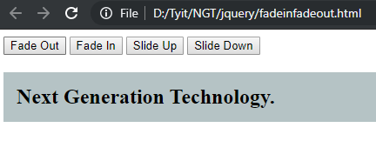

**2] Fade In:**

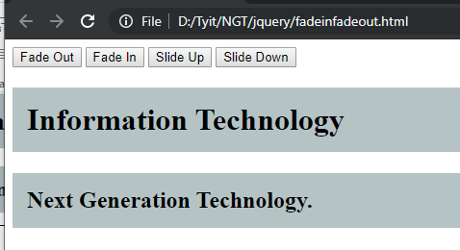

**3] Slide Up:**

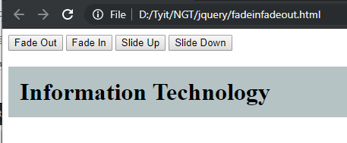

**4] Slide Down:**

