Cluster Computing
Course Code: INT-315

Continuous Assessment – 2
Submitted in partial fulfillment of the requirements for the award of degree of
Bachelor of Technology in Computer Science Engineering,

Submitted to: Richa Nigam
LOVELY PROFESSIONAL UNIVERSITY, PHAGWARA, PUNJAB.




Submitted by: Mitesh Panda (12202392) (36)

TABLE OF CONTENTS:

Serial  No. | Title | Page No.
1 | Introduction | 3
2 | Code Snippets | 3
3 | Workflow | 5
4 | Bar Plot | 6
5 | Dashboard | 7

Introduction:
Logistic Regression is a widely used statistical and machine learning technique designed for predicting binary outcomes, where the dependent variable can take only two possible values such as “yes” or “no,” “1” or “0,” or “disease” and “no disease.” Unlike linear regression, which predicts continuous numerical values, logistic regression estimates the probability that a given input belongs to a particular class. It uses the logistic or sigmoid function to map predicted values into a range between 0 and 1, making it ideal for classification tasks. The model expresses the relationship between independent variables (such as age, cholesterol level, or blood pressure) and the dependent variable (such as presence of heart disease) through a linear combination of the input features, which is then passed through the sigmoid function to produce a probability. If the resulting probability is greater than or equal to a threshold (commonly 0.5), the output is classified as 1, otherwise as 0. Logistic regression is valued for its simplicity, efficiency, and interpretability, as each coefficient indicates how a specific feature influences the likelihood of the outcome. In this project, logistic regression was applied to predict the presence of heart disease based on various health indicators. The model not only provides accurate classification but also helps identify which factors most strongly contribute to the risk of heart disease, making it both a predictive and an explanatory tool in healthcare analytics.

Code Snippets:
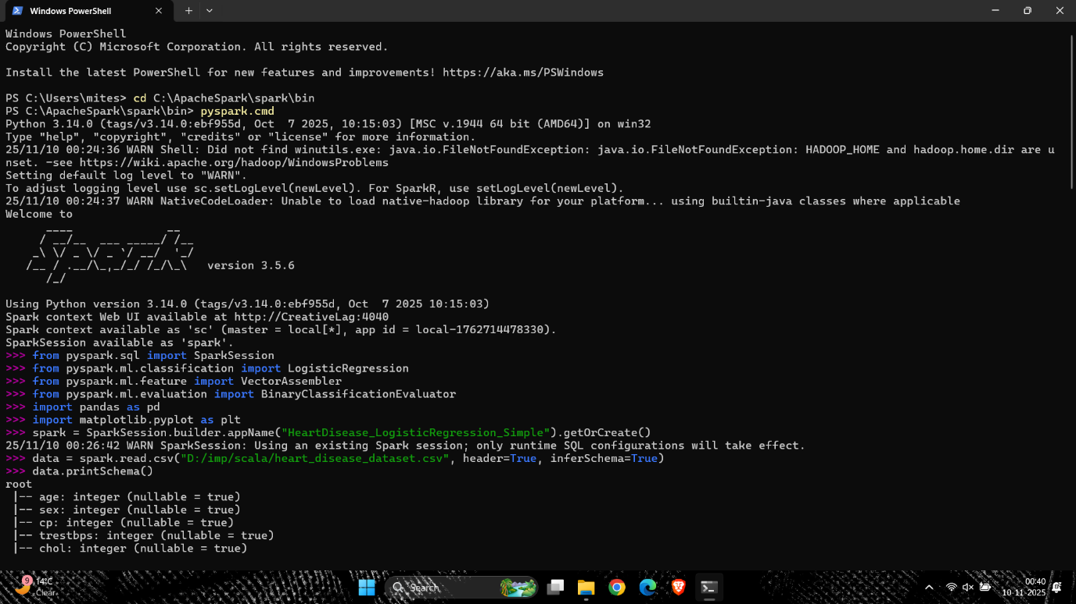

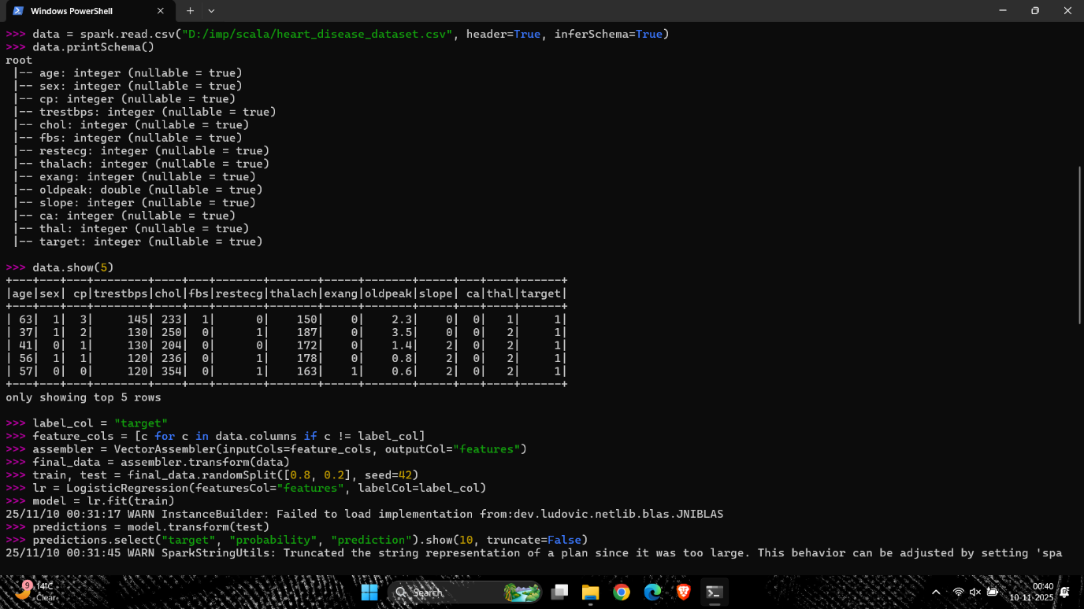




Workflow:
The workflow of this code demonstrates the implementation of Logistic Regression using PySpark to predict heart disease based on multiple health-related features. The process begins by creating a Spark session, which initializes the PySpark environment for distributed data processing. The heart disease dataset is then loaded using spark.read.csv() with headers and schema inference enabled. After verifying the data structure through printSchema() and show(), the feature columns (such as age, sex, cp, chol, etc.) are combined into a single feature vector using the VectorAssembler transformer, while the target column (target) is used as the label. The data is split into training and testing sets in an 80:20 ratio, and a logistic regression model is trained on the training data using the LogisticRegression() class. Predictions are generated on the test set, displaying the actual label, predicted probability, and final classification. The model’s accuracy is evaluated using the BinaryClassificationEvaluator, which computes the Area Under Curve (AUC), showing a performance of approximately 0.90, indicating good predictive capability. The learned coefficients and intercept are then extracted to understand the weight and direction of influence of each feature on heart disease prediction. Finally, these coefficients are visualized in a color-coded bar chart using Matplotlib, where positive values (in red) indicate features that increase heart disease risk and negative values (in blue) indicate features that reduce it. This workflow effectively integrates PySpark’s machine learning capabilities with Python’s visualization tools to perform large-scale classification and interpret feature importance.
Bar Plot: 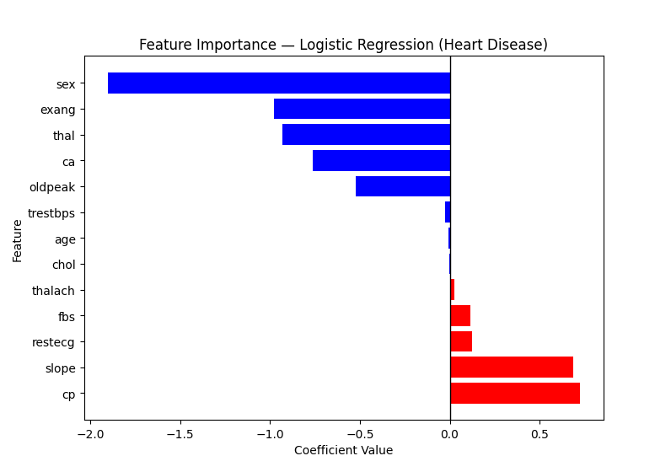

The feature importance plot illustrates how each variable influences the likelihood of heart disease as determined by the logistic regression model. The direction and magnitude of the coefficients indicate both the type and strength of association between each feature and the target outcome. Features with positive coefficients; shown in red, such as chest pain type (cp), slope of peak exercise ST segment (slope), and fasting blood sugar (fbs), have a direct relationship with the probability of heart disease meaning higher values for these features increase the likelihood of a positive diagnosis. Conversely, features with negative coefficients; shown in blue, such as sex, exercise-induced angina (exang), thalassemia (thal), number of major vessels (ca), and ST depression induced by exercise (oldpeak), exhibit an inverse relationship, suggesting that higher values for these factors decrease the likelihood of heart disease. The magnitude of each bar reflects the relative importance of the feature in the model, with chest pain type (cp) and sex emerging as the most influential predictors. Overall, the plot indicates that chest pain characteristics and ECG-related indicators play a significant role in determining heart disease risk, while demographic and exercise-related factors also contribute meaningfully to the prediction outcomes.

Dashboard:
