Experiment No.-1

Aim: To study different components of ER diagram and Double ER diagram.

Theory:
Entity:
An entity in a Database Management System (DBMS) is a real-world object, place, person, event, or concept about which data is stored. Represented as tables in a database and rectangles in Entity-Relationship (ER) diagrams, entities are fundamental building blocks, categorized as strong (independent) or weak (dependent) based on their existence.
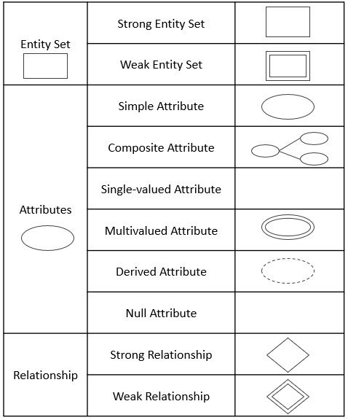
Notation:

Example:
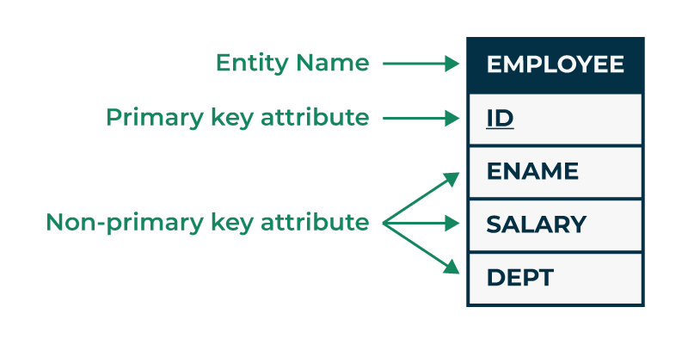
Types of Entity:
- Strong Entity:
A strong entity (or regular entity) is a standalone object in a database that exists independently of any other entity type. It is characterized by having its own unique identifier that allows every instance to be distinguished without needing context from other tables.

Notation:

Example:
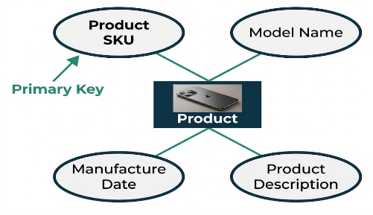

- Weak Entity:
A weak entity is a database object that cannot be uniquely identified by its own attributes and depends on a "strong" owner entity for its existence. If the owner entity is deleted, the weak entity is typically removed as well (existence dependency).


Notation:

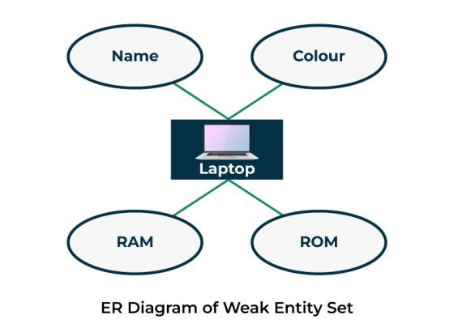
Example:

Attribute:
Attributes are the properties, characteristics, or traits that define and describe an entity (an object, concept, or thing). Implemented as columns in a relational table, attributes store specific data values for records, such as Student Name or Age for a Student entity. They provide structure, enable data retrieval, ensure data integrity, and create relationships between tables.

Notation:

Types of Attributes

- Simple Attributes:
A Simple Attribute (also known as an atomic attribute) is the most basic, indivisible unit of data used to describe an entity. Unlike composite attributes, simple attributes cannot be broken down into smaller, meaningful components.

Notation:

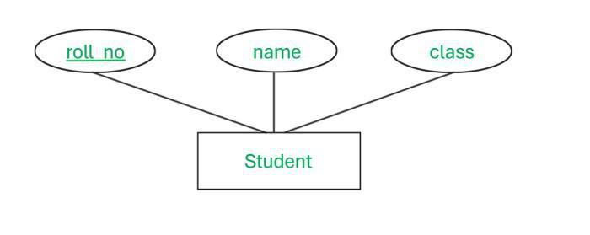
Example:

- Composite Attributes:
A composite attribute in a Database Management System (DBMS) is an attribute(property)
that can be divided into smaller, independent, and meaningful sub-parts or sub-attributes. These smaller parts are known as atomic attributes, and when combined, they form the parent composite attribute.


Notation:
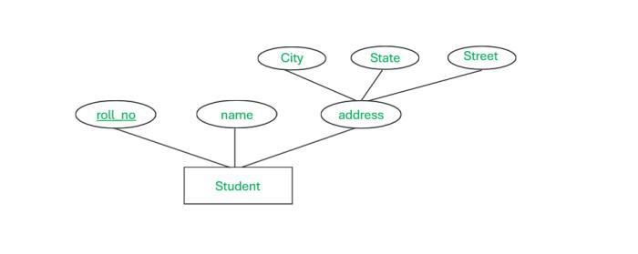
Example:

- Single-Valued Attributes:
A single-valued attribute in database management systems (DBMS) is a characteristic of an entity that holds exactly one data value for each instance. Unlike multi-valued attributes, these do not store lists or multiple entries. In ER diagrams, they are represented by a simple oval, and in relational tables, they constitute a single column.


Notation:

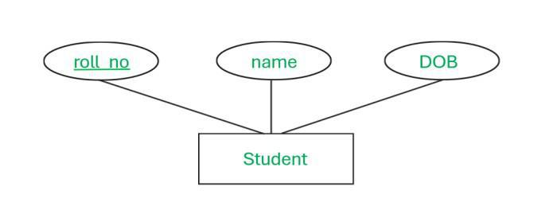
Example:

- Multi-Valued Attributes:
A multi-valued attribute in a Database Management System (DBMS) is an attribute that can store more than one value for a single entity instance. Represented by double ovals in ER diagrams, examples include a person having multiple phone numbers or a book having multiple authors. They are typically resolved by creating a separate table for the attribute.

Notation:

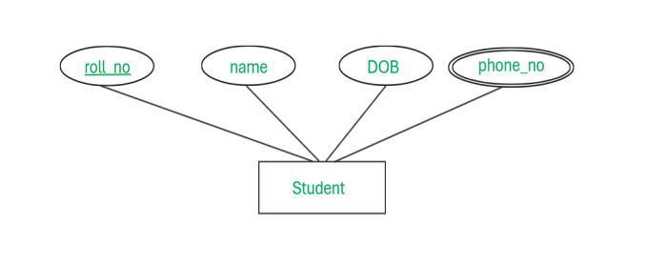
Example:

- Stored Attributes:
Stored attributes are data fields physically saved directly into a database table, representing permanent, foundational information for an entity. They do not change based on other data (unlike derived attributes) and are essential for stability, such as date of birth or employee id.

Notation:


Example

- Derived Attributes:
Derived attributes are database fields whose values are calculated or derived from other stored attributes rather than physically stored themselves. Common examples include calculating age from birthdate or total price from quantity and unit price. They save storage space, ensure data consistency, and are represented in ER diagrams by dashed ovals.

Notation:

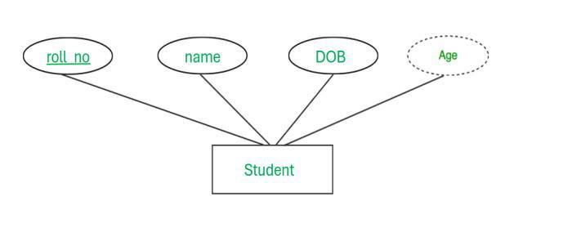
Example:

- Key Attribute:
Key Attributes are specific fields or columns within a table used to uniquely identify, distinguish, and retrieve individual records(tuples). They are foundational for maintaining data integrity and ensuring that no two records in a table are identical.

Notation:
Name

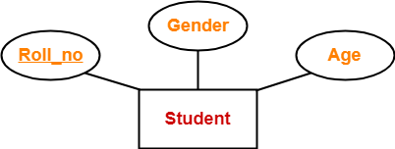
Example:

Relationship:
A Relationship is a logical connection or association between two or more entity types. These connections define how data in one table interacts with data in another, ensuring that information remains organized and consistent.

Types of Relationships
- One-to-One (1:1): Each record in Table A relates to exactly one record in Table B, and vice-versa.
Example:
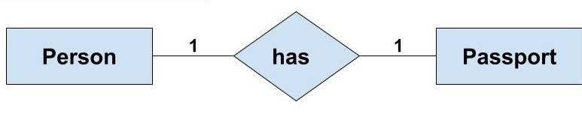
- One-to-Many (1:N): A single record in Table A can relate to multiple records in Table B, but each record in Table B relates back to only one in Table A.
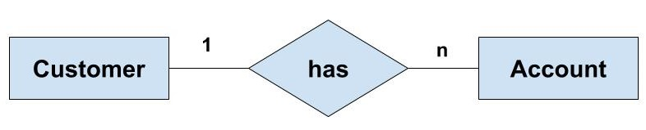
Example:

- Many-to-Many (M:N): Multiple records in Table A can relate to multiple records in Table B.
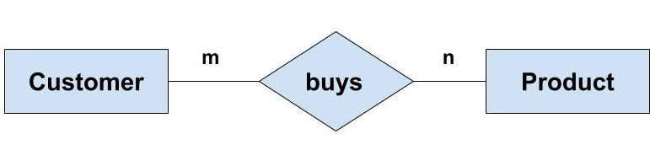
Example:

- Self-Referencing (Recursive): A record in a table relates to another record in the same table.
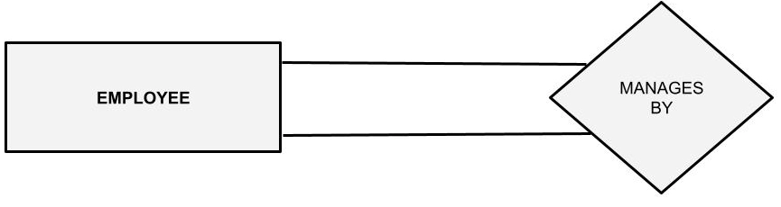
Example:
EER:
The word double refers to several specific notations in an ER (Entity-Relationship) Diagram used to represent dependencies and constraints.

- Specialization:
Specialization is a top-down approach that identifies and isolates subgroups within a higher-level entity set based on distinguishing characteristics. It takes a single, broad entity (the superclass) and breaks it down into multiple, more specific entities (the subclasses).
Example:
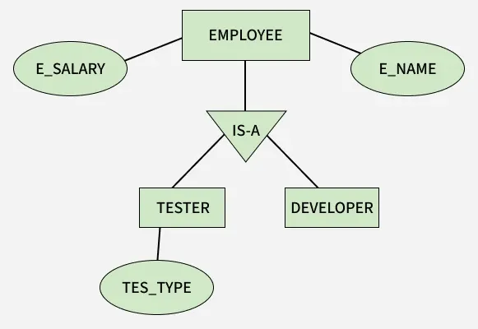

- Generalization:
Generalization is a bottom-up approach that identifies common features among several lower-level entities to create a single, higher-level entity. It is essentially the inverse of specialization.
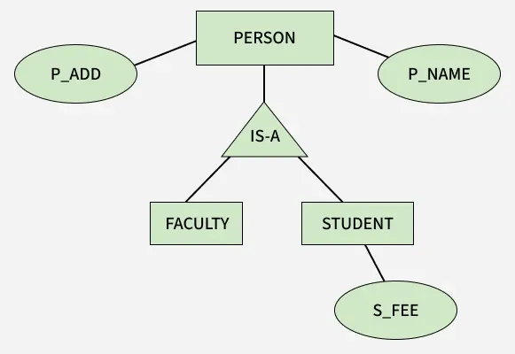
Example:

- Aggregation:
Aggregation is an abstraction technique used to represent a relationship between two entities as a single, higher-level entity. This allows the relationship itself to participate in further relationships with other entities.
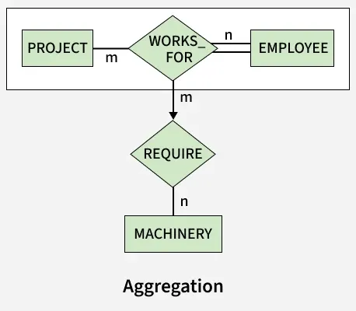
Example:

Conclusion: We have study the different components of ER diagram and Double ER diagram.

Experiment No.-2

Aim: To study the mapping of the ER &Double ER to relational schema model.

Theory:

1. ER Model:
The Entity-Relationship (ER) model is a high-level conceptual data model used to design databases. It represents:
- Entities – Objects or things (e.g., Student, Employee)
- Attributes – Properties of entities (e.g., Name, ID)
- Relationships – Associations between entities (e.g., Enrolls, Works)
The ER model is widely used for database design before implementation in relational databases.

2. EER Model:
The Enhanced Entity-Relationship (EER) model is an extension of the ER model. It includes additional features such as:
- Specialization & Generalization
- Inheritance
- Aggregation
- Categories (Union types)
These features help represent more complex real-world scenarios.

Mapping ER Model to Relational Schema:
The process of converting an ER model into a relational schema involves the following rules:
- Mapping Strong Entity Sets
- Create a table for each strong entity.
- Include all simple attributes.
- Primary key of the entity becomes the primary key of the table.
- Mapping Weak Entity Sets
- Create a table for the weak entity.
- Include partial key and attributes.
- Include primary key of the owner entity as a foreign key.
- Combine both to form a composite primary key.
- Mapping Binary Relationships:
- One-to-One (1:1)
- Add a foreign key to one of the tables.
- Preferably place it in the entity with total participation.
- One-to-Many (1:N)
- Add the primary key of the “one” side as a foreign key in the “many” side.
- Many-to-Many (M:N)
- Create a new table.
- Include primary keys of both entities as foreign keys.
- Combine them as a composite primary key.
- Mapping Multivalued Attributes
- Create a separate table.
- Include the attribute and the primary key of the entity.

5. Mapping Composite Attributes
- Break them into simple attributes and store individually.

Mapping EER Model to Relational Schema

1. Specialization / Generalization
There are several approaches:

a) Single Table Approach
- One table for the entire hierarchy.
- Include all attributes and a type discriminator.

b) Multiple Table Approach
- One table for superclass.
- Separate tables for subclasses.
- Subclass tables contain primary key of superclass.

2. Aggregation
- Treat the relationship as a higher-level entity.
- Create a separate relation for the aggregated entity.

3. Categories (Union Types)
- Create a new table.
- Include primary keys from all participating entity sets.

Algorithm:
- Identify all entities and attributes.
- Convert strong entities into tables.
- Convert weak entities with foreign keys.
- Map relationships based on cardinality.
- Handle multivalued and composite attributes.
- Apply EER concepts (specialization, aggregation, etc.).
- Define primary and foreign keys.

Example:
- ER diagram of the library Management :
- EER diagram of the Company:
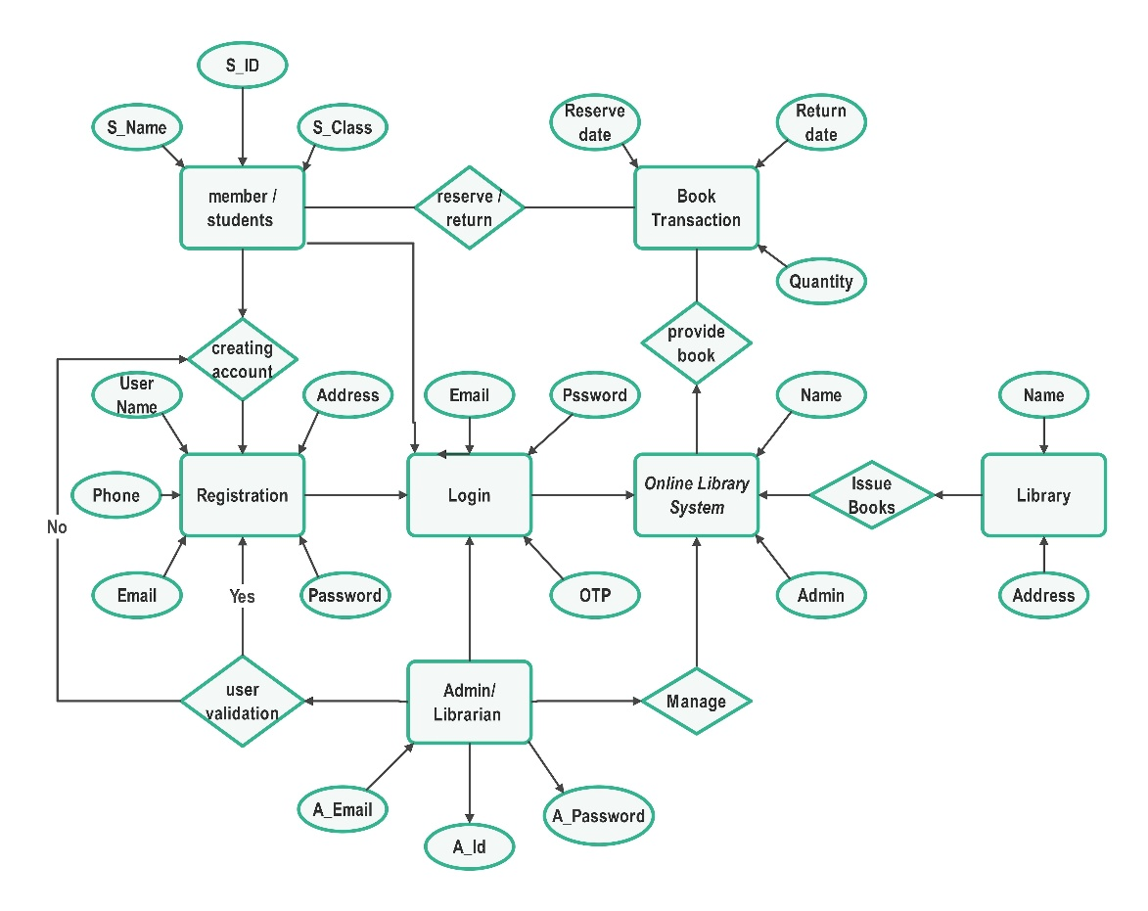
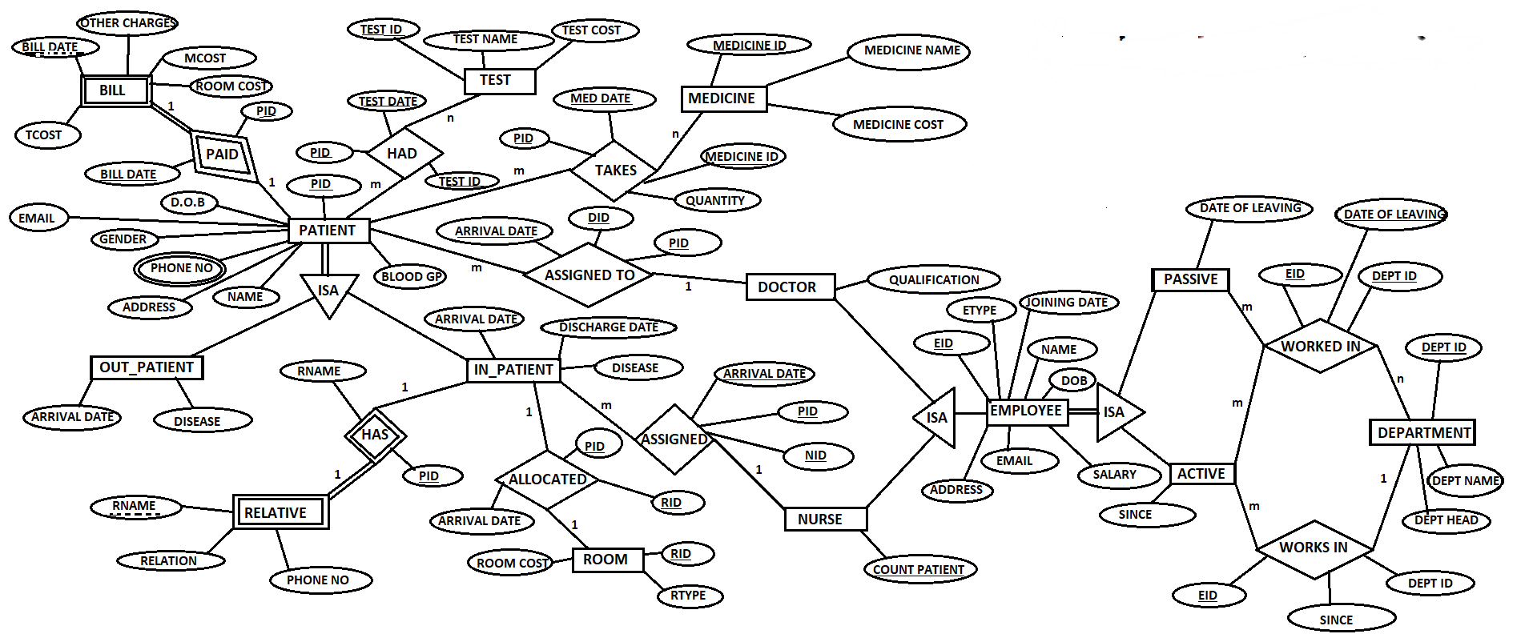

Conclusion: The ER and EER models provide a conceptual framework for database design, while the relational schema represents the logical implementation. Mapping ensures that real-world data structures are accurately transformed into database tables.

Experiment No.-3

Aim: To perform different DDL and DML language command.

Theory:
DDL:
Data Definition Language (DDL) is the architectural layer of a database that defines its structure and schema. Rather than managing individual records, it creates the "blueprint" by establishing tables, naming columns, and setting specific data types like text or numbers. It also enforces integrity rules, such as ensuring every entry has a unique ID or linking related tables together. Because these changes modify the database’s actual framework, they are usually permanent and take effect immediately upon execution.

DDL Commands:
- CREATE: Used to build new database objects like tables, indexes, and databases.
Syntax:
CREATE TABLE table_name (
column1 datatype constraint,
column2 datatype,
... );

- ALTER: Modifies the structure of an existing object, such as adding or deleting columns in a table.
Syntax:
ALTER TABLE table_name ADD column_name datatype;

- DROP: Permanently removes an object and its structure from the database.
Syntax:
DROP TABLE table_name;

- TRUNCATE: Removes all records from a table while keeping the table structure intact.
Syntax:
TRUNCATE TABLE table_name;

- RENAME: Changes the name of an existing database object.

- COMMENT: Adds or modifies descriptive comments on database objects.

DML:
Data Manipulation Language (DML) is the functional layer of SQL used to manage the actual information stored within a database's structure. While other languages build the tables, DML is used to add new records, update existing values, and remove obsolete data. It operates at the row level, allowing you to target specific entries using filters without changing the database's overall design. Critically, these actions are often transactional, meaning changes can be reviewed or undone before they are permanently saved to the system.

Functions:
DML operations focus on the content of the database without altering its underlying schema.
- Data Addition: Placing new records into existing tables.
- Data Modification: Changing specific values in existing records, often based on a unique identifier.
- Data Retrieval: Fetching specific information for viewing or analysis.
- Data Removal: Deleting one or more rows from a table.

Commands:
DML is often described through the acronym CRUD (Create, Read, Update, Delete).
- INSERT: Adds new rows of data into a table.
Syntax:
INSERT INTO table_name (col1, col2) VALUES (val1, val2);

- UPDATE: Modifies existing records within a table.
Syntax:
UPDATE table_name SET column1 = value1 WHERE condition;

- DELETE: Removes specific rows from a table.
Syntax:
DELETE FROM table_name WHERE condition;

Conclusion: This experiment successfully demonstrated the fundamental roles of DDL and DML in database management. While DDL commands (CREATE, ALTER, DROP) were used to define and modify the database structure, DML commands (INSERT, UPDATE, DELETE) allowed for the manipulation of the actual data within those structures. Mastering both is essential for building and maintaining a functional relational database.

Experiment No.-4

Aim: To perform different DCL and TCL language command.

Theory:

DCL:
"DCL" refers to three distinct, common acronyms: Data Control Language in SQL for database security, Disney Cruise Line for family-focused travel, and Degree of Combined Leverage in finance for measuring earnings risk. Data Control Language involves GRANT and REVOKE commands to manage user permissions, while Disney Cruise Line operates a fleet of themed ships featuring rotational dining and private island experiences. The Degree of Combined Leverage, calculated as operating leverage multiplied by financial leverage, indicates how sensitive a company's earnings per share are to changes in sales.
Commands:
The primary DCL commands are GRANT and REVOKE. These commands are used to manage two main types of privileges:
- System Privileges: Broad permissions that allow users to perform administrative tasks, such as creating tables or connecting to the database.
- Object Privileges: Specific permissions on individual database objects (tables, views, sequences), such as the ability to SELECT, INSERT, UPDATE, or DELETE data.

Uses of DCL
- Security Enforcement: Prevents unauthorized access to sensitive data.
- Access Management: Allows database administrators (DBAs) to assign specific roles to different users based on their needs.
- Integrity Protection: Restricts who can modify table structures or data, ensuring that only qualified users make changes.

Syntax and Examples
- GRANT Command
Used to give access privileges to a user.
- Syntax: GRANT privilege_name ON object_name TO user_name;.
- Example: GRANT SELECT, UPDATE ON Employees TO user123;.
  - Effect: This allows user123 to view and modify records in the Employees table.
- REVOKE Command
Used to take back permissions that were previously granted.
- Syntax: REVOKE privilege_name ON object_name FROM user_name;.
- Example: REVOKE UPDATE ON Employees FROM user123;.
  - Effect: This removes the ability for user123 to modify the Employees table, though they may still be able to view it if they retain SELECT privileges.

TCL:
TCL (Transaction Control Language) is the subset of SQL used to manage the "all-or-nothing" nature of database changes. Its primary role is to ensure data integrity by grouping multiple operations into a single transaction that must either succeed completely or fail entirely. This is essential for complex tasks, like a bank transfer, where money must be deducted from one account and added to another simultaneously to prevent data errors.
The system works through three main commands: COMMIT saves all changes permanently to the database, ROLLBACK undoes any pending changes if an error occurs, and SAVEPOINT creates temporary markers to undo only specific parts of a long transaction. By using these commands, TCL maintains the ACID properties of a database, ensuring that every update is intentional, verified, and safe from system crashes or conflicting user actions.

1.Commands and Types
TCL commands act as "checkpoints" for your data changes. They fall into three main types based on how they handle the transaction lifecycle:
- Finalizing Commands: Used to save changes permanently.
- Reverting Commands: Used to undo changes if an error occurs.
- Checkpointing Commands: Used to create temporary markers within a long transaction.
2.Uses of TCL
- Data Integrity: Ensures that if one part of a multi-step process fails (like a bank transfer), the entire operation is cancelled.
- Concurrency Control: Prevents other users from seeing "dirty" or uncommitted data until the transaction is finalized.
- Error Recovery: Allows a developer to "undo" mistakes made during a session before they affect the actual database.

3.Syntax and Examples

- COMMIT Command
Saves all changes made during the current transaction permanently to the database.
Syntax: COMMIT;
Example:
sql
UPDATE Accounts SET balance = balance - 500 WHERE id = 1;
UPDATE Accounts SET balance = balance + 500 WHERE id = 2;
COMMIT;
  - Effect: Both updates are saved permanently; the money transfer is complete.
- ROLLBACK Command
Undoes all changes made in the current transaction that have not yet been committed.
Syntax: ROLLBACK;
Example:
sql DELETE FROM Orders; -- Oops, deleted everything by mistake! ROLLBACK;
  - Effect: The DELETE is undone, and all records in the Orders table are restored.
- SAVEPOINT Command
Creates a point within a transaction to which you can later roll back without undoing the entire transaction.
Syntax: SAVEPOINT savepoint_name; / ROLLBACK TO savepoint_name;
- Example:
sql
INSERT INTO Students VALUES (1, 'ram');
SAVEPOINT sp1;
INSERT INTO Students VALUES (2, 'Bob');
-- Might be an error here ROLLBACK TO sp1;
COMMIT;
  - Effect: 'ram' is saved to the database, but 'Bob' is discarded.

Conclusion: This experiment successfully demonstrated the implementation of DCL and TCL commands to manage database security and operational integrity. We showed that DCL (GRANT, REVOKE) effectively controls user permissions, while TCL (COMMIT, ROLLBACK, SAVEPOINT) ensures that transactions are processed reliably and accurately. Together, these commands provide the essential tools for maintaining a secure, consistent, and error-free database environment.

Experiment No.-5

Aim: To study different constraints in oracle.

Theory:
Constraints:
In Oracle, constraints are declarative rules applied to tables to enforce data integrity and ensure the accuracy of stored information. They act as a validation layer, preventing invalid data entry during INSERT, UPDATE, or DELETE operations by verifying that every change meets specific logical conditions. By maintaining these rules at the database level, Oracle ensures that the data remains consistent across all users and applications.
These rules range from simple requirements, like ensuring a field is never empty (NOT NULL) or unique (UNIQUE), to complex business logic handled by CHECK constraints. They also manage relationships between tables via Primary and Foreign Keys, which prevent orphaned records and maintain referential integrity. Oracle provides advanced control over these constraints, allowing them to be named for easier debugging, disabled during bulk data loads, or even deferred until the end of a transaction to ensure the system always moves from one valid state to another.

Types of Constraints:

- NOT NULL: This constraint ensures that a column cannot contain NULL values. It makes data entry mandatory for that specific field, which is essential for critical information like names or IDs.
- UNIQUE: This prevents duplicate values within a column or a set of columns. While it ensures all entries are distinct, it does allow multiple NULL values unless combined with a NOT NULL constraint.
- PRIMARY KEY: This is a combination of NOT NULL and UNIQUE. It uniquely identifies each row in a table, ensuring no two rows have the same identifier and that the identifier is never empty. Each table can have only one primary key.
- FOREIGN KEY: Also known as a referential integrity constraint, it establishes a relationship between two tables. It ensures that the value in a "child" table matches a value in the "parent" table's primary or unique key, preventing "orphaned" records.
- CHECK: This allows you to define a specific logical condition that every row must satisfy. For example, a CHECK constraint can ensure a Salary column is always greater than zero or that a Status column only contains 'Active' or 'Inactive'.

Uses of Constraints:
Constraints are used to maintain Data Integrity in four key ways:
- Entity Integrity: Ensures every row is unique and identifiable (Primary Key).
- Domain Integrity: Ensures data falls within a specific range or format (Check, Not Null).
- Referential Integrity: Ensures relationships between tables remain consistent (Foreign Key).
- Business Logic Enforcement: Automates rules (like "age must be 18+") directly in the database.

Examples of Constraints:

1. PRIMARY KEY & NOT NULL
Ensures every student has a unique, mandatory ID.
sql
CREATE TABLE Students ( student_id NUMBER PRIMARY KEY, full_name VARCHAR2(100) NOT NULL );

2. UNIQUE
Ensures no two users register with the same email address.
sql
ALTER TABLE Users ADD CONSTRAINT unique_email UNIQUE (email);

3. CHECK
Ensures the "Price" column never contains a negative number.
sql
CREATE TABLE Products ( product_name VARCHAR2(50), price NUMBER CONSTRAINT check_price CHECK (price > 0) );
4. FOREIGN KEY
Ensures an order cannot be created for a customer who doesn't exist in the Customers table.
sql
CREATE TABLE Orders ( order_id NUMBER PRIMARY KEY, cust_id NUMBER, CONSTRAINT fk_customer
FOREIGN KEY (cust_id) REFERENCES Customers(cust_id) );

5. DEFAULT
Automatically sets the order date to the current day if none is provided.
sql
ALTER TABLE Orders MODIFY (order_date DEFAULT SYSDATE);

Conclusion: This study successfully demonstrated how Oracle constraints enforce data integrity and accuracy at the database level. By implementing Primary Key, Foreign Key, Unique, Not Null, and Check rules, we verified that the database can automatically prevent invalid data entry and maintain consistent relationships between tables. Ultimately, these constraints provide a critical foundation for building reliable, normalized, and error-free database systems.

Experiment No.-6

Aim: To study the aggregate function and set operation in oracle.

Theory:

Aggregate Function:

An aggregate function is a specialized mathematical operation in database management and data analysis that processes a collection of values from multiple rows to return a single, summarized result. Unlike standard scalar functions that operate on one record at a time, aggregate functions "collapse" a dataset or a specific group of data into a representative statistic, such as a total, average, or count. These functions are fundamentally deterministic and typically ignore NULL values—with the exception of COUNT(*)—to ensure that the final calculation reflects only valid data points. In practical use, they are almost always paired with the GROUP BY clause to categorize data into subsets and the HAVING clause to filter those summarized results, making them the primary tools for generating business reports and high-level data insights.

Types:

1. Counting (COUNT)
Returns the total number of items in a group.
- Syntax: SELECT COUNT(column_name) FROM table;
- Example: Count how many employees are in the "Sales" department.
sql
SELECT COUNT(EmployeeID) FROM Employees WHERE Dept = 'Sales';
Result: 15
2. Summing (SUM)
Calculates the total numeric value of a column.
- Syntax: SELECT SUM(column_name) FROM table;
- Example: Get the total revenue from all orders.

sql
SELECT SUM(Price) AS Total_Sales FROM Orders;
-- Result: 50000

3. Averaging (AVG)
Finds the arithmetic mean of a numeric column.
- Syntax: SELECT AVG(column_name) FROM table;
- Example: Find the average score of students in a class.
sql
SELECT AVG(Grade) FROM Students;

4. Extremes (MIN & MAX)
Identifies the lowest and highest values in a set.
- Syntax: SELECT MIN(column_name), MAX(column_name) FROM table;
- Example: Find the cheapest and most expensive products in a shop.
sql
SELECT MIN(Price), MAX(Price) FROM Products;

5. Categorized Aggregates (GROUP BY)
Performs any of the above calculations for specific categories.
- Syntax: SELECT category, AGG_FUNC(column) FROM table GROUP BY category;
- Example: Find total sales for each specific region.
sql
SELECT Region, SUM(Sales)
FROM StoreData
GROUP BY Region;

6. Unique Aggregates (DISTINCT)
Calculates values only for unique entries, ignoring duplicates.
- Syntax:
- SELECT AGG_FUNC(DISTINCT column) FROM table;
- Example: Count how many unique cities your customers live in.
sql
SELECT COUNT(DISTINCT City) FROM Customers;

Set Operations:
Set operations in DBMS are powerful tools derived from relational algebra that allow you to combine or compare the results of two or more queries vertically. Unlike joins, which merge tables horizontally based on shared keys, set operations treat entire result sets as collections of rows. For these operations to be valid, the participating queries must be union-compatible, meaning they must possess the same number of columns with matching data types in the same sequence. The Union operator merges all unique rows from both sets, while Union All preserves every row including duplicates. Intersection extracts only the common records found in both queries, and Set Difference (using EXCEPT or MINUS) isolates records present in the first set but absent from the second. Finally, the Cartesian Product creates a comprehensive combination by pairing every row of the first table with every row of the second, often serving as the theoretical foundation for joins. Because standard set operations (excluding Union All) automatically perform duplicate removal, they are computationally more intensive than simple selection queries but essential for complex data analysis and reporting.

Types:

1. UNION
The UNION operator combines the result sets of two or more SELECT statements and removes duplicate rows between them.
- Syntax:
sql
SELECT column_name(s) FROM table1
UNION
SELECT column_name(s) FROM table2;

- Example: If Students_A has {Alex, Maria} and Students_B has {Maria, Bob}, UNION returns {Alex, Maria, Bob}.

2. UNION ALL
UNION ALL is identical to UNION, but it keeps all duplicates. It is faster than UNION because the database doesn't have to scan for redundant data.
- Syntax:
sql
SELECT column_name(s) FROM table1
UNION ALL
SELECT column_name(s) FROM table2;

- Example: Using the same tables, UNION ALL returns {Alex, Maria, Maria, Bob}.

3. INTERSECT
The INTERSECT operator returns only the rows that are common to both SELECT statements.
- Syntax:
sql
SELECT column_name(s) FROM table1
INTERSECT
SELECT column_name(s) FROM table2;

- Example: Using the same tables, INTERSECT returns only {Maria}.

4. EXCEPT / MINUS
This operator returns rows from the first query that are not present in the second query. Note: Oracle uses MINUS, while SQL Server and PostgreSQL use EXCEPT.
- Syntax:
sql
SELECT column_name(s) FROM table1
EXCEPT -- or MINUS
SELECT column_name(s) FROM table2;

- Example: Students_A EXCEPT Students_B returns {Alex}. (It removes Maria because she exists in the second table).

5. CARTESIAN PRODUCT (CROSS JOIN)
While not always grouped with the others, it is a fundamental set operation that pairs every row from the first table with every row from the second.
- Syntax:
sql
SELECT * FROM table1
CROSS JOIN table2;

- Example: If Table1 has 2 rows and Table2 has 3 rows, the result will have 6 rows (2x3).

Conclusion: Studying aggregate functions and set operations in Oracle reveals how raw data is transformed into meaningful insights. Aggregate functions (like SUM and COUNT) are essential for summarising large datasets into single-value statistics, while set operations (like UNION and INTERSECT) provide a mathematical way to combine or compare multiple result sets. Together, these tools are fundamental for efficient data analysis, reporting, and maintaining data integrity in a relational database.

Experiment No.-7

Aim: To perform different types of joins in oracle.

Theory:
Joins:

In relational database management, joins are essential operations used to combine rows from two or more tables based on a related column, typically a primary or foreign key. This process allows for the retrieval of data spread across multiple tables as a single, unified result set, which is fundamental for effective data analysis and reporting. There are several primary types of joins: the Inner Join returns only the rows where there is a match in both tables, effectively filtering out any non-matching data. In contrast, Outer Joins—which include Left, Right, and Full variants—ensure that even unmatched rows from one or both sides are retained, filling in missing values with NULL. Advanced options like the Cross Join produce a Cartesian product of all rows from both tables, while a Self Join allows a single table to be joined with itself, which is particularly useful for querying hierarchical data such as employee-manager relationships. By using these various join mechanisms, developers can maintain a normalized database structure, reducing data redundancy while still being able to reconstruct comprehensive datasets for end-user applications.

Types:
1. INNER JOIN
This is the most common join. It returns only the rows where there is a match in both tables.
- Syntax:
sql
SELECT columns FROM TableA
INNER JOIN TableB ON TableA.key = TableB.key;
- Example: Get a list of students and the classes they are enrolled in. (Students without classes won't show up).
sql
SELECT Students.Name, Classes.ClassName
FROM Students
INNER JOIN Classes ON Students.ClassID = Classes.ID;
2. LEFT (OUTER) JOIN
Returns all rows from the left table, and the matched rows from the right table. If there is no match, the result is NULL on the right side.
- Syntax:
sql
SELECT columns FROM TableA
LEFT JOIN TableB ON TableA.key = TableB.key;
- Example: List all customers and any orders they’ve placed (including customers who haven't ordered anything yet).
- sql
SELECT Customers.Name, Orders.OrderID
FROM Customers
LEFT JOIN Orders ON Customers.ID = Orders.CustomerID;

3. RIGHT (OUTER) JOIN
Returns all rows from the right table, and the matched rows from the left table. If there is no match, the result is NULL on the left side.
- Syntax:
sql
SELECT columns FROM TableA
RIGHT JOIN TableB ON TableA.key = TableB.key;

- Example: List all products and which employees sold them (including products that have never been sold).
sql
SELECT Employees.Name, Products.ProductName
FROM Employees
RIGHT JOIN Products ON Employees.ID = Products.SellerID;

4. FULL (OUTER) JOIN
Returns all rows when there is a match in either the left or right table. It combines the results of both Left and Right joins.
- Syntax:

Sql
SELECT columns FROM TableA
FULL OUTER JOIN TableB ON TableA.key = TableB.key;

- Example: A complete list of all projects and all employees, showing who is assigned where, and who/what is unassigned.
5. CROSS JOIN
Creates a Cartesian Product, meaning it joins every row of the first table with every row of the second table.
- Syntax:
sql
SELECT columns FROM TableA CROSS JOIN TableB;
- Example: Generating all possible combinations of shirt sizes and colors.
sql
SELECT Sizes.Size, Colors.Color FROM Sizes CROSS JOIN Colors;

6. SELF JOIN
A regular join, but the table is joined with itself. This is useful for hierarchical data (like finding an employee's manager in the same employee table).
- Syntax:
sql
SELECT A.name, B.name FROM Table T1 AS A, Table T1 AS B WHERE A.key = B.key;

- Examples:
sql
SELECT
E.Name AS Employee,
M.Name AS Manager
FROM Employees AS E
LEFT JOIN Employees AS M ON E.ManagerID = M.EmpID;

Conclusion: The experiment successfully demonstrated the implementation of Inner, Outer (Left, Right, Full), and Self Joins in Oracle. It proved that joins are essential for merging data horizontally based on related keys, whereas Set Operations combine data vertically. We concluded that while Inner Joins retrieve only matching records, Outer Joins are critical for preserving rows that do not have a corresponding match in the joined table.
Experiment No.-8

Aim: To perform views in oracle.

Theory:
Views:
A view is a virtual table in a database that acts as a stored query rather than a physical storage of data. It serves as a layer of data abstraction, allowing users to interact with a specific subset of columns or rows from one or more underlying tables without seeing the full complexity of the schema. Because it is dynamic, a view automatically reflects any changes made to the base tables, ensuring that the information is always current. Beyond simplifying complex queries by encapsulating joins and calculations, views are a critical tool for security, as they allow administrators to grant access to specific data points while hiding sensitive information like salaries or private identifiers.

Types:
1. Simple View:
A Simple View is created from a single base table. It does not contain functions, groups, or joins. These are generally updatable, meaning you can insert or update data through the view.
- Syntax:
sql
CREATE VIEW view_name AS
SELECT columns FROM table_name WHERE condition;
- Example: Create a view that only shows active employees.
sql
CREATE VIEW ActiveEmployees AS
SELECT EmpID, Name, Department
FROM Employees
WHERE Status = 'Active';

2. Complex View:
A Complex View is derived from multiple tables using JOINS, or it contains functions like GROUP BY, SUM, or DISTINCT. These are usually read-only.
- Syntax:
sql
CREATE VIEW view_name AS
SELECT t1.col, t2.col, AGG_FUNC(col)
FROM table1 t1 JOIN table2 t2 ON t1.id = t2.id
GROUP BY t1.col;

- Example: A view showing total sales per department.
sql
CREATE VIEW DeptSales AS
SELECT DeptName, SUM(Amount) AS TotalRevenue
FROM Sales
GROUP BY DeptName;

3. Inline View
An Inline View is a temporary view created within a FROM clause of a larger query. it is not stored in the database schema; it exists only for the duration of the query.
- Syntax:
sql
SELECT * FROM (SELECT columns FROM table) alias_name;

- Example: Finding employees whose salary is higher than the average.
sql
SELECT Name, Salary
FROM Employees, (SELECT AVG(Salary) AS AvgSal FROM Employees) Temp
WHERE Salary > Temp.AvgSal;

4. Materialized View (Oracle/PostgreSQL)
Unlike a standard view, a Materialized View physically stores the data on disk. It is used to boost performance for massive, slow queries because the result is pre-calculated.
- Syntax:

sql
CREATE MATERIALIZED VIEW view_name
BUILD IMMEDIATE
REFRESH COMPLETE AS
SELECT columns FROM tables;

5. Force View (Specific to Oracle)
A Force View allows you to create a view even if the underlying base tables do not exist yet or if you don't have permissions at the moment of creation.
- Syntax:
sql
CREATE FORCE VIEW view_name AS
SELECT * FROM non_existent_table;

- Example:
sql
CREATE FORCE VIEW Daily_Sales_Summary AS
SELECT Transaction_Date, SUM(Amount) AS Total_Sales
FROM Transactions
GROUP BY Transaction_Date;

Conclusion: The experiment successfully demonstrated the creation and management of Simple, Complex, and Materialized Views in Oracle. We concluded that Simple Views are ideal for basic data abstraction and allowing DML operations, while Complex Views (involving joins or aggregations) are essential for simplifying multi-table queries. Furthermore, the implementation proved that views are critical for data security, as they restrict user access to specific columns without exposing the underlying table structure.

Experiment No.-9

Aim: To perform trigger in oracle.

Theory:
Trigger:
In Database Management Systems (DBMS), Trigger Theory is defined by the Event-Condition-Action (ECA) model, a framework that transforms a passive database into an active database. Unlike standard tables that simply store information, an active database monitors its own state and automatically executes procedural code when specific data modifications occur. This theory eliminates the need for external applications to manually check for every change, ensuring that business rules and data integrity are enforced directly at the storage level, regardless of which user or software is accessing the data.

Types:
1. Timing-Based Triggers
These are defined by their relationship to the triggering SQL statement (INSERT, UPDATE, or DELETE).
A. BEFORE Trigger
Executed before the data is actually modified. These are used to validate data or automatically fill in missing values.
- Syntax:
sql
CREATE TRIGGER trigger_name
BEFORE INSERT OR UPDATE ON table_name
FOR EACH ROW
BEGIN
-- logic to validate or change data
END;
- Example: Automatically setting a "CreatedDate" column to the current time before a new user is added.

sql
CREATE TRIGGER set_timestamp
BEFORE INSERT ON Users
FOR EACH ROW
SET NEW.CreatedDate = NOW();

B. AFTER Trigger
Executed after the data has been successfully modified. These are used for auditing, logging, or updating related tables.
- Syntax:
sql
CREATE TRIGGER trigger_name
AFTER DELETE OR UPDATE ON table_name
FOR EACH ROW
BEGIN
END
- Example: Inserting a record into an Audit_Log table after an employee's salary is updated.
sql
CREATE TRIGGER log_salary_change
AFTER UPDATE ON Employees
FOR EACH ROW
INSERT INTO Salary_History(EmpID, OldSalary, ChangeDate)
VALUES (OLD.id, OLD.salary, NOW());

C. INSTEAD OF Trigger
Used specifically on Views. It intercepts a command (like INSERT) on a view and performs a different action on the underlying base tables instead.
- Syntax:
sql
CREATE TRIGGER trigger_name
INSTEAD OF INSERT ON view_name
FOR EACH ROW
BEGIN
-- logic to update base tables
END;

- Example: If a view joins "Orders" and "Customers," an INSTEAD OF trigger can split one INSERT statement into two separate inserts for each base table.
2. Level-Based Triggers
These define the "granularity" or how often the trigger's code runs.
A. Row-Level Trigger
Fires once for every single row affected by the SQL statement. If an UPDATE changes 50 rows, the trigger runs 50 times.
- Syntax: Defined by the clause FOR EACH ROW.
- Example: Checking if each individual item in an order is currently in stock.
B. Statement-Level Trigger
Fires only once for the entire SQL statement, regardless of how many rows are affected.
- Syntax: Omit the FOR EACH ROW clause (default in many systems like SQL Server).
- Example: Recording the timestamp and User ID of whoever performed a bulk delete of 1,000 records.

3. Event-Based Triggers (Advanced)
Beyond simple data changes (DML), triggers can respond to structural or system events.
- DDL Triggers: Fire on CREATE, ALTER, or DROP commands.
  - Example: Preventing a junior developer from dropping a production table.
- Logon/System Triggers: Fire when a user logs in or the database shuts down.
  - Example: Restricting database access to certain IP addresses during off-hours.

Conclusion: By implementing triggers in Oracle, I successfully demonstrated how active database features automate data validation and auditing. I verified that BEFORE and AFTER triggers, using PL/SQL, effectively enforce business rules and maintain data integrity independently of external applications. This experiment confirmed that Row-Level triggers are essential for precise data control, while Statement-Level triggers provide efficient high-level monitoring.
Experiment No.-10

Aim: To study group by function and having clause in oracle.

Theory:
In Database Management Systems, the Group By function is a theoretical framework for Data Aggregation, which transforms detailed, row-level records into high-level summary information. The core theory operates on a Split-Apply-Combine model: the database engine first splits the entire dataset into distinct partitions or "buckets" based on matching values in specified columns. It then applies an aggregate function—such as SUM, COUNT, AVG, MIN, or MAX—to calculate a single value for each bucket independently. Finally, it combines these intermediate results into a final output where each row represents a unique category and its calculated total.

Types:
1. Single-Column Grouping
This is the most basic type, where rows are grouped by one unique attribute.
- Syntax:
sql
SELECT column1, aggregate_function(column2)
FROM table_name
GROUP BY column1;
- Example (Find total salary per department)
sql
SELECT Dept_ID, SUM(Salary)
FROM Employees
GROUP BY Dept_ID;

2. Multi-Column Grouping
Data is grouped into sub-categories based on a combination of two or more columns.
- Syntax:

sql
SELECT column1, column2, aggregate_function(column3)
FROM table_name
GROUP BY column1, column2;
- Example (Count employees by department and job title):
sql
SELECT Dept_ID, Job_Role, COUNT(Emp_ID)
FROM Employees
GROUP BY Dept_ID, Job_Role;

3. Grouping with HAVING (Filtered Grouping)
Used when you need to filter the results of the groups (e.g., only show groups that meet a specific calculation).
- Syntax:
sql
SELECT column1, COUNT(*)
FROM table_name
GROUP BY column1
HAVING COUNT(*) > value;
- Example (Show departments with more than 5 employees):
sql
SELECT Dept_ID, COUNT(*)
FROM Employees
GROUP BY Dept_ID
HAVING COUNT(*) > 5;

4. Grouping with ROLLUP (Hierarchical)
A specialized type used in reporting to generate sub-totals and a grand total automatically.
- Syntax (Oracle/SQL Server):
sql
SELECT Region, City, SUM(Sales)
FROM Sales_Table
GROUP BY ROLLUP (Region, City);
- Example (Sales by Region, City, and a Grand Total):
If you have data for 'North' and 'South' regions, it will show totals for each city, a sub-total for 'North', a sub-total for 'South', and one final row for the entire company.

Having Clause:
In Database Management Systems, the HAVING clause theory centers on providing a mechanism to filter data after it has been grouped and summarized. While the WHERE clause is designed to exclude individual rows from a table before any calculations occur, it cannot be used with aggregate functions like SUM, AVG, or COUNT because those values do not exist until the grouping process is finished. Consequently, the HAVING clause acts as a secondary, post-aggregation filter that operates exclusively on the resultant groups created by the GROUP BY function. This allows developers to enforce business rules on collective data, such as displaying only those departments where the "total revenue" exceeds a specific target or where the "average salary" is above a certain threshold.
Types:
1. Basic Aggregate Filtering
This is the most common type, used to filter groups based on a single mathematical calculation like COUNT, SUM, or AVG.
- Syntax:
sql
SELECT column, AGG_FUNC(column)
FROM table
GROUP BY column
HAVING AGG_FUNC(column) > value;

- Example (Find departments with more than 10 employees):
sql
SELECT Dept_ID, COUNT(Emp_ID)
FROM Employees
GROUP BY Dept_ID
HAVING COUNT(Emp_ID) > 10;

2. Multi-Condition Filtering
The HAVING clause can use logical operators like AND, OR, and NOT to filter groups based on multiple aggregate requirements.
- Syntax:
sql
SELECT column, AGG_FUNC1(col), AGG_FUNC2(col)
FROM table
GROUP BY column
HAVING condition1 AND condition2;

- Example (Find products with high sales AND high average price):
sql
SELECT Product_ID, SUM(Sales), AVG(Price)
FROM Orders
GROUP BY Product_ID
HAVING SUM(Sales) > 5000 AND AVG(Price) > 100;

3. Filtering with Expressions
You can perform arithmetic operations within the HAVING clause before the filter is applied.
- Syntax:
sql
SELECT column, SUM(col1), SUM(col2)
FROM table
GROUP BY column
HAVING (SUM(col1) - SUM(col2)) > value;

- Example (Show projects where the remaining budget is less than 1000):
sql
SELECT Project_ID, (Total_Budget - SUM(Expenses)) AS Remaining
FROM Project_Funds
GROUP BY Project_ID
HAVING (Total_Budget - SUM(Expenses))< 1000;

4. HAVING with Constants or Subqueries
A group can be filtered by comparing its aggregate value against a fixed constant or a dynamic value returned by another query.
- Syntax:
sql
SELECT column, AVG(col)
FROM table
GROUP BY column
HAVING AVG(col) > (SELECT AVG(col) FROM table);
- Example (Show departments whose average salary is higher than the company-wide average):
sql
SELECT Dept_ID, AVG(Salary)
FROM Employees
GROUP BY Dept_ID
HAVING AVG(Salary) > (SELECT AVG(Salary) FROM Employees);

Conclusion: Through this study of Oracle SQL, I successfully implemented the GROUP BY function and HAVING clause to perform advanced data aggregation. I verified that while GROUP BY is essential for partitioning raw data into summary categories using aggregate functions (like SUM and COUNT), the HAVING clause is critical for filtering these results based on calculated values. This experiment confirmed that these tools are indispensable for generating analytical reports and enforcing business rules on summarized datasets.

