Georgia Gwinnett College

The School of Science and Technology



**ITEC 3150 Section 02**

**Advanced Programming**

Final Project: Bank Database System

with javaFX and JDBC, MySQL

Prepared by

Marzieh Gourdikian

Mitesh Modi

**Course Instructor**

Dr. Wei Liu

Database Name : javafx

Username🡪 root

Password 🡪 no password has been set up

List of tables🡪 Columns (Data Fields)

1. **customers**🡪 customerID (Primary Key & Auto Increment), first_name, middle_name, last_name, email, username, password
2. **account** 🡪 customerID (Primary key & Foreign Key), Checking_Account, Checking_Balance, Saving_Account, Saving_Balance
3. **loan**🡪 loan_id (Primary key & Auto Increment), customerID (Foreign key), loan_amount, months, Remaining_months, monthly_interest, annual_interest, interest_amount_incurred, total_amount_plus_interest, Remaining_Amount_ToBe_Paid, credit_score

**Summary of all Java files:**

1. CustomerPersistor.java
2. RegistrationPage.java
3. LoanCalculator.java
4. Login.java
5. AccountsMain.java
6. LoanApplication.java
7. MakePayment.java

**SQL Script file to be imported into localhost/myphpadmin within any browser after running XAMPP control Panel:**

* **Javafx.sql**

**Software Requirements:**

* Eclipse with javaFX plugins
* Xampp Control Panel

**Both are open source software (free to download & install) from internet.**

**Step by Step Navigation (Project Description)/ How it works:**

* After opening project related files, open xampp control panel and click on start button for Apache And MySQL as shown below:

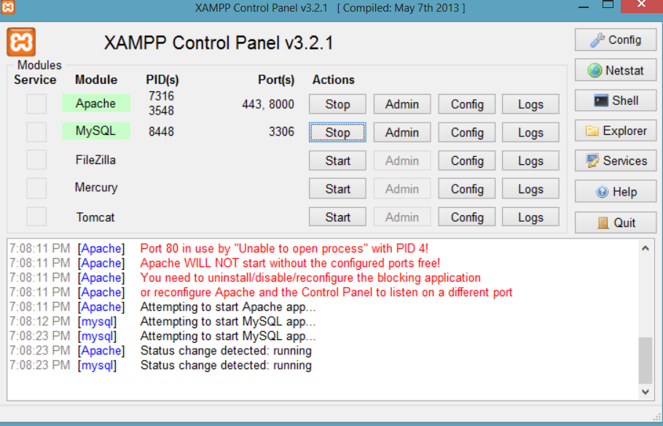

1. RegistrationPage.java:

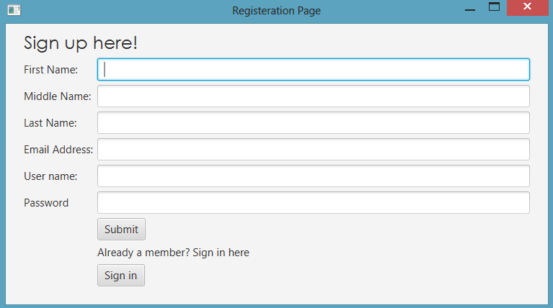

* In order to login into Customer Bank Account, one has to have registered with the BankDataBase System by filling up basic information in Text Fields as shown above.
* All the fields are required or incomplete information won’t be submitted & inserted into the database successfully.

1. Login.java: If username & password is wrong on login page, it shows the error as below:

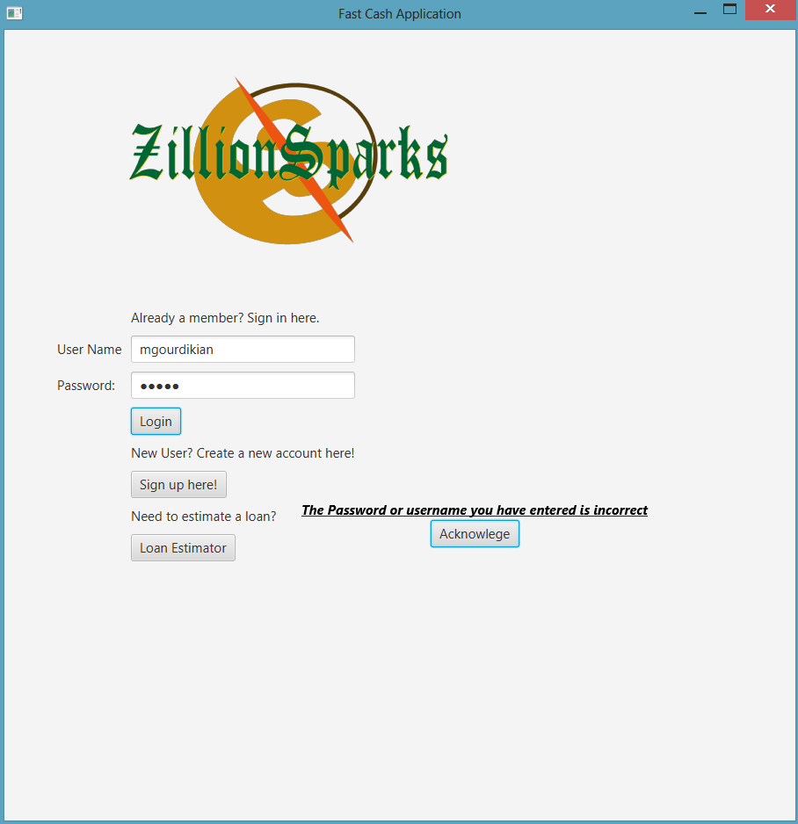

Entering any of given set of username & password as below in **users table**, will result into login successful.

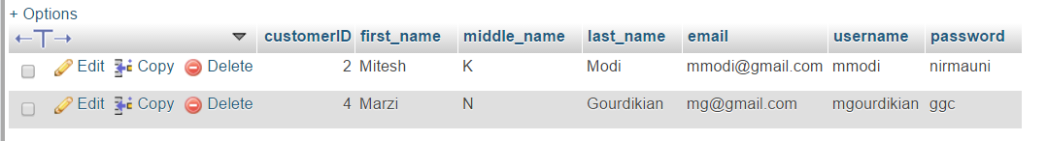

1. **AccountsMain.java:**

Successful login with right combination of username & password takes a user to AccountsMain.java Activity as shown below:

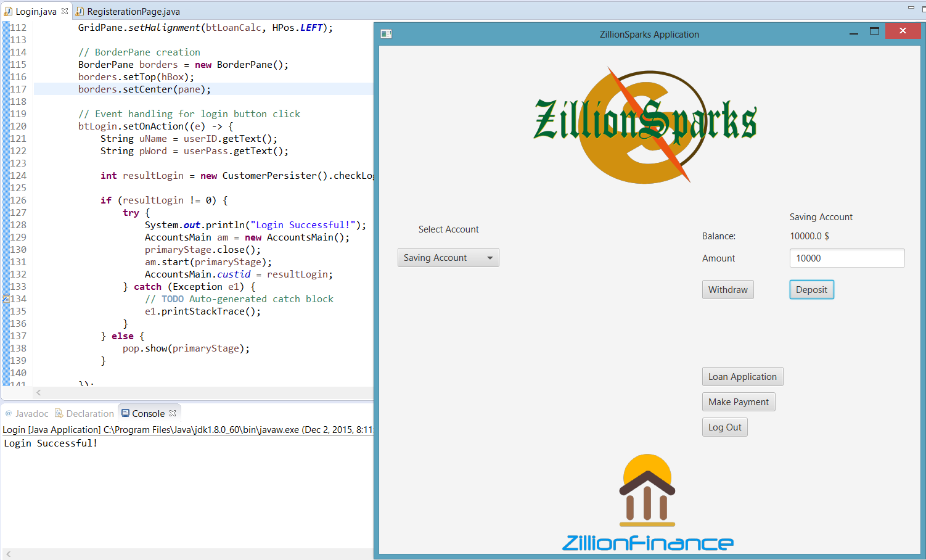

* “Login Successful!” message is only displayed when .checkLogin() method is called from CustomerPersitor.java & that method grabs the right combination of username- password from users table (users table is shown above).
* Currently, Logged in user is **mgourdikian (customerID 4)**, with 5000 in checking account & 10000 in saving account as shown in account table as below: **Before Applying deposit & withdraw**

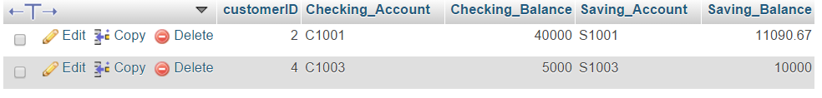

Checking Accounts & Saving Accounts are auto-generated at the time of registration and they are auto incremented String type.

Depositing 10000 into checking account makes it 15000 and withdrawing 5000 from saving account makes it 5000 remaining in the GUI, using setText() in Button Click event handler as well as account table, too.

**After Withdrawing 5000 from saving and Depositing 10000 into checking**

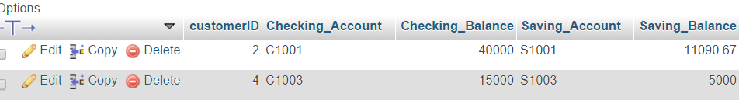

**5000 Withdrawal from Saving from 10000 of total balance**

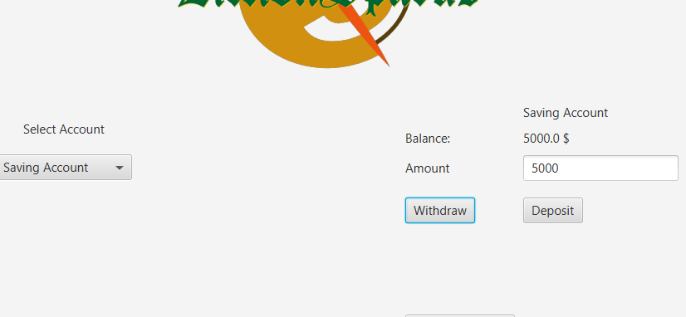

**10000 Deposit into Checking Account into total balance of 5000**

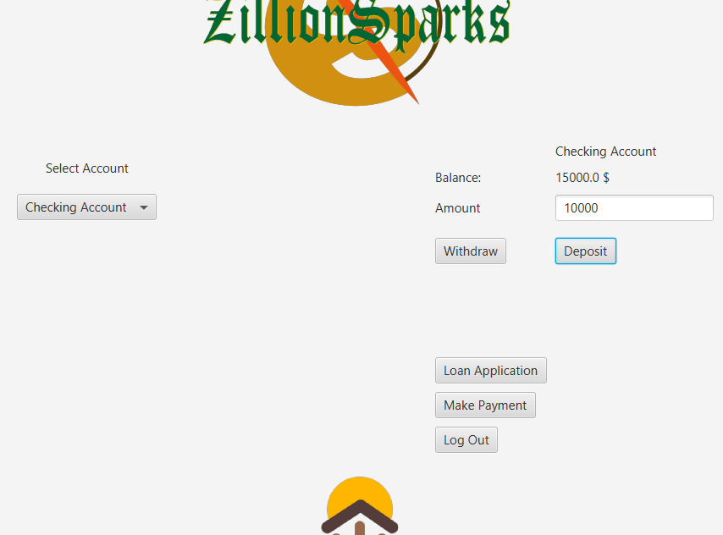

1. LoanApplication.java:

Clicking on Loan Application page takes a user to Loan Application Page where s/he can apply for a loan if s/he doesn’t have any pending previous loan to be paid.

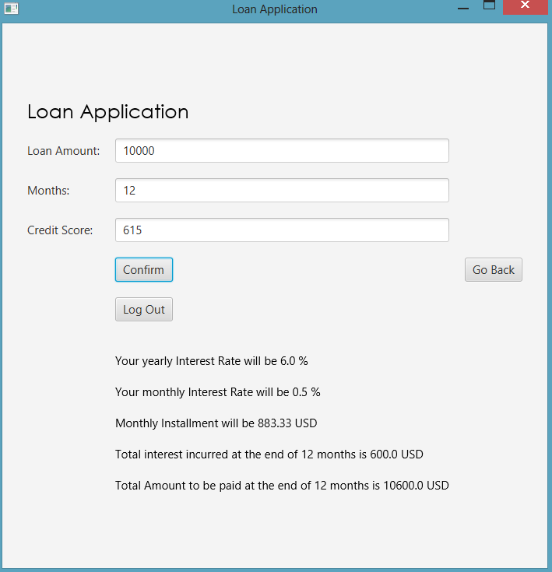

Loan data is generated into loan table upon loan acceptance and further information such as yearly/ monthly interest rate, monthly installment amount, total due amount is displayed on on GUI, using setText() . In below loan table, new loan data is generated with a **customerID 4 which belongs to mgourdikian**.



After applying for a loan, second-time application is denied due to remaining loan amount to be paid. The error message is displayed, as shown below:

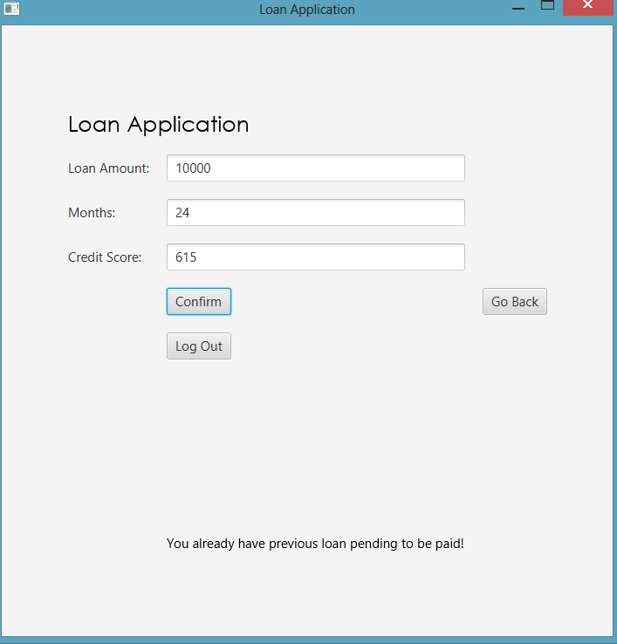

1. MakePayment.java:

To make a payment, one can go to Make Payment from Accounts Main activity. Customer can make a payment from Checking Account or Saving Account and appropriate amount will be deducted from respective account (whichever account is used to make a payment) in **account table** and inside **loan table, Remaining Amount to be paid** and Remaining months are the fields, will be updated accordingly.

* After each successful payment, the message is displayed showing

1. Remaining amount (including interest) to be paid,
2. Numbers of months left to make a full loan payment
3. Average Monthly Installment Amount to make successful payments at the end of all those remaining months (also known as loan duration)

For example, customerID 4 have 10600 USD (including incurred interest amount) and 12 month to pay all of the amount. And, Customer pays 1000 USD in first installment from saving account which has currently 5000 USD in it, and result will be as shown below:

Before payment,

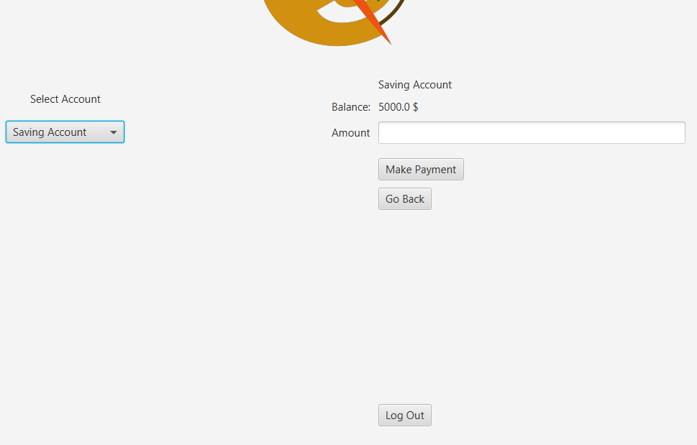

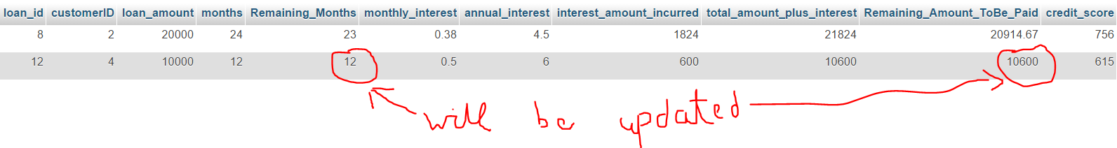

After payment,

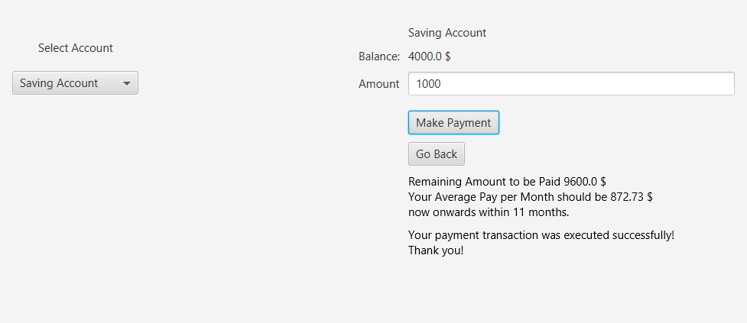



* Logout Buttons are available on every activity after successful login, so clicking on log out button from any activity will make this application available for another customer to use on the same system!