Module(JQuery Basic,Effects&Advanced)-5

1. What is JQuery?

Ans:- JQuery is a small,fast and lightweight java script library. JQuery is platform-independent. jQuery means “write less do more”.

1. How to Apply CSS Using JQuery, How to Add Class and Remove Class in Jquery , JQuery Animation?

Ans:- i. Apply CSS using JQuery .

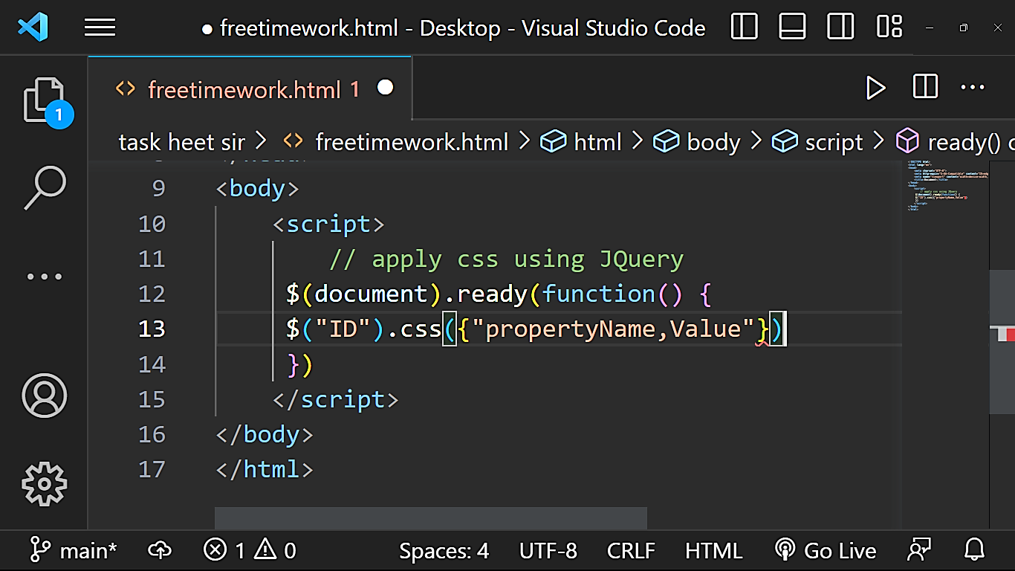

ii. Add class and remove class.

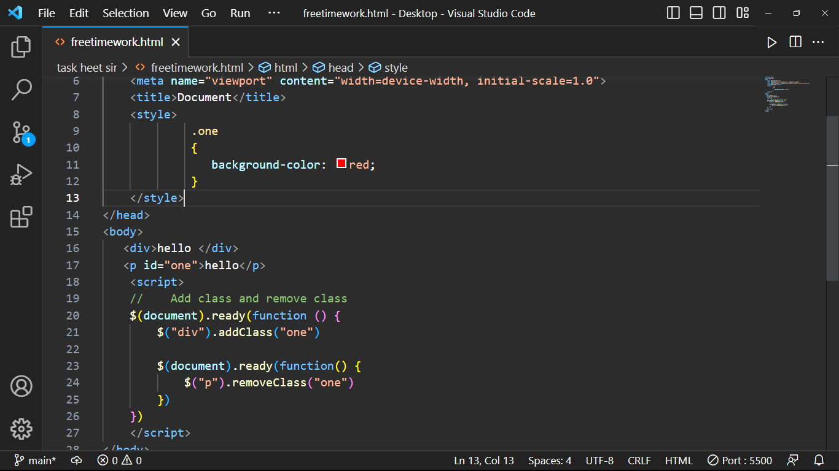

iii. JQuery animation.

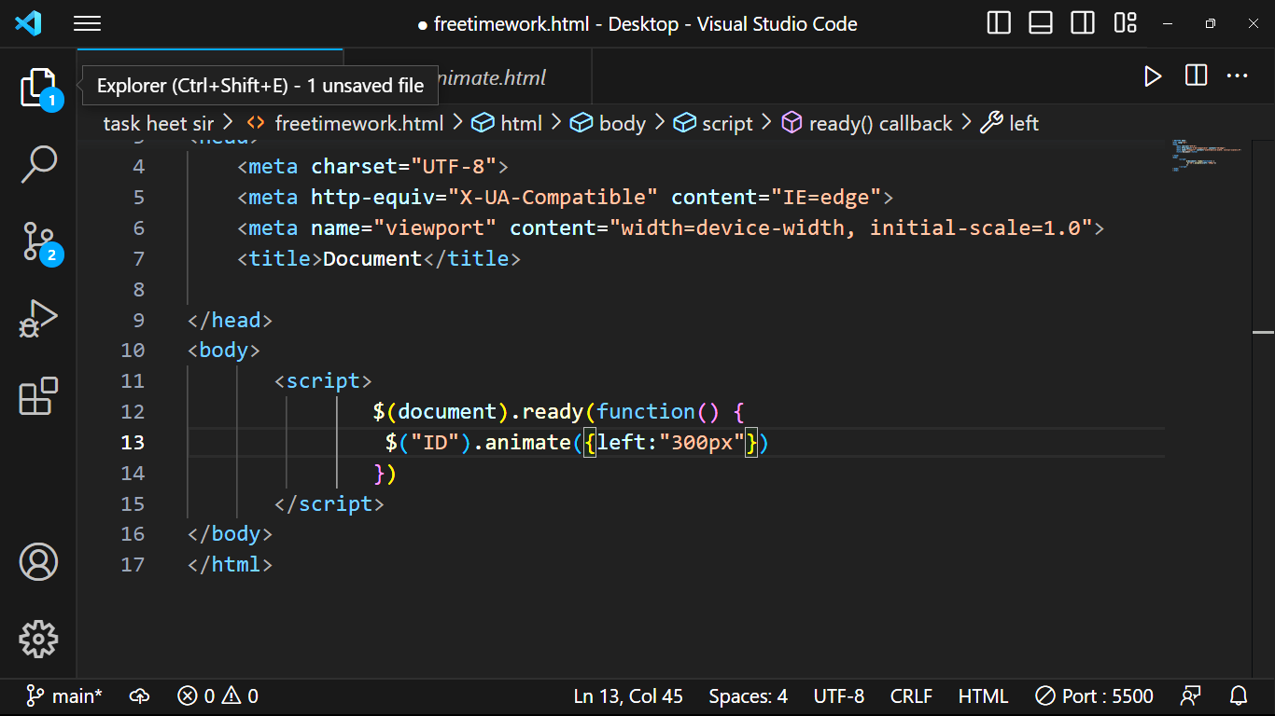

**3.How to create slider with animation?**

Ans:-

