|  |  |  |  |  |
| --- | --- | --- | --- | --- |
| Field Name | Data type | Field Length | Constraint | Description |
| Name | Char | 100 | Not Null | Farmer name and customer name |
| Email | Email | 100 | Not Null | Farmer email and customer email |
| Password | Char | 100 | Not Null | User set passwords |
| Mobile | Int | - | Not Null | Mobile numbers |
| User type | Char | 100 | Not Null | Type user farmer or customer |
| Image | Image | - | - | Customer or farmer image |
| Address | Char | 100 | Not Null | Adrress |

Data Dictionary

Use Case (Customer side)

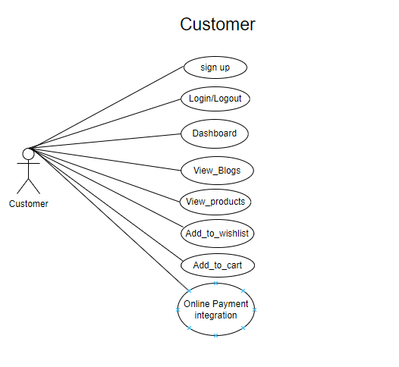

Use Case diagram (Farmer side )

