1. Acknowledgement

*Designed and developed an E-Commerce website which provided services like Amazon and Flipkart. Was responsible for developing webpage using html, CSS , JS, Python and Django for back-end. Also used email API and payment gateway API worked with rest API to retrieve data in case anyone losses/forgets their password.*

2.Introduction

*project name is e-garderner website this website is use for plants and farming tools to add product and Buy.*

Models:- User,

Category,

Product,

Blog,

Cart,

Transaction,

Wishlist

User:- Farmer , Customer

Database:- sqlite3

Django version:- 4.2.5

Installed apps:- myapp,

Payment Integration:- Razorpay

Views base:- Function base view

|  |  |  |  |  |
| --- | --- | --- | --- | --- |
| Field Name | Data type | Field Length | Constraint | Description |
| Name | Char | 100 | Not Null | Farmer name and customer name |
| Email | Email | 100 | Not Null | Farmer email and customer email |
| Password | Char | 100 | Not Null | User set passwords |
| Mobile | Int | - | Not Null | Mobile numbers |
| User type | Char | 100 | Not Null | Type user farmer or customer |
| Image | Image | - | - | Customer or farmer image |
| Address | Char | 100 | Not Null | Adrress |

3.Data Dictionary

4.Use Case (Customer side)

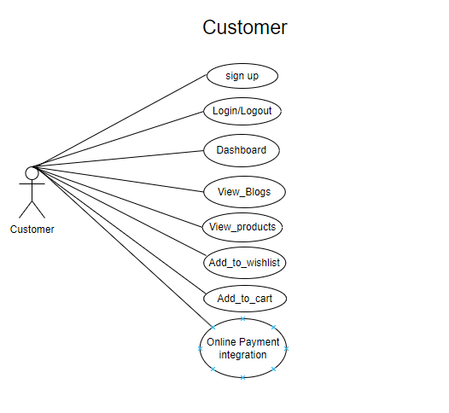

5.Use Case diagram (Farmer side )

