Mithil Patel

DSC 640: Week 3 & 4 Dashboard assignment

01/18/2023

**Dashboard Write-up**

Due to a recent incident involving an airplane crash, rumors were circulating in the media surrounding the danger of traveling in airplanes. The rumors have cast fear in people and have negatively impacted the aviation industry. An assumption can be drawn from the media’s claim regarding airplane safety. If airplanes are unsafe, one would expect the number of airplane incidents to rise over the years as more people opt to travel via air. However, the data tells us a completely different story. A dataset containing the number of incidents from two different time intervals suggests a higher number of airplane incidents occurring from 1985 - 1999 compared to 2000 – 2014 (Fig. 1). Additionally, a bar chart shown in Figure 2 shows a similar trend where a higher number of fatalities occurring during the early years of commercial airlines compared to later years. The high fatalities during the early years can be attributed to primitive technology and the industry’s early phase, where rules and regulations were implemented with very limited knowledge. With the advancement of technology, airplanes’ safety and efficiency improved significantly, resulting in a lower fatality rate in recent years. In contrast, data shows that motor vehicle fatality reached its highest peak (approximately 56,000/year) fifty years after cars became widely available to the public (see Fig. 3). In recent years, the average fatality is nearly 45,000 car-related deaths per year, which is astronomy high compared to 56 death involving airplane crashes. In figure 4, we can observe that the fatality increases at a much faster rate than the rate of new vehicles for the first fifty years; however, the rate begins to decline to 45,000 death per year slowly and eventually hovers around that number (Fig. 4).

An ethical concern would be to remain transparent with data since partiality and manipulation of data result in a risk to public safety and potential loss of lives. Now that we have established that traveling by airplane is a much safer option than traveling by car, we shall highlight the economic benefits of traveling by air. Over two decades, the base airfare has only increased by 8% after adjusted dollar to inflation; meanwhile, the “All-in” fare, which includes round-trip plus baggage, has decreased by approximately 48% (Fig. 5). Furthermore, since commercial airplanes have become safe and accessible, more travelers trust airplanes as a means of transportation (Fig. 6). In essence, the news and media outlets spread panic amongst the public regarding the risk of traveling in airplanes when air travel is far safer than motor vehicles. Also, it is economical and saves considerable time when traveling far by plane.

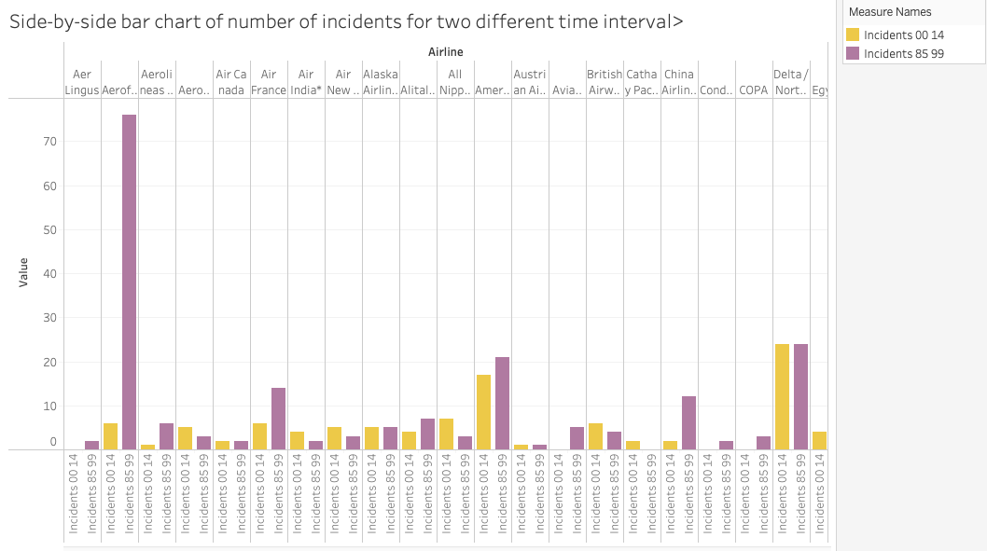

Fig. 1: Bar chart of incidents reported from 1985 – 1999 and 2000 – 2014.

Fig 2: Bar charts of fatalities reported from 1985 – 1999 and 2000 – 2014.

Fig 3: A scatterplot showing the number of deaths due to car crash over the years.

Fig 4: Line charts showing a relationship between number of vehicles (cars) and deaths.

Fig 5: Line charts of base air fare and “All-in” fare from 1990 – 2021.

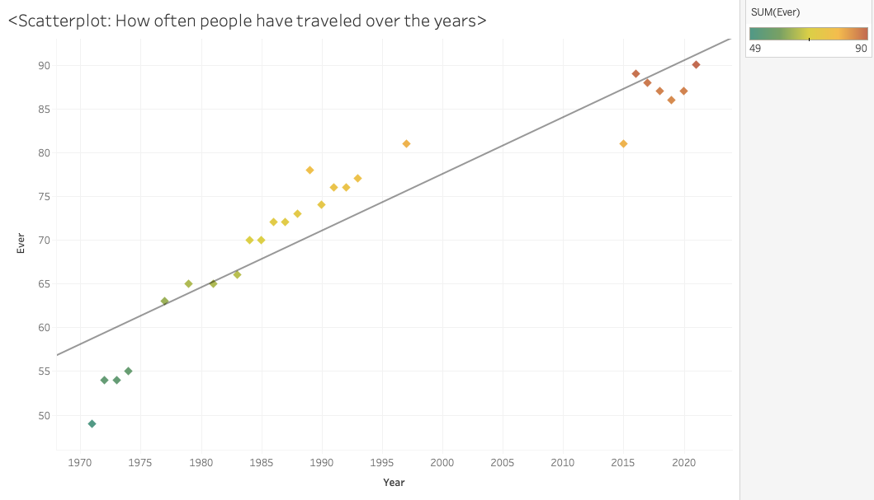

Fig 6: Scatter plot of how often people have traveled via airplanes over the years.