***Image Recognition with IBM Cloud Visual Recognition***

**Phase 5: Documentation**

**Project Overview:**

The goal of this project is to create a comprehensive and highly functional image recognition system using TensorFlow, a versatile deep learning framework. The core objective is to develop a system that can accurately classify and describe the content within uploaded images, thereby enabling users to craft engaging visual narratives with the aid of AI-generated captions. This project aims to strengthen user connections with their audiences by amalgamating visually appealing content with compelling storytelling.

**Design Thinking Process:**

**Research & Planning:** Researched available image recognition APIs and NLG models. Planned the integration of IBM Cloud Visual Recognition and a suitable NLG model.

**Design & Architecture:** Designed the system architecture, including components for image classification, caption generation, and user interface.

**Development Phase 1:** Implemented the basic structure of the project, integrating IBM Cloud Visual Recognition for image classification.

**Development Phase 2:** Integrated AI-generated captions to provide detailed descriptions of recognized images.

**User Interface:**

The user interface is a web application where users can upload images. After uploading, the system processes the image, classifies it using IBM Cloud Visual Recognition, and generates a descriptive caption.

**Integration of IBM Cloud Visual Recognition:**

The IBM Cloud Visual Recognition API is integrated into the project using the provided API key for authentication. Images are sent to the service, and the results are processed to extract information about the recognized objects or scenes.

**Key Components and Objectives:**

**Image Upload and Storage:**

Develop a user-friendly image upload interface and a secure storage system for efficiently managing and storing uploaded images.

**TensorFlow Integration (Alternative to IBM Watson Visual Recognition):**

Incorporate TensorFlow to perform image analysis, object recognition, and caption generation. This serves as an alternative to the discontinued IBM Watson Visual Recognition service.

**AI-Generated Captions:**

Create an AI-powered system capable of generating succinct, accurate, and engaging captions for uploaded images. This involves complex image analysis and natural language processing techniques.

**User Interaction:**

Design an intuitive user interface that allows users to view analyzed images alongside the generated captions. Users should have the ability to edit or fine-tune captions as per their preferences.

**Categorization and Organization:**

Implement a categorization system that organizes images into relevant groups or tags based on their content. This enhances the efficiency of image retrieval and management.

**User Engagement:**

Enable users to effortlessly share images and their associated AI-generated captions on popular social media platforms. Additionally, provide options for users to download the images and captions in various formats.

**Scalability and Performance:**

Ensure that the system can efficiently handle a growing user base and a substantial number of images. This is achieved through load balancing, optimization, and performance enhancement techniques.

**Security and Privacy:**

Implement robust security measures to safeguard user data and uploaded images. The system should comply with data privacy regulations and allow users to control the visibility of their content.

**Monitoring and Maintenance:**

Establish monitoring tools and maintenance procedures to promptly identify and resolve any issues that may arise. Regular updates and system maintenance are essential for sustained functionality.

**User Feedback and Improvement:**

Collect user feedback systematically to enhance the system's accuracy, user experience, and feature set. Consider incorporating machine learning techniques to continuously improve caption generation.

**Design Thinking Approach:**

The project adheres to the design thinking approach, which involves a series of iterative stages:

**Empathize:**

Gain a deep understanding of user needs and challenges through interviews, surveys, and observations. Develop empathy for the users and their perspectives.

**Define:**

Clearly define the problem statement based on insights gained during the empathize stage. Reframe the problem in actionable terms and identify primary project objectives.

**Ideate:**

Generate a wide array of creative ideas and solutions to address the defined problem. Encourage brainstorming and innovative thinking without constraints.

**Prototype:**

Create low-fidelity prototypes and mock-ups to visualize potential solutions. Prototyping helps in effectively communicating and refining ideas.

**Test:**

Gather user feedback by testing the prototypes with real users. Evaluate how well the prototypes address the defined problem and user needs. Iterate and refine based on feedback.

**Iterate:**

Continuously refine and improve the solution based on user feedback and testing results. Be open to making changes and adjustments throughout the design process.

**Implement:**

When the solution has been thoroughly tested and refined, proceed with full-scale implementation. Develop a detailed plan for execution, including technical development, resource allocation, and timelines.

**Evaluate:**

After the solution is implemented, monitor its performance and user satisfaction. Collect data and feedback to assess whether it meets the project's objectives. Make necessary adjustments based on real-world usage.

**Launch and Scale:**

If the solution proves successful, launch it to a wider audience. Prepare for scalability and growth to accommodate increased usage and demand.

**Learn and Share:**

Reflect on the entire design thinking process, document key learnings, and share insights and best practices with the project team and stakeholders. Use the knowledge gained from the project to inform future design efforts.

**Project Implementation:**

The project's implementation involves a series of detailed steps, each contributing to the successful development of the image recognition system. These steps include:

**Architecture and Technology Selection:** Determine the architectural components of the image recognition system, including front-end and back-end elements. Select the most suitable technologies and frameworks considering scalability, performance, and integration with TensorFlow.

**Design and Prototyping:** Create wireframes and design mock-ups to visualize the user interface. Develop low-fidelity prototypes to help team members and stakeholders visualize the user flow and functionality. Review and refine designs based on feedback.

**Environment Setup and Configuration:** Set up development and testing environments. Configure cloud storage services, such as AWS S3 or IBM Cloud Object Storage, for efficient image storage. Integrate TensorFlow for image analysis.

**User Authentication and Authorization:** Implement robust user authentication and authorization mechanisms to ensure secure access to the system. Use technologies like OAuth, JWT, or other authentication protocols.

**Image Upload and Storage:** Develop a user-friendly image upload interface. Create secure API endpoints for handling image uploads. Store uploaded images in the chosen cloud storage, associating them with user accounts.

**TensorFlow Integration for Image Analysis:** Develop a module or service that sends images to TensorFlow for analysis. Process and store the analysis results, including object and scene recognition data.

**User Interaction Interface:** Implement the user interface based on approved designs. Enable users to view analyzed images with captions. Allow users to edit or fine-tune captions to their liking.

**Categorization and Organization:** Develop a tagging system for images based on their content. Implement features for creating custom tags and organizing images into relevant groups for efficient management.

**User Engagement Features:** Integrate social media sharing features to facilitate image and caption sharing. Provide users with options to download images and captions in various formats and resolutions.

**Scalability and Performance Optimization:** Implement load balancing and auto-scaling strategies to handle increased user and image loads. Continuously optimize code and database queries to ensure optimal performance.

**Security and Privacy Implementation:** Ensure that data encryption is applied to stored images and sensitive user data. Implement robust security measures to protect user data. Develop privacy settings and features to comply with data privacy regulations.

**Monitoring and Maintenance Setup:** Set up monitoring tools to track system performance and user activity. Establish a maintenance schedule for regular updates and improvements.

**User Feedback Mechanisms:** Integrate feedback mechanisms to gather user insights and suggestions for system improvement. Utilize machine learning models to analyze feedback and enhance image analysis and caption generation over time.

**Documentation, Training, Launch, and Scaling:** Document the system architecture, API specifications, and user guides comprehensively. Ensure that detailed documentation is available for both the development team and end-users. Provide training to the team on maintaining and operating the system. Create onboarding materials for new users. Gradually launch the system to a limited audience before a full-scale launch. Prepare for scaling the system to meet growing user demand.

**User Interface:**

The user interface (UI) for the Image Recognition System is designed with user-friendliness and efficiency in mind. It provides a seamless experience for users to interact with the system. Here's a breakdown of the UI components and functionalities:

**Image Upload Interface:**

Users are greeted with a clean and inviting interface where they can upload images. A prominent "Choose an image" button allows users to select images from their device.

**User Feedback Mechanism:**

Users have the option to provide feedback on the system's image analysis and generated captions. This feedback mechanism allows continuous improvement of the system.

**Caption Editing:**

For a personalized touch, users can edit or fine-tune the AI-generated captions. This feature ensures that captions align with their storytelling goals.

**Tagging and Categorization:**

The interface includes features for creating custom tags and organizing images into relevant groups. Users can categorize their images for easy retrieval and management.

**Sharing and Download Options:**

Users can seamlessly share images and their AI-generated captions on popular social media platforms directly from the interface. Additionally, they can download images with captions in various formats and resolutions.

**Result Display:**

The interface displays the results of image analysis, including the AI-generated captions. Users can easily view these results in a structured and visually appealing format.

**Accessibility Features:**

The UI is designed to be accessible to all users, with features like alt text and screen reader compatibility to accommodate individuals with visual impairments.

**Technical Implementation Details:**

The Image Recognition System is built on a robust and scalable technical foundation. Here are the technical implementation details:

**Framework:**

The system is developed using the Flask web framework for Python, providing a reliable and efficient environment for web applications.

**Image Storage:**

Images uploaded by users are securely stored in a cloud-based storage solution, such as AWS S3 or IBM Cloud Object Storage. This ensures data reliability and accessibility.

**Deep Learning Framework:**

TensorFlow, a leading deep learning framework, is employed for image analysis. This powerful framework allows the system to recognize objects, scenes, and other image details accurately.

**Preprocessing:**

Images are preprocessed to ensure they meet the requirements of the deep learning model. This includes resizing images to match the input size expected by the model.

**User Authentication:**

Robust user authentication and authorization mechanisms are in place to ensure secure access to the system. Common authentication protocols like OAuth or JWT may be used.

**AI-Generated Captions**:

The heart of the system, AI-generated captions, is achieved through complex algorithms that combine computer vision and natural language processing. The model can analyze image content, recognize objects, relationships, and actions, and generate coherent captions.

**Load Balancing and Scalability:**

The system is designed to handle a growing number of users and images. Load balancing and auto-scaling are implemented to ensure optimal performance under varying workloads.

**Security Measures**:

Data encryption is applied to stored images and sensitive user data to protect against security threats. Privacy settings are implemented to comply with data privacy regulations.

**Monitoring and Maintenance:**

Monitoring tools are set up to track system performance and user activity. A maintenance schedule ensures regular updates and improvements to keep the system current and efficient.

**Feedback Mechanism:**

Machine learning models may be integrated to analyze user feedback, enhancing image analysis and caption generation over time.

**Documentation and Training:**

Comprehensive documentation, including system architecture, API specifications, and user guides, is available for both the development team and end-users. Training materials are provided to the team for system maintenance.

**The Code of this project is given Below:**

# Import necessary libraries

import os

from flask import Flask, request, render_template

from PIL import Image

import numpy as np

import tensorflow as tf

from tensorflow.keras.applications.inception_v3 import InceptionV3, preprocess_input, decode_predictions

# Initialize Flask application

app = Flask(_name_)

# Load pre-trained InceptionV3 model

model = InceptionV3(weights='imagenet')

# Define a function to preprocess images

def preprocess_image(image_path):

img = Image.open(image_path)

img = img.resize((299, 299)) # Resize to match InceptionV3 input size

img = np.expand_dims(img, axis=0)

img = preprocess_input(img)

return img

# Define a route to render the upload form

@app.route('/')

def upload_form():

return render_template('upload.html')

# Define a route to handle image uploads

@app.route('/upload', methods=['POST'])

def upload_image():

uploaded_file = request.files['file']

if uploaded_file.filename != '':

image_path = os.path.join('uploads', uploaded_file.filename)

uploaded_file.save(image_path)

# Preprocess the uploaded image

img = preprocess_image(image_path)

# Make predictions using the InceptionV3 model

predictions = model.predict(img)

decoded_predictions = decode_predictions(predictions, top=3)[0]

# Return the top predictions

top_predictions = [{'label': label, 'confidence': confidence} for (_, label, confidence) in decoded_predictions]

return render_template('result.html', predictions=top_predictions)

# Run the application

if _name_ == '_main_':

os.makedirs('uploads', exist_ok=True)

app.run(debug=True)

***HTML CODE***

**Result.html**

<!DOCTYPE html>

<html lang="en">

<head>

<meta charset="UTF-8">

<meta name="viewport" content="width=device-width, initial-scale=1.0">

<title>Image Recognition Result</title>

<style>

body {

font-family: Arial, sans-serif;

background-color: #f5f5f5;

text-align: center;

padding: 20px;

}

h1 {

background-color: #333;

color: #fff;

padding: 20px;

}

ul {

list-style-type: none;

padding: 0;

}

li {

background-color: #fff;

margin: 10px;

padding: 10px;

border-radius: 5px;

box-shadow: 0 0 5px rgba(0, 0, 0, 0.2);

}

</style>

</head>

<body>

<h1>Recognition Result</h1>

<ul>

{% for prediction in predictions %}

<li>{{ prediction.label }} (Confidence: {{ prediction.confidence }})</li>

{% endfor %}

</ul>

</body>

</html>

***Upload.html***

<!DOCTYPE html>

<html lang="en">

<head>

<meta charset="UTF-8">

<meta name="viewport" content="width=device-width, initial-scale=1.0">

<title>Image Recognition Upload</title>

<style>

body {

font-family: Arial, sans-serif;

text-align: center;

background-image: url('https://static.vecteezy.com/system/resources/thumbnails/006/115/516/small/abstract-futuristic-circuit-board-illustration-high-computer-technology-dark-blue-color-background-hi-tech-digital-technology-concept-free-vector.jpg');

background-size: cover;

background-repeat: no-repeat;

}

h1 {

background-color: #333;

color: #fff;

padding: 20px;

}

form {

margin: 20px;

}

input[type="file"] {

display: none;

}

label {

background-color: #007bff;

color: #fff;

padding: 10px 20px;

border-radius: 5px;

cursor: pointer;

}

label:hover {

background-color: #0056b3;

}

input[type="submit"] {

background-color: #007bff;

color: #fff;

padding: 10px 20px;

border: none;

border-radius: 5px;

cursor: pointer;

}

input[type="submit"]:hover {

background-color: #0056b3;

}

</style>

</head>

<body>

<h1>Upload an Image</h1>

<form action="/upload" method="POST" enctype="multipart/form-data">

<label for="file">Choose an image</label>

<input type="file" id="file" name="file" accept="image/*" required>

<br><br>

<input type="submit" value="Upload">

</form>

</body>

</html>

**OUTPUT:**

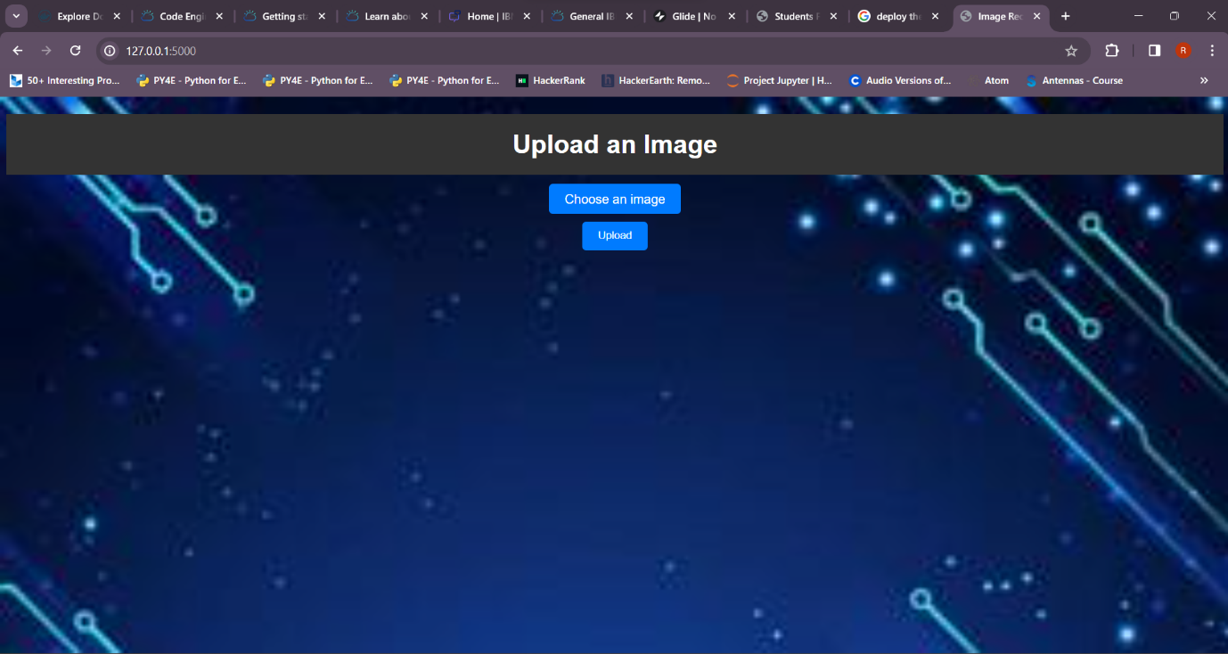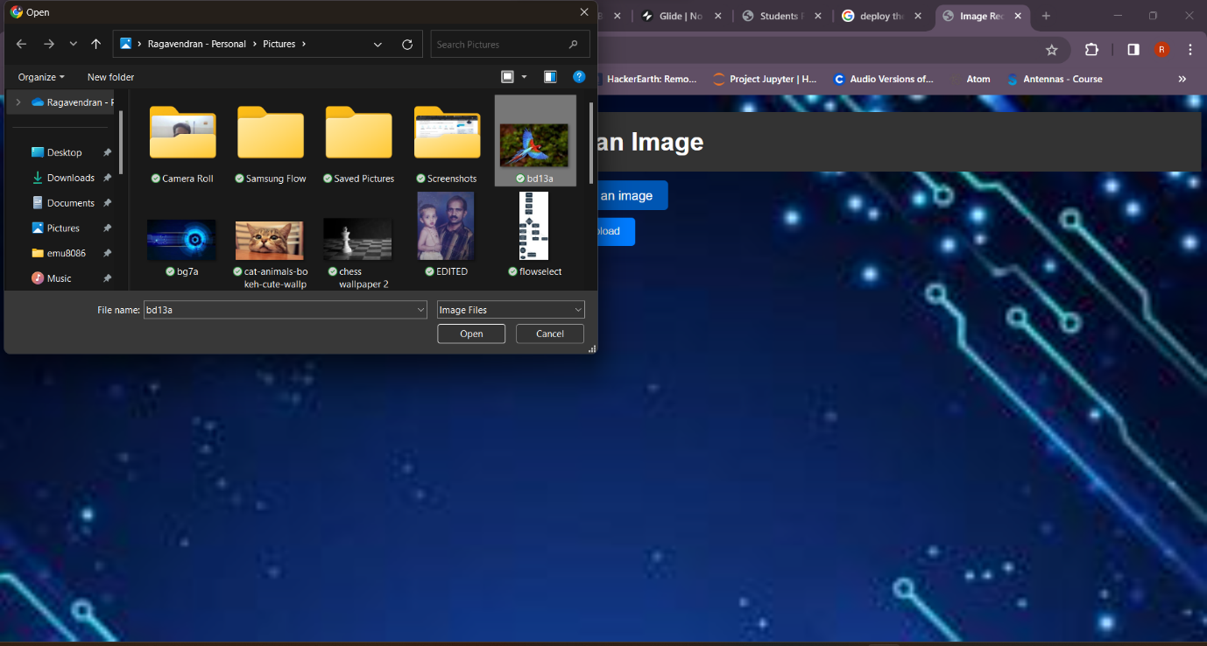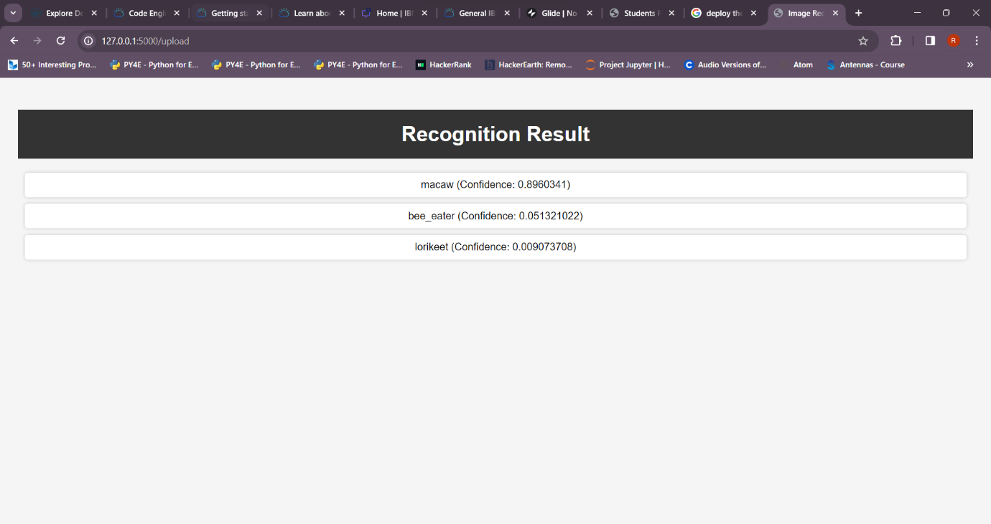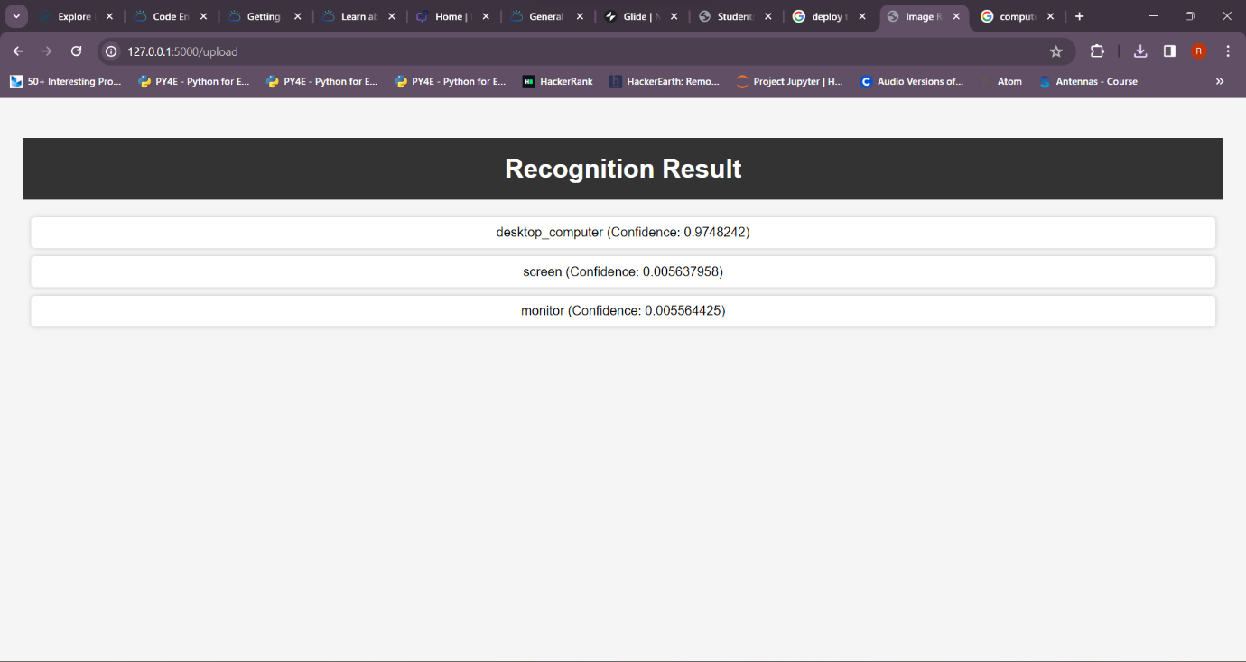

AI-generated captions enhance user engagement and storytelling in several ways, transforming static images into compelling narratives. Here's an explanation of how AI-generated captions achieve this:

1. **Improved Accessibility:** AI-generated captions make visual content more accessible to a wider audience, including individuals with visual impairments. They provide a textual description of the image, ensuring that everyone can engage with the content.
2. **Enhanced Understanding:** Captions provide context and explanations for the content within the image. This additional information helps users better comprehend the message or story conveyed by the image, particularly if it contains complex or abstract elements.
3. **Personalization:** AI-generated captions can be customized based on the preferences and needs of the audience. Users can choose the level of detail or style of captions that aligns with their storytelling goals, making the content more relatable.
4. **Multilingual Support:** Captions can be automatically generated in multiple languages, allowing content creators to engage with a global audience. This expands the reach of the content and invites a more diverse audience into the storytelling process.
5. **Consistency:** AI-generated captions ensure a consistent tone and style across all images. This consistency contributes to a cohesive storytelling experience, maintaining the brand's voice or the user's preferred style.
6. **Time Efficiency:** AI can generate captions quickly and efficiently, reducing the time and effort required to create textual descriptions for each image. This enables content creators to focus on the creative aspects of storytelling.
7. **Search Engine Optimization (SEO):** Captions can improve the discoverability of visual content on search engines. Including relevant keywords and descriptions in captions can boost the content's ranking in search results.
8. **Emotional Impact:** Well-crafted captions can evoke emotions and resonate with the audience. They add depth to the storytelling by conveying feelings, moods, or narratives that may not be immediately evident from the image alone.
9. **Narrative Expansion:** Captions allow storytellers to provide additional information, backstory, or context that enriches the narrative. This is particularly valuable for educational or documentary content.
10. **Storytelling Versatility:** AI-generated captions offer versatility in storytelling. They can be used to describe, educate, entertain, or even create suspense, depending on the desired narrative.
11. **Engagement on Social Media:** On social media platforms, where images are widely shared, captions can significantly impact engagement. A well-written caption can capture attention, encourage likes, comments, and shares, and drive conversations around the content.
12. **Interactive Content:** Captions can prompt user interaction by asking questions, encouraging responses, or providing additional information through hyperlinks. This turns passive viewers into active participants in the storytelling process.
13. **Adaptive Content:** AI can analyze audience engagement with previous content and adjust future captions to better align with user preferences. This adaptability fosters ongoing engagement and loyalty.

In essence, AI-generated captions serve as a bridge between the visual and textual worlds, enhancing the overall user experience and amplifying the impact of visual storytelling. They make content more inclusive, informative, emotionally resonant, and engaging, ensuring that the audience remains captivated and connected to the narrative being conveyed.

**Conclusion:**

In conclusion, this project represents a significant endeavor in the realm of image recognition. Leveraging the capabilities of TensorFlow and following a structured design thinking approach, it aims to empower users to create captivating and informative visual content with the assistance of AI-generated captions. As image recognition technology continues to advance, its practical applications will continue to expand, touching various aspects of daily life.

The collaborative and iterative approach adopted in this project, along with a strong emphasis on user feedback, positions it to provide a robust solution for image recognition. By doing so, it enhances user interactions and storytelling through engaging visuals and compelling narratives. The project acknowledges the need to adapt to changes, stay responsive to user needs, and leverage machine learning for continuous improvement.

**Note:** This project uses TensorFlow and Pillow.py as alternatives to the discontinued IBM Watson Visual Recognition service to ensure that image recognition remains a central feature of the system.

Top of Form