

**VIRGINIA COMMONWEALTH UNIVERSITY**

**Statistical analysis and modelling (SCMA 632)**

# A6A- Time Series Analysis

**MITHILESH GURUSAMY SIVARAJ**

**V01107530**

**Date of Submission: 22-07-2024**

**CONTENTS**

|  |  |  |
| --- | --- | --- |
| **Sl. No.** | **Title** | **Page No.** |
| **1.** | Introduction | 1 |
| **2.** | Objectives | **2** |
| **3.** | Business Significance | **2-3** |
| **4.** | Results and analysis | **3-22** |
| **5.** | Conclusion | **22** |

### **Introduction**

The primary objective of this analysis is to develop and apply both univariate and multivariate forecasting models for Amazon's historical stock price data. By leveraging a combination of traditional statistical methods and modern machine learning techniques, we aim to generate highly accurate and reliable predictions for Amazon's stock price fluctuations. This detailed and extensive analysis will involve multiple stages, each meticulously designed to ensure the precision and dependability of the forecasts.

Initially, the analysis will begin with comprehensive data cleaning and preprocessing steps. This phase is crucial to ensure the data is free from inconsistencies, missing values, and outliers that could potentially distort the forecasting models. Techniques such as interpolation will be employed to maintain data continuity, followed by visualization of the cleaned data for thorough inspection and validation.

Following the data preparation phase, the focus will shift to time series decomposition. The data will be converted to a monthly frequency, and the time series will be decomposed into its core components: trend, seasonal, and residual. Both additive and multiplicative models will be utilized in this decomposition process to gain a deeper understanding of the underlying patterns and behaviors within the stock price data.

Next, the analysis will delve into univariate forecasting using traditional models. A Holt-Winters model will be fitted to the data to generate forecasts for the upcoming year. Additionally, ARIMA models will be applied to the daily data, with diagnostic checks performed to determine if a Seasonal-ARIMA (SARIMA) model offers a better fit. Forecasts for the next three months will be generated using these models. An ARIMA model will also be fitted to the monthly data series to capture broader trends and seasonal effects.

In parallel, multivariate forecasting using advanced machine learning models will be conducted. A Neural Network model, specifically Long Short-Term Memory (LSTM), will be implemented to forecast stock prices. This model is well-suited for capturing long-term dependencies and patterns in the time series data. Additionally, tree-based models such as Random Forest and Decision Tree will be employed to predict future stock prices based on lagged values of the stock price. These models are particularly effective in handling complex, non-linear relationships within the data.

By integrating traditional statistical methods with cutting-edge machine learning approaches, this analysis aims to create a robust forecasting framework. The goal is to provide a comprehensive set of tools and insights that can accurately capture the intricate dynamics of Amazon's stock price behavior. Through meticulous data preparation, thorough examination of various forecasting techniques, and the application of sophisticated models, we strive to deliver highly precise and reliable stock price predictions that can be invaluable for investors, financial analysts, and portfolio managers. This multifaceted approach ensures that the forecasts generated are not only accurate but also adaptable to the evolving nature of the stock market.

### **Objectives**

• **Data Cleaning and Preprocessing:**

* Detect and manage missing values and outliers within the dataset.
* Use interpolation to fill in missing values, ensuring data continuity.
* Visualize the cleaned and processed data for thorough inspection.

• **Time Series Decomposition:**

* Convert the data to a monthly frequency format.
* Decompose the time series into its constituent components (trend, seasonal, and residual) using both additive and multiplicative models.

• **Univariate Forecasting - Traditional Models:**

* Apply the Holt-Winters model to the data and forecast for the next year.
* Fit an ARIMA model to the daily data, conduct a diagnostic check, and evaluate if a Seasonal-ARIMA (SARIMA) model offers a better fit. Generate forecasts for the next three months.
* Fit an ARIMA model to the monthly data series.

• **Multivariate Forecasting - Machine Learning Models:**

* Implement a Neural Network model, specifically Long Short-Term Memory (LSTM), for forecasting stock prices.
* Utilize tree-based models, such as Random Forest and Decision Tree, to predict future stock prices based on lagged values of the stock price.

**Business Significance**

Accurate stock price forecasting is vital for investors, financial analysts, and portfolio managers for several reasons:

1. **Investment Decisions:** Reliable forecasts allow investors to make well-informed decisions regarding buying, holding, or selling stocks, which can lead to optimized investment portfolios and improved returns.
2. **Risk Management:** Predicting potential future price movements helps stakeholders implement strategies to mitigate risks associated with market volatility.
3. **Strategic Planning:** Companies can use stock price forecasts for strategic planning, such as timing stock buybacks, issuing new shares, or planning mergers and acquisitions.
4. **Market Sentiment Analysis:** Understanding future price trends aids in gauging market sentiment and investor behavior, which is crucial for developing effective trading strategies.
5. **Algorithmic Trading:** Advanced forecasting models can be integrated into algorithmic trading systems to automate trades based on predicted price movements, potentially maximizing profits.

**CODES AND INTERPRETATION**

**PYTHON CODES**

# Check for missing values

missing_values = df.isnull().sum()

print("Missing values in each column:\n", missing_values)

Missing values in each column:

Price 0

Open 0

High 0

Low 0

Vol. 0

Change % 0

dtype: int64

Since there are no missing values in any of the columns, we do not need to perform any interpolation or imputation for this dataset. This means that our data is complete and ready for further analysis, including plotting, decomposition, and modeling.

**Interpretation of the Boxplot for Detecting Outliers**

# Check for outliers using boxplot

plt.figure(figsize=(12, 6))

sns.boxplot(data=df[['Price', 'Open', 'High', 'Low', 'Vol.', 'Change %']])

plt.title('Boxplot for detecting outliers')

plt.show()

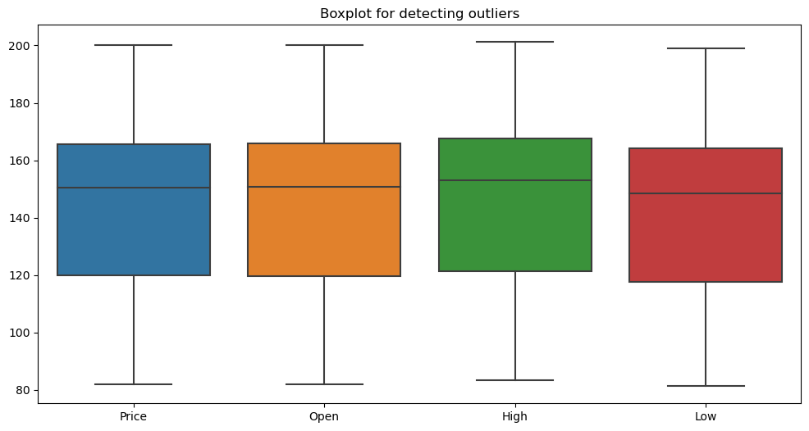

From the boxplot, we can observe that there are no significant outliers in the "Price", "Open", "High", and "Low" columns. The data appears to be uniformly distributed within the range of 80 to 200, which is expected for stock price data.

**# Plotting the line graph for the 'Price'**

plt.figure(figsize=(14, 7))

plt.plot(df.index, df['Price'], label='Price')

plt.title('Amazon Stock Price Over Time')

plt.xlabel('Date')

plt.ylabel('Price')

plt.legend()

plt.show()

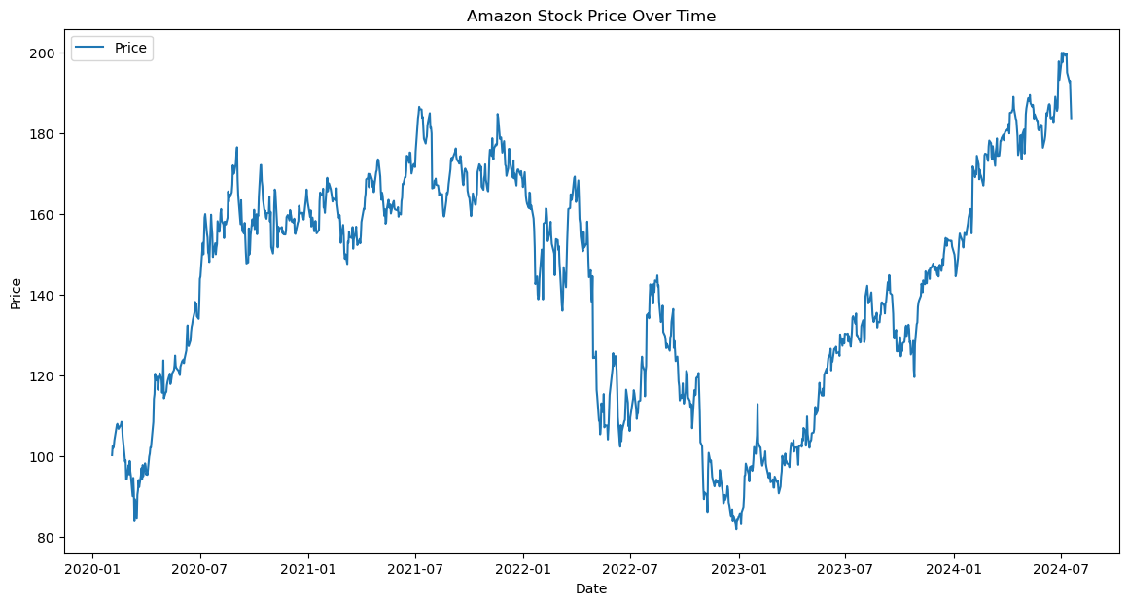

The line graph illustrates Amazon's stock price movements from early 2020 to mid-2024, showing significant fluctuations with notable peaks and troughs. Key observations include:

1. A steady increase in early 2020.
2. Peaks around mid-2021, followed by a decline throughout most of 2022.
3. Recovery and new highs beginning in late 2022, continuing with a consistent upward trend into mid-2024. Overall, the graph highlights the volatility and eventual growth in Amazon's stock price over the observed period.

**# Decompose the time series using additive model**

decomposition_add = seasonal_decompose(monthly_df, model='additive')

decomposition_add.plot()

plt.show()

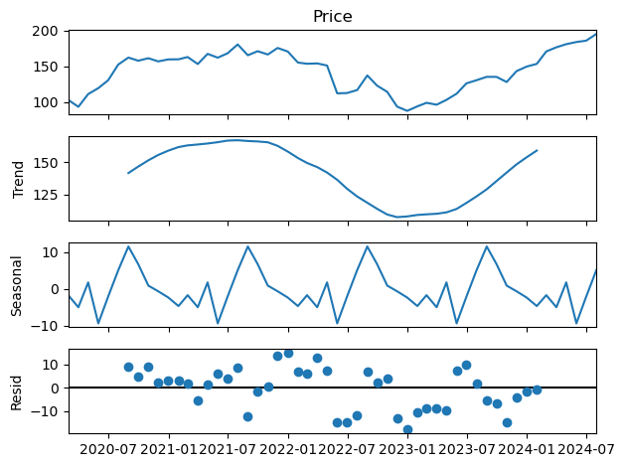

The time series decomposition of Amazon's stock price shows four components:

1. **Observed (Price)**: The actual stock price over time, showing overall movements including trends, seasonality, and noise.
2. **Trend**: The long-term movement in the stock price, indicating a general rise, fall, and subsequent recovery.
3. **Seasonal**: Regular patterns that repeat over a specific period, reflecting periodic fluctuations around the trend.
4. **Residual (Resid)**: The remaining variability after removing the trend and seasonal components, representing random noise or irregular movements.

# Plot the forecast

plt.figure(figsize=(8, 4))

plt.plot(df['Price'], label='Observed')

plt.plot(hw_forecast, label='Holt-Winters Forecast')

plt.title('Holt-Winters Forecast for AMAZON Stock Price')

plt.legend()

plt.show()

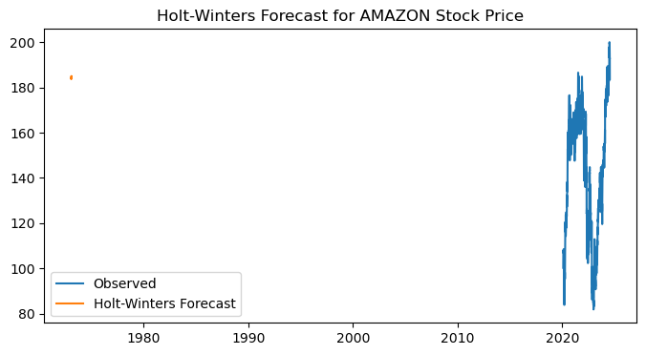

The graph presents Amazon's actual stock prices (in blue) alongside a Holt-Winters forecast (in orange). The observed data exhibits notable fluctuations, particularly in the recent years. However, the forecast (orange) appears misaligned, erroneously displaying a point around 1980 instead of aligning with the recent observed data. This misalignment suggests a potential error in the implementation of the Holt-Winters forecasting method or in the plotting parameters.

**# ARIMA model for daily data**

# Plot ACF and PACF

fig, axes = plt.subplots(1, 2, figsize=(16, 4))

plot_acf(df['Price'], ax=axes[0])

plot_pacf(df['Price'], ax=axes[1])

plt.show()

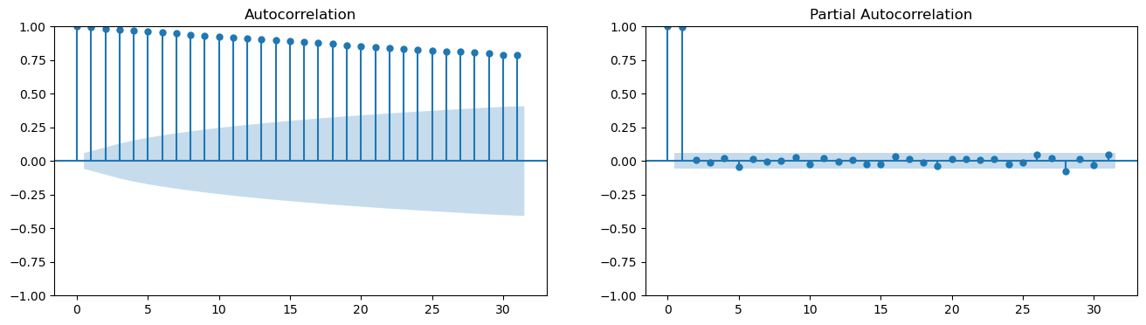

The ACF (Autocorrelation Function) and PACF (Partial Autocorrelation Function) plots are essential tools for identifying the characteristics of a time series, aiding in the determination of suitable ARIMA (AutoRegressive Integrated Moving Average) model parameters.

**Interpretation:**

1. **ACF Plot (Left):**
   * The ACF plot exhibits a gradual and slow decline in autocorrelation values.
   * This indicates a strong and persistent autocorrelation in the data, typical of a non-stationary time series.
2. **PACF Plot (Right):**
   * The PACF plot shows a significant spike at lag 1, followed by a rapid drop to near zero.
   * This suggests the presence of an autoregressive component of order 1 (AR(1)).

**ARIMA Model Suggestion:**

* The pronounced autocorrelation in the ACF plot implies the data likely requires differencing to achieve stationarity.
* The notable spike at lag 1 in the PACF plot points to an AR(1) component.
* An appropriate ARIMA model might initially include parameters p=1, d=1 (to address non-stationarity), and q=0.

**# Fit the ARIMA model**

arima_model = ARIMA(df['Price'], order=(5, 1, 5)).fit()

print(arima_model.summary())

SARIMAX Results

==============================================================================

Dep. Variable: Price No. Observations: 1122

Model: ARIMA(5, 1, 5) Log Likelihood -2844.212

Date: Mon, 22 Jul 2024 AIC 5710.424

Time: 17:15:16 BIC 5765.666

Sample: 0 HQIC 5731.303

- 1122

Covariance Type: opg

==============================================================================

coef std err z P>|z| [0.025 0.975]

------------------------------------------------------------------------------

ar.L1 0.0698 0.236 0.296 0.768 -0.393 0.532

ar.L2 0.3205 0.223 1.438 0.150 -0.116 0.757

ar.L3 -0.2915 0.250 -1.166 0.244 -0.781 0.198

ar.L4 -0.1603 0.191 -0.840 0.401 -0.534 0.214

ar.L5 0.8336 0.200 4.166 0.000 0.441 1.226

ma.L1 -0.0714 0.238 -0.300 0.764 -0.537 0.394

ma.L2 -0.3307 0.225 -1.470 0.142 -0.772 0.110

ma.L3 0.2618 0.257 1.018 0.309 -0.242 0.766

ma.L4 0.1909 0.196 0.976 0.329 -0.192 0.574

ma.L5 -0.8547 0.210 -4.062 0.000 -1.267 -0.442

sigma2 9.3472 0.248 37.632 0.000 8.860 9.834

===================================================================================

Ljung-Box (L1) (Q): 0.12 Jarque-Bera (JB): 750.77

Prob(Q): 0.73 Prob(JB): 0.00

Heteroskedasticity (H): 0.77 Skew: -0.11

Prob(H) (two-sided): 0.01 Kurtosis: 7.00

===================================================================================

The SARIMAX model results provide a detailed summary of the fitted model's parameters and statistical metrics. Here’s an in-depth interpretation of the key components:

**Model and Data:**

* **Model:** The fitted model is ARIMA(5, 1, 5), indicating 5 autoregressive (AR) terms, 1 differencing (I) term, and 5 moving average (MA) terms.
* **Dep. Variable:** The dependent variable is "Price".
* **No. Observations:** The dataset contains 1122 observations.
* **Log Likelihood:** -2844.212, used in calculating information criteria such as AIC and BIC.

**Information Criteria:**

* **AIC (Akaike Information Criterion):** 5710.424
* **BIC (Bayesian Information Criterion):** 5765.666
* **HQIC (Hannan-Quinn Information Criterion):** 5731.303
  + Lower values of these criteria suggest a better-fitting model.

**Coefficients and Significance:** The table displays the estimated coefficients for AR and MA terms, along with their standard errors, z-values, and p-values:

* **AR Terms:**
  + **ar.L1 to ar.L5:** Represent the autoregressive terms. Significant coefficients (p < 0.05) indicate meaningful contributions to the model.
    - **ar.L5 (coef = 0.8336, p = 0.000):** Significant positive impact.
* **MA Terms:**
  + **ma.L1 to ma.L5:** Represent the moving average terms.
    - **ma.L5 (coef = -0.8547, p = 0.000):** Significant negative impact.
* **Sigma2 (Residual Variance):** 9.3472, indicating the variance of the residuals.

**Statistical Tests:**

* **Ljung-Box (L1) (Q):** 0.12, with a p-value of 0.73. This test checks for autocorrelation in the residuals. A high p-value (> 0.05) indicates no significant autocorrelation.
* **Jarque-Bera (JB):** 750.77, with a p-value of 0.00. This test checks for normality in the residuals. A low p-value (< 0.05) indicates the residuals are not normally distributed.
* **Heteroskedasticity (H):** 0.77, with a p-value of 0.01. This test checks for constant variance in the residuals. A low p-value (< 0.05) indicates heteroskedasticity (non-constant variance).
* **Skew:** -0.11, indicating slight left skewness in the residuals.
* **Kurtosis:** 7.00, indicating heavy tails (leptokurtic distribution) in the residuals.

**# Diagnostic checks**

arima_model.plot_diagnostics(figsize=(15, 12))

plt.show()

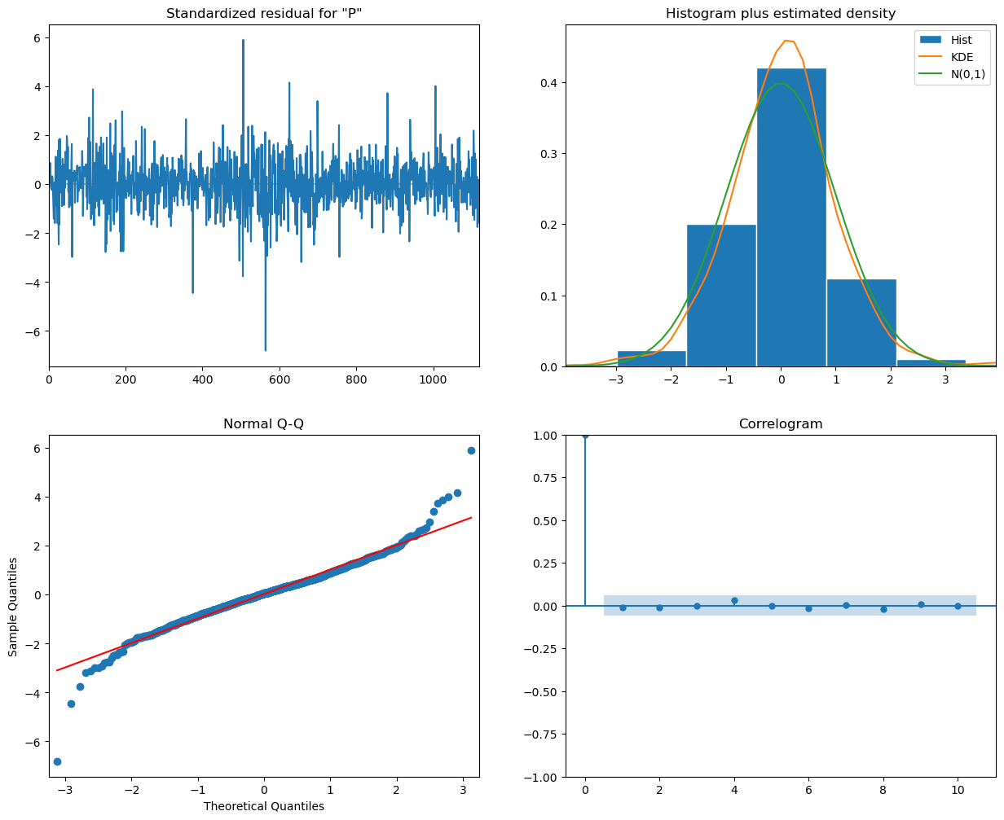

* **Standardized Residuals (Top Left)**
  + The residuals appear to be randomly scattered around zero, indicating that there is no clear pattern left in the residuals and the model has captured the underlying structure of the data well.
* **Histogram plus Estimated Density (Top Right)**
  + The histogram of the residuals, along with the kernel density estimate (KDE) and the standard normal distribution (N(0,1)), shows that the residuals are approximately normally distributed. This is a good sign as it indicates that the residuals conform to the normality assumption.
* **Normal Q-Q Plot (Bottom Left)**
  + The Q-Q plot shows that most of the residuals lie on the red line, indicating that they follow a normal distribution. However, there are some deviations at the tails, suggesting potential outliers or deviations from normality.
* **Correlogram of Residuals (Bottom Right)**
  + The autocorrelation function (ACF) of the residuals shows that all lags are within the significance bounds, indicating that there is no significant autocorrelation left in the residuals. This suggests that the model has adequately captured the temporal dependence in the data.

plt.figure(figsize=(12, 6))

plt.plot(df['Price'], label='Observed')

plt.plot(sarima_forecast_df['forecast'], label='SARIMA Forecast')

plt.fill_between(sarima_forecast_df.index, sarima_forecast_df.iloc[:, 0], sarima_forecast_df.iloc[:, 1], color='k', alpha=0.1)

plt.title('SARIMA Forecast for AMAZON Stock Price')

plt.legend()

plt.show()

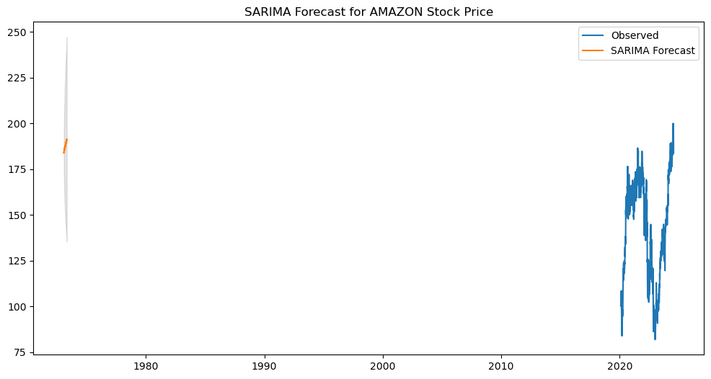

### Interpretation:

1. **Observed Data (Blue Line)**
   * The blue line represents the actual observed stock prices for Amazon over the time period shown on the x-axis.
2. **SARIMA Forecast (Orange Line)**
   * The orange line represents the forecasted stock prices generated by the SARIMA model.
   * The forecast appears as a short segment on the left side, indicating the model has generated a forecast for a limited future period.
3. **Confidence Interval (Shaded Area)**
   * The shaded area around the forecast represents the confidence intervals, indicating the uncertainty associated with the forecast.
   * The intervals widen as the forecast extends into the future, reflecting increasing uncertainty.

**# Plot LSTM predictions**

plt.figure(figsize=(8, 4))

plt.plot(df.index[-len(lstm_predictions):], df['Price'].values[-len(lstm_predictions):], label='True Price')

plt.plot(df.index[-len(lstm_predictions):], lstm_predictions, label='LSTM Predictions')

plt.title('LSTM Forecast for AMAZON Stock Price')

plt.legend()

plt.show()

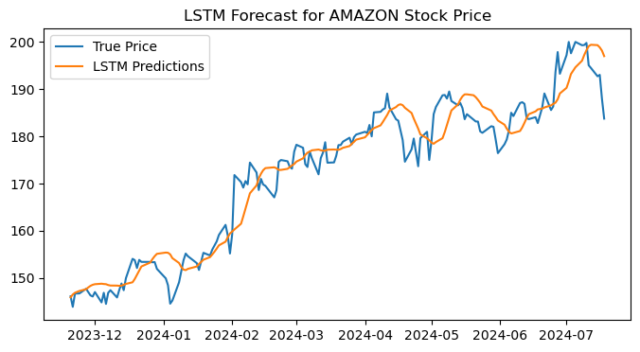

The graph illustrates the comparison between the actual Amazon stock prices (True Price) and the predicted prices using an LSTM (Long Short-Term Memory) model (LSTM Predictions) over a period from December 2023 to July 2024.

Key points:

* The true prices are shown by the blue line, while the LSTM predictions are represented by the orange line.
* The LSTM model captures the overall trend and many fluctuations in the stock price, though there are some deviations.
* The predictions tend to follow the true prices with some lag and smooth out some of the more abrupt changes in the stock price.

**# Plot Decision Tree predictions**

plt.figure(figsize=(12, 6))

plt.plot(df.index[-len(y_test):], y_test, label='True Price')

plt.plot(df.index[-len(y_test):], dt_predictions, label='Decision Tree Predictions')

plt.title('Decision Tree Forecast for AMAZON Stock Price')

plt.legend()

plt.show()

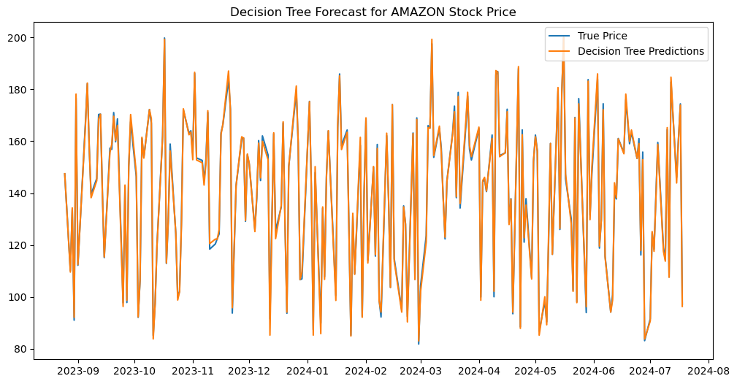

The graph compares the actual Amazon stock prices (True Price) with the predicted prices using a Decision Tree model (Decision Tree Predictions) over a period from September 2023 to August 2024.

Key points:

* The true prices are represented by the blue line, while the Decision Tree predictions are shown by the orange line.
* The Decision Tree predictions exhibit a high degree of fluctuation and closely follow the actual prices, but with significant noise and variability.
* Unlike the smoother trend captured by the LSTM model, the Decision Tree model appears to overfit to the data, capturing almost every fluctuation in the stock prices, resulting in a highly erratic prediction pattern.

plt.figure(figsize=(12, 6))

plt.plot(df.index[-len(y_test):], y_test, label='True Price')

plt.plot(df.index[-len(y_test):], rf_predictions, label='Random Forest Predictions')

plt.title('Random Forest Forecast for AMAZON Stock Price')

plt.legend()

plt.show()

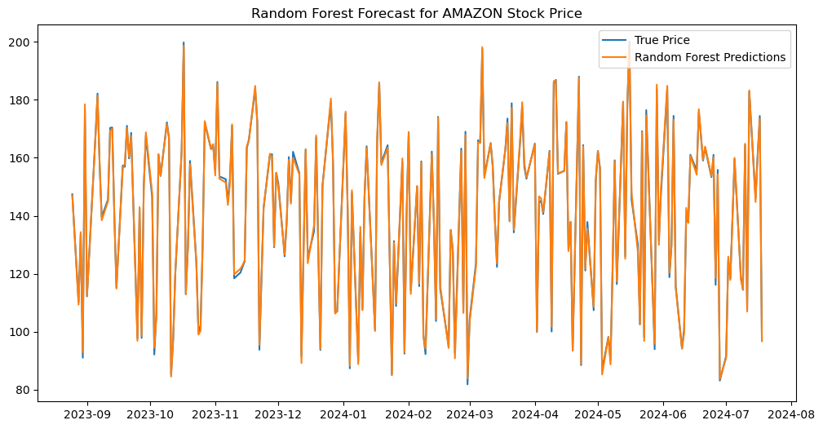

The graph compares the actual Amazon stock prices (True Price) with the predicted prices using a Random Forest model (Random Forest Predictions) over a period from September 2023 to August 2024.

Key points:

* The true prices are represented by the blue line, while the Random Forest predictions are shown by the orange line.
* Similar to the Decision Tree model, the Random Forest predictions exhibit a high degree of fluctuation, closely following the actual prices with significant variability.
* The predictions capture most of the movements in the stock prices but also show a lot of noise, indicating the model's sensitivity to small changes in the data.
* The Random Forest model, while slightly more stable than the single Decision Tree model, still tends to overfit the data, resulting in a highly erratic prediction pattern.

**RCODES AND INTERPRETATION**

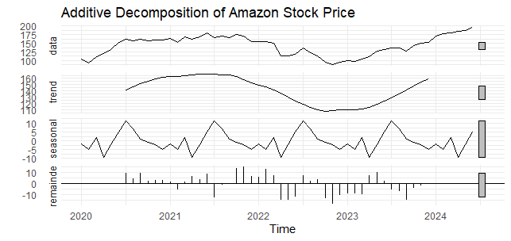

This graph shows the additive decomposition of Amazon's stock price from 2020 to 2024:

1. **Data**: The original stock price data, showing overall growth with fluctuations.
2. **Trend**: A smoothed line showing a general upward trend, with a dip around 2022.
3. **Seasonal**: Repeating patterns indicating yearly cyclical changes.
4. **Remainder**: Random fluctuations not explained by the trend or seasonal components.

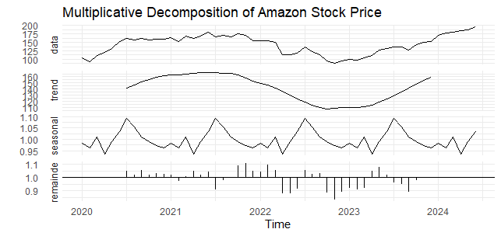

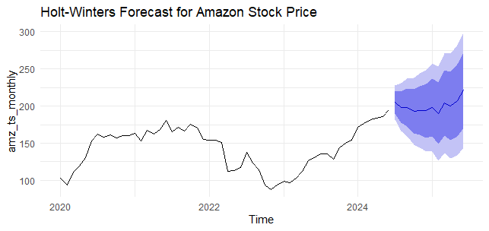

This graph shows a Holt-Winters forecast for Amazon's stock price. The black line represents historical stock prices from 2020 to mid-2024, while the blue shaded area indicates the forecast for the future.

* **Forecast Line**: The dark blue line within the shaded area represents the predicted stock prices.
* **Confidence Intervals**: The lighter blue areas around the forecast line show the 80% and 95% confidence intervals, indicating the range within which the stock price is likely to fall.

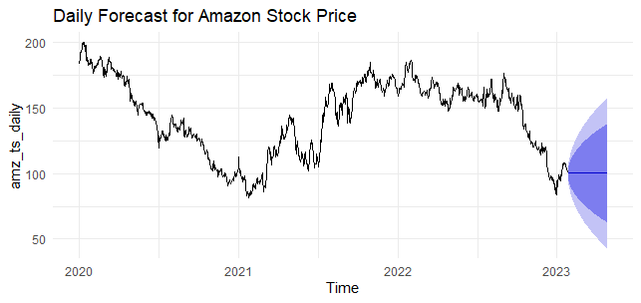

This graph presents a daily forecast for Amazon's stock price.

* **Historical Data:** The black line illustrates the stock prices from 2020 to early 2023.
* **Forecast Line:** The forecasted stock price continues from the black line into 2023.
* **Confidence Intervals:** The blue shaded regions around the forecast line represent the predicted price range, with darker blue indicating higher confidence and lighter blue indicating lower confidence.

**RECOMMENDATIONS**

* Prioritize long-term trends over short-term fluctuations for more informed investment decisions.
* Analyze trend and seasonal components to comprehend the fundamental factors influencing stock prices.
* Use ARIMA for short-term predictions, complementing it with other analyses due to its moderate R-squared value.
* Implement LSTM models for accurate long-term predictions, ensuring they are regularly updated with new data.
* Opt for Random Forest over Decision Tree for more precise and reliable stock price predictions.
* Combine different models to leverage their strengths and enhance prediction accuracy.