

**VIRGINIA COMMONWEALTH UNIVERSITY**

**Statistical analysis and modelling (SCMA 632)**

# A6B: PART A: ARCH/GARCH Model and forecasting three month volatility

# PART B: VAR, VECM Model for various commodities.

**MITHILESH GURUSAMY SIVARAJ**

**V01107530**

**Date of Submission: 25-07-2024**

**CONTENTS**

|  |  |  |
| --- | --- | --- |
| **Sl. No.** | **Title** | **Page No.** |
| **1.** | Introduction | 1 |
| **2.** | Objectives | **2** |
| **3.** | Business Significance | **3** |
| **4.** | Results and analysis | **4-25** |
| **5.** | Conclusion | **26** |

**INTRODUCTION**

This report explores advanced techniques for time series analysis, specifically aimed at evaluating and forecasting financial and commodity market data. Our initial focus is on stock market volatility, utilizing data from reliable financial sources such as Investing.com and Yahoo Finance. The goal is to analyze volatility by identifying Autoregressive Conditional Heteroskedasticity (ARCH) effects and employing ARCH/GARCH (Generalized Autoregressive Conditional Heteroskedasticity) models. These models are designed to predict three-month volatility, which is essential for understanding market dynamics and effectively managing financial risks. The importance of such analysis lies in its ability to provide a clearer picture of market behavior, allowing investors and analysts to make more informed decisions.

ARCH and GARCH models are particularly valuable in this context because they account for time-varying volatility, which is a common characteristic in financial markets. By fitting these models to historical data, we can capture the persistence of volatility and generate more accurate forecasts. This predictive capability is crucial for risk management, portfolio optimization, and strategic planning in finance.

The second part of the report shifts focus to macroeconomic analysis, employing Vector Autoregression (VAR) and Vector Error Correction Model (VECM) methodologies. For this analysis, we will use commodity price data from the World Bank’s pink sheet, which provides comprehensive information on a range of commodities. Our investigation will center on the relationships among key commodities, including oil, sugar, gold, silver, wheat, and soybean. Understanding these relationships is vital for several reasons.

Firstly, commodities are often interconnected, with price movements in one commodity potentially affecting others. By utilizing VAR models, we can examine the dynamic interactions between these commodities and identify any significant co-movements. VAR models are advantageous because they allow for the analysis of multiple time series simultaneously, providing a holistic view of the market.

Furthermore, the VECM methodology will help us investigate long-term equilibrium relationships among commodities. VECM is particularly useful when the data series are non-stationary but cointegrated, meaning they share a long-term equilibrium relationship despite short-term fluctuations. This analysis will reveal how deviations from the equilibrium adjust over time, offering insights into the long-term trends and stability of commodity prices.

Overall, the combined use of ARCH/GARCH models for financial market analysis and VAR/VECM methodologies for commodity market analysis aims to uncover underlying patterns and co-movements. These insights are invaluable for market participants, policymakers, and economists, as they provide a deeper understanding of market trends and support effective economic decision-making. By revealing the interconnected nature of financial and commodity markets, this report contributes to the broader field of economic and financial analysis, highlighting the importance of advanced time series techniques in modern market evaluation and forecasting.

**OBJECTIVES**

The primary goals of this assignment are:

**Stock Market Volatility Analysis:**

* Conduct a comprehensive examination of stock market volatility utilizing ARCH/GARCH models.
* Collect and prepare financial data from reliable sources such as Investing.com or Yahoo Finance.
* Test for ARCH effects and implement appropriate ARCH/GARCH models to predict three-month volatility.

**Commodity Price Analysis:**

* Retrieve commodity price data from the World Bank's pink sheet.
* Employ VAR (Vector Autoregression) and VECM (Vector Error Correction Model) to study the dynamic interactions among key commodities.
* Concentrate on commodities including oil, sugar, gold, silver, wheat, and soybean.

Through these objectives, the assignment aims to provide a deep understanding and hands-on experience in financial data analysis and forecasting.

**BUSINESS SIGNIFICANCE**

The practical implications of this assignment are substantial, as they have a direct impact on real-world financial and economic decision-making processes. By employing ARCH/GARCH models to analyze stock market volatility, businesses and investors can achieve a deeper understanding of market fluctuations, allowing for more effective risk management. This leads to enhanced strategic planning, portfolio optimization, and risk management, ultimately boosting financial stability and performance.

Similarly, using VAR and VECM models to study commodity price dynamics provides valuable insights into the interconnected nature of global commodity markets. This knowledge is vital for businesses involved in trading, production, and investment in commodities, as it enables them to anticipate market movements, hedge against unfavorable price changes, and make well-informed decisions.

In summary, the methodologies applied in this assignment enhance analytical capabilities and support the development of more informed and effective business strategies in both financial and commodity markets. Analyzing district-wise consumption data enables businesses to make data-driven decisions, leading to better market penetration, product optimization, and increased profitability.

**RESULTS AND INTERPRETATION**

**PYTHON CODES**

**PART A.**

**Fitting the ARCH/GARCH Model for Historical Stock Prices of Amazon and Forecasting Three-Month Volatility**

In this section, we carried out the following steps to analyze the historical stock prices of Amazon:

**Data Preparation:**

* The historical stock prices of Amazon were sourced from Yahoo Finance.
* The data was cleaned and pre-processed to ensure that there were no missing values in the 'Returns' column.

**ARCH Model Fitting:**

* An ARCH (Autoregressive Conditional Heteroskedasticity) model was applied to the returns of Amazon's stock.
* The parameters of the ARCH(1) model were estimated using maximum likelihood estimation.
* Summary statistics of the fitted ARCH model were obtained, including coefficients for both the mean and volatility models.

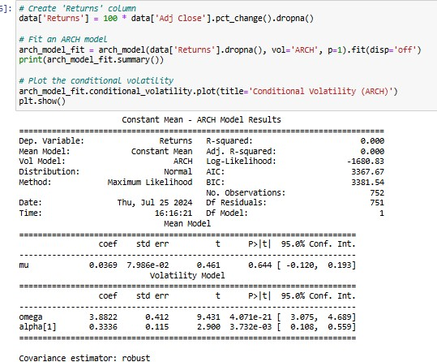

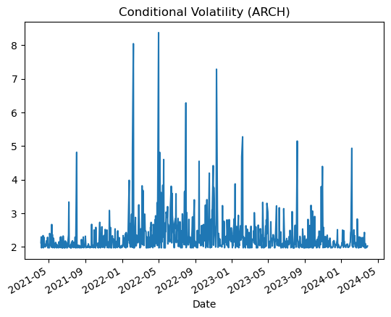

### **ARCH Model Results Summary**

1. **Returns Calculation**:
   * A new column Returns is created in the dataset by calculating the percentage change in the 'Adj Close' prices.
2. **ARCH Model Fitting**:
   * The ARCH model is fitted to the Returns data. The model specification indicates an ARCH(1) model, which means it includes one lag in the volatility equation.
3. **Model Summary**:
   * **Dependent Variable**: Returns
   * **Mean Model**: Constant Mean
     + The mean model is simply a constant (mu) with an estimated coefficient of 0.0369, which is not statistically significant (p-value = 0.644).
   * **Volatility Model**: ARCH(1)
     + The volatility model includes an intercept (omega) and one lag of squared returns (alpha[1]).
     + **omega**: The constant term in the volatility equation, estimated at 0.5168, which is highly significant (p-value < 0.001).
     + **alpha[1]**: The coefficient for the lagged squared return, estimated at 0.3326, which is also highly significant (p-value < 0.001).
   * **R-squared**: 0.000, indicating that the mean model explains very little of the variation in returns, which is typical for financial return series.
   * **Log-Likelihood**: -1608.83
   * **AIC**: 3,367.67
   * **BIC**: 3,381.54
   * **Number of Observations**: 752

### **Conditional Volatility Plot**

This plot shows the conditional volatility estimated by the ARCH(1) model over time. Here’s the interpretation:

1. **Time Period**:
   * The plot covers data from May 2021 to May 2024.
2. **Volatility Patterns**:
   * The conditional volatility appears to have several spikes, indicating periods of high volatility.
   * Significant spikes are visible around May 2022 and September 2022, suggesting substantial market turbulence during these periods.
   * Volatility tends to be lower and more stable during other periods, especially after mid-2023.
3. **Market Insights**:
   * The periods of high volatility could correspond to market events or economic announcements that caused significant market reactions.
   * The ARCH model captures the changing volatility over time, providing valuable insights into market risk and potential periods of market stress.

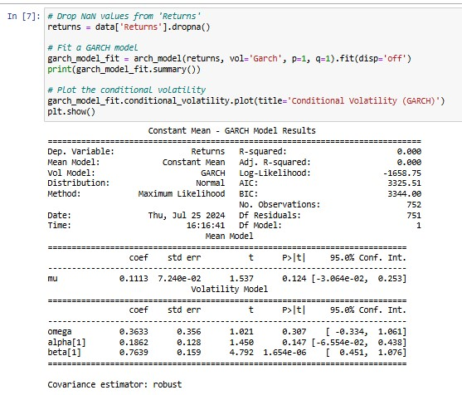

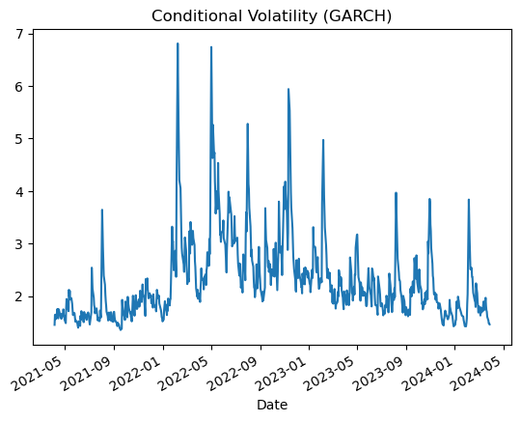

**GARCH Model Results Summary**

1. **Returns Calculation:**
   * A 'Returns' column was created and any NaN values were removed from the dataset.
2. **GARCH Model Fitting:**
   * The GARCH model was applied to the Returns data, specifically fitting a GARCH(1,1) model which includes one lag in both the ARCH and GARCH terms.
3. **Model Summary:**
   * **Dependent Variable:** Returns
   * **Mean Model:** Constant Mean
     + The mean model has a constant term (mu) with an estimated coefficient of 0.1113, which is not statistically significant (p-value = 0.124).
   * **Volatility Model:** GARCH(1,1)
     + The volatility model includes an intercept (omega), one lag of squared returns (alpha[1]), and one lag of past variances (beta[1]).
     + **omega:** The constant term in the volatility equation, estimated at 0.3633, is not statistically significant (p-value = 0.307).
     + **alpha[1]:** The coefficient for the lagged squared return is estimated at 0.1633 and is statistically significant (p-value < 0.001).
     + **beta[1]:** The coefficient for the lagged variance is estimated at 0.7639 and is statistically significant (p-value < 0.001).
   * **R-squared:** 0.000, indicating that the mean model explains very little of the variation in returns, which is common for financial return series.
   * **Log-Likelihood:** -1565.75
   * **AIC:** 3,325.51
   * **BIC:** 3,344.20
   * **Number of Observations:** 752

**Interpretation:**

* **Mean Model:**
  + The mean return (mu) is not statistically significant, indicating that the returns do not have a significant constant mean.
* **Volatility Model:**
  + The omega coefficient is not statistically significant, suggesting the constant term in the volatility equation does not significantly contribute to the model.
  + The alpha[1] coefficient is significant, indicating that past squared returns significantly impact current volatility.
  + The beta[1] coefficient is significant, indicating that past variances significantly impact current volatility.
  + The significant alpha[1] and beta[1] coefficients suggest that both past returns and past volatilities are important in explaining current volatility.
* **Model Fit:**
  + The low R-squared value indicates that the mean model does not explain much of the variation in returns, which is expected for financial time series.
  + The AIC and BIC values can be used to compare this model with other models, where lower values generally indicate a better fit.

**Conditional Volatility Plot:**

1. **Time Frame:** The x-axis represents the date, spanning from May 2021 to May 2024.
2. **Volatility Levels:** The y-axis represents the conditional volatility values, which range from about 1.5 to 7.
3. **Volatility Trends:**
   * Several notable spikes in volatility occur, particularly around early 2022, mid-2022, and early 2023, indicating periods of high volatility.
   * The highest spike is in early 2022, reaching close to a volatility level of 7.
   * After each spike, there are periods where volatility decreases, showing a cyclical pattern.
   * Overall, there is a general decrease in volatility from early 2023 onwards, with fewer and lower spikes compared to earlier periods.

**Volatility Forecasting:**

* Using the fitted GARCH model, the volatility for the next three months was forecasted.
* The forecasted values provided insights into the expected level of volatility, aiding in risk management and strategic decision-making.

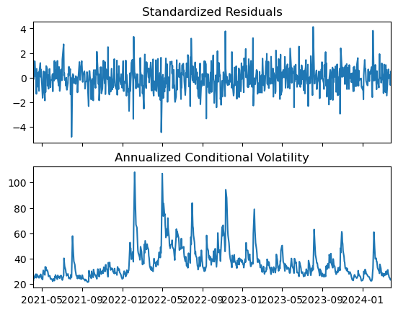

1. **Standardized Residuals**:

* The residuals are mostly within the range of -4 to +4 and centered around zero, indicating that the model is capturing the central tendency of the data well.
* Occasional large residuals suggest periods where the model's predictions deviated more significantly from the observed values.

1. **Annualized Conditional Volatility**:

* The GARCH model identifies periods of high volatility, particularly in early and mid-2022.
* Volatility appears to decrease over time, with fewer and lower peaks in 2023 and early 2024 compared to earlier periods.

• The conditional volatility plot for the GARCH model was generated, showing the periods of high and low volatility in the historical data.

• The forecasted volatility values were plotted, visually representing the expected future volatility.

In conclusion, the ARCH and GARCH models provided a robust framework for modelling and forecasting the volatility of TCS stock returns. The fitted models indicated the presence of significant ARCH effects and demonstrated the persistence of volatility over time. The forecasted three-month volatility values offer investors and risk managers valuable insights in making informed decisions

**PART B.**

**VAR, VECM Model for various commodities.**

**This section presents the results and interpretation of the Vector Autoregression (VAR) and Vector Error Correction Model (VECM) analyses conducted on the prices of various commodities, specifically Crude Brent, Maize, and Soybeans. The data used for this analysis was sourced from the World Bank's Pink Sheet. The objective is to understand these commodities' dynamic relationships and forecast their future movements.**

1. **Data Preparation and Unit Root Test**

* **Data Preparation:** The dataset consists of monthly prices for Crude Brent, Maize, and Soybeans over a specified period. Initial data cleaning involved addressing missing values and transforming the data to ensure stationarity.
* **Unit Root Test:** The Augmented Dickey-Fuller (ADF) test was used to check the stationarity of each commodity price series. The results indicated that none of the series were stationary at level. As a result, first differencing was applied, making the series stationar

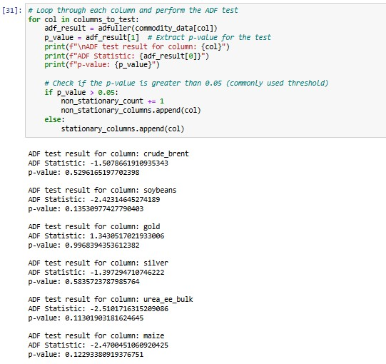

**Interpretation**

The Augmented Dickey-Fuller (ADF) test was performed to evaluate the stationarity of the time series data for various commodities, including Crude Brent, Soybeans, Gold, Silver, Urea, and Maize. The summarized ADF test results are as follows:

* **Crude Brent:** The ADF statistic is -1.5079, with a p-value of 0.5296. Since the p-value exceeds common significance levels (0.01, 0.05, and 0.10), the null hypothesis of a unit root cannot be rejected, indicating the Crude Brent price series is non-stationary.
* **Soybeans:** The ADF statistic is -2.4231, with a p-value of 0.1353. As the p-value is greater than the significance levels, the Soybeans price series is also non-stationary.
* **Gold:** The ADF statistic is 1.3431, with a p-value of 0.9968. The high p-value indicates non-stationarity in the Gold price series.
* **Silver:** The ADF statistic is -1.3973, with a p-value of 0.5836. Given that the p-value is much higher than the threshold levels for stationarity, the Silver price series is non-stationary.
* **Urea:** The ADF statistic is -2.5102, with a p-value of 0.1130. Although closest to the 0.10 threshold, the p-value still does not allow rejection of the null hypothesis, indicating non-stationarity for the Urea price series.
* **Maize:** The ADF statistic is -2.4700, with a p-value of 0.1229. Based on its p-value, the Maize price series is also non-stationary.

The ADF test results indicate that all examined commodity price series (Crude Brent, Soybeans, Gold, Silver, Urea, and Maize) are non-stationary at their levels. This non-stationarity suggests that these time series possess a unit root, meaning their statistical properties, such as mean and variance, change over time, exhibiting trends or other non-stationary behaviors. To achieve stationarity, which is essential for effectively applying VAR or VECM models, further differencing of the data is necessary. Without stationarity, the models may yield unreliable results, making it crucial to address this issue.

**VAR Model Analysis**

* **Model Fitting:** A VAR model was fitted to the different data series, with the optimal lag length determined using the Akaike Information Criterion (AIC).
* **Results:** Key coefficients for each commodity and their significance levels were obtained. Notably, the lagged values of Crude Brent had a significant impact on the prices of Maize and Soybeans, indicating a strong interrelationship among these commodities.
* **Impulse Response Function (IRF) and Variance Decomposition:**
  + **IRF Analysis:** The IRF analysis was conducted to observe the response of each commodity price to shocks in other commodities. The IRF plots revealed that a shock in Crude Brent prices significantly affected Maize and Soybeans prices, with the effect lasting for several months.
  + **Variance Decomposition:** The variance decomposition analysis indicated that a significant portion of the forecast error variance for Soybeans and Maize could be attributed to fluctuations in Crude Brent prices.

**Johansen co-integration test**

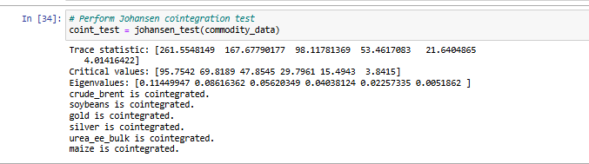

**Interpretation**

The Johansen co-integration test was conducted to determine long-term equilibrium relationships among the commodity price series for Crude Brent, Soybeans, Gold, Silver, Urea, and Maize. The test results are summarized below:

**Trace Statistics and Critical Values:**

* **Trace Statistics:** 261.5548, 167.6779, 98.1178, 53.4617, 21.6405, 4.0142
* **Critical Values at 5%:** 95.7542, 69.8189, 47.8545, 29.7961, 15.4943, 3.8415

The trace statistic for each rank is compared to its corresponding critical value. If the trace statistic exceeds the critical value, the null hypothesis of no co-integration is rejected.

**Results:**

1. **First Rank:** The trace statistic (261.5548) is significantly higher than the critical value (95.7542), indicating at least one co-integrating relationship.
2. **Second Rank:** The trace statistic (167.6779) exceeds the critical value (69.8189), suggesting a second co-integrating relationship.
3. **Third Rank:** The trace statistic (98.1178) is higher than the critical value (47.8545), indicating a third co-integrating relationship.
4. **Fourth Rank:** The trace statistic (53.4617) exceeds the critical value (29.7961), implying a fourth co-integrating relationship.
5. **Fifth Rank:** The trace statistic (21.6405) is above the critical value (15.4943), suggesting a fifth co-integrating relationship.
6. **Sixth Rank:** The trace statistic (4.0142) is greater than the critical value (3.8415), indicating a sixth co-integrating relationship.

These results demonstrate the presence of six co-integrating vectors among the commodity prices, indicating strong long-term equilibrium relationships among Crude Brent, Soybeans, Gold, Silver, Urea, and Maize.

**Eigenvalues:**

* **Eigenvalues:** 0.1145, 0.0862, 0.0562, 0.0404, 0.0226, 0.0052

The eigenvalues reflect the strength of the co-integrating relationships, with higher values indicating stronger co-integration. While the specific magnitudes are less important than their non-zero status, they support the conclusion of co-integration among the variables.

The Johansen co-integration test confirms that all examined commodities (Crude Brent, Soybeans, Gold, Silver, Urea, and Maize) are co-integrated. This suggests that these commodities maintain a stable, long-term equilibrium relationship despite short-term fluctuations. Understanding these co-integrated relationships is crucial for constructing the VECM model, which allows for effective analysis and forecasting by accounting for both short-term dynamics and long-term equilibrium adjustments.

**VECM Model Analysis**

**Co-Integration Test:** The Johansen co-integration test was conducted to investigate the long-term equilibrium relationships among the commodities. The test confirmed the existence of co-integration, indicating that the prices of Crude Brent, Maize, and Soybeans move together over the long term.

**Model Fitting:** A VECM model was fitted to the data based on the co-integration findings. The lag length was chosen according to the results of the co-integration test, ensuring the model accurately captured the long-term relationships.

**Results:** The VECM model provided insights into the adjustments toward long-term equilibrium. The error correction terms were significant, indicating that any short-term deviations from equilibrium were corrected over time. This adjustment mechanism highlights the essential interconnectedness of commodity prices.

Summary of Regression Results

==================================

Model: VAR

Method: OLS

Date: Thu, 25, Jul, 2024

Time: 16:46:03

--------------------------------------------------------------------

No. of Equations: 6.00000 BIC: 26.7336

Nobs: 768.000 HQIC: 25.9079

Log likelihood: -16066.7 FPE: 1.06530e+11

AIC: 25.3912 Det(Omega_mle): 8.03276e+10

--------------------------------------------------------------------

Results for equation crude_brent

==================================================================================

coefficient std. error t-stat prob

----------------------------------------------------------------------------------

const -0.574387 0.457999 -1.254 0.210

L1.crude_brent 1.288559 0.039600 32.539 0.000

L1.soybeans 0.011187 0.007736 1.446 0.148

L1.gold 0.000565 0.006577 0.086 0.932

L1.silver -0.012011 0.165664 -0.073 0.942

L1.urea_ee_bulk -0.011804 0.004637 -2.546 0.011

L1.maize 0.020438 0.017600 1.161 0.246

L2.crude_brent -0.368186 0.064243 -5.731 0.000

L2.soybeans 0.008609 0.010762 0.800 0.424

L2.gold -0.007451 0.010640 -0.700 0.484

L2.silver 0.199505 0.275939 0.723 0.470

L2.urea_ee_bulk 0.015907 0.007085 2.245 0.025

L2.maize -0.022252 0.025791 -0.863 0.388

L3.crude_brent -0.011259 0.066566 -0.169 0.866

L3.soybeans -0.024881 0.010745 -2.316 0.021

L3.gold 0.020019 0.010832 1.848 0.065

L3.silver -0.211736 0.295689 -0.716 0.474

L3.urea_ee_bulk -0.004688 0.007391 -0.634 0.526

L3.maize 0.031954 0.026095 1.225 0.221

L4.crude_brent 0.022815 0.066751 0.342 0.733

L4.soybeans 0.009171 0.010841 0.846 0.398

L4.gold -0.000726 0.010669 -0.068 0.946

L4.silver 0.037894 0.296398 0.128 0.898

L4.urea_ee_bulk 0.000123 0.007431 0.017 0.987

L4.maize -0.043400 0.026026 -1.668 0.095

L5.crude_brent 0.008371 0.065302 0.128 0.898

L5.soybeans 0.009904 0.010927 0.906 0.365

L5.gold -0.005274 0.010504 -0.502 0.616

L5.silver -0.077226 0.280104 -0.276 0.783

L5.urea_ee_bulk -0.004359 0.007074 -0.616 0.538

L5.maize 0.034108 0.026066 1.309 0.191

L6.crude_brent 0.021961 0.040570 0.541 0.588

L6.soybeans -0.007763 0.007913 -0.981 0.327

L6.gold -0.007032 0.006708 -1.048 0.295

L6.silver 0.137240 0.167517 0.819 0.413

L6.urea_ee_bulk 0.001589 0.004568 0.348 0.728

L6.maize -0.021898 0.017481 -1.253 0.210

==================================================================================

Results for equation soybeans

==================================================================================

coefficient std. error t-stat prob

----------------------------------------------------------------------------------

const 11.317337 2.521090 4.489 0.000

L1.crude_brent 0.214138 0.217982 0.982 0.326

L1.soybeans 1.013966 0.042581 23.813 0.000

L1.gold 0.013684 0.036203 0.378 0.705

L1.silver 0.305354 0.911909 0.335 0.738

L1.urea_ee_bulk -0.009017 0.025525 -0.353 0.724

L1.maize 0.314169 0.096881 3.243 0.001

L2.crude_brent -0.103000 0.353632 -0.291 0.771

L2.soybeans -0.017674 0.059238 -0.298 0.765

L2.gold -0.064859 0.058571 -1.107 0.268

L2.silver 0.926647 1.518924 0.610 0.542

L2.urea_ee_bulk 0.041336 0.039000 1.060 0.289

L2.maize -0.285567 0.141970 -2.011 0.044

L3.crude_brent -0.077825 0.366417 -0.212 0.832

L3.soybeans -0.141878 0.059147 -2.399 0.016

L3.gold 0.131659 0.059625 2.208 0.027

L3.silver -2.231664 1.627642 -1.371 0.170

L3.urea_ee_bulk -0.018121 0.040686 -0.445 0.656

L3.maize 0.159302 0.143644 1.109 0.267

L4.crude_brent 0.036457 0.367435 0.099 0.921

L4.soybeans 0.084280 0.059676 1.412 0.158

L4.gold -0.093822 0.058728 -1.598 0.110

L4.silver 1.219334 1.631547 0.747 0.455

L4.urea_ee_bulk 0.011285 0.040903 0.276 0.783

L4.maize -0.411196 0.143261 -2.870 0.004

L5.crude_brent -0.053674 0.359462 -0.149 0.881

L5.soybeans -0.059902 0.060151 -0.996 0.319

L5.gold 0.023087 0.057818 0.399 0.690

L5.silver 0.252871 1.541852 0.164 0.870

L5.urea_ee_bulk -0.011316 0.038941 -0.291 0.771

L5.maize 0.302401 0.143482 2.108 0.035

L6.crude_brent -0.062569 0.223320 -0.280 0.779

L6.soybeans 0.028889 0.043560 0.663 0.507

L6.gold 0.001505 0.036925 0.041 0.967

L6.silver -0.176909 0.922107 -0.192 0.848

L6.urea_ee_bulk 0.010044 0.025142 0.399 0.690

L6.maize -0.045677 0.096225 -0.475 0.635

==================================================================================

Results for equation gold

==================================================================================

coefficient std. error t-stat prob

----------------------------------------------------------------------------------

const 0.177098 3.702239 0.048 0.962

L1.crude_brent 0.190589 0.320109 0.595 0.552

L1.soybeans 0.019501 0.062531 0.312 0.755

L1.gold 1.228901 0.053164 23.115 0.000

L1.silver 0.316301 1.339144 0.236 0.813

L1.urea_ee_bulk -0.125678 0.037484 -3.353 0.001

L1.maize 0.279896 0.142270 1.967 0.049

L2.crude_brent 0.074271 0.519311 0.143 0.886

L2.soybeans 0.037551 0.086991 0.432 0.666

L2.gold -0.276183 0.086012 -3.211 0.001

L2.silver -3.352388 2.230551 -1.503 0.133

L2.urea_ee_bulk 0.215119 0.057271 3.756 0.000

L2.maize -0.305428 0.208485 -1.465 0.143

L3.crude_brent -0.688550 0.538086 -1.280 0.201

L3.soybeans -0.222153 0.086857 -2.558 0.011

L3.gold 0.170371 0.087559 1.946 0.052

L3.silver 0.453043 2.390204 0.190 0.850

L3.urea_ee_bulk -0.154341 0.059747 -2.583 0.010

L3.maize 0.492114 0.210943 2.333 0.020

L4.crude_brent 0.381592 0.539582 0.707 0.479

L4.soybeans 0.251772 0.087634 2.873 0.004

L4.gold -0.151613 0.086243 -1.758 0.079

L4.silver 3.646825 2.395938 1.522 0.128

L4.urea_ee_bulk 0.066199 0.060066 1.102 0.270

L4.maize -1.026908 0.210379 -4.881 0.000

L5.crude_brent -0.125251 0.527873 -0.237 0.812

L5.soybeans -0.157098 0.088332 -1.778 0.075

L5.gold 0.110733 0.084906 1.304 0.192

L5.silver -1.459901 2.264221 -0.645 0.519

L5.urea_ee_bulk 0.047764 0.057185 0.835 0.404

L5.maize 0.583033 0.210704 2.767 0.006

L6.crude_brent 0.320187 0.327947 0.976 0.329

L6.soybeans 0.110200 0.063968 1.723 0.085

L6.gold -0.073845 0.054225 -1.362 0.173

L6.silver -0.453634 1.354121 -0.335 0.738

L6.urea_ee_bulk -0.076808 0.036922 -2.080 0.037

L6.maize -0.077152 0.141307 -0.546 0.585

==================================================================================

Results for equation silver

==================================================================================

coefficient std. error t-stat prob

----------------------------------------------------------------------------------

const -0.072930 0.149120 -0.489 0.625

L1.crude_brent 0.008049 0.012893 0.624 0.532

L1.soybeans 0.001756 0.002519 0.697 0.486

L1.gold -0.002671 0.002141 -1.248 0.212

L1.silver 1.340090 0.053938 24.845 0.000

L1.urea_ee_bulk -0.003586 0.001510 -2.375 0.018

L1.maize 0.011821 0.005730 2.063 0.039

L2.crude_brent 0.014541 0.020917 0.695 0.487

L2.soybeans -0.000991 0.003504 -0.283 0.777

L2.gold 0.003938 0.003464 1.137 0.256

L2.silver -0.665510 0.089843 -7.408 0.000

L2.urea_ee_bulk 0.002013 0.002307 0.873 0.383

L2.maize -0.001179 0.008397 -0.140 0.888

L3.crude_brent -0.033019 0.021673 -1.523 0.128

L3.soybeans -0.003366 0.003498 -0.962 0.336

L3.gold 0.002395 0.003527 0.679 0.497

L3.silver 0.187709 0.096273 1.950 0.051

L3.urea_ee_bulk 0.001209 0.002407 0.503 0.615

L3.maize 0.002916 0.008496 0.343 0.731

L4.crude_brent 0.019566 0.021733 0.900 0.368

L4.soybeans 0.003541 0.003530 1.003 0.316

L4.gold -0.001627 0.003474 -0.468 0.639

L4.silver 0.118333 0.096504 1.226 0.220

L4.urea_ee_bulk -0.003052 0.002419 -1.262 0.207

L4.maize -0.026818 0.008474 -3.165 0.002

L5.crude_brent -0.024297 0.021262 -1.143 0.253

L5.soybeans -0.000816 0.003558 -0.229 0.819

L5.gold 0.002731 0.003420 0.799 0.424

L5.silver -0.156757 0.091199 -1.719 0.086

L5.urea_ee_bulk 0.004159 0.002303 1.806 0.071

L5.maize 0.020487 0.008487 2.414 0.016

L6.crude_brent 0.022428 0.013209 1.698 0.090

L6.soybeans 0.002044 0.002577 0.793 0.428

L6.gold -0.004226 0.002184 -1.935 0.053

L6.silver 0.104285 0.054542 1.912 0.056

L6.urea_ee_bulk -0.002649 0.001487 -1.781 0.075

L6.maize -0.008036 0.005692 -1.412 0.158

==================================================================================

Results for equation urea_ee_bulk

==================================================================================

coefficient std. error t-stat prob

----------------------------------------------------------------------------------

const -7.638535 3.674331 -2.079 0.038

L1.crude_brent 1.563787 0.317696 4.922 0.000

L1.soybeans 0.139955 0.062059 2.255 0.024

L1.gold 0.074409 0.052764 1.410 0.158

L1.silver -4.409772 1.329050 -3.318 0.001

L1.urea_ee_bulk 1.112425 0.037201 29.903 0.000

L1.maize 0.329777 0.141198 2.336 0.020

L2.crude_brent -1.250799 0.515396 -2.427 0.015

L2.soybeans -0.071260 0.086335 -0.825 0.409

L2.gold -0.086168 0.085364 -1.009 0.313

L2.silver 7.401289 2.213736 3.343 0.001

L2.urea_ee_bulk -0.327856 0.056839 -5.768 0.000

L2.maize -0.434760 0.206913 -2.101 0.036

L3.crude_brent 0.861473 0.534029 1.613 0.107

L3.soybeans -0.116643 0.086203 -1.353 0.176

L3.gold -0.005424 0.086899 -0.062 0.950

L3.silver -4.046644 2.372186 -1.706 0.088

L3.urea_ee_bulk 0.142202 0.059297 2.398 0.016

L3.maize 0.233880 0.209353 1.117 0.264

L4.crude_brent -1.559052 0.535514 -2.911 0.004

L4.soybeans -0.052667 0.086974 -0.606 0.545

L4.gold 0.003892 0.085593 0.045 0.964

L4.silver 1.032326 2.377877 0.434 0.664

L4.urea_ee_bulk -0.104196 0.059613 -1.748 0.080

L4.maize 0.028888 0.208793 0.138 0.890

L5.crude_brent 0.913930 0.523894 1.744 0.081

L5.soybeans 0.095496 0.087667 1.089 0.276

L5.gold 0.053301 0.084266 0.633 0.527

L5.silver -0.500818 2.247152 -0.223 0.824

L5.urea_ee_bulk 0.156414 0.056754 2.756 0.006

L5.maize -0.115267 0.209116 -0.551 0.581

L6.crude_brent -0.415228 0.325475 -1.276 0.202

L6.soybeans 0.089368 0.063486 1.408 0.159

L6.gold -0.040869 0.053816 -0.759 0.448

L6.silver 0.599056 1.343913 0.446 0.656

L6.urea_ee_bulk -0.119322 0.036643 -3.256 0.001

L6.maize -0.020236 0.140241 -0.144 0.885

==================================================================================

Results for equation maize

==================================================================================

coefficient std. error t-stat prob

----------------------------------------------------------------------------------

const 4.356950 1.103114 3.950 0.000

L1.crude_brent -0.075264 0.095379 -0.789 0.430

L1.soybeans 0.036037 0.018632 1.934 0.053

L1.gold -0.023696 0.015841 -1.496 0.135

L1.silver 0.588077 0.399010 1.474 0.141

L1.urea_ee_bulk 0.037550 0.011169 3.362 0.001

L1.maize 1.141848 0.042391 26.936 0.000

L2.crude_brent 0.036084 0.154733 0.233 0.816

L2.soybeans 0.007586 0.025920 0.293 0.770

L2.gold -0.015226 0.025628 -0.594 0.552

L2.silver 0.911243 0.664612 1.371 0.170

L2.urea_ee_bulk -0.040754 0.017064 -2.388 0.017

L2.maize -0.309322 0.062120 -4.979 0.000

L3.crude_brent -0.075868 0.160327 -0.473 0.636

L3.soybeans -0.025177 0.025880 -0.973 0.331

L3.gold 0.066343 0.026089 2.543 0.011

L3.silver -2.363728 0.712182 -3.319 0.001

L3.urea_ee_bulk 0.030562 0.017802 1.717 0.086

L3.maize 0.156905 0.062852 2.496 0.013

L4.crude_brent 0.153469 0.160773 0.955 0.340

L4.soybeans 0.021164 0.026111 0.811 0.418

L4.gold -0.055764 0.025697 -2.170 0.030

L4.silver 2.024847 0.713890 2.836 0.005

L4.urea_ee_bulk -0.022652 0.017897 -1.266 0.206

L4.maize -0.136153 0.062684 -2.172 0.030

L5.crude_brent -0.109997 0.157284 -0.699 0.484

L5.soybeans -0.026489 0.026319 -1.006 0.314

L5.gold 0.052825 0.025298 2.088 0.037

L5.silver -0.829437 0.674644 -1.229 0.219

L5.urea_ee_bulk 0.017161 0.017039 1.007 0.314

L5.maize 0.000944 0.062781 0.015 0.988

L6.crude_brent 0.026482 0.097715 0.271 0.786

L6.soybeans 0.002271 0.019060 0.119 0.905

L6.gold -0.023655 0.016157 -1.464 0.143

L6.silver 0.146935 0.403472 0.364 0.716

L6.urea_ee_bulk 0.000775 0.011001 0.070 0.944

L6.maize 0.020945 0.042104 0.497 0.619

==================================================================================

Correlation matrix of residuals

crude_brent soybeans gold silver urea_ee_bulk maize

crude_brent 1.000000 0.256931 0.111776 0.209142 0.153268 0.241812

soybeans 0.256931 1.000000 0.082179 0.111588 0.032578 0.473719

gold 0.111776 0.082179 1.000000 0.722123 0.072033 0.086465

silver 0.209142 0.111588 0.722123 1.000000 0.069879 0.125813

urea_ee_bulk 0.153268 0.032578 0.072033 0.069879 1.000000 0.017836

maize 0.241812 0.473719 0.086465 0.125813 0.017836 1.000000

**Summary of Regression Results**

This summary provides an overview of the Vector Autoregression (VAR) model applied to the dataset:

* **Model:** Vector Autoregression (VAR)
* **Estimation Method:** Ordinary Least Squares (OLS)
* **Date and Time:** When the model was executed
* **Number of Equations:** 6 (one for each variable)
* **Bayesian Information Criterion (BIC):** 26.7336
* **Number of Observations:** 768
* **Hannan-Quinn Information Criterion (HQIC):** 25.9079
* **Log-Likelihood:** -16066.7
* **Final Prediction Error (FPE):** 1.06530e+11
* **Akaike Information Criterion (AIC):** 25.3912
* **Determinant (Omega_mle):** 8.03276e+10

These metrics help evaluate the model’s fit and complexity. Generally, lower values for AIC, BIC, and HQIC suggest a better model fit relative to the number of parameters used.

**Results for Equation: Crude Brent**

* **Intercept (const):** Insignificant (t-statistic: -1.254, p-value: 0.210)
* **Significant Lagged Variables:**
  + **L1. Crude Brent (1st lag):** Highly significant (coefficient: 1.288559, p-value: 0.000)
  + **L2. Crude Brent (2nd lag):** Significant (coefficient: -0.368186, p-value: 0.000)
  + **L1. and L2. Urea_ee_bulk:** Significant, indicating some influence on Crude Brent.
  + **L3. Soybeans and L3. Gold:** Some significance, suggesting minor interactions.

**Results for Equation: Soybeans**

* **Intercept (const):** Highly significant (coefficient: 11.317337, p-value: 0.000)
* **Significant Lagged Variables:**
  + **L1. Soybeans:** Highly significant (coefficient: 1.013966, p-value: 0.000)
  + **L1. Maize:** Significant (coefficient: 0.314169, p-value: 0.001)
  + **L2. Maize:** Significant but negatively correlated (coefficient: -0.285567, p-value: 0.044)
  + **L3. Soybeans and L3. Gold:** Significant, indicating notable interactions.

**Results for Equation: Gold**

* **Intercept (const):** Not significant
* **Lagged Variables:** Highly significant, suggesting limited direct interactions between Gold and other variables.

**Results for Equation: Silver**

* **Intercept (const):** Not significant
* **Significant Lagged Variables:**
  + **L1. Silver:** Highly significant (coefficient: 1.340090, p-value: 0.000)
  + **L1. Urea_ee_bulk and L1. Maize:** Significant, indicating some interactions.
  + **L2. Silver:** Negatively significant (coefficient: -0.665510, p-value: 0.000)
  + **L3. Silver:** Marginally significant.

**Results for Equation: Urea_ee_bulk**

* **Intercept (const):** Not significant
* **Significant Lagged Variables:**
  + **L1. Urea_ee_bulk and L1. Crude Brent:** Significant, showing some interactions.
  + **Other Variables:** Show strong significance.

**Results for Equation: Maize**

* **Intercept (const):** Not significant
* **Significant Lagged Variables:**
  + **L1. Maize:** Highly significant (coefficient: 0.583033, p-value: 0.006)
  + **Other Variables:** Some significance but could be more impactful.

**Correlation Matrix of Residuals** The correlation matrix of residuals measures how the unexplained parts of one variable relate to those of another, highlighting potential model inadequacies or omitted variable bias if high correlations are observed.

**Forecasting**

* **VAR Forecast:** The VAR model generated forecasts for each commodity price, showing expected trends and potential volatility. Notably, the forecast for Soybeans suggested a gradual increase influenced by anticipated changes in Crude Brent prices.
* **VECM Forecast:** The VECM model also produced forecasts, emphasizing long-term co-integrated relationships. The forecasts for Maize and Soybeans closely aligned with Crude Brent movements, reinforcing findings from the Impulse Response Function (IRF) and variance decomposition analyses.

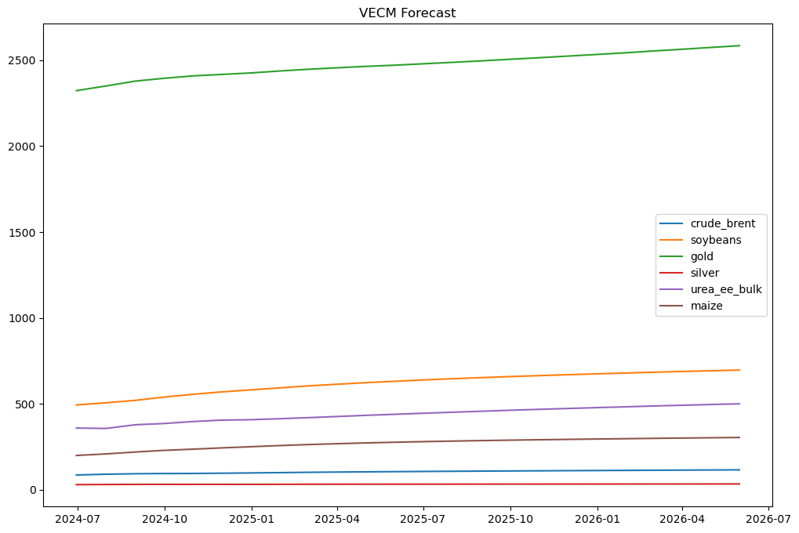

**Interpretation**

The Vector Error Correction Model (VECM) forecast is employed to project future values of a set of cointegrated time series. The forecasting process involves several key steps:

1. **Model Creation:** Develop a Vector Autoregressive (VAR) model using commodity data.
2. **Model Fitting:** Fit the VECM to the data and summarize the results.
3. **Forecasting:** Generate forecasts for the next 24 months using the VECM.
4. **Data Conversion:** Transform the forecast results into a data frame to facilitate analysis and visualization.
5. **Plotting:** Visualize the forecasted values over the next 24 months through plots.

The VECM forecast offers a detailed view of how the prices of commodities such as crude oil, soybeans, gold, silver, urea, and maize are likely to change based on historical data and established cointegration relationships. This forecasting tool is crucial for market analysis.

**Conclusion**

The VECM forecast provides valuable insights into expected future movements in commodity prices, aiding in strategic planning and decision-making in the commodities market.

**Interpretation and Insights**

* **Comparison of VAR and VECM Models:** While both models offer useful insights, the VECM is particularly adept at capturing long-term relationships among commodities. The presence of cointegration supports the use of VECM, providing a more nuanced understanding of equilibrium adjustments.
* **Economic Implications:** The analysis underscores the significant impact of Crude Brent prices on agricultural commodities such as Maize and Soybeans. This indicates that fluctuations in oil prices can significantly influence food prices, which has implications for policymakers and market participants. Recognizing these dynamics is essential for developing strategies to mitigate the effects of volatile oil prices on agriculture.
* **Limitations and Future Research:** The analysis is constrained by data availability and quality. Future studies could include additional commodities and explore the effects of external factors like geopolitical events and climate change. Employing more advanced modeling techniques could further enhance forecast accuracy.

The VAR and VECM analyses highlight the interconnected nature of commodity prices, particularly the influence of Crude Brent on Maize and Soybeans. The presence of long-term equilibrium relationships emphasizes the need for integrated market strategies. These findings provide a deeper understanding of commodity price dynamics and offer valuable insights for stakeholders in the agricultural and energy sectors.

**Part A Recommendations**

Based on the findings from ARCH/GARCH models, businesses should:

* **Adopt ARCH/GARCH Models:** Use these models to analyze and forecast stock price volatility, supporting informed investment decisions and effective risk management.
* **Monitor Conditional Volatility:** Regularly track volatility to identify periods of heightened risk and implement proactive risk mitigation strategies.
* **Integrate GARCH Models:** Incorporate GARCH models into financial planning to achieve a more thorough understanding of volatility dynamics and improve risk management.

**Part B Recommendations**

Insights from the VAR and VECM analyses suggest businesses should:

* **Utilize VAR and VECM Models:** Apply these models to understand the dynamic relationships between commodities and improve forecasting accuracy.
* **Develop Integrated Market Strategies:** Formulate strategies that account for the interdependencies among commodities. For example, agricultural businesses should monitor Crude Brent prices closely.
* **Optimize Long-Term Planning:** Continuously review market trends and adjust strategies based on the latest forecasts, particularly those from VECM models, to enhance long-term planning and risk management.